A comparison of heat flow interpolations near subduction zones

Surface heat flow near subduction zones provides indirect observations of geodynamic processes at depth. Global heat flow databases, therefore, may test and generate hypotheses about subduction zone thermal structure and geodynamics. Here we argue that sampling from heat flow interpolations, rather than projecting discrete observations onto single trench-perpendicular transects, is a better framework for hypothesis testing. We make a direct comparison between Kriging and similarity interpolations, based on the First and Third Laws of Geography, of the most current global heat flow database and consider the implications for current geodynamic models and future subduction zone research. Inconsistent spatial patterns and variance characterize heat flow near subduction zones, regardless of interpolation method, countering hypotheses of common thermal structure (e.g. thin backarc lithospheres) and geodynamics (e.g. coupling) among subduction zones. Improving interpolations will further test current geodynamic models and should guide future data acquisitions.

# Introduction

Heat escaping the solid Earth’s surface indicates a dynamically cooling planet. Surface heat flow databases (Hasterok & Chapman, 2008; F. Lucazeau, 2019; Pollack et al., 1993) provide a way to investigate and quantify geodynamics by relating the amount of heat escaping Earth’s surface to heat-transferring and heat-generating subsurface processes such as diffusion, hydrothermal circulation, radioactive decay, fault motion, subduction dynamics, and mantle convection (Currie et al., 2004; Currie & Hyndman, 2006; Fourier, 1827; Furlong & Chapman, 2013; Yoshitsugu Furukawa, 1993; Gao & Wang, 2014; Hasterok, 2013; Kerswell et al., 2020; Parsons & Sclater, 1977; Pollack & Chapman, 1977; Rudnick et al., 1998; Carol A. Stein & Stein, 1992, 1994; Wada & Wang, 2009). Surface heat flow observations continue to motivate research, evident by more than 1,393 publications compiled in the most recent heat flow database, although the rate of publications using surface heat flow has declined since the mid 1980’s (Jennings & Hasterok, 2021).

Questions such as calculating the global surface heat flux from continents and oceans require interpolating discrete heat flow observations onto a continuous approximation of Earth’s surface. Interpolation attempts commonly use one or more geographic, geologic, geochronologic, or geophysical proxies to predict heat flow at unknown locations by association with similar observation sites (e.g., bathymetry or elevation, proximity to active or ancient orogens, seafloor age, upper mantle shear wave velocities, David S. Chapman & Pollack, 1975; Davies, 2013; B. Goutorbe et al., 2011; W. H. Lee & Uyeda, 1965; F. Lucazeau, 2019; John G. Sclater & Francheteau, 1970; Shapiro & Ritzwoller, 2004). These methods are called *similarity methods* (Figure 1) and follow the assumptions embedded in the Third Law of Geography (hereafter referred to as the Third Law): *the more similar the geographic configuration of two points, the more similar their values* (Zhu et al., 2018).

Using prior information in estimation is an advantage of the Third Law and is arguably the most reasonable approach for interpolating surface heat flow. Our understanding of geodynamics and near-surface heat flow perturbations implies a strong relationship between surface heat flow and the set of local physical conditions (e.g., B. Goutorbe et al., 2011), irrespective of the location. For example, younger oceanic plates should have higher surface heat flow than older plates (Carol A. Stein & Stein, 1992), subducting oceanic plates will lower surface heat flow near trenches (Yoshitsugu Furukawa, 1993), and hydrothermal circulation of seawater can modify heat escaping from oceanic crust (Hasterok et al., 2011). Interpolation by the Third Law makes reasoned predictions of heat flow with priors from many independently-tested geodynamic models. Disadvantages of the Third Law include strong bias towards geodynamic models, making determinations where, in fact, deviations from such models occur, and multiple interacting sources of uncertainty from many proxy datasets.

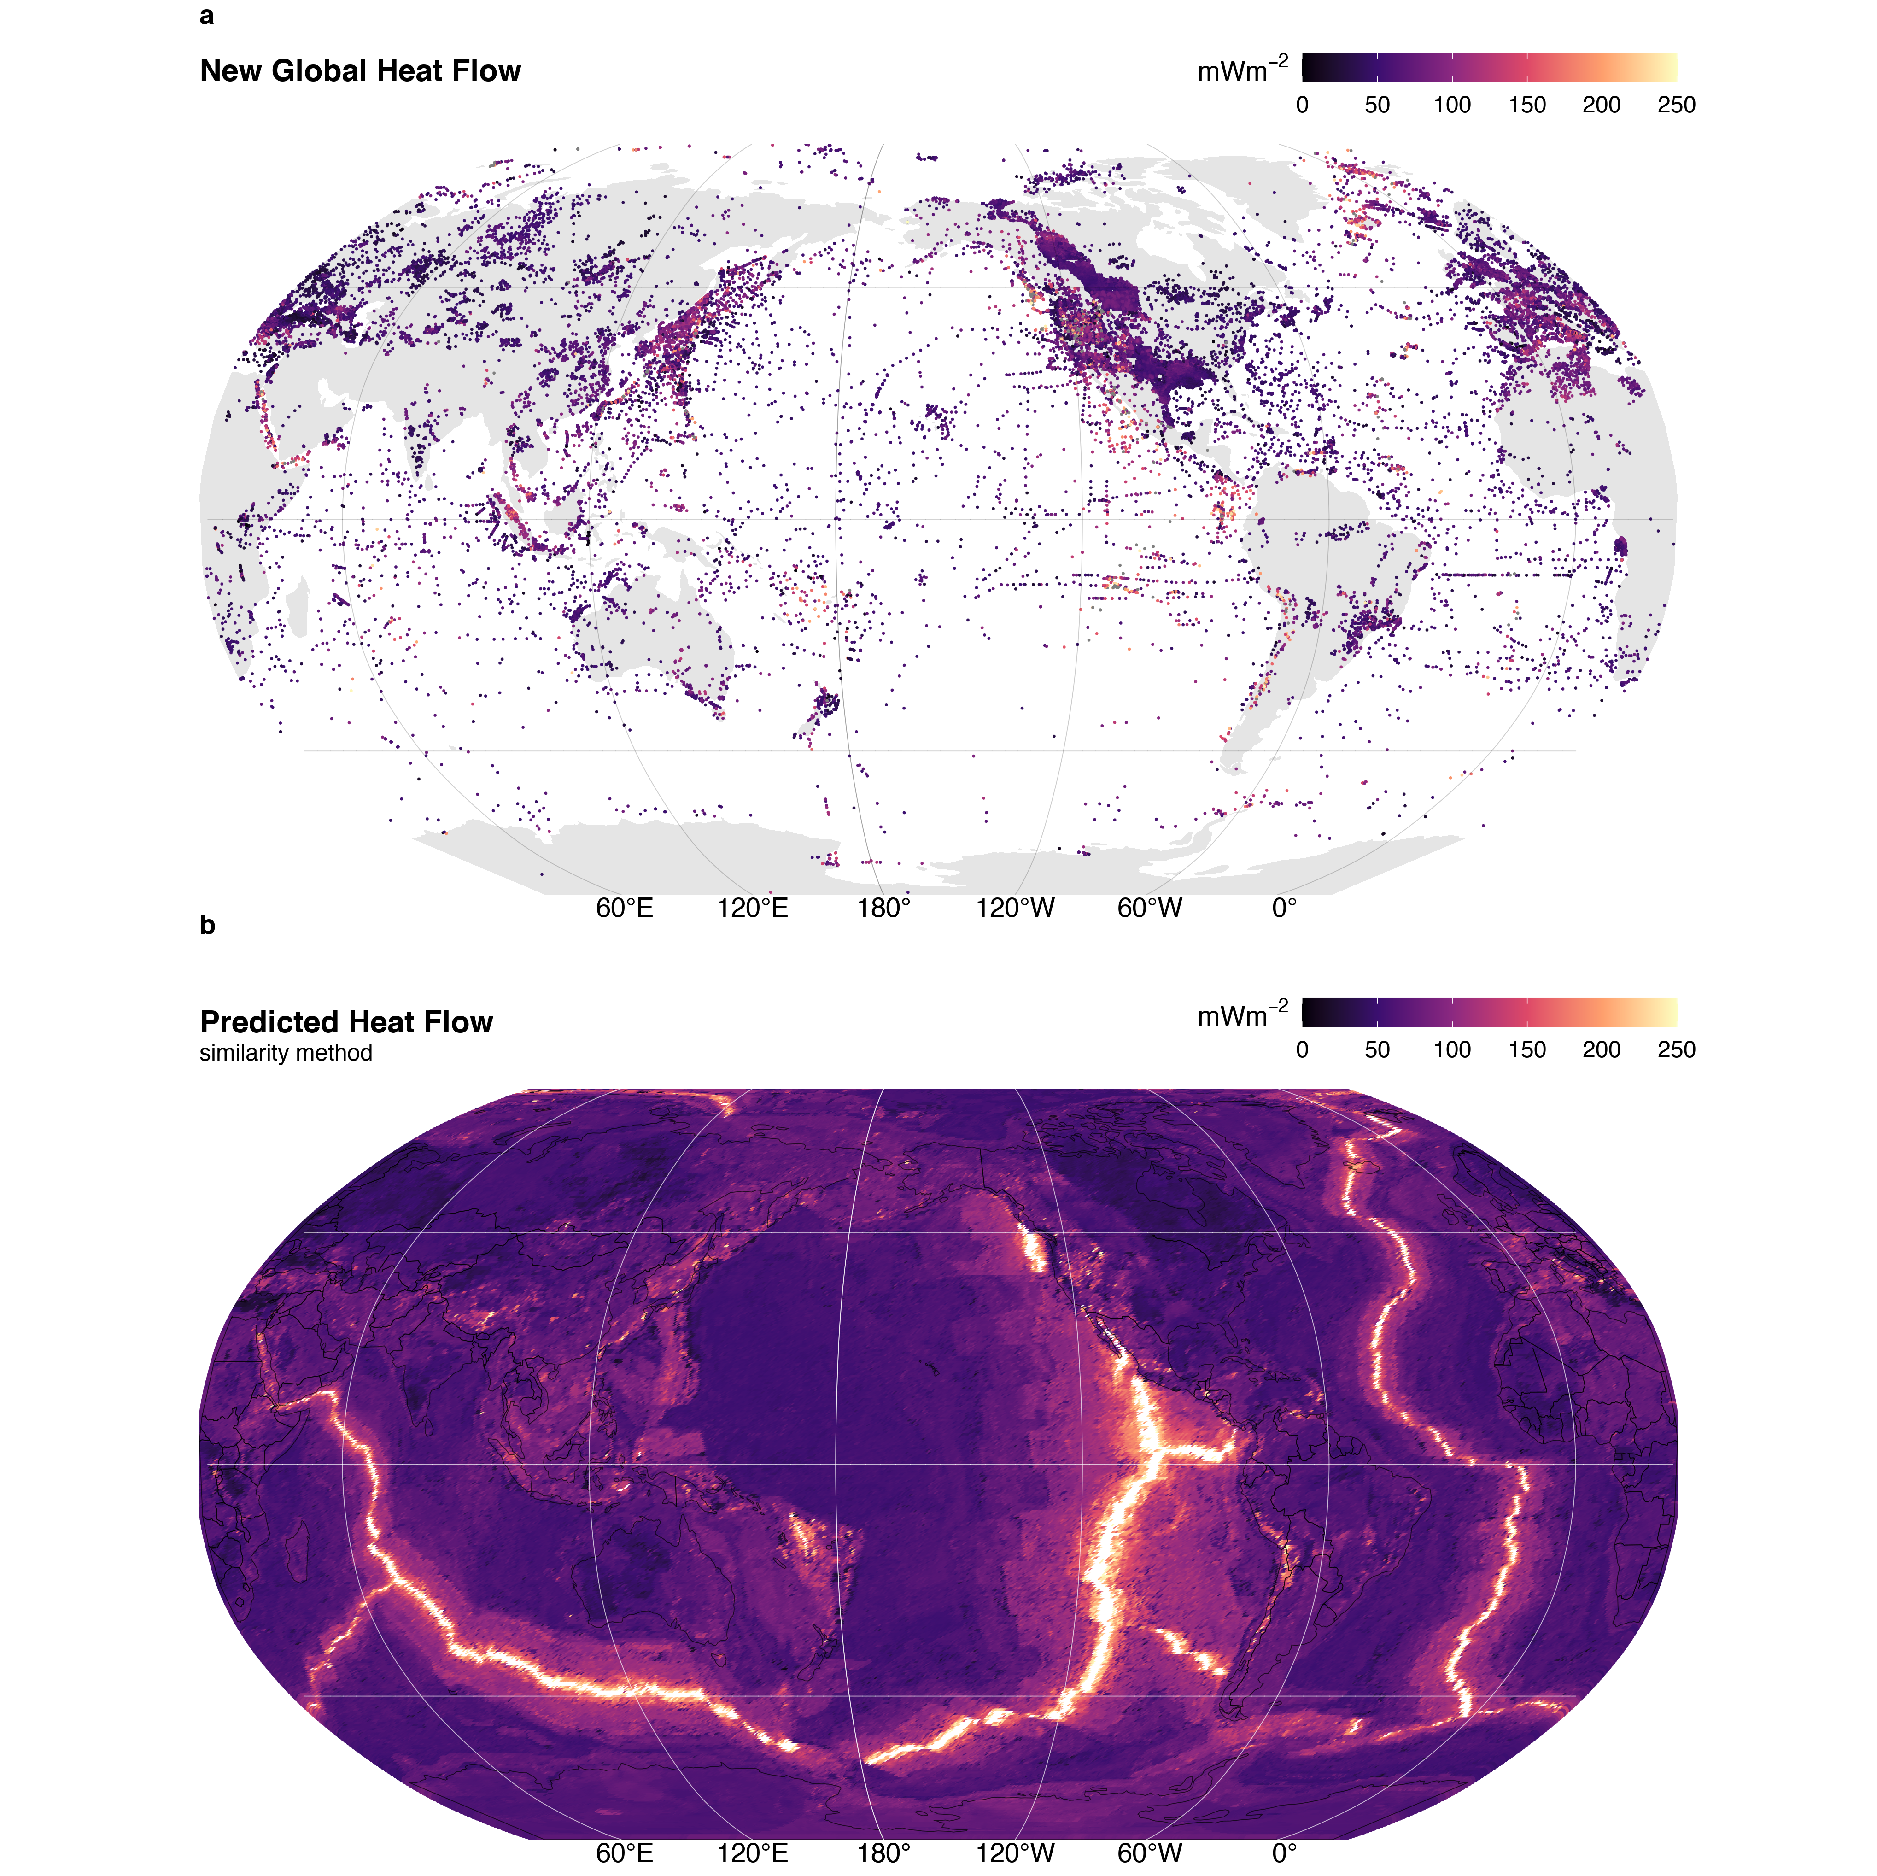

Figure 1: Global heat flow. (a) The NGHF database (n = 69729) and (b) interpolation by similarity method. Data from Lucazeau (2019).

In contrast to the Third Law, there exists some degree of spatial dependence, or continuity, in the distribution of surface heat flow. A pair of surface heat flow observations taken one meter apart will be strongly correlated. The correlation between pairs of observations will likely decrease with increasing distance between the pairs (Goovaerts, 1997). This is encapsulated in the First Law of Geography (hereafter referred to as the First Law): *everything is related, but nearer things are more related* (Krige, 1951; Matheron, 1963). The spatial (dis)continuity of surface heat flow represents the areal extent of geodynamic processes and their interactions. For example, patterns of consistently low surface heat flow outline the areal extent of cratons (Figure 1) and consistent patterns of heat flow near volcanic arcs are interpreted to reflect common backarc lithospheric thermal structures (Currie et al., 2004; Currie & Hyndman, 2006; Roy D. Hyndman et al., 2005) and slab-mantle mechanical coupling depths in subduction zones (Yoshitsugu Furukawa, 1993; Kerswell et al., 2020; Wada & Wang, 2009).

Predicting surface heat flow by considering many nearby observations (i.e. Kriging, Krige, 1951) is advantageous because spatial dependence is conserved and uncertainty is only dependent on the distance between pairs of observations (Chiles & Delfiner, 2009). However, Kriging is disadvantageous because it assumes that the underlying distribution of heat flow is *stationary* (constant in space and time), which likely fails in geodynamically complex regions. This problem is overcome by relaxing assumptions of stationarity and applying techniques that respect the Second Law of Geography: *spatial phenomena are inherently heterogenous* (Goodchild, 2004), such as directional Kriging or Markov-Bayes techniques that include proxies as priors (Bárdossy, 1997).

In this study we attempt to answer the following questions: 1) Are global heat flow interpolations predicted by Kriging and similarity methods comparable? 2) What are the implications of the differences according to the implicit assumptions embodied in the First and Third Laws of Geography? 3) Which method is better suited for hypothesis testing? 4) How can the interpolations presented here guide future data collection efforts?

We first use ordinary Kriging to interpolate the New Global Heat Flow (NGHF) database of F. Lucazeau (2019). We then compare our interpolation results to those of F. Lucazeau (2019) and consider the implications of Kriging (First Law) vs. similarity (Third Law) methods of interpolation. We restrict our comparison to areas near subduction zone segments defined by Syracuse & Abers (2006) for two reasons: 1) to provide heat flow interpolations and statistics useful to subduction zone research, and 2) to emphasize differences and idiosyncrasies in both interpolation approaches in a complex tectonic and thermal setting. We find that Kriging and similarity methods are comparable for most subduction segments. Both interpolations show inconsistent patterns of heat flow and spatial continuity. This result implies sampling heat flow along single trench-perpendicular transects is an incomplete framework for hypothesis testing. Further, inconsistent spatial continuity and heat flow patterns counter hypotheses of common thermal structure and geodynamics among subduction zones. We suggest future research focus on generating high-quality interpolations and discuss considerations for data acquisition priorities.

# Methods

## The NGHF Database

The NGHF database was downloaded from the supplementary material of F. Lucazeau (2019). It contains 69729 data points, their locations in latitude/longitude, and metadata—including a data quality rank (Code 6) from A to D (with Code 6 = Z = undetermined). The reader is referred to F. Lucazeau (2019) for details on compilation, references, and historical perspective on the NGHF and previous compilations. We use NGFH because it is the most recent database available, has been carefully compiled, and is open-access.

Like F. Lucazeau (2019), we exclude 4790 poor quality observations (Code 6 = D) from our analysis. We further remove 350 data points without heat flow observations and two without geographic information. Multiple observations at the same location are parsed to avoid singular covariance matrices during Kriging:

$$\begin{matrix}f\left(X_{i}^{q},Y_{i}^{q}\right) & = \\ X_{i}^{q}>Y_{i}^{q} & →z_{i}=x_{i} \\ X_{i}^{q}<Y_{i}^{q} & →z_{i}=y_{i} \\ X_{i}^{q}=Y_{i}^{q} & →z_{i}=RAND\left(x_{i},y_{i}\right)\end{matrix} \left(1\right)$$

where $X_{i}^{q}$ and $Y_{i}^{q}$ represent the quality of each duplicate observation pair at location $i$, $RAND$ is a random function that selects either the observation $x_{i}$ or $y_{i}$, and $z_{i}$ stores the observation selected by $f\left(X_{i}^{q},Y_{i}^{q}\right)$. The final dataset used for Kriging has $n=$ 55274 observations after parsing $n=$ 32430 duplicate observation.

## Kriging

Kriging is a three-step process that involves first estimating an experimental variogram, $\hat{γ}\left(h\right)$, fitting the experimental variogram with one of many variogram models, $γ\left(h\right)$, and finally using the modelled variogram to predict random variables at unknown locations (Cressie, 2015; Krige, 1951). We use the general-purpose functions defined in the “R” package gstat (Gräler et al., 2016; Pebesma, 2004) to perform all three steps. We begin by estimating an experimental variogram as defined by Bárdossy (1997):



where $N\left(h\right)$ is the number of pairs of points, $Z\left(u_{i}\right)$ and $Z\left(u_{j}\right)$, separated by a lag distance, $h=\left|u_{i}-u_{j}\right|$. We evaluate $\hat{γ}\left(h\right)$ at fifteen lag distances by binning the irregular spaced data with a bin width, $δ$, equal to a proportion of the maximum lag distance, $c$, divided by the number of lags used to evaluate the variogram. The lag cutoff parameter, $c$, is optimized by genetic algorithm (discussed below). The binwidth is then $δ=\text{max}\left(N\left(h\right)\right)/\left(15c\right)$, and $N\left(h\right)←N\left(h,δh\right)=\{i,j:\left|u_{i}-u_{j}\right|∈[h-δh,h+δh)\}$. In simple terms, Equation 2 represents the similarity, or dissimilarity, between pairs of observations in space. Equation 2 is adheres to the First Law of Geography and is derived from the theory of *regionalized variables* (Matheron, 1963, 2019), which formally defines a probabilistic framework for spatial interpolation of natural phenomena. It is important for the reader to understand the fundamental assumptions implicit in Equation 2 in order to understand the comparison of interpolation techniques discussed later. The basic assumptions used in our Kriging method are:

* $\hat{γ}\left(h\right)$ is directionally invariant (isotropic)
* $\hat{γ}\left(h\right)$ is evaluated in two-dimensions and neglects elevation, $Z\left(u\right)∈R^{2}$
* The first and second moments of $Z\left(u\right)$ have the following conditions over the domain $D$:

$$\begin{matrix} & E\left[Z\left(u\right)\right]=mean=constant, & ∀u∈D \\ & E\left[\left(Z\left(u+h\right)-mean\right)\left(Z\left(u\right)-mean\right)\right]=C\left(h\right), & ∀\left|u,u+h\right|∈D\end{matrix} \left(3\right)$$

The last assumption (Equation 3) is called “second-order stationarity” and is implicit in the First Law of Geography. It assumes the underlying probability distribution of the random variable, $Z\left(u\right)$, does not change in space and the covariance, $C\left(h\right)$, only depends on the distance, $h$, between two random variables. These assumptions are expected to be valid in cases where the underlying natural process is stochastic, spatially continuous, and has the property of additivity such that $\frac{1}{n}\sum_{i=1}^{n}{Z}\left(u_{i}\right)$ has the same meaning as (Bárdossy, 1997).

The following are two illustrative cases where Equation 3 is likely valid:

1. The thickness of a sedimentary unit with a homogeneous concentration of radioactive elements can be approximated by $q_{s}=q_{b}+∫A dz$, where $q_{b}$ is a constant heat flux entering the bottom of the layer and $A$ is the heat production within the layer with thickness (Furlong & Chapman, 2013). If we have two samples, $Z\left(u_{1}\right)=31 mW/m^{2}$ and $Z\left(u_{2}\right)=30.5 mW/m^{2}$, their corresponding thicknesses would be $Z'\left(u_{1}\right)=1000 m$ and $Z'\left(u_{2}\right)=500 m$ for $A=0.001 mW/m^{3}$ and $q_{b}=30 mW/m^{2}$. The variable, $Z\left(u\right)$, in this case is additive because the arithmetic mean of the samples is a good approximation of the average sedimentary layer thickness, $\left(Z\left(u_{1}\right)+Z\left(u_{2}\right)\right)/2=750 m$.
2. The age of young oceanic lithosphere can be approximated by $q_{s}\left(t\right)=kT_{b}{\left(πκt\right)}^{-1/2}$, where $q_{s}\left(t\right)$ is the surface heat flow of a plate with age, $t$, $T_{b}$ is the temperature at the base of the plate, $k$ is thermal conductivity, and $κ=k/ρC_{p}$ is thermal diffusivity (Carol A. Stein & Stein, 1992). For $k=3.138 W/mK$, $ρ=3330 kg/m^{3}$, $C_{p}=1171 J/kgK$, $T_{b}={1350}^{∘}C$, two samples, $Z\left(u_{1}\right)=180 mW/m^{2}$ and $Z\left(u_{2}\right)=190 mW/m^{2}$, would correspond to plates with ages of $Z'\left(u_{1}\right)=10 Ma$, and $Z'\left(u_{2}\right)=9 Ma$, respectively. Since $Z\left(u_{1}\right)+Z\left(u_{2}\right)/2=185 mW/m^{2}$ and $Z'\left(185 mW/m^{2}\right)=9.5 Ma=Z'\left(u_{1}\right)+Z'\left(u_{2}\right)/2$, the variable $Z\left(u\right)$ in this case is also additive.

In contrast, Equation 3 is likely invalid in regions that transition among two or more tectonic regimes. For example, the expected heat flow $E\left[Z\left(u\right)\right]=mean$ will change when moving from a spreading center to a subduction zone. $E\left[Z\left(u\right)\right]=mean≠constant$ over the region of interest. Proceeding with Equation 3 in this case has the effect of masking the geodynamic complexity. In other words, the First Law of Geography is violated and the geodynamic complexity will be *invisible* to Kriging predictions unless heatflow observations are sufficiently dense. We will see that this has important implications when comparing our Kriging method to F. Lucazeau (2019)’s interpolation method, which is exactly opposite of this formalism—it only considers the similarities among physical proxies and not spatial dependence.

The second step is to fit the experimental variogram with a variogram model, $γ\left(h\right)$. In this study we fit two popular variogram models to the experimental variogram. We use models with sills, which implies the spatial dependence between pairs of points has a finite range. The spherical and exponential variogram models used in this study are defined as (Chiles & Delfiner, 2009; Cressie, 2015):

$$\begin{matrix}sph & ←γ\left(h\right)=\left\{\begin{matrix}n+s\left(\frac{3h}{2a}-\frac{1}{2}{\left(\frac{h}{a}\right)}^{3}\right), & \text{if }0≤h≤a \\ n+s, & \text{if }h>a\end{matrix}\right. \\ exp & ←γ\left(h\right)=n+s\left(1-exp\left(\frac{-h}{a}\right)\right), \text{if }h≥0\end{matrix} \left(4\right)$$

where $n$ is the nugget, $s$ is the sill, and $a$ is the effective range. The effective range, $a$, is related to the range, $r$, by $a=r$ and $a=r/3$ for spherical and exponential models, respectively (Gräler et al., 2016; Pebesma, 2004). We use the function fit.variogram in gstat to try both variogram models. The best model is selected by the minimum misfit by weighted least square (WLS, Pebesma, 2004).

We use ordinary Kriging for our interpolation step, which predicts the value of a random function, $\hat{Z}\left(u\right)$, at unknown locations as a linear combination of all known locations in the domain, (Bárdossy, 1997):

$$\hat{Z}\left(u\right)=\sum_{i=1}^{n}{λ_{i}}Z\left(u_{i}\right), ∀u∈D \left(5\right)$$

The conditions in Equation 3 set up a constrained minimization problem since one has:

$$E\left[Z\left(u\right)\right]=mean, ∀u∈D \left(6\right)$$

The linear estimator must obey

$$E\left[\hat{Z}\left(u\right)\right]=\sum_{i=1}^{n}{λ_{i}}E\left[Z\left(u_{i}\right)\right]=mean \left(7\right)$$

so the weights must be

$$\sum_{i=1}^{n}{λ_{i}}=1 \left(8\right)$$

This is the first constraint, also known as the unbiased condition, which states that the sum of the weights must equal one. However, there is an infinite set of real numbers one could use for the weights, $λ_{i}$. Our goal is to find the set of weights in Equation 5 that minimizes the estimation variance. This can be solved by minimizing the covariance function, $C\left(h\right)$ from Equation 3:

$$\begin{matrix}σ^{2}\left(u\right)=Var\left[Z\left(u\right)-\hat{Z}\left(u\right)\right]=E\left[{\left(Z\left(u\right)-\sum_{i=1}^{n}{λ_{i}}Z\left(u_{i}\right)\right)}^{2}\right] & = \\ E\left[Z{\left(u\right)}^{2}+\sum_{j=1}^{n}{\sum_{i=1}^{n}{λ_{j}}}λ_{i}Z\left(u_{j}\right)Z\left(u_{i}\right)-2\sum_{i=1}^{n}{λ_{i}}Z\left(u_{i}\right)Z\left(u\right)\right] & = \\ & C\left(0\right)+\sum_{j=1}^{n}{\sum_{i=1}^{n}{λ_{j}}}λ_{i}C\left(u_{i}-u_{j}\right)-2\sum_{i=1}^{n}{λ_{i}}C\left(u_{i}-u\right)\end{matrix} \left(9\right)$$

Minimizing Equation 9 with respect to the unbiased condition (Equation 8), yields the best linear unbiased estimator (BLUE, Bárdossy, 1997) for Equation 5 and together are considered the Kriging system. In our case, this is done by the function krige in gstat. We use the function krige.cv in gstat to estimate the misfit between observations and Kriging interpolations by ten-fold cross validation (Pebesma, 2004).

Further, we use a general purpose genetic algorithm, ga, from the R package, GA (Scrucca, 2013, 2017), to optimize Kriging parameters after Z. Li et al. (2018). The results from the genetic algorithm are comparable to the non-genetic-algorithm results. However, some inconsistent variogram fitting by the algorithm is suspect. We present these results and discuss their implications in sec. 8.2.

## Map Projection and Interpolation Grid

We interpolate onto the same 0.5 $​^{∘}$ C x 0.5 $​^{∘}$ C grid as F. Lucazeau (2019) so a direct difference could be calculated between our interpolation methods and F. Lucazeau (2019)’s. The NGHF and grid with predicted heat flow from F. Lucazeau (2019) were transformed into a Pacific-centered Robinson coordinate reference system (CRS) defined using the proj string (PROJ contributors, 2021):

+proj=robin +lon_0=-155 +lon_wrap=-155 +x_0=0 +y_0=0  
+ellps=WGS84 +datum=WGS84 +units=m +no_defs

All geographic operations, including Kriging and taking the difference with F. Lucazeau (2019)’s heat flow predictions, are performed in the above CRS using the general-purpose functions in the “R” package sf (Pebesma, 2018). We define the Kriging domain near individual arc segments in two steps: 1) 1000 $km$ buffers are drawn around the arc segments as defined by Syracuse & Abers (2006). 2) The bounding box of the 1000 $km$ buffer is expanded by 10% on all sides (Figure 2). We use F. Lucazeau (2019)’s grid for Kriging predictions so differences can be taken point-by-point at the exact same locations.

We provide the complete NGHF database (F. Lucazeau, 2019), filtered and parsed NGHF database, heat flow interpolations (from F. Lucazeau, 2019, and this study), and our code as supplementary information to support FAIR data policy (Wilkinson et al., 2016). These materials can also be retrieved from the official repository at <https://doi.org/10.17605/OSF.IO/CA6ZU>.

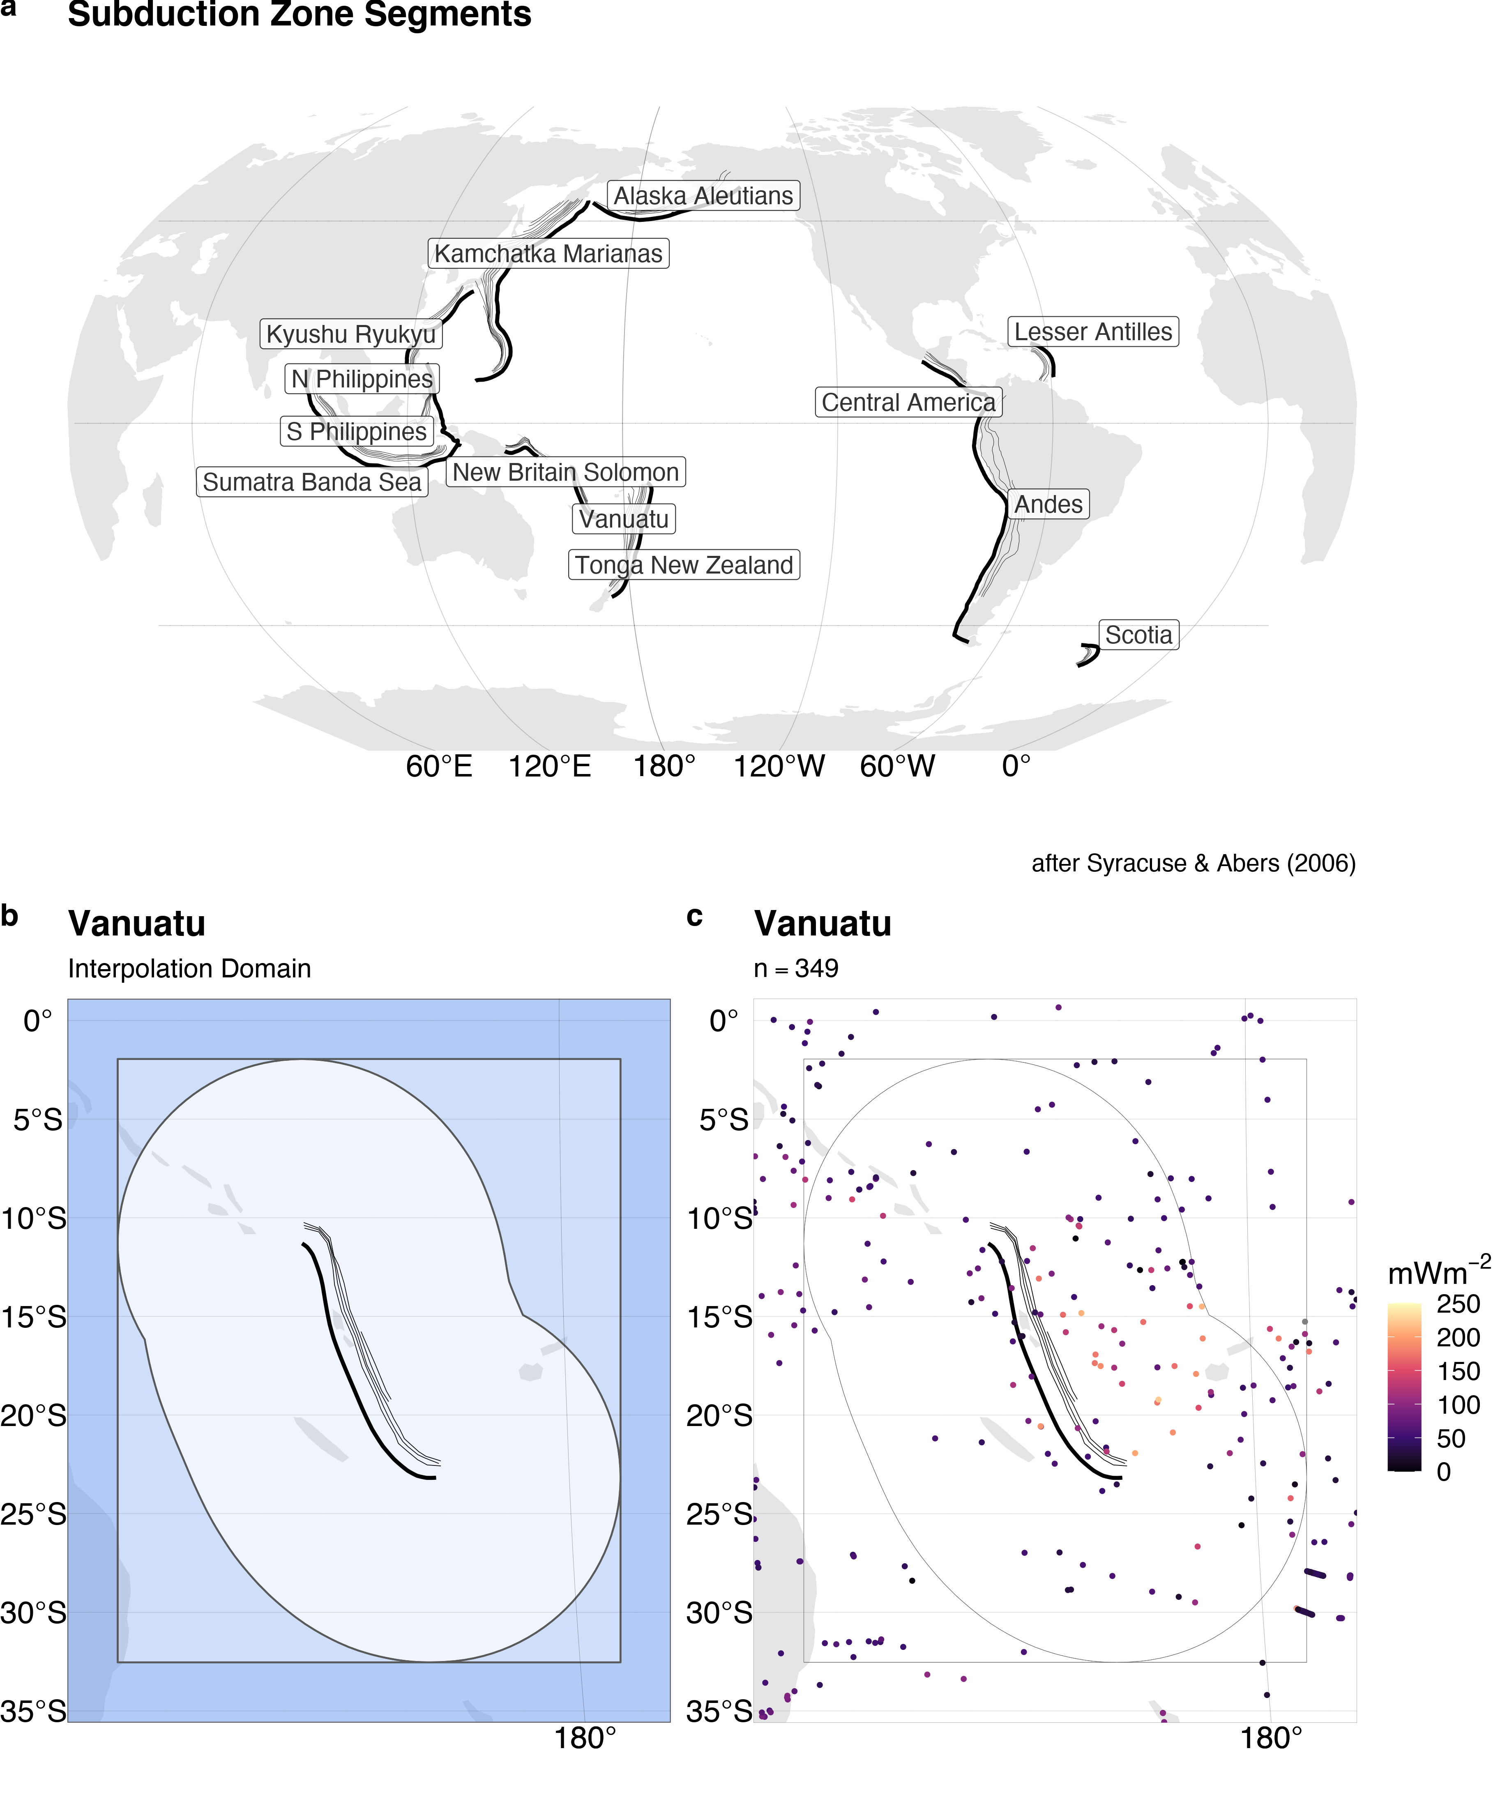

Figure 2: Subduction zone segments and interpolation domain. (a) Heat flow is interpolated around thirteen subduction zone segments by (b) drawing a 1000km buffer (lightest blue) around each segment and expanding the buffer’s bounding box (medium blue) by 10\% on all sides (darkest blue). (c) The NGHF database is cropped within the largest rectangle. Data from Syracuse \& Abers (2006) and Lucazeau (2019).

# Results

## Heat Flow Near Subduction Zone Segments

Summary statistics for surface heat flow observations by subduction zone segment are given in Table 1 and Figure 3. Surface heat flow is median-centered around 45-70 $mWm^{-2}$ and narrowly distributed (excluding outliers) with inter-quartile ranges (IQR) from 12 to 50 $mWm^{-2}$ for most subduction zone segments. Alaska Aleutians is the exception with a higher median of 184 $mWm^{-2}$ and broader range (IQR = $250 mW^{-2}$). The whole distributions (including outliers) for all segments are strongly right-skewed with maximum heat flow values of several thousand of $mWm^{-2}$ or more. Heat flow values above 250 $mWm^{-2}$ are considered geothermal areas by F. Lucazeau (2019), which we adopt as a relevant empirical limit for anomalously high heat flow.

Table 1: Heat flow ($mWm^{-2}$) observations

|  |  |  |  |  |  |  |  |
| --- | --- | --- | --- | --- | --- | --- | --- |
| Segment | n | Min | Max | Median | IQR | Mean | Sigma |
| Alaska Aleutians | 2794 | 4 | 7765 | 184 | 206 | 233 | 347 |
| Andes | 5229 | 7 | 911 | 45 | 50 | 87 | 88 |
| Central America | 5044 | 8 | 911 | 45 | 48 | 88 | 91 |
| Kamchatka Marianas | 3958 | 1 | 20900 | 70 | 48 | 110 | 412 |
| Kyushu Ryukyu | 3247 | 1 | 20900 | 72 | 44 | 118 | 453 |
| Lesser Antilles | 3535 | 13 | 1334 | 41 | 13 | 53 | 54 |
| N Philippines | 1002 | 3 | 20900 | 71 | 35 | 166 | 778 |
| New Britain Solomon | 180 | 3 | 174 | 64 | 42 | 69 | 30 |
| S Philippines | 1442 | 1 | 20900 | 71 | 43 | 138 | 644 |
| Scotia | 72 | 13 | 145 | 76 | 23 | 74 | 28 |
| Sumatra Banda Sea | 3038 | 1 | 1350 | 65 | 47 | 76 | 66 |
| Tonga New Zealand | 505 | 1 | 416 | 54 | 40 | 64 | 45 |
| Vanuatu | 349 | 1 | 283 | 54 | 40 | 64 | 44 |

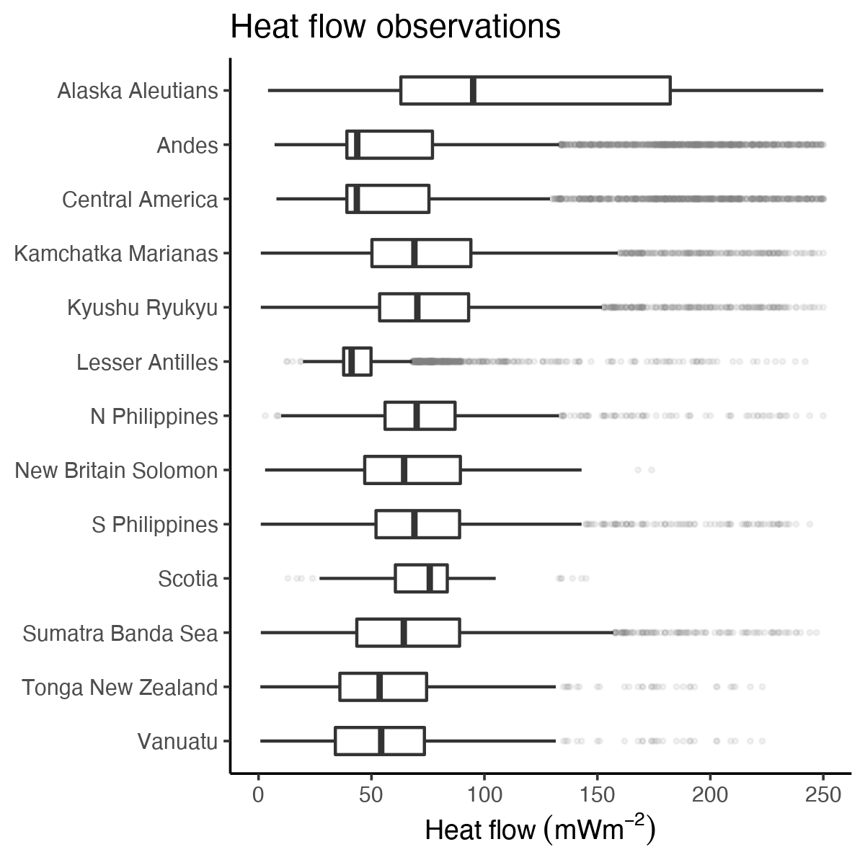

Figure 3: Distribution of heat flow observations. Heat flow near most segments is centered around $50 mWm^{-2}$ and highly skewed right (shadowy dot outliers). The skeweness likely represents sampling near geothermal systems, volcanic arcs, or spreading centers. Data from Lucazeau (2019).

## Variogram Models

The optimal variogram models and associated errors are given in Table 2. Almost twice as many experimental variograms are fit with spherical models (8) compared to exponential models (5). Variogram model sills vary substantially among the subduction zone segments between 9 and 1538 $mWm^{-2}$. Variogram model ranges also vary substantially among segments from 4 to 1676 $km$.

No apparent correlation exists between variogram model range and subduction zone segment length, number of heat flow observations, nor domain area (Figure 4). Most subduction zone segments show spatial dependence of a few hundred kilometers or less, irrespective of the number of observations or segment size. The exceptions are Kyushu Ryukyu (range = 1774 $km$) and Vanuatu (range = 573 $km$), whose model variogram ranges are, perhaps, anomalously high.

Table 2: Optimal varigram models

|  |  |  |  |
| --- | --- | --- | --- |
| Segment | Model | Sill $\left[mWm^{-2}\right]$ | Range $\left[km\right]$ |
| Alaska Aleutians | Sph | 286 | 222 |
| Andes | Sph | 87 | 342 |
| Central America | Sph | 85 | 338 |
| Kamchatka Marianas | Exp | 442 | 284 |
| Kyushu Ryukyu | Sph | 522 | 1150 |
| Lesser Antilles | Exp | 36 | 80 |
| N Philippines | Sph | 824 | 237 |
| New Britain Solomon | Exp | 29 | 89 |
| S Philippines | Sph | 705 | 412 |
| Scotia | Exp | 9 | 4 |
| Sumatra Banda Sea | Sph | 67 | 136 |
| Tonga New Zealand | Sph | 47 | 128 |
| Vanuatu | Sph | 48 | 574 |

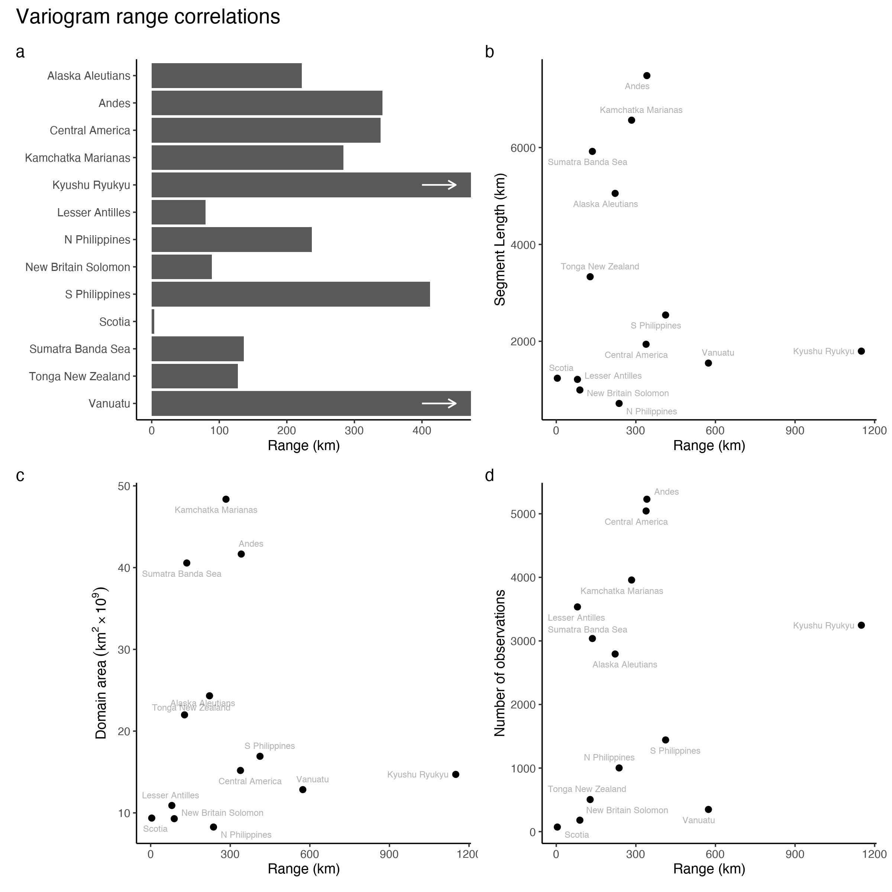

Figure 4: Summary of variogram model ranges and correlations with other features. (a) Variogram model ranges are variable, but generally below 400 km. Variogram model ranges show no correlation with segment length (b), number of heat flow observations (c), nor domain area (d). The spatial dependenc of heat flow is apparently independent of these parameters.

## Interpolation Comparison

Summary statistics for the interpolation differences are given in Table 3 and Figure 5. Note that the difference is taken at the exact same locations for every prediction. Differences between the similarity method and Kriging are small for most segments with the exception of Central America, which shows a broader distribution of differences than the other segments. The median differences range from -9 to 7 $mWm^{-2}$ with inter quartile ranges from 15 to 62 $mWm^{-2}$. Similar to the distribution of heat flow in these areas, the minimum and maximum difference in predicted heat flow are extreme and represent the failure of one method to predict extreme outliers of the other.

Table 3: Predicted heat flow ($mWm^{-2}$) differences

|  |  |  |  |  |  |  |
| --- | --- | --- | --- | --- | --- | --- |
| Segment | Min | Max | Median | IQR | Mean | Sigma |
| Alaska Aleutians | -551 | 2696 | -2 | 20 | 3 | 71 |
| Andes | -189 | 2336 | 2 | 35 | 13 | 72 |
| Central America | -189 | 2731 | 8 | 63 | 44 | 146 |
| Kamchatka Marianas | -2433 | 297 | 4 | 16 | 4 | 42 |
| Kyushu Ryukyu | -2434 | 139 | 5 | 24 | 2 | 78 |
| Lesser Antilles | -99 | 589 | 0 | 15 | 6 | 32 |
| N Philippines | -2220 | 281 | 1 | 24 | -3 | 78 |
| New Britain Solomon | -81 | 236 | 2 | 22 | 5 | 20 |
| S Philippines | -272 | 370 | 5 | 26 | 7 | 30 |
| Scotia | -62 | 1001 | -4 | 24 | 5 | 33 |
| Sumatra Banda Sea | -307 | 386 | 0 | 20 | 2 | 20 |
| Tonga New Zealand | -112 | 1696 | -9 | 23 | -1 | 30 |
| Vanuatu | -166 | 1657 | 7 | 27 | 8 | 40 |

Prediction differences are either approximately normally distributed, or skewed right. Right skew and a tendency of medians to deviate positively from zero both reflect a systematic overprediction of heat flow by the similarity method compared to Kriging (Figure 5). However, Alaska Aleutians, Scotia, and Tonga New Zealand have negative median differences. While there is a tendency for the similarity method to overpredict heat flow compared to Kriging, it is not true in every case.

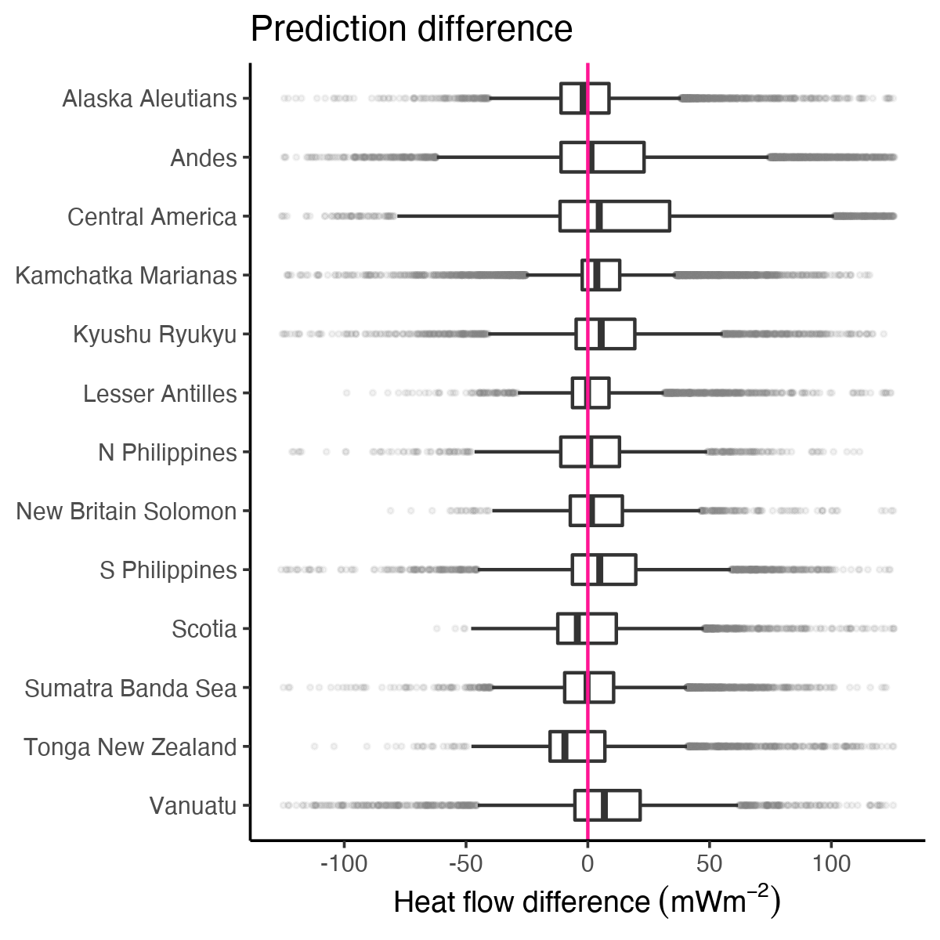

Figure 5: Point-by-point differences of predicted heat flow between similarity and Kriging interpolations (difference = similarity - Krige). The differences for most subduction zone segments are median-centered at or near-zero with IQRs from 16 to 62. Outliers (shadowy dots) extend to extreme positive and negative differences.

Notable sources of prediction differences include 1) tectonic features predicted by similarity that are absent from Kriging or 2) general discordance between the spatial continuity of heat flow observations and similarity predictions. For example, high heat flow representing Galápagos triple junction is predicted by similarity to the SW of the Central America segment (Figure 6a). However, none of the triple junction arms, nor the Galápagos hot spot, are well defined in the Kriged prediction (Figure 6b). The interpolation comparison for Central America highlights two distinct regions—bright differences along the arms of the triple junction and muted agreement to the E and NE of the Cocos Plate (Figure 6c). Note the moderate differences within the Cocos Plate in Figure 6a where similarity predicts high heat flow by proximity to the nearby spreading centers, but heat flow in the region is, in fact, relatively low (compare Figure 6a, b, c). Similar discordance between high similarity predictions and low heat flow observations are observed in many subduction zone segments, especially near spreading centers predicted by similarity (e.g. Figure 12; see sec. 8.1).

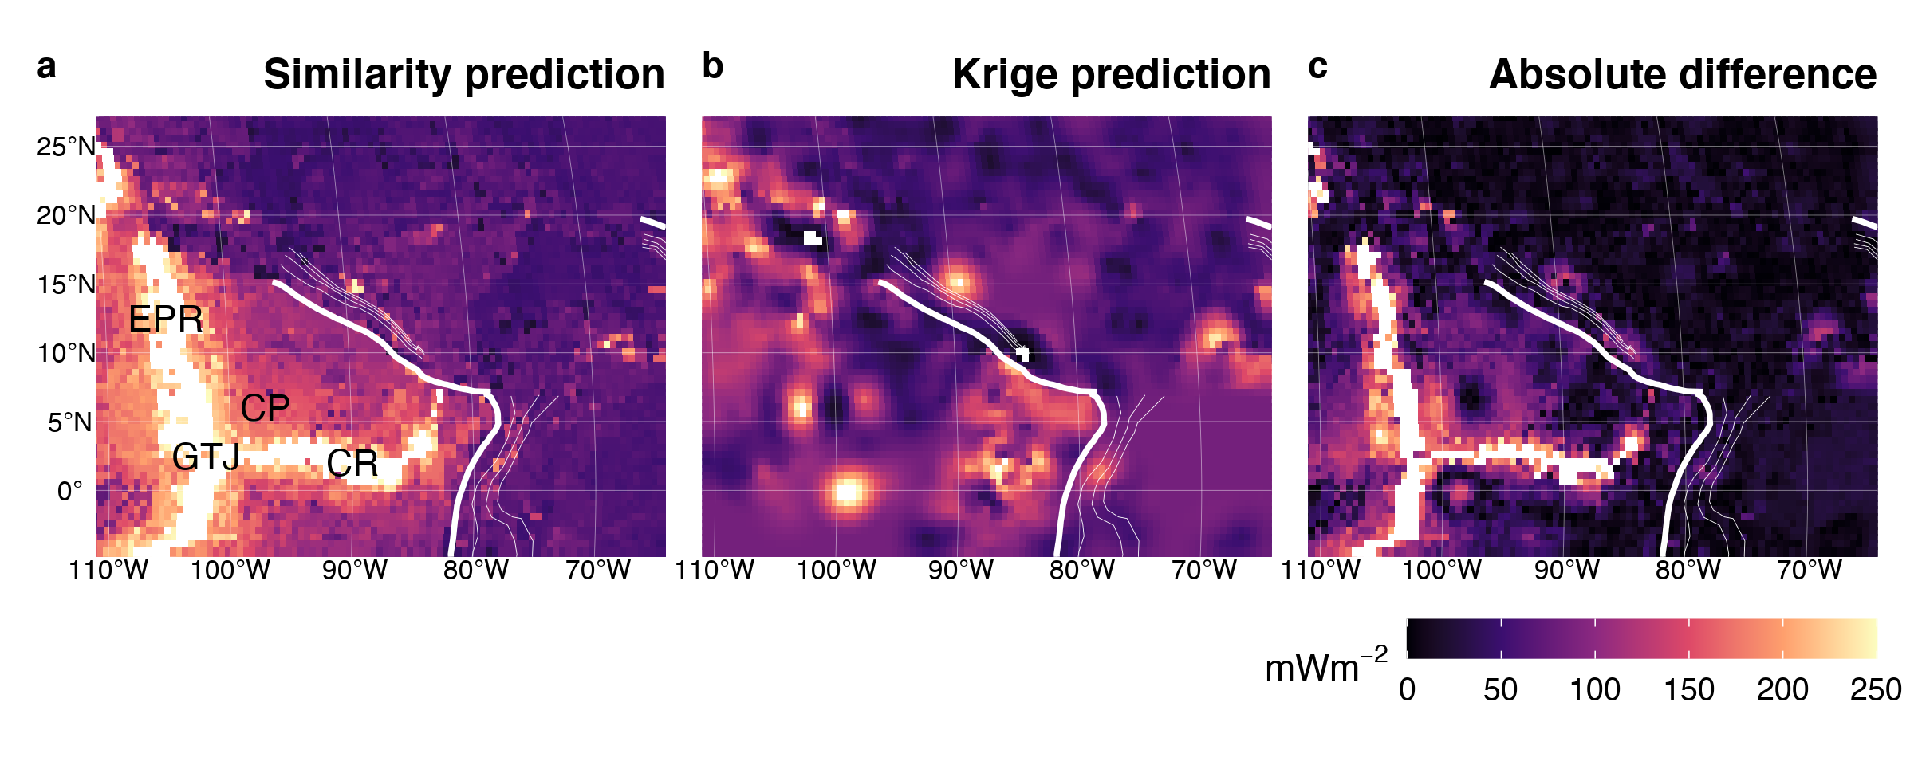

Figure 6: Similarity vs. Kriging predictions for Central America. The Galápagos triple junction (GTJ), East Pacific Rise (EPR), and Cocos Ridge (CR) are predicted by similarity (a), but not by Kriging (b). Note the moderate difference between predictions within the Cocos Plate (CP) where similarity predicts high heat flow but observations are low (c). Bold and thin white lines represent the subduction zone segment boundary and plate depth, respectively, as defined by Syracuse \& Abers (2006). Heat flow data and similarity prediction from Lucazeau (2019).

On the other side of the Caribbean Plate, near the Lesser Antilles segment, similarity and Kriging predictions show good agreement. The Mid-Atlantic Ridge to the E appears in both predictions (Figure 7a, b). The spreading center is better defined with Kriging in this case, as compared to the Galápagos triple junction, because the observational density and spatial coverage near the Lesser Antilles segment are sufficiently high and continuous near the Mid-Atlantic Ridge (see sec. 8.1). However, the comparison still highlight spreading centers as similarity tends to predict higher heat flow than observations.

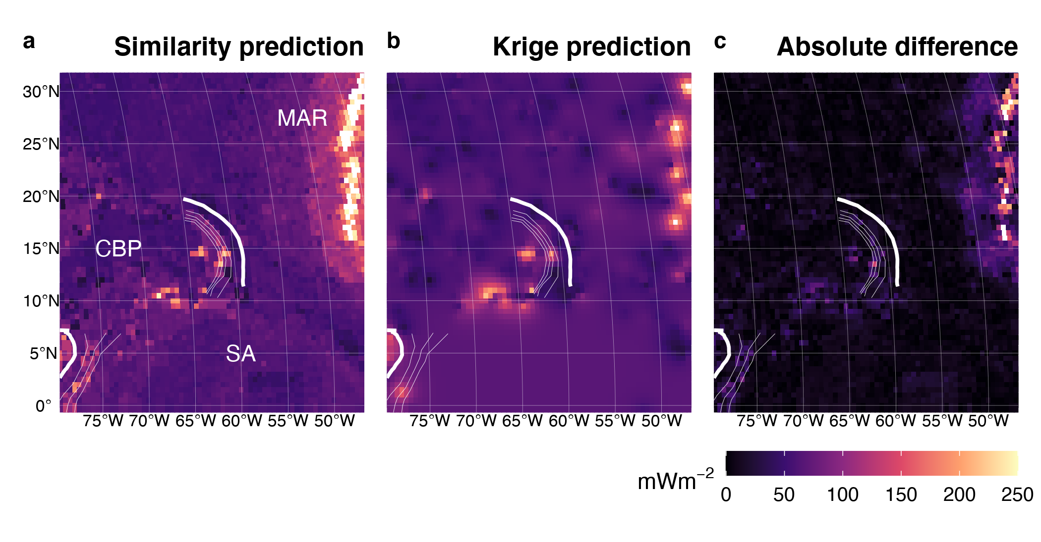

Figure 7: Similarity vs. Kriging predictions for the Lesser Antilles. The Mid-Atlantic Ridge (MAR) predicted by similarity (a) is also defined by Kriging (b) because of adequate observational density and spatial coverage near the spreading center. Good agreement between similarity and Kriging exist for the entire domain (c). CBP = Caribbean Plate, SA = South America. Bold and thin white lines represent the subduction zone segment boundary and plate depth, respectively, as defined by Syracuse \& Abers (2006). Heat flow data and similarity prediction from Lucazeau (2019).

Another example of good agreement between similarity and Kriging are interpolations near the Sumatra Banda Sea segment (Figures 8, 20). Note the textural and structural complexity predicted by similarity (Figure 8a) compared to the smooth featureless Kriging predictions (Figure 8b). Despite the textural and structural differences, the difference between similarity and Kriging within the Sunda Plate, Australian Plate, and W Philippine Sea Plate is small (Figure 8c).

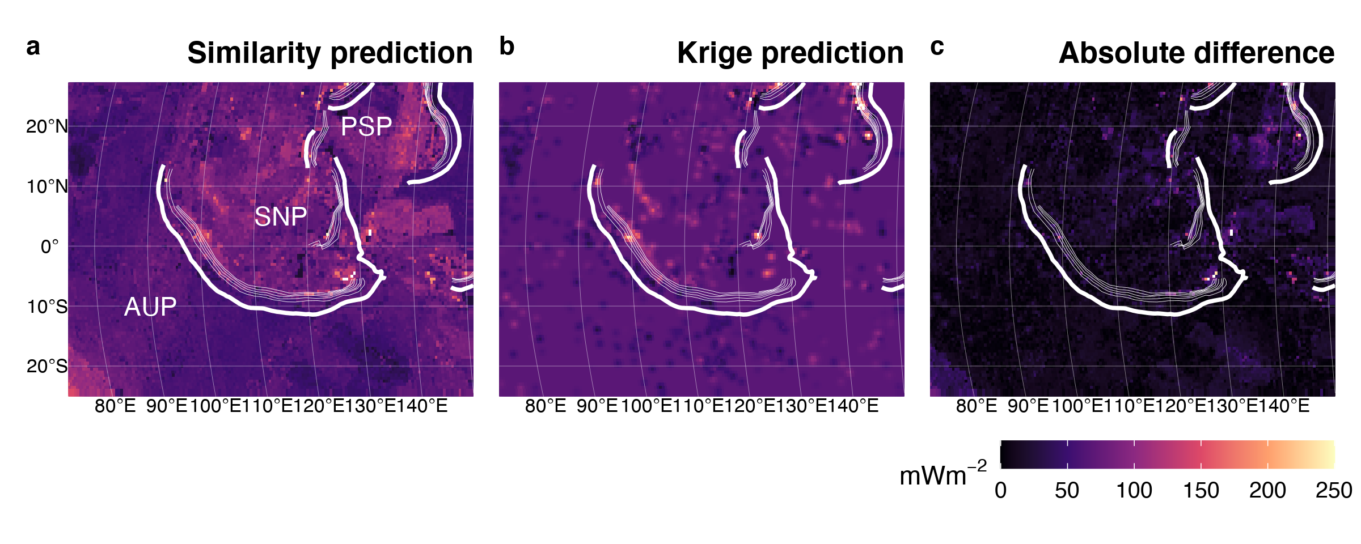

Figure 8: Similarity vs. Kriging predictions for Sumatra Banda Sea. Similarity predictions are texutrally and structurally complex (a), while Kriging is smooth and featureless (b). Despite the textural and structural difference, the interpolations are similar, especially within the Sunda Plate (SNP), Australian Plate (AUP) and W Philippine Sea Plate (PSP). Bold and thin white lines represent the subduction zone segment boundary and plate depth, respectively, as defined by Syracuse \& Abers (2006). Heat flow data and similarity prediction from Lucazeau (2019).

Heat flow predictions near the Scotia segment illustrate a case where heat flow observations are incredibly sparse. Similarity predicts high heat flow from the East Scotia Ridge (ESR) and the WSW-ENE trending transform boundary separating the Scotia and Sandwich Plates from the Antartic Plate (Figure 9a). Figure 9b appears featureless because very few heat flow observations (n = 72) define a flat experimental variogram for all lag distances greater than four kilometers (no spatial dependence beyond 4 km, Table 2, Figure 21). Kriging predicts the expected (mean) heat flow value for the entire domain (Figure 9b), in this case, according to Equation 5. Interestingly, the expected heat flow is a fine predictor for most of the ocean basin, except near the spreading center and transform fault (Figure 9c). The New Britain Solomon segment shows a similar comparison (Figure 18) with good agreement between similarity and Kriging despite very few heat flow observations, little spatial dependence (small variogram range), and a featureless Kriged interpolation.

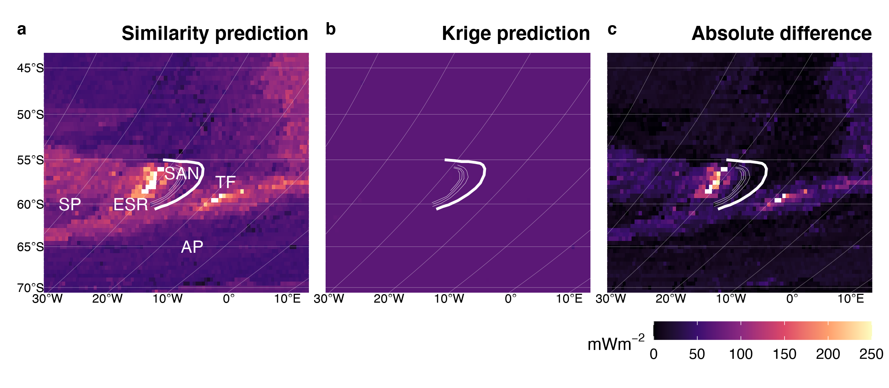

Figure 9: Similarity vs. Kriging predictions for Scotia. (a) Similarity predicts high heat flow for two tectonic features, the East Scotia Ridge (ESR) and a transform fault (TF) separating the Scotia and Sandwich Plates (SP, SAN) from the Antartic Plate (AP). Kriging (b) is featureless because of incredibly sparse data. Despite few heat flow observations. Kriging predictions are only significantly different than similarity predictions near the ESR and transform fault (c). Bold and thin white lines represent the subduction zone segment boundary and plate depth, respectively, as defined by Syracuse \& Abers (2006). Heat flow data and similarity prediction from Lucazeau (2019).

While similarity tends to define tectonic features and Kriging tends to smooth out tectonic features, we find the opposite pattern within the tectonically-complex region near Vanuatu. Similarity predicts the N-S trending spreading center separating the New Hebrides plate from the Balmoral Reef and Conway Reef microplates (Figure 10a). However, heat flow observations are sufficiently dense and continuous to partially resolve the short ridge segments and transform faults outlining the microplates between Vanuatu and the Tonga New Zealand segments by Kriging (Figure 10b). The differences (Figure 10c) are difficult to interpret because of the somewhat random discordance between interpolation methods.

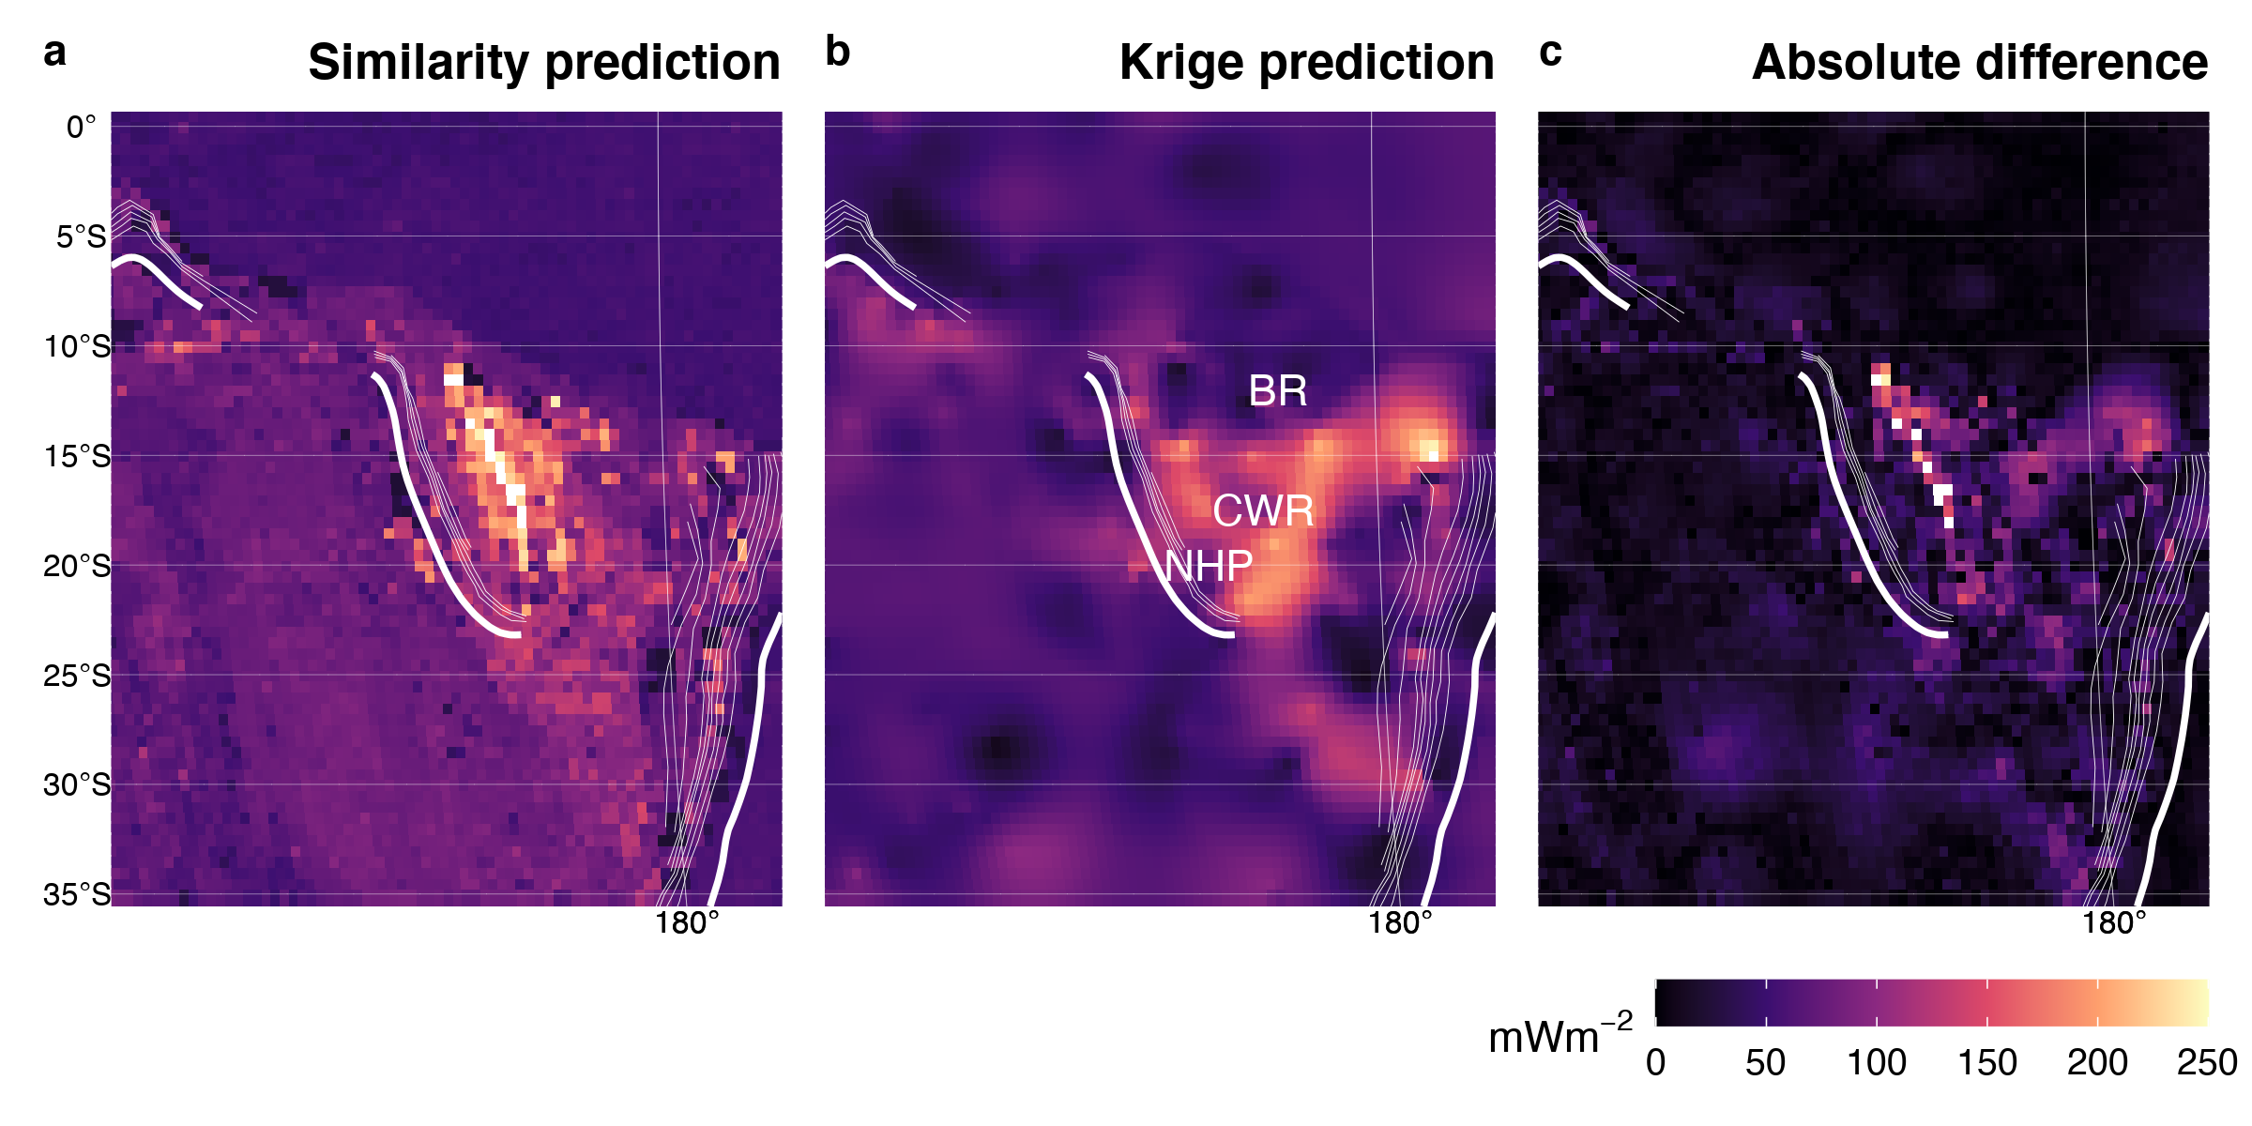

Figure 10: Similarity vs. Kriging predictions for Vanuatu. (a) Similarity resolved the spreading center separating the New Hebrides Plate (NHP) from the Balmoral Reef (BR) and Conway Reef (CR) microplates. Sufficient heat flow observations allow Kriging to resolve additional ridge segments and transform faults outlining BR and CR (b). The difference between similarity and Kriging (c) is discordant and difficult to interpret. Bold and thin white lines represent the subduction zone segment boundary and plate depth, respectively, as defined by Syracuse \& Abers (2006). Heat flow data and similarity prediction from Lucazeau (2019).

# Discussion

## The First and Third Laws of Geography

The Third Law of Geography states that *two points with similar geographic configurations should have similar values*. In the context of heat flow near subduction systems and associated spreading centers, the Third Law produces interpolations that highlight discrete tectonic features (spreading centers and large fault systems) with complex regional texture. At first glance the textural complexity may be misconstrued as realistic interpolations, but is merely an artifact of the similarity method. The texture predicted by similarity is artificial insofar as it does not represent spatial changes in surface heat flow. Rather each prediction location represents an independent assignment of heat flow by association to all other locations with similar geographic configurations (B. Goutorbe et al., 2011; F. Lucazeau, 2019; Zhu et al., 2018). The extent to which similarity predictions represent real changes of heat flow in space is entirely dependent on the reliability of the Third Law, the quality of the physical proxies, and the selected combination of proxies used for interpolation.

We note a few inconsistencies with F. Lucazeau (2019)’s similarity predictions in the domains considered in this study. First, F. Lucazeau (2019)’s predictions systematically overpredict heat flow near spreading centers, justifying an adjustment to their algorithm. Second, known tectonic features within the tectonically-complex region near Vanuatu may be better resolved by Kriging than F. Lucazeau (2019)’s predictions. It is important to note, however, that Vanuatu is the only case where Kriging resolves tectonic features that similarity does not; the trend is otherwise opposite. Moreover, the inconsistencies near Vanuatu do not imply algorithmic issues and can likely be resolved by similarity using a finer-scale grid.

The more important inconsistencies are general discordance between similarity predictions and observations. Disagreements with observations imply failures of the Third Law, which are not easily correctable algorithmically. Cross-validation statistics given by F. Lucazeau (2019) demonstrate good agreement with observations in general. The cross-validation error may be sufficiently small for calculating global heat flux and probing other relevant questions on the global scale. However, testing hypotheses which require sampling heat flow on the subduction zone segment scale should carefully consider where predictions and observations differ, regardless of the interpolation method (discussed further below).

Unlike the Third Law, the First Law of Geography by definition does not allow discordance between predictions and observations. This fact can be colloquially stated as *everything is related, but nearer things are more related (and points at the exact same location are perfectly related)*. More formally, the covariance of two points at the same location must be zero. Comparing the First and Third Laws reveals further asymmetry in the sources of errors. Sources of interpolation error include: 1) quality of heat flow observations (First & Third Law), 2) variance of predictions at unknown locations (First & Third Law), 3) residuals of predictions at known locations (Third Law), 4) Kriging weights (variogram model; First Law), 5) variances of physical proxies (Third Law), 6) combinations of physical proxies (Third Law), 7) similarity weights (similarity model; Third Law). Interpolation uncertainty is easier to conceptualize and quantify for First Law interpolations than Third Law interpolations.

Arguments in favour of First or Third Law interpolations, however, are not easily generalized. Third Law interpolations are justified in cases with inadequate heat flow observations (e.g. Scotia and New Britain Solomon). First Law interpolations are arguably more favourable in all cases with adequate heat flow observations because 1) enough observations will resolve important features, 2) spatial dependency is respected, and 3) there are fewer sources of uncertainty. However, it is difficult to know what “adequate” observational density and spatial coverage are *a priori*. In any case, it may not be feasible to achieve adequate observational density and spatial coverage due to time and budget constraints. Therefore, hypotheses and sampling strategies should be constructed with careful consideration of whether First or Third Law interpolations are more appropriate on a case-by-case basis.

Regardless of the methodology, the present interpolations show inconsistent patterns of heat flow and spatial variance, implying either 1) disorganized subsurface thermal structure, 2) spatially heterogeneous dynamics, or 3) broad obfuscation of subsurface thermal structure and dynamics by near-surface processes. Therefore we encourage a more antireductionist view of subduction zone dynamics. We point out that while testing of many important subduction-related questions may not be feasible with the current global database, the idea of broad dynamic commonality among subduction systems does not hold up to scrutiny from the heat flow interpolations presented here.

## Hypothesis Testing

Testing hypotheses relating to subduction dynamics require sampling of heat flow in order to apply statistical models. Sampling in previous work commonly uses a three-part strategy: 1) draw a cross-section line perpendicular to the trench, 2) draw a rectangle with arbitrary width bisected by the section line, 3) gather all heat flow observations within the rectangle and project them onto the section line (e.g., Currie et al., 2004; Currie & Hyndman, 2006; Roy D. Hyndman et al., 2005; Wada & Wang, 2009). This sampling strategy is simple and most effective if measurements along section lines are equally spaced with high spatial density. Observations along straight transects perpendicular to trenches, however, are rare in the NGHF except for a few studies e.g. near the Lesser Antilles and Sumatra Banda Sea segments, 16, Figure 20, (F. Lucazeau, 2019). There are additional limitations to this method, including: 1) the method increasingly violates the First Law as the size of the sampling rectangle increases—projecting more disparate points onto the section line—and 2) sampling must be repeated many times along strike to fully characterize the spatial distribution of heat flow near subduction zone segments. Despite these limitations, previous work use single transects to characterize whole subduction zones, which are then compared to make broad claims about global subduction dynamics (e.g., Currie et al., 2004; Currie & Hyndman, 2006; Roy D. Hyndman et al., 2005; Kerswell et al., 2020; Wada & Wang, 2009).

Hypotheses such as common depths of slab-mantle mechanical coupling and commonly thin backarc lithospheres (Currie et al., 2004; Currie & Hyndman, 2006; Yoshitsugu Furukawa, 1993; Kerswell et al., 2020; Wada & Wang, 2009) cannot be adequately tested using the single-transect method described above. First and Third Law interpolations show that spatial variance in heat flow near subduction zone segments is simply too high to support any claim that subduction dynamics are operating on vastly similar spatiotemporal scales either within or among subduction zone segments. For example, sampling along section lines offset at 50 $km$ from previously published section lines (Currie et al., 2004; Currie & Hyndman, 2006; Yoshitsugu Furukawa, 1993; Wada & Wang, 2009) is unlikely to reproduce results. Insofar as heat flow can reliably answer questions about subduction zone dynamics in space and time, hypothesis must be qualified with sampling techniques that consider the appropriate number of dimensions for the question being asked. Sampling and projection onto a one-dimensional section line is insufficient for testing hypotheses about the two-dimensional distribution of dynamic processes.

## Heat Flow Sampling Strategies

With a comparison of two approaches and interpolations, important questions may be considered:

1. Is collecting more heat flow data necessary for future subduction zone research?
2. Where should data collection efforts be focused?
3. Should First or Third Law interpolations be favoured when prioritizing data collection targets?

More data collection is unequivocally conducive to deeper understanding of subduction zone dynamics. Assuming inexpensive and rapid raster acquisition of marine and terrestrial heat flow is far in the future, discrete data collection from probes and boreholes remain the primary methods of collection. Below we discuss reasonable strategies for data collection without making concrete recommendations. We hope the reader is convinced by now that two-dimensional interpolations of heat flow are preferred for testing hypotheses regarding geodynamics near subduction zones. Therefore, the focus of future data collection efforts should be production of high-quality interpolations in these regions. Strategies for producing higher-quality and higher-resolution interpolations depends on the method, so a decision must first be made to use Kriging (First Law), similarity (Third Law), or another method (e.g. Second Law).

Kriging interpolation quality scales with spatial density of observations. High-density, grid-like surveys across the forearc and backarc regions are likely to yield good results. Regularly-spaced grids are preferred overs single transects because an infinite number of transects can be sampled from a high-quality interpolation. Grid spacing should not exceed the ranges given in Table 2. Careful avoidance of potential near-surface perturbations should be prioritized over regular spacing if possible.

Surveying heat flow is temporally, energetically, and monetarily expensive. We suggest prioritizing small segments like Scotia, the Lesser Antilles, and New Britain Solomon as Kriging targets because they currently have few observations and their relatively lengths allow for denser surveying. An alternative strategy is to choose a segment with existing high-density coverage and survey within observational gaps. Regular spacing is less important in the latter case.

Similarity interpolation quality depends on the combination of physical proxies and their associated heat flow distributions used in the similarity algorithm (B. Goutorbe et al., 2011; F. Lucazeau, 2019). Therefore, the quality of similarity interpolations scale with the quality of the proxy datasets. A decision must first be made on the best combination of proxy datasets, followed by careful scrutiny of the quality of the dataset. B. Goutorbe et al. (2011) provides relevant datasets with measures of each dataset’s effect on a global heat flow interpolation. Datasets with the strongest degradation effects (removing them from the interpolation algorithm leads to less accurate results), such as topography, lithospheric thickness, and velocity structure (B. Goutorbe et al., 2011), should be used in future algorithms and prioritized for quality control and improvement. The cost-benefit of improving proxy datasets varies among datasets. Some datasets, like topography, are relatively easy to improve through quality control and remote acquisition, whereas improving other datasets, like lithospheric heat production or lithospheric thickness, are more involved. Contending with numerous datasets and sources of uncertainty (discussed above) make improvements to Third Law interpolations challenging.

Simple Kriging methods are comparable to similarity methods for interpolating heat flow near subduction zone systems according to Figure 5 and Table 3. Improvements to Kriging interpolations will likely outpace similarity methods with focused surveying of specific segments because high-density surveying, although costly, is more straightforward than simultaneously improving many proxy datasets. Coincidentally, high-density sampling improves similarity interpolations because any addition of high-quality measurements incrementally improves existing proxy datasets. Therefore, we suggest strategies for future heat flow acquisitions favour First Law interpolations and focus on high-density surveying of one priority segment at a time. In principle this strategy generates reliable First Law interpolations while making incremental improvements to Third Law interpolations.

# Conclusions

This study uses Kriging to interpolate the New Global Heat Flow database (F. Lucazeau, 2019) and makes a direct comparison between Kriging and similarity (F. Lucazeau, 2019) interpolations near subduction zone segments. The differences between interpolations highlight four important points of consideration:

1. Inconsistent patterns of heat flow and spatial variance characterize most subduction zone segments, countering hypotheses of common thermal structure or geodynamics (e.g. coupling depths)
2. Kriging and similarity interpolation methods produce similar results near subduction zone segments
3. For testing hypotheses regarding thermal structure and geodynamics, sampling from two-dimensional interpolations is favoured over gathering and projecting discrete observations onto single-transects
4. Focused improvements to heat flow interpolations is encouraged to test current hypotheses and advance subduction zone research
5. Improving Kriging (First Law) interpolations through focused surveys within priority subduction zone segments is a favourable strategy for future data acquisition

# Open Research

All data, code, and heat flow interpolations can be found at https://doi.org/10.17605/OSF.IO/CA6ZU, the official Open Science Framework data repository. All code is MIT Licensed and free for use and distribution (see license details).

We thank D. Hasterok for providing the NGHF references and guidance on citing. This work was supported by the National Science Foundation grant OIA1545903 to M. Kohn, S. Penniston-Dorland, and M. Feineman.

# References

Bárdossy, A. (1997). Introduction to geostatistics. *Institute of Hydraulic Engineering, University of Stuttgart*.

Chapman, D. S., & Pollack, H. N. (1975). Global heat flow: A new look. *Earth and Planetary Science Letters*, *28*(1), 23–32.

Chiles, J.-P., & Delfiner, P. (2009). *Geostatistics: Modeling spatial uncertainty* (Vol. 497). John Wiley & Sons.

Cressie, N. (2015). *Statistics for spatial data*. John Wiley & Sons.

Currie, C., & Hyndman, R. D. (2006). The thermal structure of subduction zone back arcs. *Journal of Geophysical Research: Solid Earth*, *111*(B8).

Currie, C., Wang, K., Hyndman, R. D., & He, J. (2004). The thermal effects of steady-state slab-driven mantle flow above a subducting plate: The cascadia subduction zone and backarc. *Earth and Planetary Science Letters*, *223*(1-2), 35–48.

Davies, J. H. (2013). Global map of solid earth surface heat flow. *Geochemistry, Geophysics, Geosystems*, *14*(10), 4608–4622.

Fourier, J. (1827). Mémoire sur les températures du globe terrestre et des espaces planétaires. *Mémoires de l’Académie Royale Des Sciences de l’Institut de France*, *7*, 570–604.

Furlong, K. P., & Chapman, D. S. (2013). Heat flow, heat generation, and the thermal state of the lithosphere. *Annual Review of Earth and Planetary Sciences*, *41*, 385–410.

Furukawa, Y. (1993). Depth of the decoupling plate interface and thermal structure under arcs. *Journal of Geophysical Research: Solid Earth*, *98*(B11), 20005–20013.

Gao, X., & Wang, K. (2014). Strength of stick-slip and creeping subduction megathrusts from heat flow observations. *Science*, *345*(6200), 1038–1041.

Goldberg, D. E. (1989). Genetic algorithms in search. *Optimization, and MachineLearning*.

Goodchild, M. F. (2004). The validity and usefulness of laws in geographic information science and geography. *Annals of the Association of American Geographers*, *94*(2), 300–303.

Goovaerts, P. (1997). *Geostatistics for natural resources evaluation*. Oxford University Press on Demand.

Goutorbe, B., Poort, J., Lucazeau, F., & Raillard, S. (2011). Global heat flow trends resolved from multiple geological and geophysical proxies. *Geophysical Journal International*, *187*(3), 1405–1419.

Gräler, B., Pebesma, E., & Heuvelink, G. (2016). Spatio-temporal interpolation using gstat. *The R Journal*, *8*, 204–218. Retrieved from <https://journal.r-project.org/archive/2016/RJ-2016-014/index.html>

Hasterok, D. (2013). A heat flow based cooling model for tectonic plates. *Earth and Planetary Science Letters*, *361*, 34–43.

Hasterok, D., & Chapman, D. (2008). Global heat flow: A new database and a new approach. In *AGU fall meeting abstracts* (Vol. 2008, pp. T21C–1985).

Hasterok, D., Chapman, D., & Davis, E. (2011). Oceanic heat flow: Implications for global heat loss. *Earth and Planetary Science Letters*, *311*(3-4), 386–395.

Hyndman, R. D., Currie, C. A., & Mazzotti, S. P. (2005). Subduction zone backarcs, mobile belts, and orogenic heat. *GSA Today*, *15*(2), 4–10.

Jennings, S., & Hasterok, D. (2021). HeatFlow.org. *Heatflow.org*. Retrieved from <http://heatflow.org/>

Kerswell, B. C., Kohn, M. J., & Gerya, T. V. (2020). Backarc lithospheric thickness and serpentine stability control slab-mantle coupling depths in subduction zones. *Earth and Space Science Open Archive*, 34. <https://doi.org/10.1002/essoar.10503710.1>

Krige, D. G. (1951). A statistical approach to some basic mine valuation problems on the witwatersrand. *Journal of the Southern African Institute of Mining and Metallurgy*, *52*(6), 119–139.

Lee, W. H., & Uyeda, S. (1965). Review of heat flow data. *Terrestrial Heat Flow*, *8*, 87–190.

Li, Z., Zhang, X., Clarke, K. C., Liu, G., & Zhu, R. (2018). An automatic variogram modeling method with high reliability fitness and estimates. *Computers & Geosciences*, *120*, 48–59.

Lucazeau, F. (2019). Analysis and mapping of an updated terrestrial heat flow data set. *Geochemistry, Geophysics, Geosystems*, *20*(8), 4001–4024.

Matheron, G. (1963). Principles of geostatistics. *Economic Geology*, *58*(8), 1246–1266.

Matheron, G. (2019). *Matheron’s theory of regionalized variables*. International Association for.

Parsons, B., & Sclater, J. G. (1977). An analysis of the variation of ocean floor bathymetry and heat flow with age. *Journal of Geophysical Research*, *82*(5), 803–827.

Pebesma, E. (2004). Multivariable geostatistics in S: The gstat package. *Computers & Geosciences*, *30*, 683–691.

Pebesma, E. (2018). Simple Features for R: Standardized Support for Spatial Vector Data. *The R Journal*, *10*(1), 439–446. <https://doi.org/10.32614/RJ-2018-009>

Pollack, H. N., & Chapman, D. S. (1977). On the regional variation of heat flow, geotherms, and lithospheric thickness. *Tectonophysics*, *38*(3-4), 279–296.

Pollack, H. N., Hurter, S. J., & Johnson, J. R. (1993). Heat flow from the earth’s interior: Analysis of the global data set. *Reviews of Geophysics*, *31*(3), 267–280.

PROJ contributors. (2021). *PROJ coordinate transformation software library*. Open Source Geospatial Foundation. Retrieved from <https://proj.org/>

Rudnick, R. L., McDonough, W. F., & O’Connell, R. J. (1998). Thermal structure, thickness and composition of continental lithosphere. *Chemical Geology*, *145*(3-4), 395–411.

Sclater, J. G., & Francheteau, J. (1970). The implications of terrestrial heat flow observations on current tectonic and geochemical models of the crust and upper mantle of the earth. *Geophysical Journal International*, *20*(5), 509–542.

Scrucca, L. (2013). GA: A package for genetic algorithms in R. *Journal of Statistical Software*, *53*(4), 1–37. Retrieved from <https://www.jstatsoft.org/v53/i04/>

Scrucca, L. (2017). On some extensions to GA package: Hybrid optimisation, parallelisation and islands evolution. *The R Journal*, *9*(1), 187–206. Retrieved from <https://journal.r-project.org/archive/2017/RJ-2017-008/>

Shapiro, N. M., & Ritzwoller, M. H. (2004). Inferring surface heat flux distributions guided by a global seismic model: Particular application to antarctica. *Earth and Planetary Science Letters*, *223*(1-2), 213–224.

Stein, C. A., & Stein, S. (1992). A model for the global variation in oceanic depth and heat flow with lithospheric age. *Nature*, *359*(6391), 123–129.

Stein, C. A., & Stein, S. (1994). Constraints on hydrothermal heat flux through the oceanic lithosphere from global heat flow. *Journal of Geophysical Research: Solid Earth*, *99*(B2), 3081–3095.

Syracuse, E. M., & Abers, G. A. (2006). Global compilation of variations in slab depth beneath arc volcanoes and implications. *Geochemistry, Geophysics, Geosystems*, *7*(5).

Wada, I., & Wang, K. (2009). Common depth of slab-mantle decoupling: Reconciling diversity and uniformity of subduction zones. *Geochemistry, Geophysics, Geosystems*, *10*(10).

Wilkinson, M. D., Dumontier, M., Aalbersberg, Ij. J., Appleton, G., Axton, M., Baak, A., et al. (2016). The FAIR guiding principles for scientific data management and stewardship. *Scientific Data*, *3*(1), 1–9.

Zhu, A.-X., Lu, G., Liu, J., Qin, C.-Z., & Zhou, C. (2018). Spatial prediction based on third law of geography. *Annals of GIS*, *24*(4), 225–240.

# Appendix

## Heat flow observations and predictions (non-GA)

The following figures are a complete set of compositions showing heat flow observations, variograms, Kriged interpolations, similarity interpolations from F. Lucazeau (2019), and interpolation differences for each subduction zone segment. The variograms in this section were not fit using the genetic algorithm (described in sec. 8.2) and correspond to the interpolation results presented in the main text.

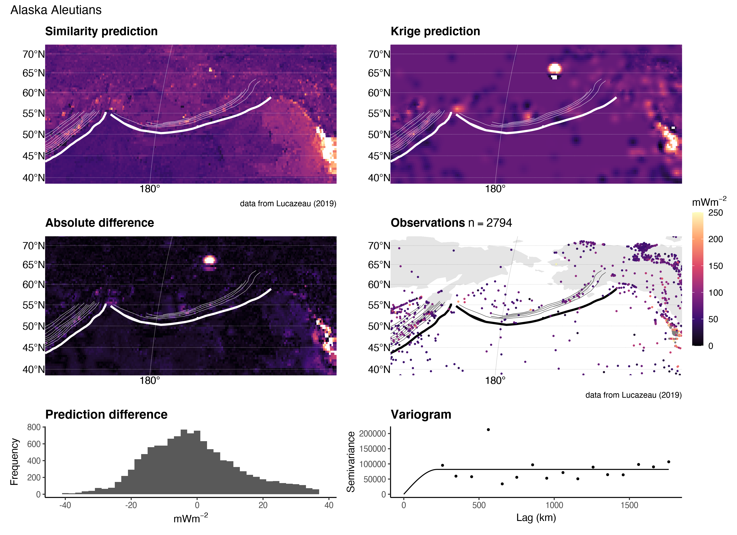

Figure 11: Similarity vs. Kriging predictions for Alaska Aleutians.

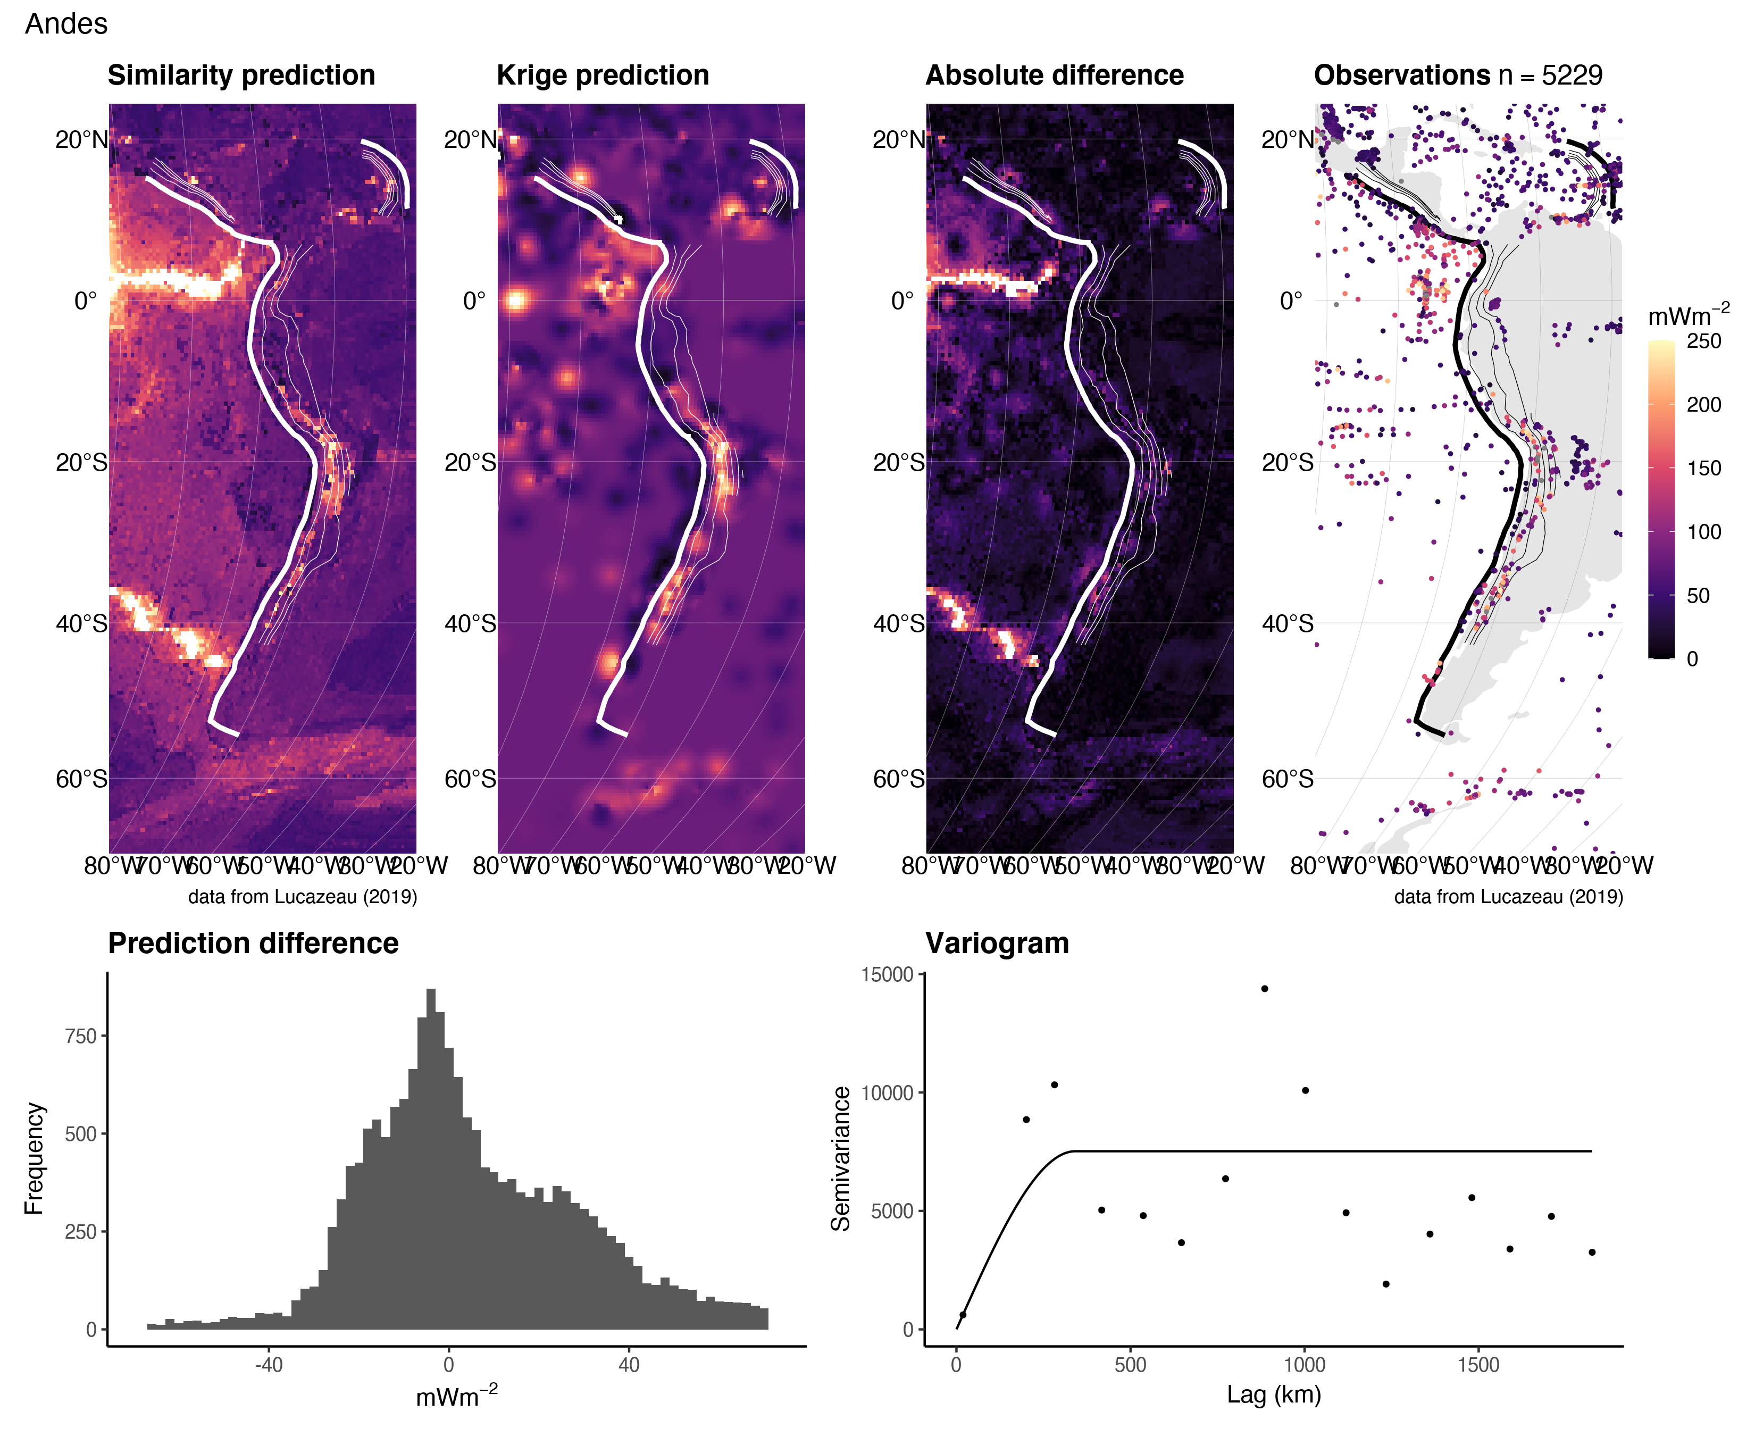

Figure 12: Similarity vs. Kriging predictions for the Andes.

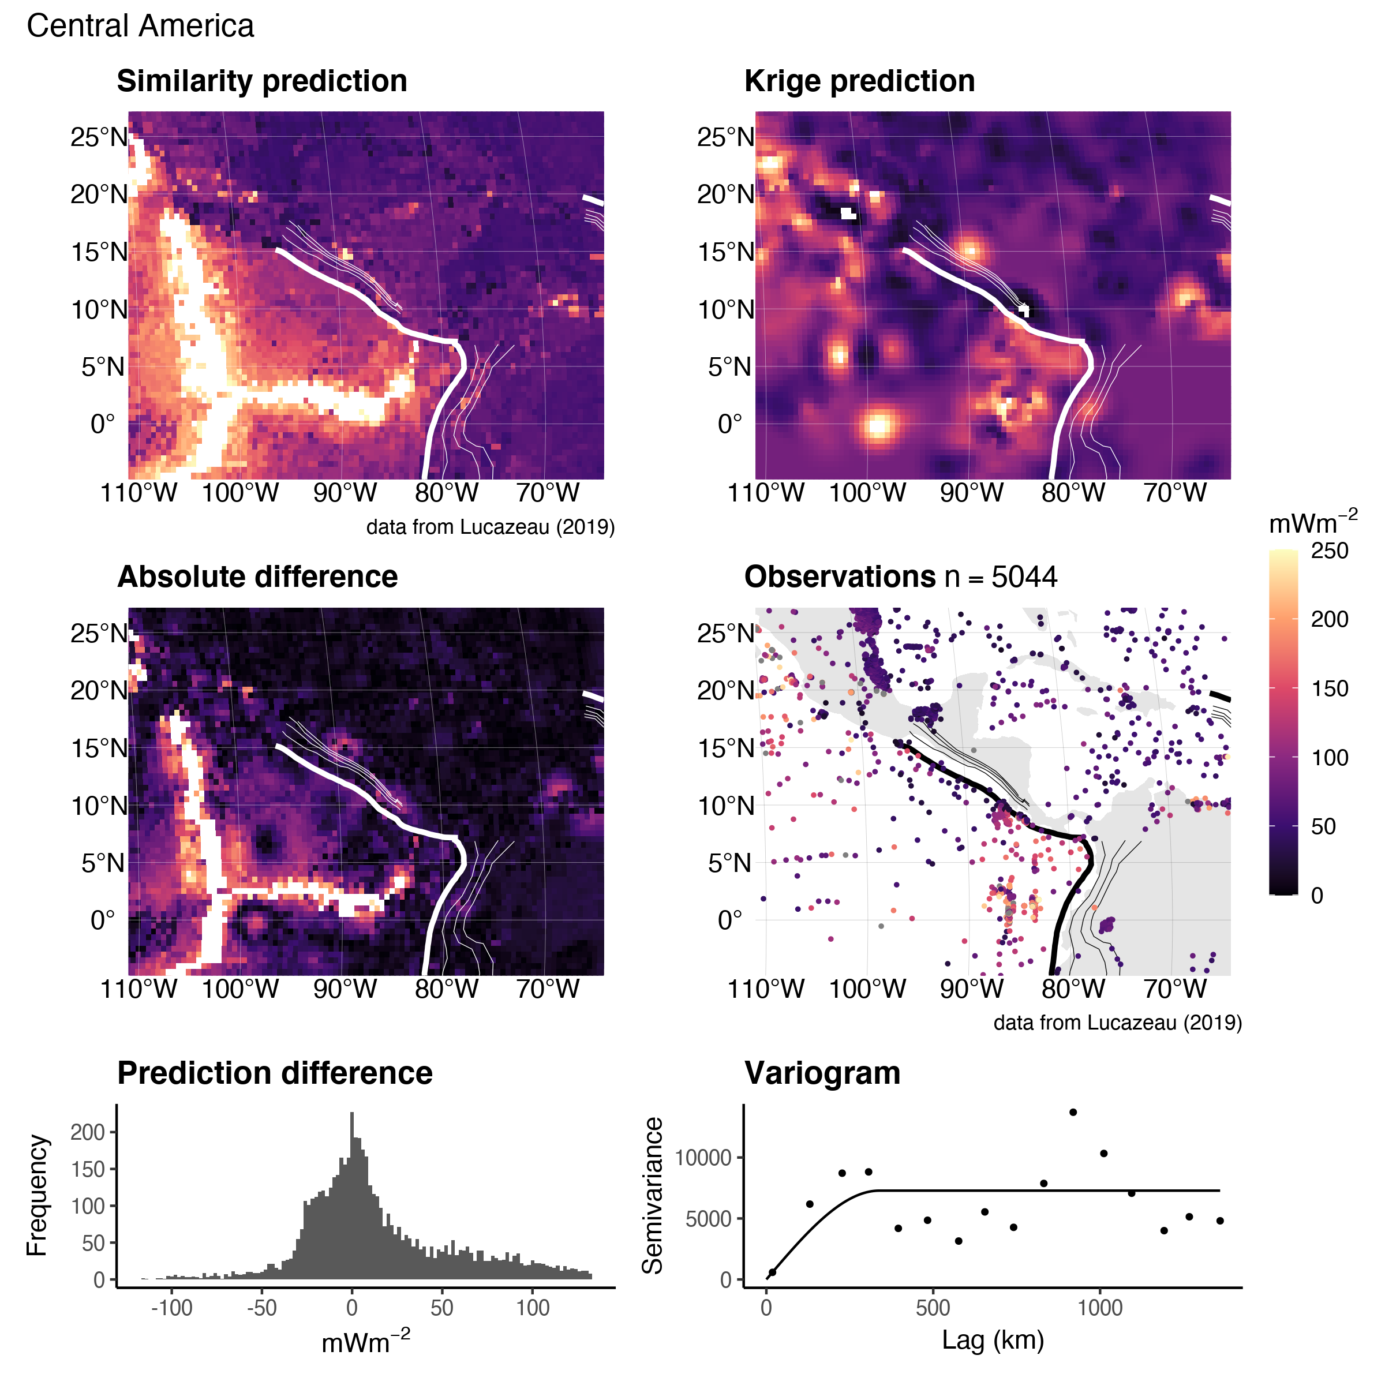

Figure 13: Similarity vs. Kriging predictions for Central America.

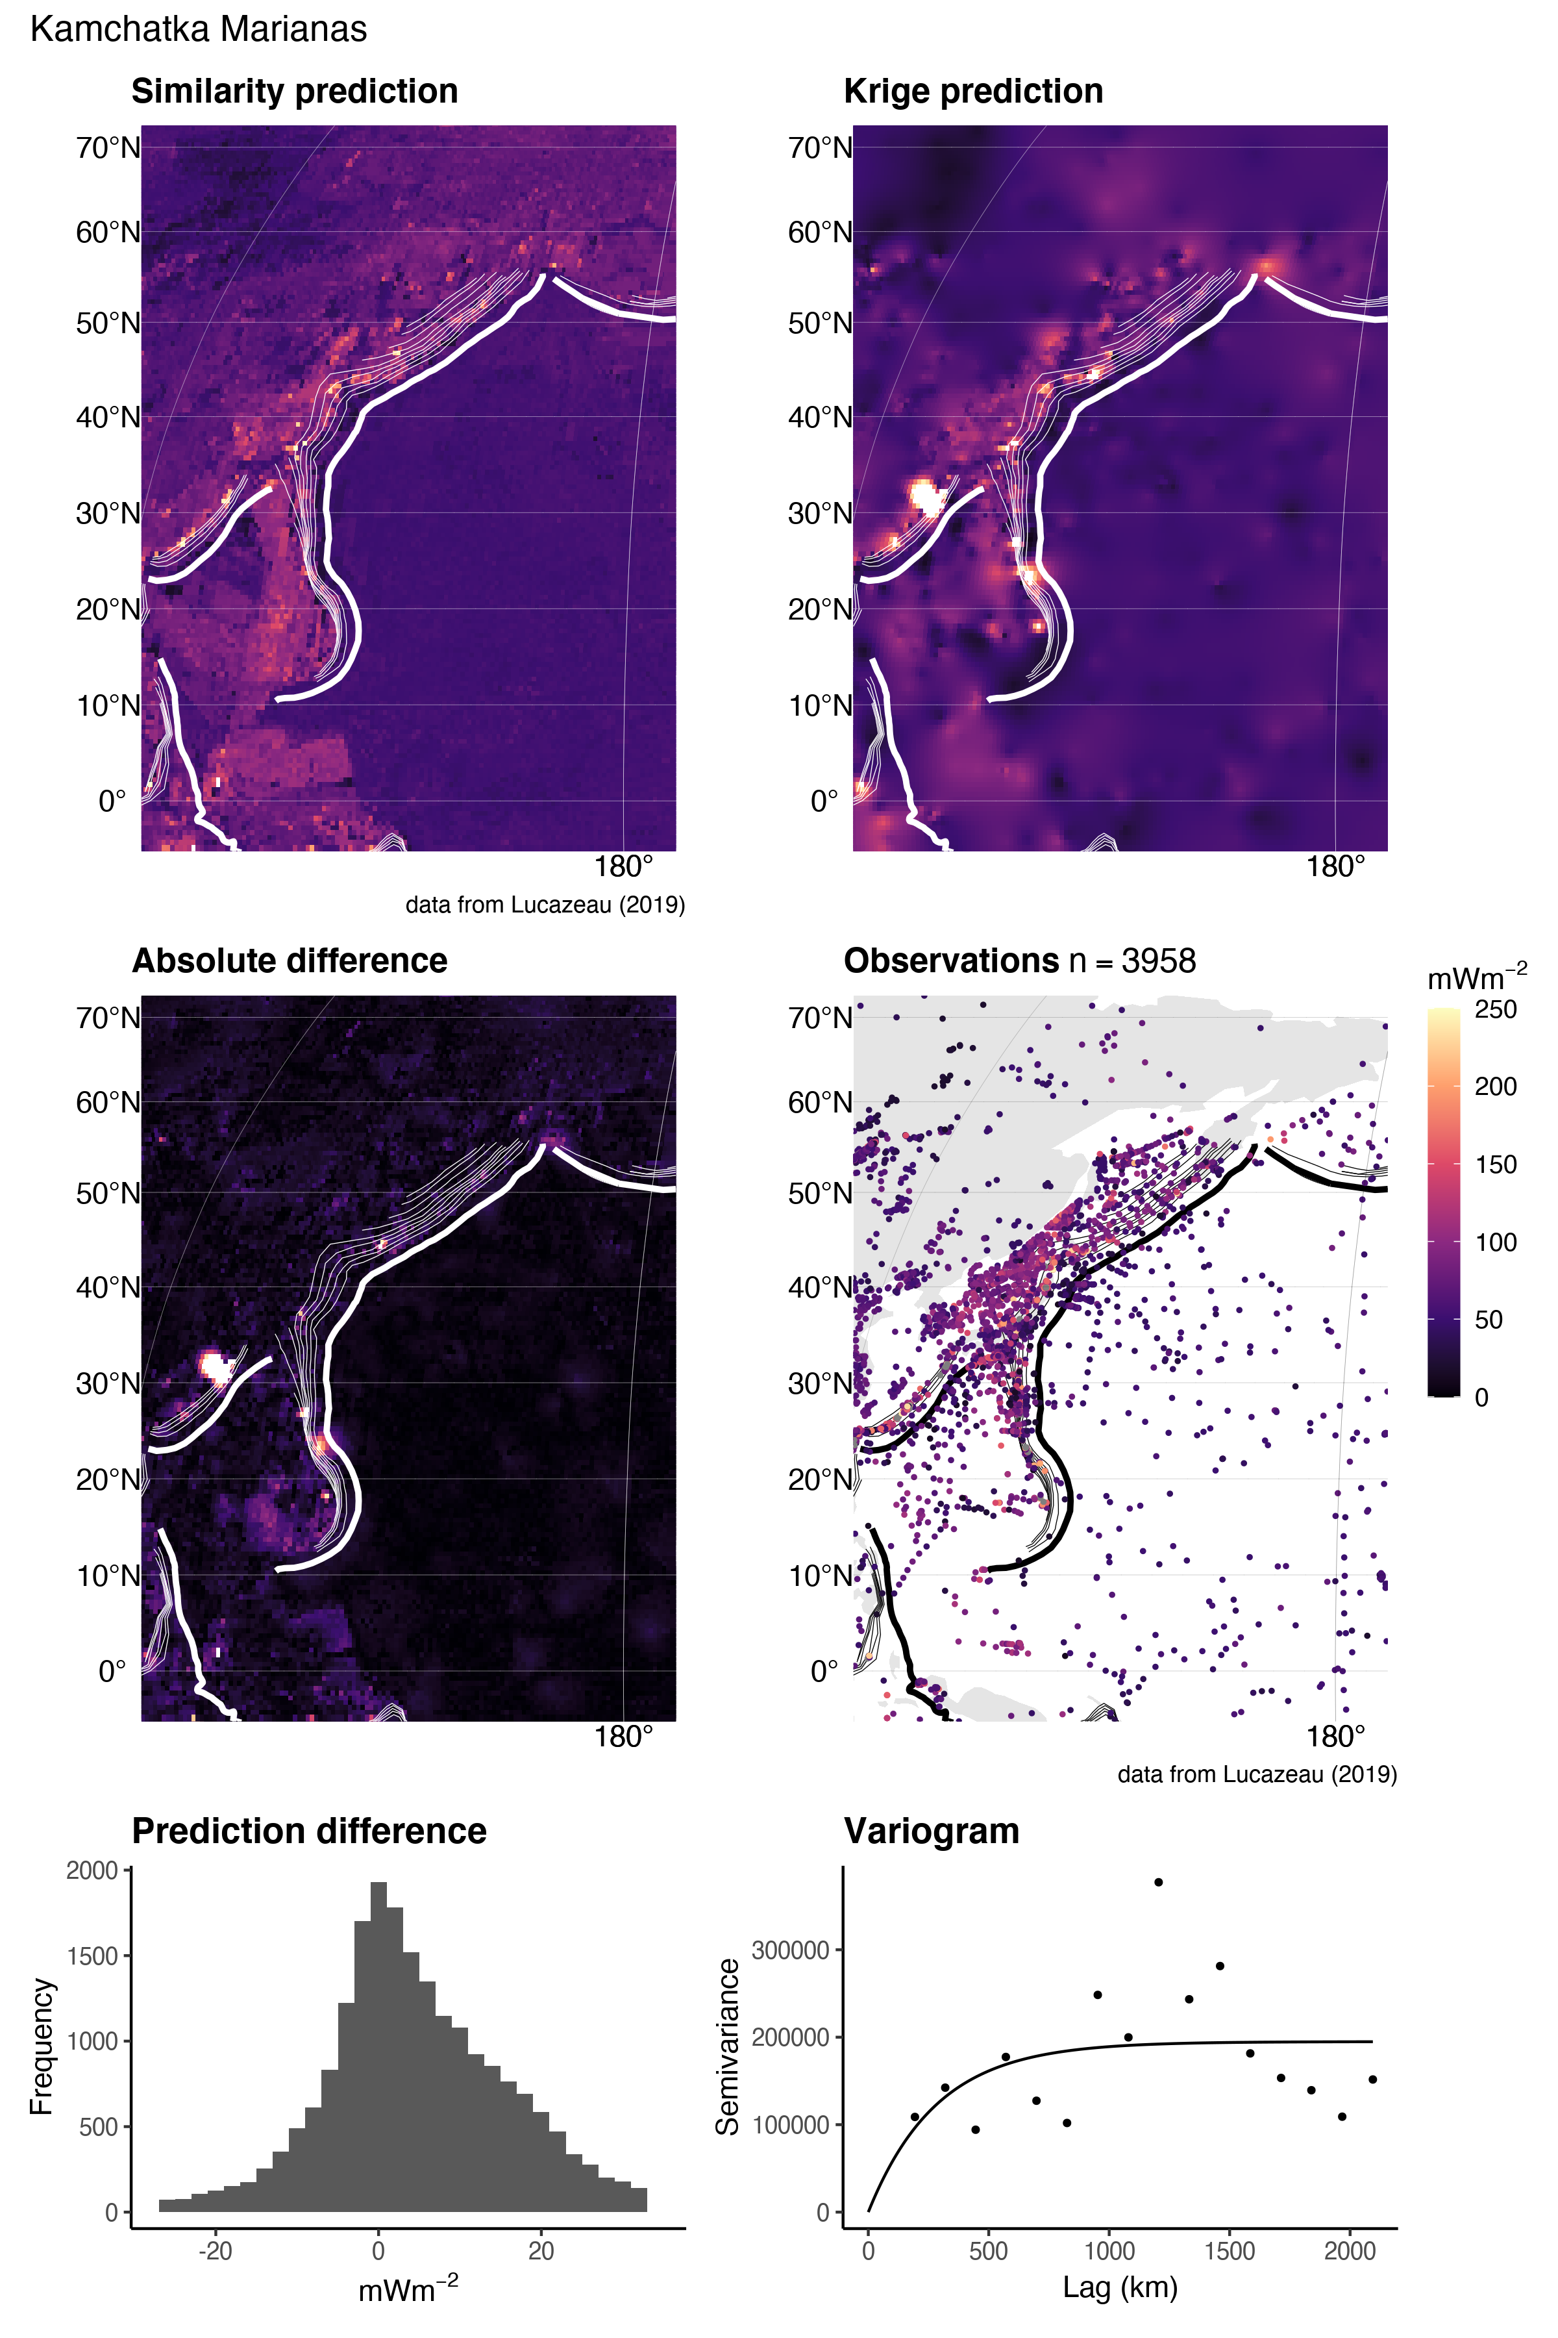

Figure 14: Similarity vs. Kriging predictions for Kamchatka Marianas.

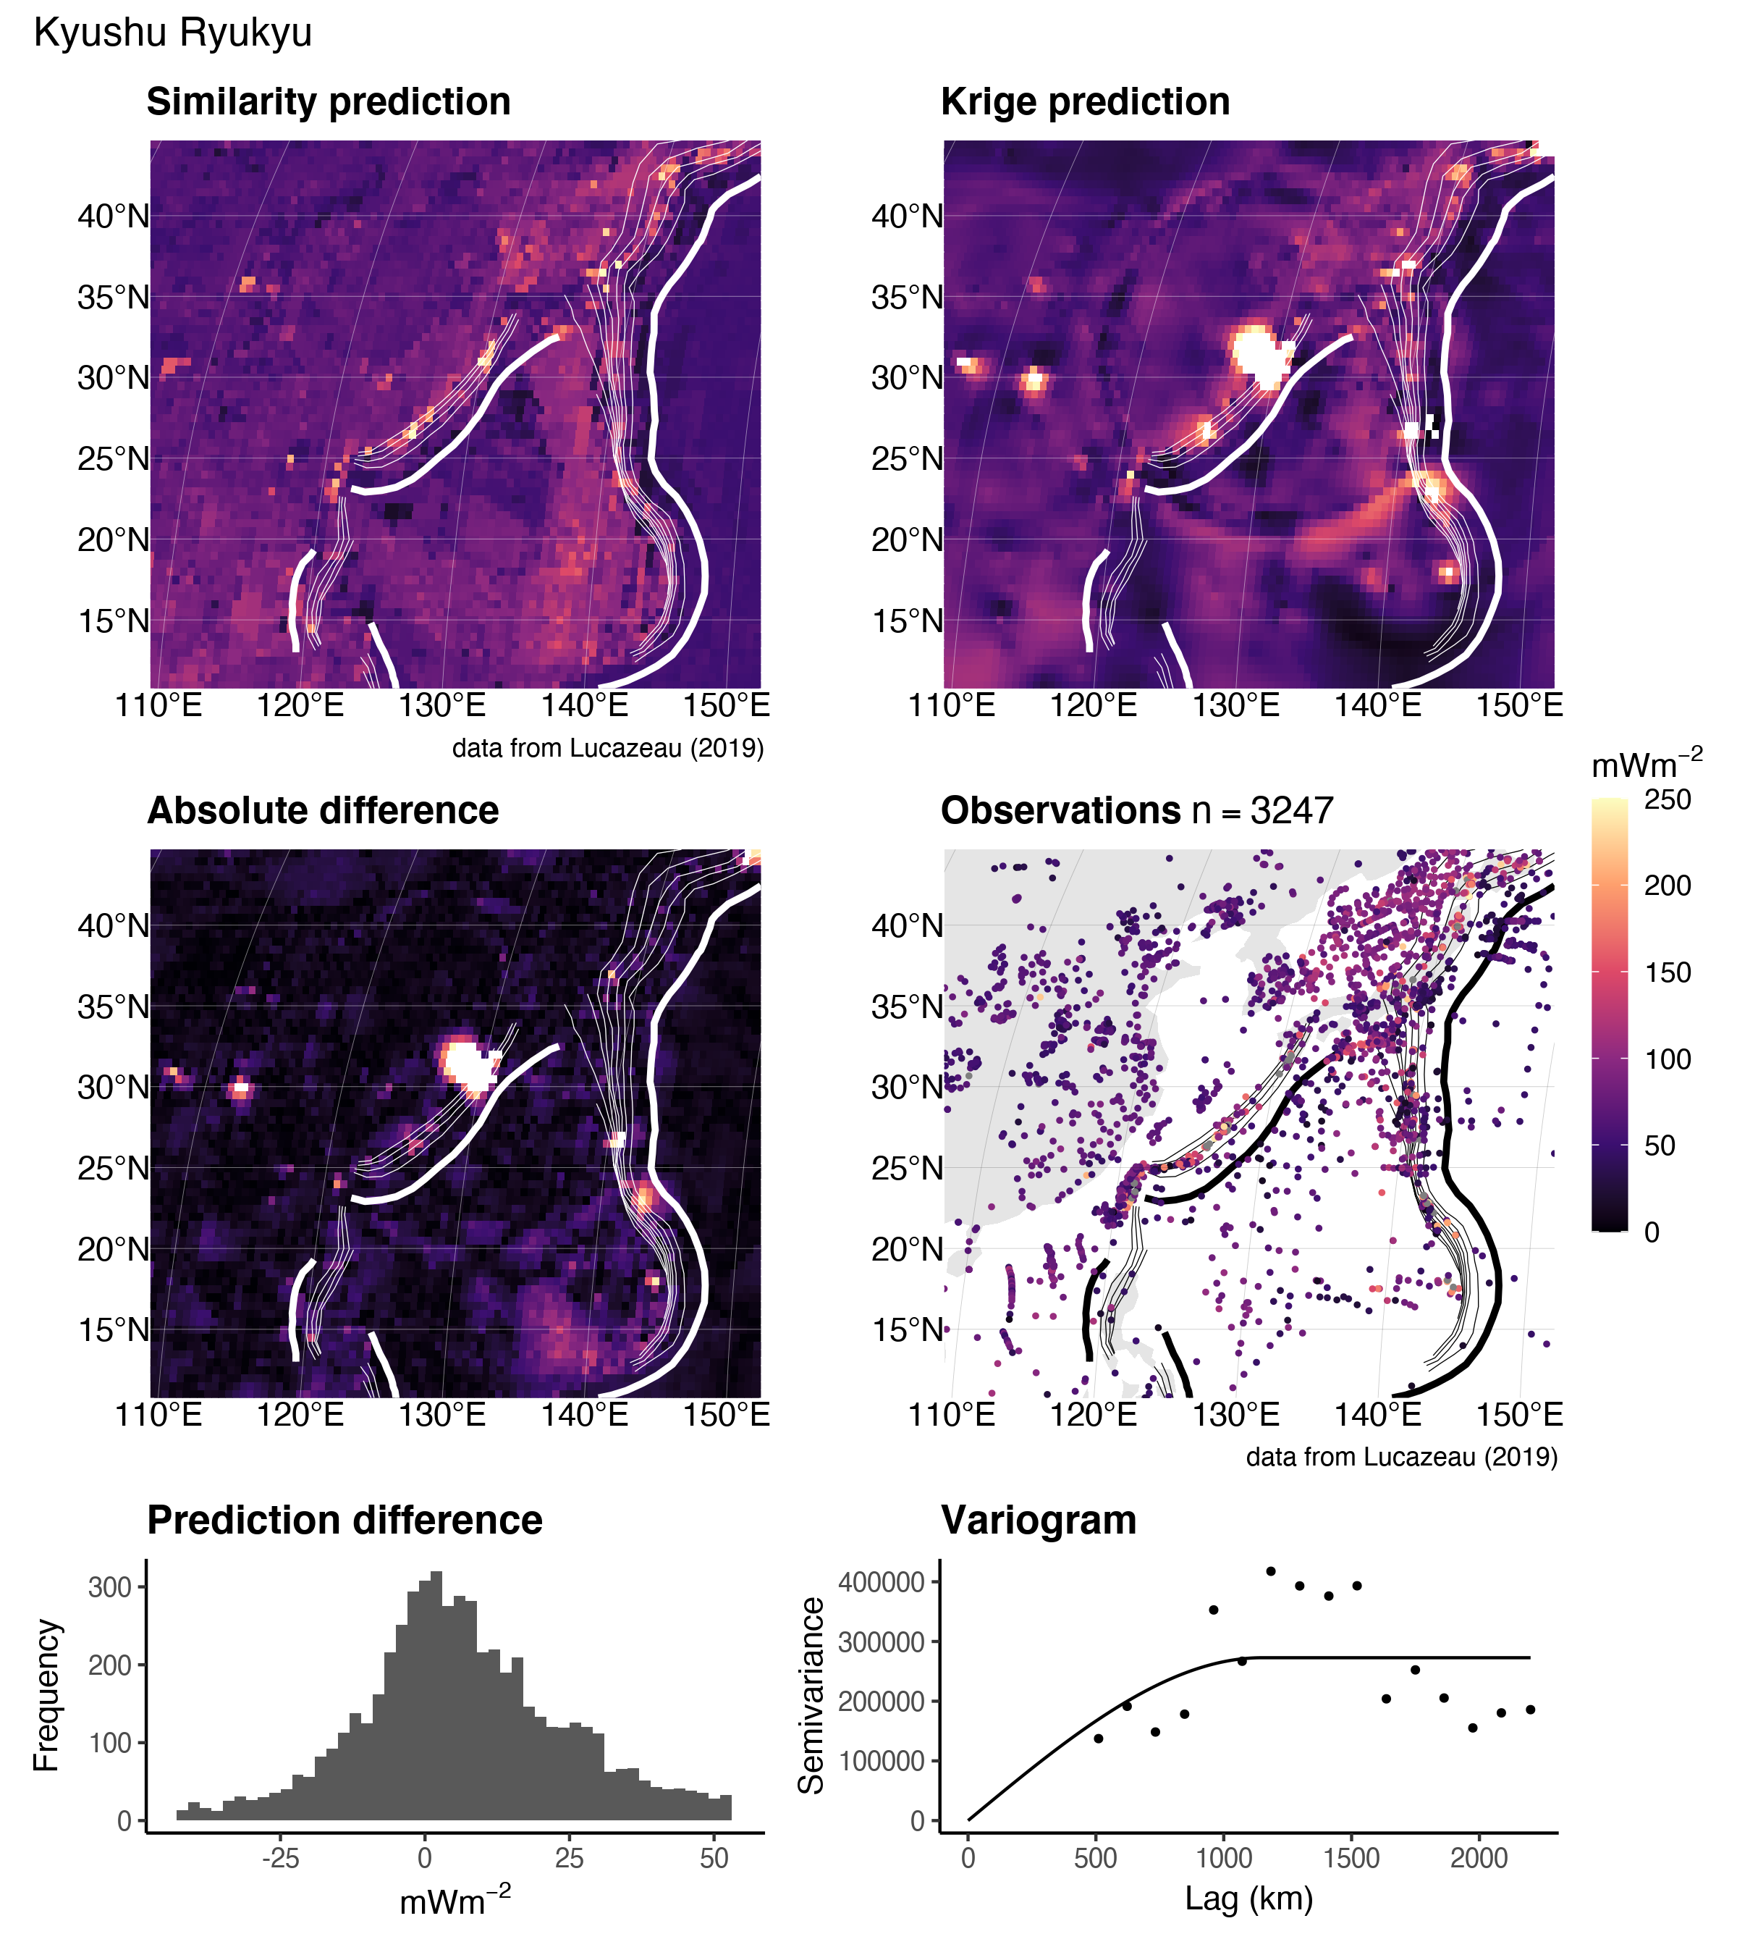

Figure 15: Similarity vs. Kriging predictions for Kyushu Ryukyu.

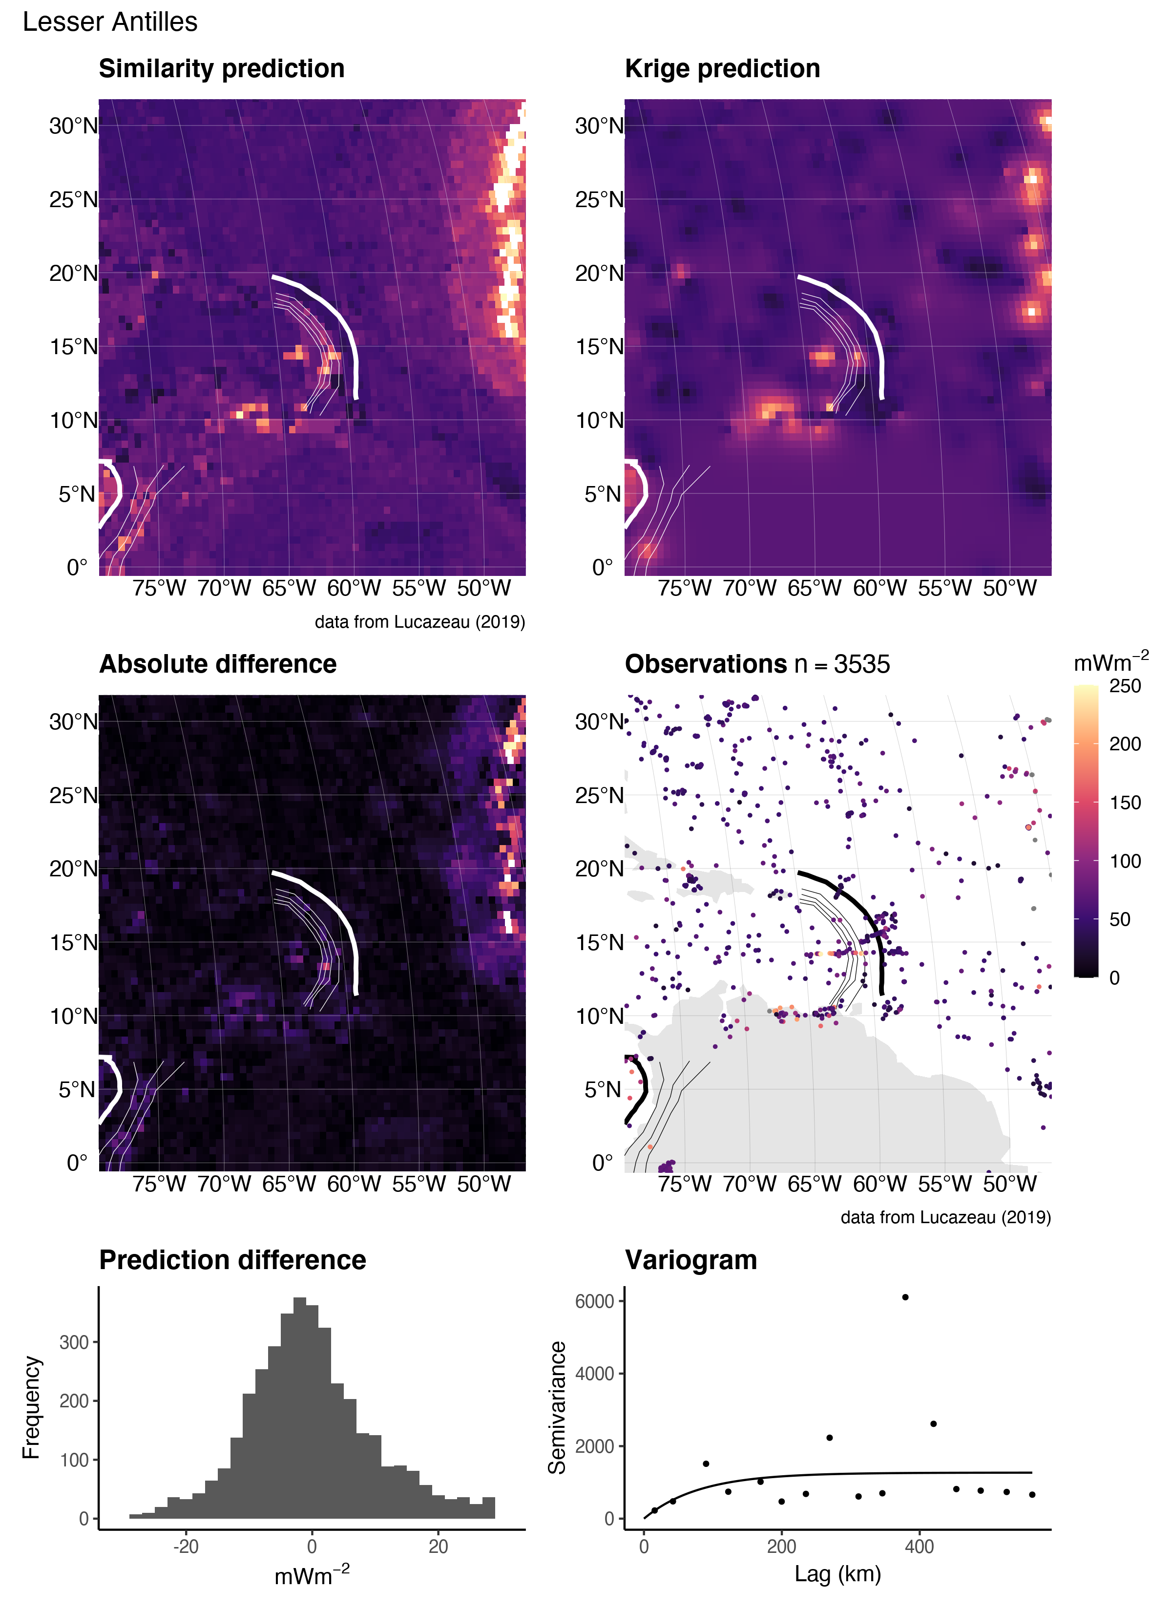

Figure 16: Similarity vs. Kriging predictions for the Lesser Antilles.

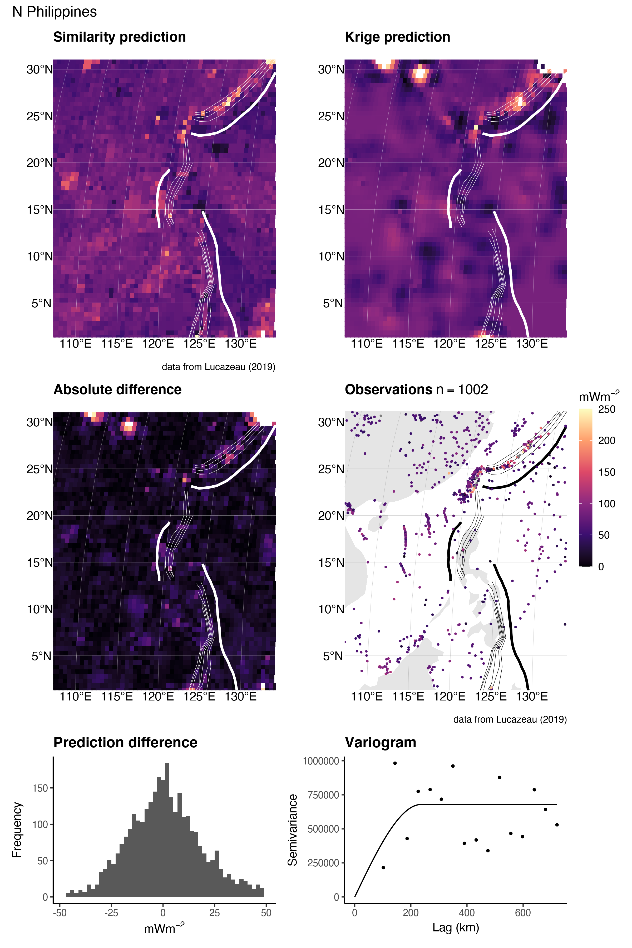

Figure 17: Similarity vs. Kriging predictions for N. Philippines.

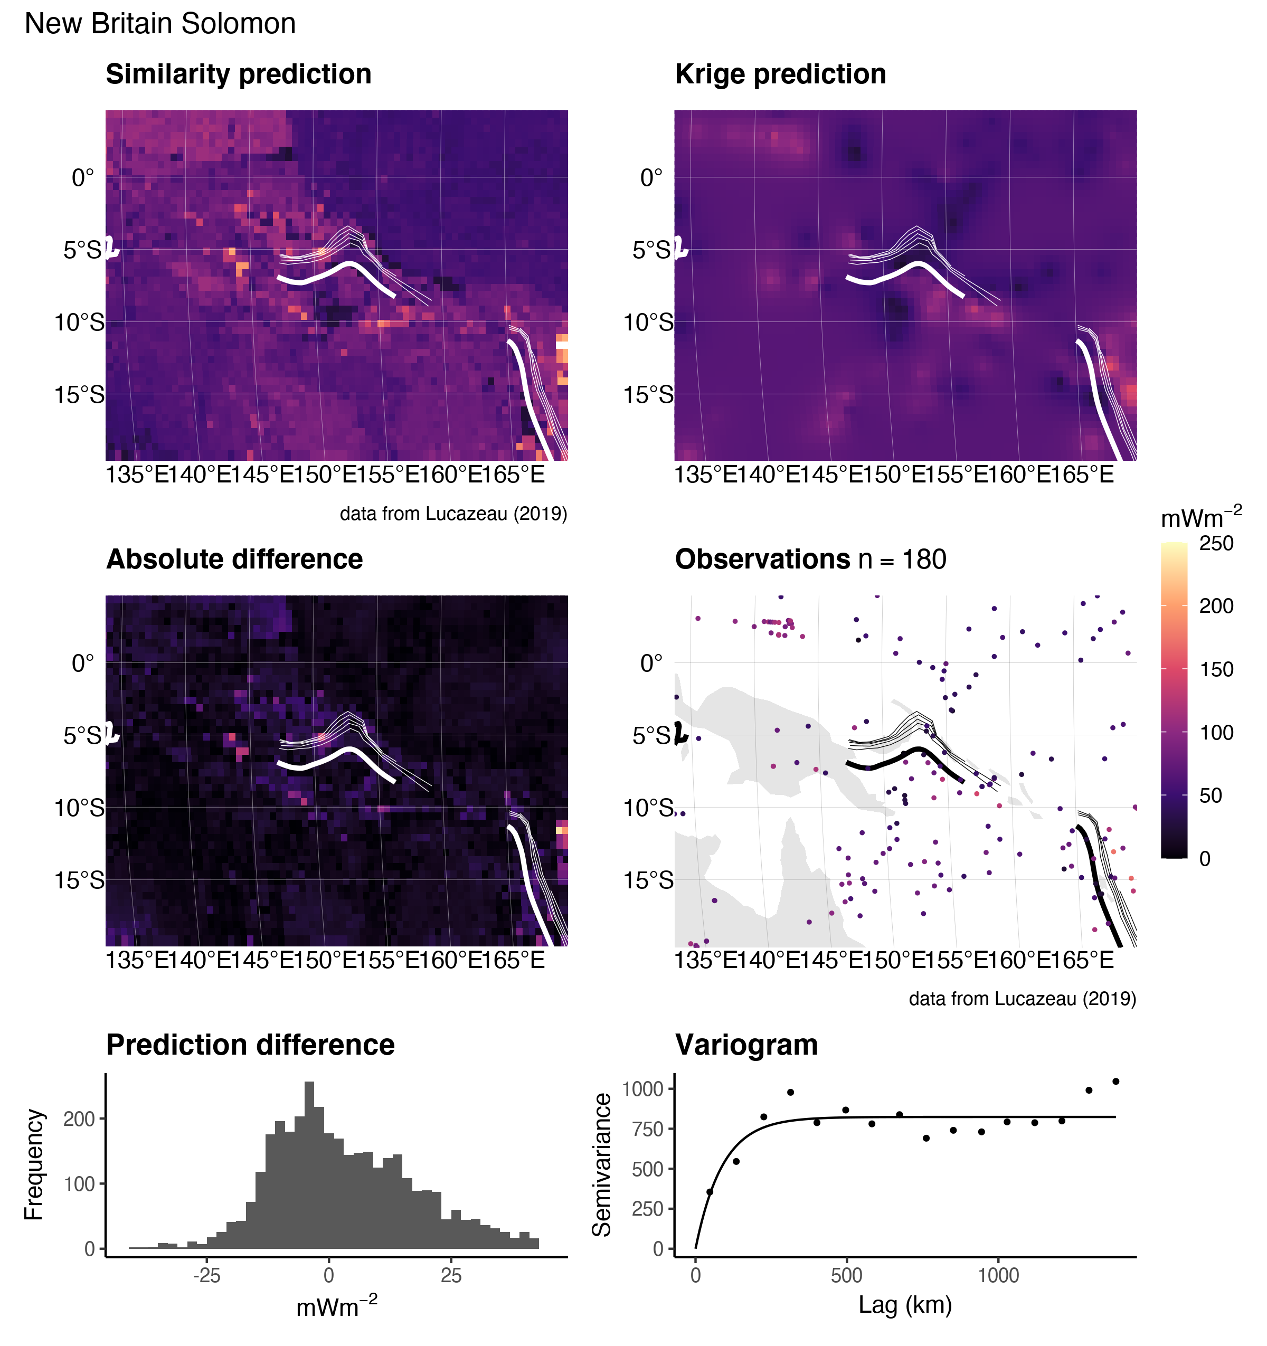

Figure 18: Similarity vs. Kriging predictions for New Britain Solomon.

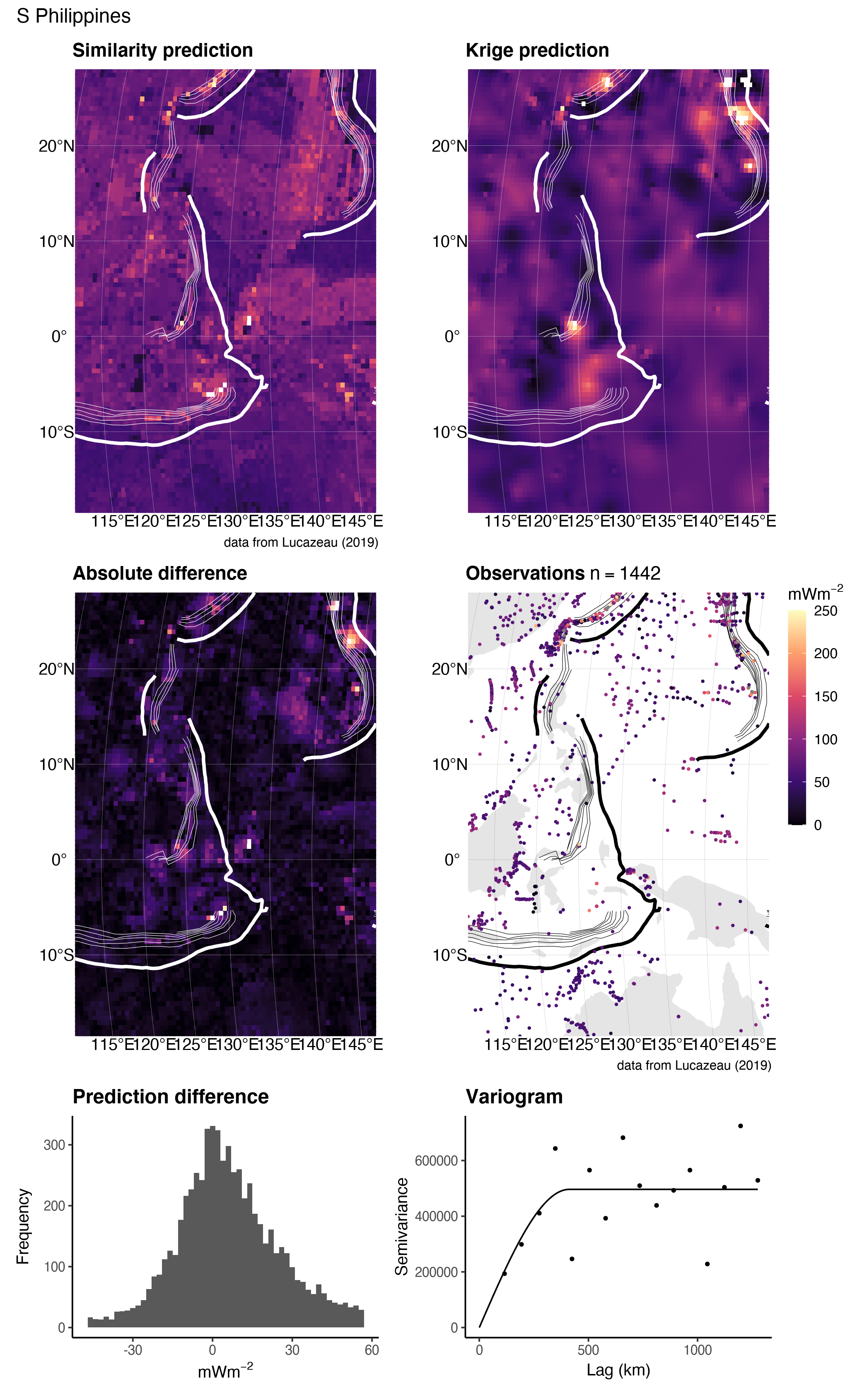

Figure 19: Similarity vs. Kriging predictions for S. Philippines.

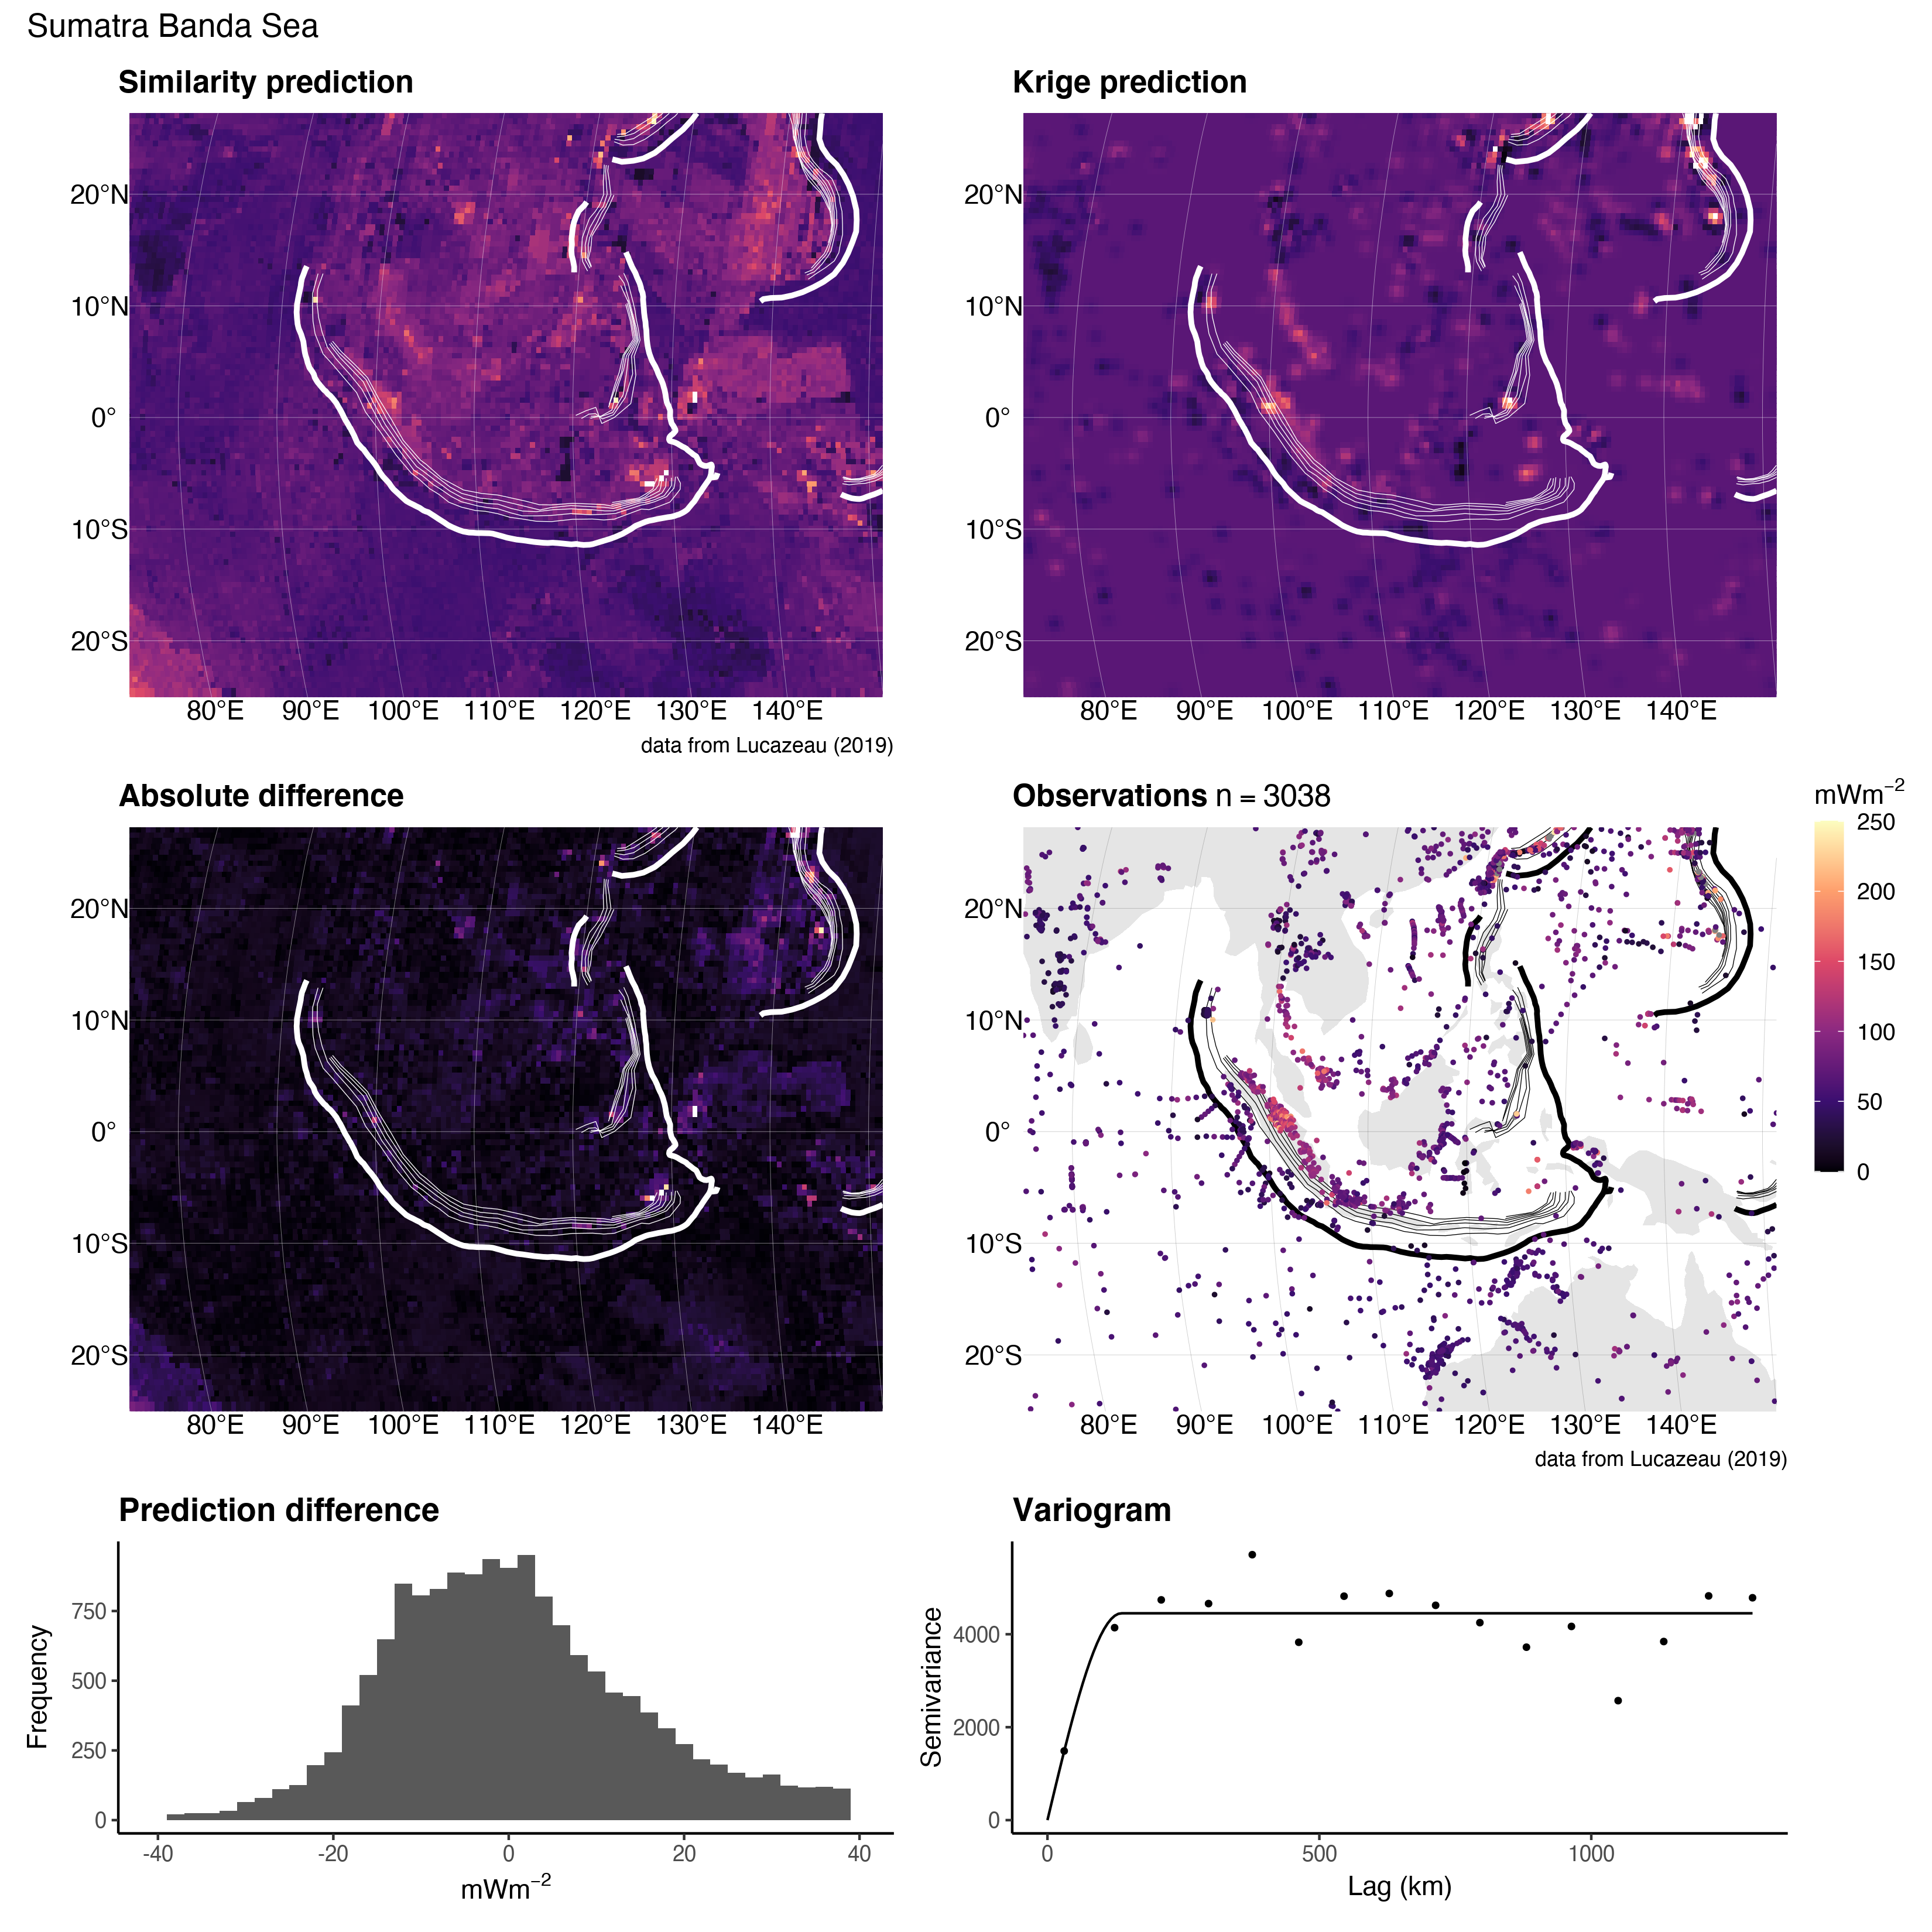

Figure 20: Similarity vs. Kriging predictions for Sumatra Banda Sea.

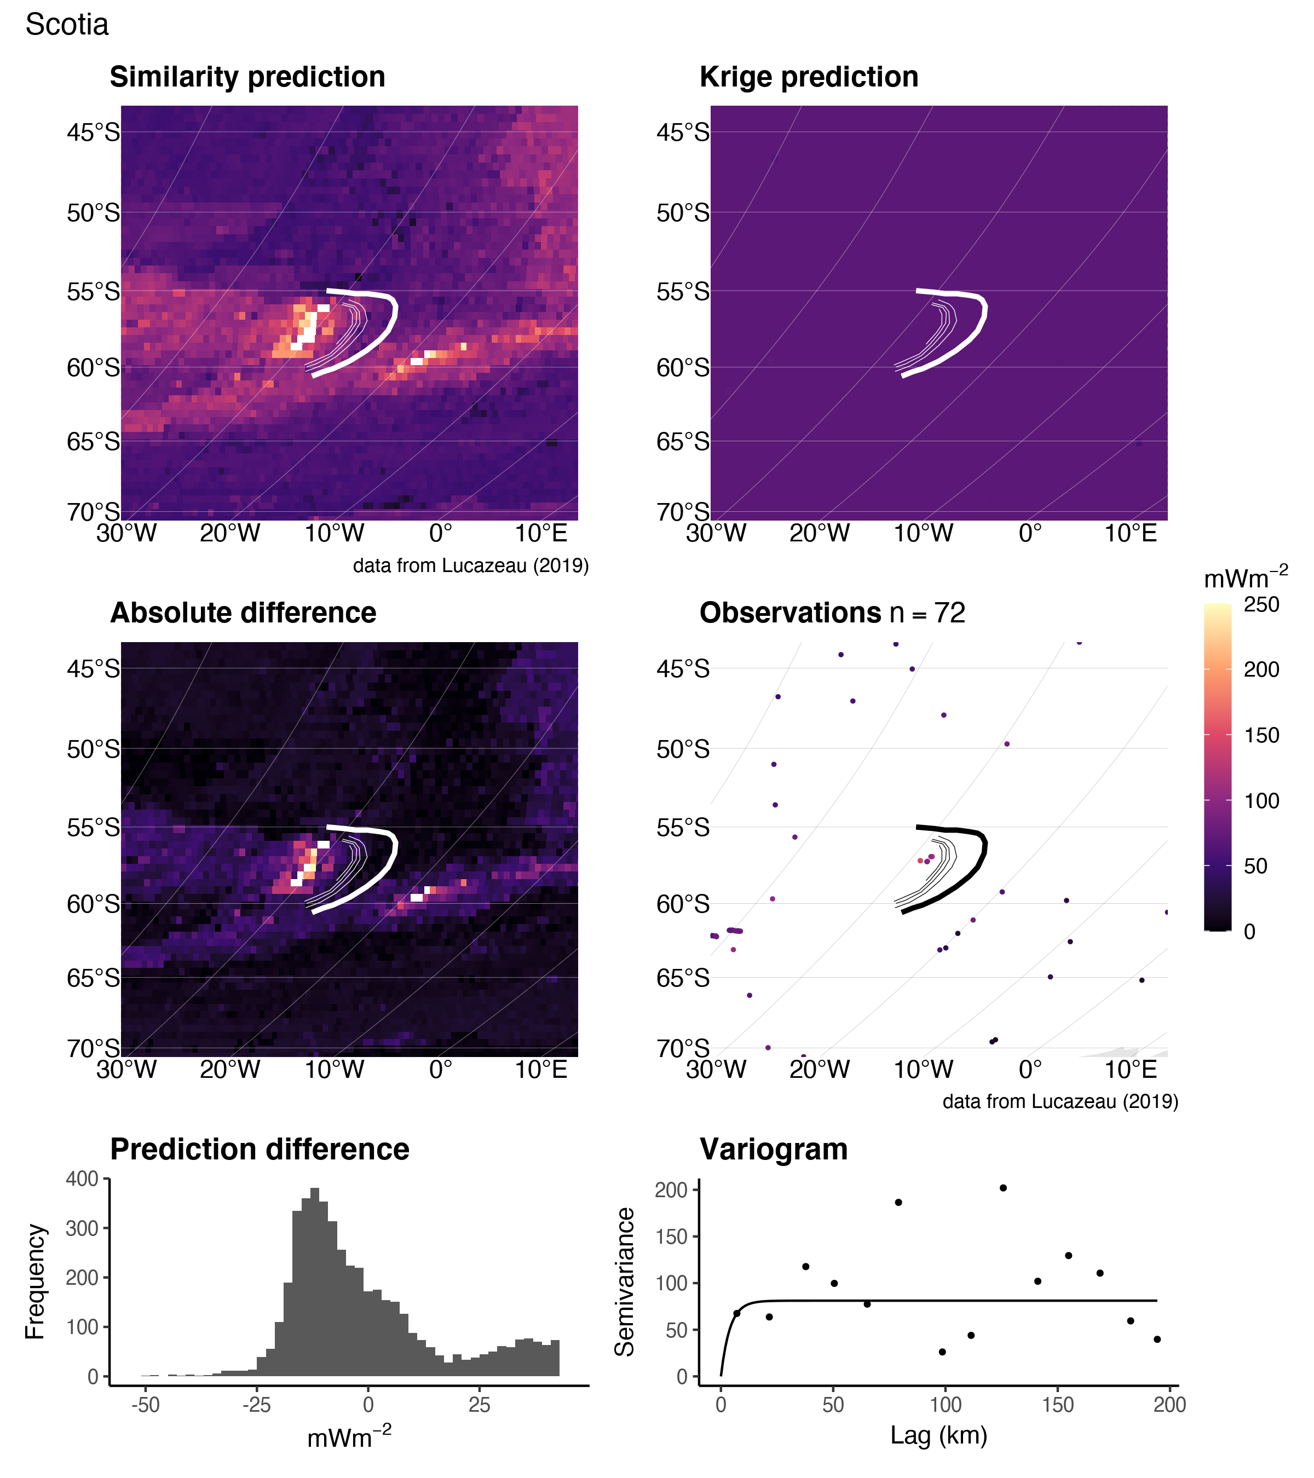

Figure 21: Similarity vs. Kriging predictions for Scotia.

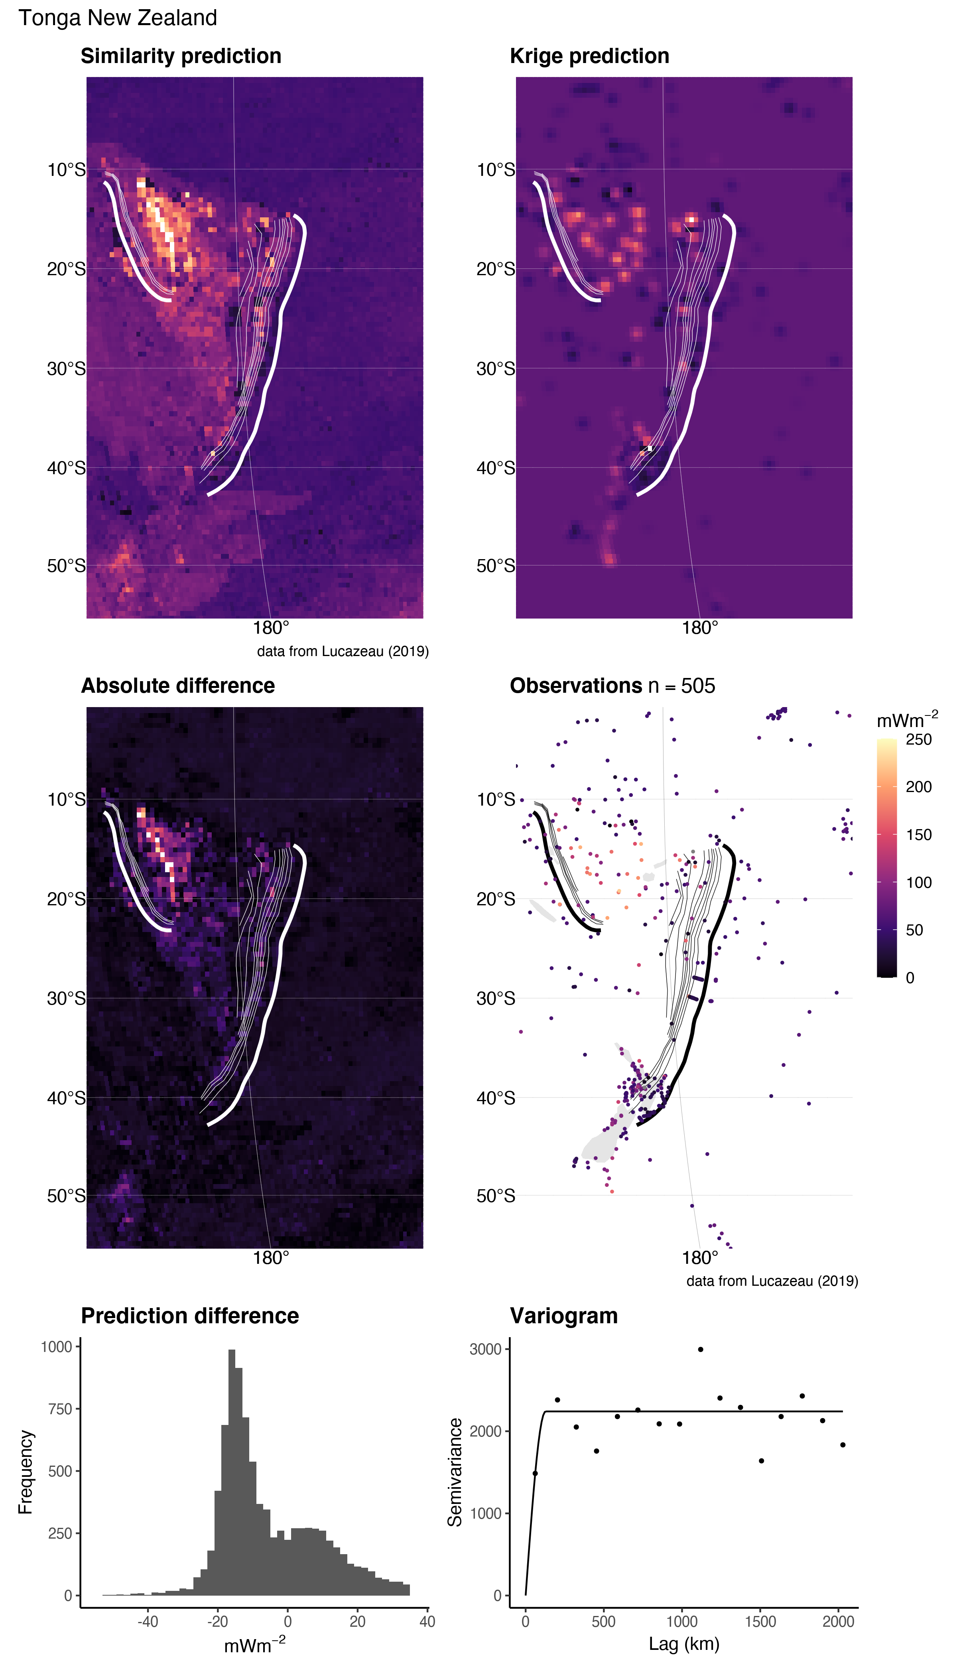

Figure 22: Similarity vs. Kriging predictions for Tonga New Zealand.

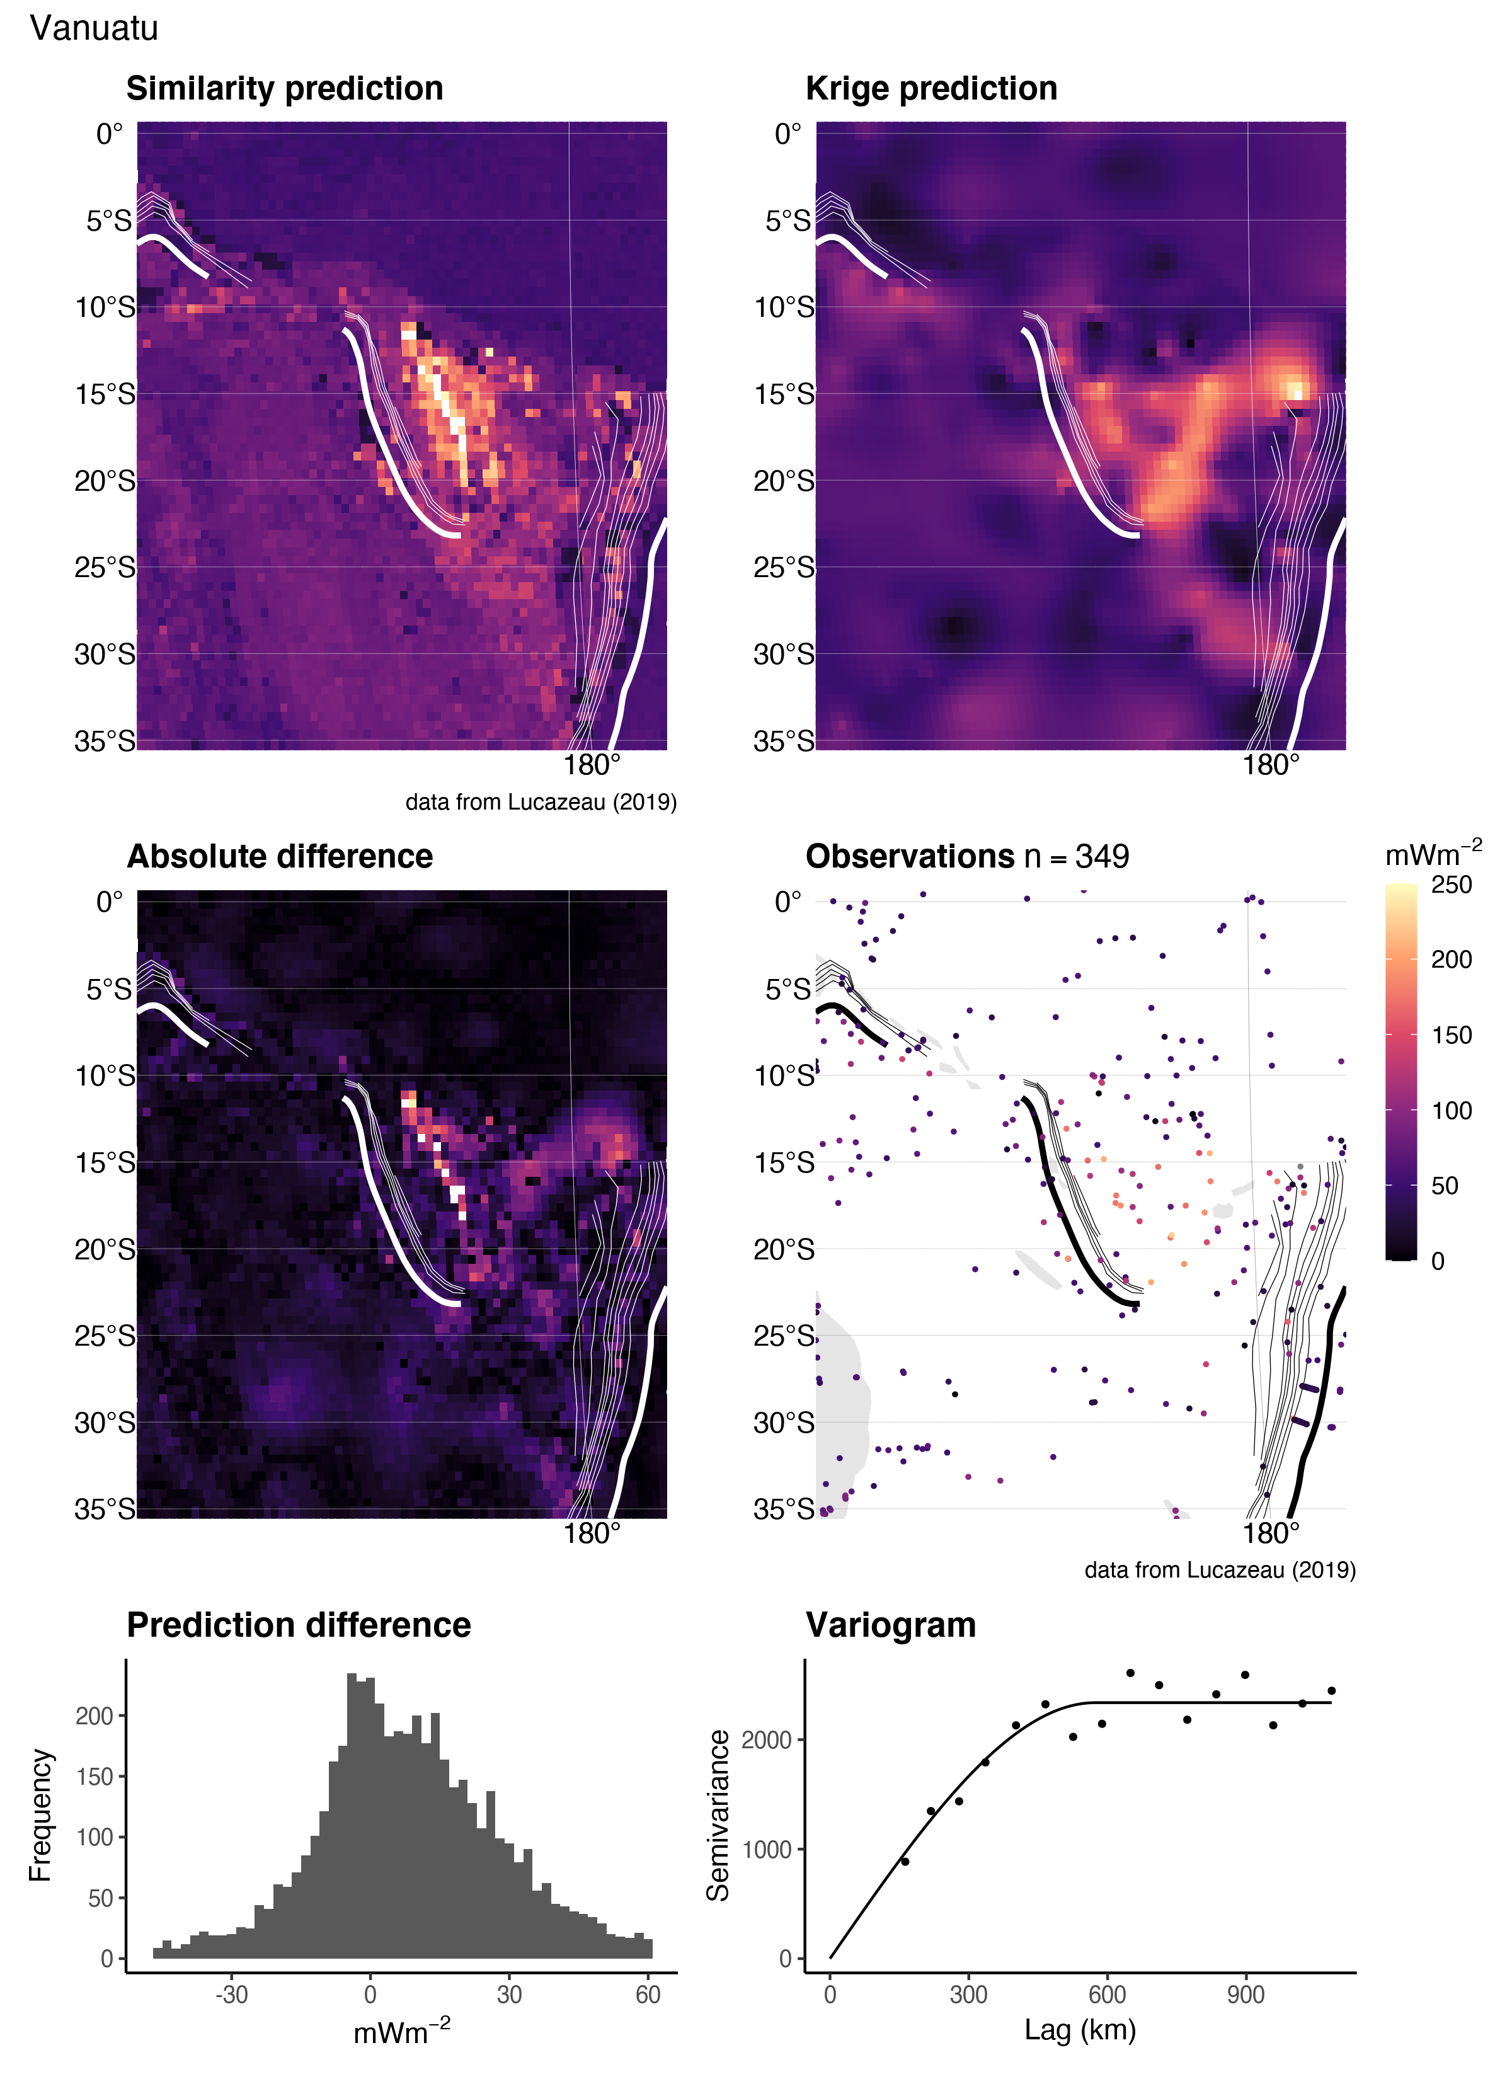

Figure 23: Similarity vs. Kriging predictions for Vanuatu.

## Kriging Optimization

Achieving a useful Kriging results depends on one’s choice of many Kriging parameters ($Θ$). In this study, we investigate a set of parameters, $Θ$:

$$Θ=\{c,w,m,s,a,n,S\} \left(10\right)$$

where $c$ is the lag cutoff proportion, $w$ is the lag window, $m$ is the model type (sph or exp), $s$ is the sill, $a$ is the effective range, $n$ is the nugget, and $S$ is the maximum distance for local Kriging. Only points within $S$ from the prediction location are used for Kriging. The lag cutoff is the maximum separation distance between pairs of points used in the experimental variogram (i.e. the x-axis maximum limit) calculated as a fraction of the overall maximum separation distance for all observations, $Z\left(u\right)$, in the domain, $D$. The lag window, $w$, shifts the lags where the variogram is evaluated by removing the first $n$ lags and adding $n$ lags to the right side of the variogram. This is necessary to avoid negative ranges, $a$, when fitting experimental variograms with anomalously high variances at small lag distances.

Our goal is to find $Θ$ such that our interpolation, $f\left(x_{i};Θ\right)$, gives the most useful outcome—defined by minimizing a cost function, $C\left(Θ\right)$—that represents the error between the set of real observations, $Z\left(u_{i}\right)$ and predictions, $\hat{Z}\left(u\right)$. We define a cost function that simultaneously considers the misfit between the experimental and modelled variogram and between the Kriging predictions and observed heat flow (after Z. Li et al., 2018):

$$C\left(Θ\right)=\left(1-w\right)C_{F}\left(Θ\right)+wC_{I}\left(Θ\right) \left(11\right)$$

where $C_{F}\left(Θ\right)$ is the root mean square error (RMSE) of the modelled variogram fit calculated by WLS, and $C_{I}\left(Θ\right)$ is the RMSE of the Kriging result calculated by cross-validation. The weight, $w$, is set to 0.5 in our study, which balances the effects of $C_{F}\left(Θ\right)$ and $C_{I}\left(Θ\right)$ on the cost function. The final expression to minimize becomes:

$$\begin{matrix}C\left(Θ\right)=\frac{1-w}{σ_{E}} & \sqrt{\frac{1}{N\left(h\right)}\sum_{k=1}^{N}{w}\left(h_{k}\right){\left[\hat{γ}\left(h_{k}\right)-γ\left(h_{k};Θ\right)\right]}^{2}} + \\ \frac{w}{σ_{S}} & \sqrt{\frac{1}{M}\sum_{i=1}^{M}{{\left[Z\left(u_{i}\right)-\hat{Z}\left(u_{i};Θ\right)\right]}^{2}}}\end{matrix} \left(12\right)$$

where N(h) is the number of pairs of points used to calculate the experimental variogram, $\hat{γ}\left(h_{k}\right)$, $σ_{E}$ is the standard deviation of the experimental variogram, $\hat{γ}\left(h\right)$, $w\left(h_{k}\right)$ is the weight in WLS and defines the importance of the $kth$ lag in the error estimate. We use $w\left(h_{k}\right)=N_{k}/h_{k}^{2}$. $Z\left(u_{i}\right)$ and $\hat{Z}\left(u_{i};Θ\right)$ are the measured and predicted values, respectively, $σ_{s}$ is the standard deviation of the predicted values, $\hat{Z}\left(u_{i}\right)$, and M is the number of measurements in $Z\left(u_{i}\right)$. For $C_{I}\left(Θ\right)$ we use ten-fold cross-validation, which splits the dataset, $\left|Z\left(u_{i}\right), ∀u_{i}∈D\right|$ into ten equal intervals and tests one interval against the remaining nine. This process is then repeated over all intervals so that the whole dataset has been cross-validated.

Minimization of $C\left(Θ\right)$ is achieved by a genetic algorithm that simulates biologic natural selection by differential success (Goldberg, 1989). Our procedure is as follows:

1. Initiate fifty *chromosomes*, $ξ$, with random starting parameters defined within the search domain (Table 4)
2. Evaluate the fitness of each individual chromosome as $-C\left(Θ\right)$ for the entire population
3. Allow the population to exchange genetic information by sequentially performing genetic operations:
4. Selection: the top 5% fittest chromosomes survive each generation
5. Crossover: pairs of chromosomes have an 80% chance of exchanging genetic information
6. Mutation: there is a 10% chance for random genetic mutations
7. Evaluate the fitness of the new population
8. If the termination criterion is met, do step (6), otherwise continue to evolve by repeating steps (3) and (4)
9. Decode the best chromosome and build the optimal variogram

We use the general-purpose functions in the “R” package GA (Scrucca, 2013, 2017) to perform each step in the above procedure.

Table 4: Parameters and ranges used in the optimization algorithm

|  |  |  |
| --- | --- | --- |
| Parameter | Search Domain | Units |
| Lag Cutoff (c) | [$1/3$, $1/15$] | NA |
| Lag Window (w) | [1, 5] | NA |
| Model (m) | [Spherical, Exponential] | NA |
| Sill (s) | [1, $1000\sqrt{2}$] | $$mWm^{-2}$$ |
| Effective Range (a) | [1, 1000] | km |
| Nugget (n) | [1, $1000\sqrt{2}$] | $$mWm^{-2}$$ |
| Local Search (S) | [1, 1000] | km |

## Genetic algorithm results

The optimal variogram models and associated errors $C_{F}\left(Θ\right)$ and $C_{I}\left(Θ\right)$ are given in Table **¿tbl:ga.variogram.summary.table?**.

## New Global Heat Flow Database References

Abbott, D., Menke, W., Hobart, M., Anderson, R. N., & Embley, R. W. (1984). Correlated sediment thickness, temperature gradient and excess pore pressure in a marine fault block basin. *Geophys. Res. Lett.*, *11*, 485–488.

Abbott, D. H., Hobart, M. A., & Embley, R. W. (1986). Heat flow and mass wasting in the Wilmington Canyon region: U.S. Continental margin. *Geo-Marine Lett.*, *6*, 131–138.

Abbott, Dallas H., Morton, J. L., & Holmes, M. L. (1986). Heat flow measurements on a hydrothermally-active, slow-spreading ridge: The escanaba trough. *Geophysical Research Letters*, *13*, 678–680. <https://doi.org/10.1029/GL013i007p00678>

Akhmedzyanov, V. R., Ermakov, A. V., & Khutorskoy, M. D. (2012). New data on heat flow in the north atlantic region. *Doklady Earth Sciences*, *442*(1), 91–96. <https://doi.org/10.1134/s1028334x12010011>

Albert-Beltran, J. F. (1979). Heat flow and temperture gradient data from Spain. In V. Cermak & L. Rybach (Eds.), *Terrestrial heat flow in europe* (pp. 261–266). Springer Verlag.

Alexandrino, C. H., & Hamza, V. M. (2008). Estimates of heat flow and heat production and a thermal model of the são francisco craton. *International Journal of Earth Sciences*, *97*(2), 289–306. <https://doi.org/10.1007/s00531-007-0291-y>

Aliev, S. A., Ashirov, T., Lipsits, Yu. M., Sopiev, V. A., & Sudakov, N. P. (1979). Novye dannye o teplovom potoke cherez dno kaspiiskogo morya (russ.). *Izvestiya An Turkm. Ssr, Ser. Fiziko-Tekhnicheskikh, Khimiches- Kikh I Geologicheskikh Nauk*, *2*, 124–126.

Allis, R. G. (1975). *Geothermal measurements in five small lakes of northwestern Ontario, Canada* (Master’s thesis). University of Toronto.

Allis, R. G., & Garland, G. D. (1979). Heat flow measurements under some lakes in the superior province of the canadian shield. *Canadian Journal of Earth Sciences*, *16*, 1954–1961. <https://doi.org/10.1139/e80-112>

Anderson, E. M. (1940). Loss of heat by conduction from the Earth’s crust. *Proc. R. Soc. Edinb.*, *60*, 192–209.

Anderson, R. N. (1975). Heat flow in the mariana marginal basin. *Journal of Geophysical Research*, *80*, 4043–4048. <https://doi.org/10.1029/JB080i029p04043>

Anderson, R. N., & Hobart, M. A. (1976). The relation between heat flow, sediment thickness, and age in the eastern pacific. *Journal of Geophysical Research*, *81*, 2968–2989. <https://doi.org/10.1029/JB081i017p02968>

Anderson, R. N., & Larue, D. K. (1991). Wellbore heat flow from the Toa Baja scientific drillhole, Puerto Rico. *Geophysical Research Letters*, *18*, 537–540. <https://doi.org/10.1029/91gl00391>

Anderson, Roger N., & Von Herzen, R. P. (1978). Heat flow on the pacific-antarctic ridge. *Earth and Planetary Science Letters*, *41*(4), 451–460. <https://doi.org/10.1016/0012-821x(78)90176-0>

Anderson, R. N., Moore, G. F., Schilt, S. S., Cardwell, R. C., & Tréhu, A. (1976a). Heat flow near a fossil ridge on the north flank of the Galapagos spreading center. *J. Geophys. Res.*, *81*, 1828–1838.

Anderson, R. N., Langseth, M. G., Vacquier, V., & Francheteau, J. (1976b). New terrestrial heat flow measurements on the nazca plate. *Earth and Planetary Science Letters*, *29*, 243–254. <https://doi.org/10.1016/0012-821x(76)90128-x>

Anderson, R. N., Langseth, M. G., & Sclater, J. G. (1977). The mechanism of heat transfer through the floor of the Indian Ocean. *J. Geophys. Res.*, *82*, 3391–3490.

Anderson, R. N., Hobart, M. A., Von Herzen, R. P., & Fornari, D. J. (1978). Geophysical surveys on the East Pacific Rise–Galapagos rise system. *Geophys. J. Roy. Astr. Soc.*, *54*, 141–166.

Anderson, R. N., Langseth, M. G., Hayes, D. E., Watanabe, T., & Yasui, M. (1978). Heat flow, thermal conductivity, thermal gradient. In D. E. Hayes (Ed.), *Geophysical atlas of the east and southeast asian seas*. Geol. Soc. Am.

Anderson, R. N., Hobart, M. A., & Langseth, M. G. (1979). Geothermal convection through oceanic crust and sediments in the Indian Ocean. *Science*, *204*, 828–832.

Andreescu, M., Burst, D., Demetrescu, C., Ene, M., & Polonic, G. (1989). On the geothermal regime of the Moesian Platform and Getic Depression. *Tectonophysics*, *164*, 281–286.

Andrews-Speed, C. P., Oxburgh, E. R., & Cooper, B. A. (1984). Temperatures and depth dependent heat flow in western North Sea. *Bull. Am. Ass. Petrol. Geol.*, *68*, 1764–1781.

Arnaiz-Rodríguez, M. S., & Orihuela, N. (2013). Curie point depth in venezuela and the eastern caribbean. *Tectonophysics*, *590*(0), 38–51. <https://doi.org/10.1016/j.tecto.2013.01.004>

Arney, B. H. (1982). Evidence of form higher temperatures from alteration minerals, Bostic 1-A Well, Mountain Home, Idaho. *Geothermal Res. Council Trans.*, *6*, 3–6.

Arshavskaya, N. I., Galdin, N. E., Karus, E. V., Kuznetsov, O. L., Lubimova, E. A., Milanovskii, S. Y., et al. (1984). Teplovye svoistva porod. In *Kolskaya sverkhglubo- kaya. Issledovanie glubinnogo stroeniya kontinentalnoi kory s po- moshchyyu bureniya kolskoi sverkhglubokoi skvazhiny. (Pod red. Koz- lovskii e.a.)* (pp. 341–348). Moskva, Nedra.

Artemenko, V. I., Selyaninov, V. G., Smirnova, L. A., & Strygin, V. N. (1986). Avtonom- nyi tsifrovoi termozond dlya morskikh geotermicheskikh issledovanii (atstm-1) (russ.). *Okeanologiya*, *T.26, Vyp.6*, 1033–1038.

ASCOPE Secretariat*Terrestrial heat flow map of southeast asia*. (1986). (No. ASCOPE Technical Paper TP/6). Jakarta, Indonesia.

Ashirov, T. A. (1984). Geotermicheskoe pole turkmenii. - moskva: nauka.

Ashirov, T. O. (1985). Teplovom pole v predelakh zapadnogo borta yuzhno- kaspiiskoi depressii. - izvestiya an turkm. Ssr, ser. Fiziko-tekh- nicheskikh, khimicheskikh i geologicheskikh nauk. (russ.), *2*, 70–74.

Atroshchenko, P. P. (1975). Geotermicheskie usloviya severnoi chasti pri- pyatskoi vpadiny (russ.). *Minsk Nauka I Tekhnika*, *104*.

Avetisyyants, A. A. (1974a). Teplovoe pole geosinklinalnogo obramleniya vostochno-evropeiskoi platformy. Armeniya i sopredelnye territorii (russ.). *Glubinnyi Teplovoi Potok Evropeiskoi Chasti SSSR. Kiev, Naukova Dumka*, *V*, 90–95.

Avetisyyants, A. A. (1974b). Teplovoi potok v armenii (russ.). *Geotermiya. Otchety Po Geotermicheskim Issledovaniyam V SSSR. Vypusk 1-2. Ot- Chety Za 1971-1972 Gg. Moskva*, 44–47.

Avetisyyants, A. A. (1979). Geotermicheskie usloviya nedr armenii (russ.). *Moskva Nauka*, *88*.

Avetisyyants, A. A., Ananyan, A. L., & Igumnov, V. A. (1968). Teplovoi potok po skvazhine kadzharan - 480. - doklady an arm. Ssr. 1968. *T. 46*.

Balabashin, V. I., & Koptev, A. A. (2004). Results of the 6th cruise of r/v "academic lavrentiev" in 1987 (personal communication). In *CD rom: Geothermal gradient and heat flow data in and around japan* (p. –). Geological Survey of Japan, AIST, 2004.

Balkan-Pazvantoğlu, E., & Erkan, K. (2019). Temperature-depth curves and heat flow in central part of Anatolia, Turkey. *Tectonophysics*, *757*, 24–34. <https://doi.org/10.1016/j.tecto.2019.02.019>

Ballard, S. I. I. I., Pollack, H. N., & Skinner, N. J. (1987). Terrestrial heat flow in botswana and namibia. *Journal of Geophysical Research*, *92*, 6291–6300. <https://doi.org/10.1029/JB092iB07p06291>

Balling, N. (1979). Subsurface temperatures and heat flow estimates in Denmark. In V. Cermak & L. Rybach (Eds.), *Terrestrial heat flow in europe* (pp. 1161–1171). Springer Verlag.

Balling, N. (1986). *Temperature of geothermal reservoirs in denmark. Report to commission of the european communities.* Geophysical Laboratory, University of Aarhus.

Balling, N. (1991). Catalogue of heat flow density data: denmark. In V. Cermak, R. Haenel, & V. Zui (Eds.), *Geothermal atlas of europe* (pp. 111–112). Berlin: Hermann Haack Verlagsgesellschaft mbH.

Balling, N., Kristiansen, J. I., & Saxov, S. (1984). Geothermal measurements from the vestmanna-1 and lopra-1 boreholes. In A. N.-N. O. Berthelsen & J. Rasmussen (Eds.), *The deep drilling project 1980-1981 in the faeroe islands* (Vol. Supplementum IX Vol., pp. 137–148). Tórshavn: Foroya Fróõskaparfelag.

Balling, N., Breiner, N., & Waagstein, R. (2006). Thermal structure of the deep lopra-1/1A borehole in the faroe islands. *Geological Survey of Denmark and Greenland Bulletin*, *9*, 91–107.

Balobaev, V. N., & Deviatkin, V. N. (1982). Merzlotno-geotermicheskie usloviya zapadnoy jakutii v svyasi s neftegasonosnostiu (russ.). *Gidrogeologiya Neftegasonosnykh Oblastey Sibirskoy Platformy. Novosibirsk: Igig So an SSSR*, 18–22.

Balobaev, V. T. (1978). Reconstructsiya paleoklimata po sovremennym geotermicheskim dannym (russ.). Edmonton, Alberta, Canada.

Balobaev, V. T., & Deviatkin, V. N. (1982). Geothermics and geothermal. energy. In V. Cermak & R. Haenel (Eds.) (pp. 107–110). E. Schweizerbartische Verlagsbuch - Handlung, Stutgart.

Balobaev, V. T., & Levchenko, A. I. (1978). Geotermicheskie osobennosti i merz- laya zona hr.suntar-khayata (na primere nezhdaninskogo mestorozh- deniya). *Geoteplofizicheskie Issledovaniya V Sibiri. No- Vosibirsk: Nauka*, 129–142.

Banda, E., Albert-Bertran, J. F., Fernàndez, M., & Garcia de la Noceda, C. (1991). Catalogue of heat flow density data: spain. In V. Cermak, R. Haenel, & V. Zui (Eds.), *Geothermal atlas of europe* (p. 124). Berlin: Hermann Haack Verlagsgesellschaft mbH.

Barr, S. M., Ratanasathien, B., Breen, D., Ramingwong, T., & Sertsrivanit, S. (1979). Hot springs and geothermal gradient in northern Thailand. *Geothermics*, *8*, 85–95.

Batir, J. F., Blackwell, D. D., & Richards, M. C. (2016). Heat flow and temperature-depth curves throughout alaska: Finding regions for future geothermal exploration. *Journal of Geophysics and Engineering*, *13*(3), 366. <https://doi.org/10.1088/1742-2132/13/3/366>

Bauer, M. S., & Chapman, D. S. (1986). Thermal regime at the upper Stillwater Dam site, Uinta Mountains, Utah: Implications for terrain, microclimate and structural corrections in heat flow studies. *Tectonophysics*, *128*, 1–20.

Bayer, R., Couturie, J. P., & Vasseur, G. (1982). Données geophysique recentes sur le Massif de la Margeride. *Ann. Geophys.*, *38*, 431–447.

Beach, R. D. W., Jones, F. W., & Majorowicz, J. A. (1987). Heat flow and heat generation estimates for the Churchill basement of the western Canadian Basin in Alberta, Canada. *Geothermics*, *16*, 1–16.

Beamish, D., & Busby, J. (2015). The cornubian geothermal province: Heat production and flow in SW england. *Geophysical Journal International*, *submitted*.

Beardsmore, G. R. (2004). The influence of basement on surface heat flow in the Cooper Basin. *Explor. Geophys.*, *35*, 223–235.

Beardsmore, G. R. (2005). High-resolution heat-flow measurements in the southern Carnarvon Basin, Western Australia. *Explor. Geophys.*, *36*, 206–215.

Beardsmore, G. R., & Altmann, M. J. (2002). A heat flow map of the Dampier sub-basin. (M. Keep & S. J. Moss, Eds.). Perth, WA: Proceedings of Petroleum Exploration Society of Australia Symposium.

Beck, A. E. (1977). Climaticially perturbed temperature gradients and their effect on regional and continental heat-flow means. *Tectonophysics*, *41*, 17–39.

Beck, A. E., & Logis, Z. (1964). Terrestrial flow of heat in the Brent crater. *Nature*, *201*, 383.

Beck, A. E., & Mustonen, E. (1972). Preliminary heat flow data from ghana. *Nature Physical Science*, *235*, 172–174. <https://doi.org/10.1038/physci235172a0>

Beck, A. E., & Neophytou, J. P. (1968). Heat flow and underground water flow in the Coronation mine area. In A. R. Byers (Ed.), *Symposium on the geology of coronation mine, saskatchewan* (pp. 229–239). Geol. Surv. Can.

Beck, A. E., & Sass, J. H. (1966). A preliminary value of heat flow at the Muskox intrusion near Coppermine, N.W.T., Canada. *Earth Planet. Sci. Lett.*, *1*, 123–129.

Beck, A. E., Hamza, V. M., & Chang, C. C. (1976). Analysis of heat flow data—correlation of thermal resistivity and shock metamorphic grade and its use as evidence for an impact origin of the Brent Crater. *Canadian Journal of Earth Sciences*, *13*, 929–936.

Becker, D., & Meincke, W. (1968). Der waermefluss zwischen harz und priegnitz. *Z. F. Angew. Geol.*, *14*, 291–297.

Becker, K. (1981). *Heat flow studies of spreading center hydrothermal processes* (PhD thesis). Scripps Institution of Oceanography.

Becker, K., & Fisher, A. T. (1991). A brief review of heat-flow studies in the Guaymas Basin, Gulf of California. In J. P. Dauphin & B. R. T. Simoneit (Eds.), *The gulf and peninsular province of the californias* (Vol. 47, pp. 709–720). Tulsa: Am. Assoc. Petrol. Geol.

Becker, K., & Von Herzen, R. P. (1983a). Heat flow on the western flank of the east pacific rise at 21°n. *Journal of Geophysical Research*, *88*, 1057–1066. <https://doi.org/10.1029/JB088iB02p01057>

Becker, K., & Von Herzen, R. P. (1983b). Heat transfer through the sediments of the mounds hydrothermal area Galapagos spreading center at 86 $​^{∘}$ w. *J. Geophys. Res.*, *88*, 995–1008.

Becker, K., & Von Herzen, R. P. (1996). Pre-drilling observations of conductive heat flow at the TAG active mound using DSV Alvin. *Initial Reports ODP*, *158*, 23–29.

Becker, K., Langseth, M. G., & Von Herzen, R. P. (1983). Deep crustal geothermal measurements. Hole 504B. Legs 69 and 70. *Initial Reports DSDP*, *69*.

Ben-Avraham, Z., & Von Herzen, R. P. (1987). Heat flow and continental breakup: The Gulf of Elat (Aqaba). *J. Geophys. Res.*, *92*, 1407–1416.

Benfield, A. E. (1939). Terrestrial heat flow in Britain. *Proc. Roy. Soc. London A*, *173*, 430–450.

Benfield, A. E. (1947). A heat flow value for a well in California. *Am. J. Sci.*, *245*, 1–18.

Bentkowski, W. H., & Lewis, T. J. (1989). *Thermal measurements in cordillera boreholes of opportunity 1984-1987* (Open File No. 2048) (p. 30p.). Pacific Geoscience Centre: Geological Survey of Canada.

Bentkowski, W. H., & Lewis, T. J. (1994). *Heat flow determinations in the cordillera: 1988-1992* (Open File No. 298). P.O. Box 6000, Sidney, B.C., Canada: Pacific Geoscience Centre.

Berthier, F., Fabriol, R., & Puvilland, P. (1984). *Évaluation des ressources géothermiques basse énergie en République de Haiti. Recherche d’un projet type: Synthèse des travaux de terrain (géologie, géochimie, géophysique)* (No. 84 Sgn 206 Gth). Brgm.

Birch, F. (1947). Temperature and heat flow in a well near Colorado Springs. *Am. J. Sci.*, *245*, 733–753.

Birch, F. (1950). Flow of heat in the Front Range, Colorado. *Geol. Soc. Am. Bull.*, *61*, 567–630.

Birch, F. (1954). Thermal conductivity, climatic variation, and heat flow near Calumet, Michigan. *Am. J. Sci.*, *252*, 1–25.

Birch, F. (1956). Heat flow at Eniwetok Atoll. *Bulletin of Geological Society of America*, *67*, 941–942. [https://doi.org/10.1130/0016-7606(1956)67[941:hfaea]2.0.co;2](https://doi.org/10.1130/0016-7606(1956)67%5b941:hfaea%5d2.0.co;2)

Birch, Francis S. (1964). *Some heat flow measurements in the Atlantic Ocean* (Master’s thesis). University of Wisconsin.

Birch, Francis S. (1965). Heat flow near the New England seamounts. *Journal of Geophysical Research*, *70*, 5223–5226. <https://doi.org/10.1029/JZ070i020p05223>

Birch, Francis S. (1970). The barracuda fault zone in the western north atlantic- geological and geophysical studies. *Deep Sea Res.*, *17*, 841–849. <https://doi.org/10.1016/0011-7471(70)90002-1>

Birch, F. S., & Halunen, A. (1966). Heat flow measurements in the Atlantic Ocean, Indian Ocean, Mediterranean Sea, and Red Sea. *J. Geophys. Res.*, *71*, 583–586.

Black, G. L., Blackwell, D. D., & Steele, J. L. (1983). Heat flow in the Oregon Cascades. In G. R. Priest & B. F. Vogt (Eds.), *Geology and geothermal resources of the central oregon cascade range* (Vol. 15, p. 123). Oregon Dept. Geology Mineral Industries.

Blackman, D. K., Von Herzen, R. P., & Lawver, L. A. (1987). Heat flow and tectonics in the western Ross Sea, Antarctica. In A. K. Cooper & F. J. Davey (Eds.), *The antarctic continental margin: Geology and geophysics of the western ross sea* (Vol. 5b). Houston, Texas: Circum-Pacific Council for Energy; Mineral Resources.

Blackwell, David D. (1967). *Terrestrial heat flow determinations in the northwestern united states* (PhD thesis). Harvard University, Cambridge, Massachussets.

Blackwell, D. D. (1969). Heat flow determinations in the northwestern United States. *Journal of Geophysical Research*, *74*, 992–1007. <https://doi.org/10.1029/JB074i004p00992>

Blackwell, D. D. (1974). Terrestrial heat flow and its implications on the location of geothermal reservoirs in Washington (pp. 21–33). Washington Division of Mines; Geology; Washington Division of Mines; Geology.

Blackwell, D. D. (1980). *Heat flow and geothermal gradient measurements in washington to 1979 and temperature-depth data collected during 1979* (Open-File Rept. No. 80–89). Washington Department of Natural Resources.

Blackwell, D. D., & Baag, C. (1973). Heat flow in a blind geothermal area near marysville, montana. *Geophysics*, *38*, 941–956. <https://doi.org/10.1190/1.1440384>

Blackwell, D. D., & Baker, S. L. (1988). Thermal analysis of the breitenbush geothermal system. *Geothermal Resources Council Trans.*, *12*, 221–226.

Blackwell, D. D., & Carter, L. S. (1989). Thermal aspect data. In D. D. Blackwell (Ed.), *Decade of north american geology*. Cd-rom, NOAA, Geophys. Data Center.

Blackwell, D. D., & Chapman, D. S. (1977). Interpretation of geothermal gradient and heat flow data for Basin and Range geothermal systems. *Geothermal Res. Council Trans.*, *1*, 19–20.

Blackwell, D. D., & Richards, M. (2004). *Geothermal Map of North America*. American Assoc. Petroleum Geologist (AAPG). <https://doi.org/10.1130/dnag-csms-v6.1>

Blackwell, D. D., & Steele, J. L. (1987). Geothermal data from deep holes in the oregon cascade range. *Geothermal Resources Council Trans.*, *11*, 317–322.

Blackwell, D. D., Holdaway, M. J., Morgan, P., Petefish, D., Rape, T., Steele, J. L., et al. (1975). Results and analysis of exploration and deep drilling at Marysville geothermal area. In *The Marysville, Montana Geothermal Project final report*. Richland, Washington: Battelle Pacific NW Laboratories.

Blackwell, David D., Hull, D. A., Bowen, R. G., & Steele, J. L. (1978). *Heat flow of oregon, oregon* (Special Paper No. 4) (p. 42p.). Usgs. Retrieved from <http://www.oregongeology.org/pubs/OG/OGv65n01.pdf>

Blackwell, D. D., Bowen, R. G., Hull, D. A., Riccio, J., & Steele, J. L. (1982). Heat flow, arc volcanism, and subduction in northern Oregon. *J. Geophys. Res.*, *87*, 8735–8754.

Blackwell, D. D., Kelley, S. A., & Edmiston, R. C. (1986). Analysis and interpretation of thermal data from the borax lake geothermal project, oregon. *Geothermal Resources Council Trans.*, *10*, 169–174.

Blackwell, D. D., Steele, J. L., Kelley, S. A., & Korosec, M. A. (1990). Heat flow in the state of Washington and the Cascade thermal conditions. *J. Geophys. Res.*, *95*, 19495–19516.

Boccaletti, M., Fazzuoli, M., Loddo, M., & Mongelli, F. (1977). Heat flow measurements on the northern apennines arc. *Tectonophysics*, *41*, 101–112. <https://doi.org/10.1016/0040-1951(77)90182-2>

Bodell, J., & Chapman, D. S. (1982). Heat flow in the north-central Colorado Plateau. *J. Geophys. Res.*, *87*, 2869–2884.

Bodmer, P., & Rybach, L. (1984). Geothermal map of switzerland (heat flow density). *Geophysique*, *22*, 46–47.

Bodmer, P. H. (1982). *Beitragen zur geotermie der schweiz* (PhD thesis). Inst. fuer Geophysik, ETH Zuerich.

Bodmer, P. H. (1983). *Heat flow density calculations*. Inst. fuer Geophysik, ETH Zuerich.

Bogomolov, Yu. G. (1970). Dannye o teplovom rezhime zemnoi kory yugo-zapada BSSR (russ.). *Doklady an BSSR*, *14*(1), 57–60.

Bojadgieva, K. (n.d.). Pers. comm.

Boldizsar, T. (1956). Terrestrial heat flow in Hungary. *Geofisica Pura e Applicata*, *34*, 66–70.

Boldizsar, T. (1975). Research and development of geothermal energy production in Hungary. *Geothermics*, *4*, 44–50.

Boldizsár, T. (1959). Terrestrial heat flow in the Nagylengyel oilfield. *Publ. Min. Fak. Sopron.*, *20*, 27–34.

Boldizsár, T. (1963). Terrestrial heat flow in the natural steam field at Larderello. *Geofis.pura Appl.*, *56*, 115–122.

Boldizsár, T. (1964). Geothermal measurements in the twin shaft of Hosszuheteny. *Acta Techn. Acad. Sci. Hungry*, *47*(3-4), 293–308.

Boldizsár, T. (1965). Heat flow in Oligocene sediments at Szentendre. *Pure and Applied Geophysics*, *61*, 127–138. <https://doi.org/10.1007/bf00875769>

Boldizsár, T. (1966). Heat flow in the natural gas field of Hadjuszoboszlo. *Pure and Applied Geophysics*, *64*, 121–125. <https://doi.org/10.1007/bf00875537>

Boldizsár, T. (1967). Terrestrial heat flow in Hungarian Permian strata. *Pure and Applied Geophysics*, *67*, 128–132. <https://doi.org/10.1007/bf00880570>

Boldizsár, T. (1968). Geothermal data from the Vienna Basin. *Journal of Geophysical Research*, *73*(2), 613–618. <https://doi.org/10.1029/JB073i002p00613>

Bonneville, A., Von Herzen, R. P., & Lucazeau, F. (1997). Heat flow over Reunion hot spot track: Additional evidence for thermal rejuvenation of oceanic lithosphere. *J. Geophys. Res.*, *102*, 22731–22747.

Bookman, C. A., Malone, I., & Langseth, M. G. (1972). *Sea Floor Geothermal Measurements from Conrad Cruise 13* (Tech. Rept. No. 5-cu-5-72, Ntis Ad749983) (Vol. 5–Cu–5–72, Ntis Ad749983, p. –). Lamont-Doherty Geological Observatory Palisades N.Y.

Bookman, C. A., Malone, I., & Langseth, M. G. (1973). *Sea floor geothermal measurements from Vema cruise 26* (Tech Rept. No. 7-cu-7-73). Columbia Univ.

Borel, R. A. (1995). *Geothermics of the gypsy site, northcentral oklahoma* (Master’s thesis). Univ. of Oklahoma, Norman, Oklahoma.

Bossolasco, L., & Paulau, C. (1965). Il flusso geotermico sotto il Monte Bianco. *Geof. E Meteorol.*, *14*, 135–138.

Bossolasco, M., & Palau, C. (1967). Il flusso geotermico sotto il Monte Bianco. *Geofis. Meteorol.*, *14*, 135–138.

Bott, M. H. P., Johnson, G. A. L., Mansfield, J., & Wheildon, J. (1972). Terrestrial heat flow in north-east England. *Geophys. J. Roy. Astr. Soc.*, *27*, 277–288.

Boulos, F. K. (1987). Geothermal gradients inside water wells of east Oweinat area, south western dester of Egypt. *Revista Brasileira de Geofisica*, *5*, 165–172.

Bowen, R. G. (1973). Geothermal activity in 1972. *Ore Bin,* *35*(1), 4–7.

Bowen, R. G., Blackwell, D. D., & Hull, D. A. (1977). *Geothermal exploration studies in oregon* (Misc. Paper No. 19) (Vol. 1977, p. 50p.). Oregon Department Of Geology And Mineral Industries.

Bowin, C., Purdy, G. M., Johnston, C., Shor, G., Lawver, L., Hartono, H. M. S., & Jezek, P. (1980). Arc-continent collision in Banda Sea region. *AAPG Bull.*, *64*, 868–915.

Boyce, R. E. (1981). Electrical resistivity, sound velocity, thermal conductivity, density-porosity, and temperature, obtained by laboratory techniques and well logs: D site 462 in the Naru Basin of hte Pacific Ocean. *Initial Reports DSDP*, *61*, 849–853.

Bram, K. (1979). Heat flow measurements in the Federal Republic of Germany. In V. Cermak & L. Rybach (Eds.), *Terrestrial heat flow in europe* (pp. 191–196). Springer Verlag.

Bram, K. (1980). New heat flow observations on the reykjanes ridge. *Journal of Geophysics*, *47*, 86–90.

Brewster, D., & Pollack, H. N. (1976). Continued heat flow investigations in the Michigan basin deep borehole. *EOS Trans. AGU*, *57*, 760.

Brigaud, F., Lucazeau, F., Ly, S., & Sauvage, J. F. (1985). Heat flow from the west african shield. *Geophysical Research Letters*, *12*(9), 549–552. <https://doi.org/10.1029/GL012i009p00549>

Brock, A. (1989). Heat flow measurements in ireland. *Tectonophysics*, *164*(2-4), 231–236. <https://doi.org/10.1016/0040-1951(89)90016-4>

Brock, A., & Barton, K. J. (1984). *Equilibrium temperature and heat flow density measurements in ireland* (Final Report On Contract No.Eg-A-1-022-Eir(H) with University College Galway, Applied Geophysics Unit. Agv Report Agr 84/1 No. AGV Report AGR 84-1). University College Galway.

Brott, C. A., Blackwell, D. D., & Mitchell, J. C. (1976). *Heat flow study of the snake river plain region, idaho. Geothermal investigations in idaho, water information bull. 30, part 8* (Water Information Bull. No. 30) (p. –). Idaho Department of Water Resources; Idaho department of water resources.

Brott, C. A., Blackwell, D. D., & Mitchell, J. C. (1978). Tectonic implications of the heat flow western Snake River, Idaho. *Geol. Soc. Am. Bull.*, *89*, 1697–1707.

Brunnerova, Z., Skorepa, J., & Simanek, V. (1975). Bituminous indications in the roblin RO-1 borehole in the barrandian, to the SW of prague. *Vestnik U Str. Ust. Geol.*, *50*, 217–229.

Buachidze, I. M., Buachidze, G. I., Goderzishvili, N. A., Mkheidze, B. S., & Shaorshadze, M. P. (1980). Geotermicheskie usloviya i termalnye vody gruzii. Tbilisi, sabchota sakartvelo. 206 s. (russ.).

Bucher, G. J. (1980). *Heat flow and radioactivity studies in the Ross Island–Dry Valley area, Antarctica* (PhD thesis). Univ. Wyoming.

Buffler, R. T. (1984). *Initial Reports DSDP*, *77*, 234–238.

Bugge, T., Elvebakk, G., Fanavoll, S., Mangerud, G., Smelror, M., Weiss, H. M., et al. (2002). Shallow stratigraphic drilling applied in hydrocarbon exploration of the nordkapp basin, barents sea. *Marine and Petroleum Geology*, *19*(1), 13–37. <https://doi.org/10.1016/s0264-8172(01)00051-4>

Bulashevich, Yu. P., & Shchapov, V. A. (1983). Geotermicheskaya kharakteristika urala (russ.). *Primenenie Geotermii V Regionalnykh I Poiskovo-Raz- Vedochnykh Issledovaniyakh. Svedrlovsk, Uralskii Nauchnyi Tsentr.*, 3–17.

Bullard, E. C. (1939). Heat flow in South Africa. *Proceeding of the Royal Society London Serie A*, *173*, 474–502. <https://doi.org/10.1098/rspa.1939.0159>

Bullard, E. C. (1954). The flow of heat through the floor of the Atlantic Ocean. *Proceeding of the Royal Society London Serie A*, *222*, 408–429. <https://doi.org/10.1098/rspa.1954.0085>

Bullard, E. C., & Day, A. (1961). The flow of heat throught the floor of the Atlantic Ocean. *Geophys. J.*, *4*, 282–292.

Bullard, E. C., & Niblett, E. R. (1951). Terrestrial heat flow in England. *Mon. Not. R. Astr. Soc.*, *4*, 309–312.

Bullard, E. C., Maxwell, A. E., & Revelle, R. (1958). Heat flow through the deep sea floor. *Advances in Geophysics*, *3*, 153–181.

Burch, T. K., & Langseth, M. G. (1981). Heat flow determination in three DSDP boreholes near the japan trench. *Journal of Geophysical Research*, *86*, 9411–9419. <https://doi.org/10.1029/JB086iB10p09411>

Burgassi, P. D., Ceron, P., Ferara, G. S., Sestini, G., & Toro, B. (1970). Geothermal gradient and heat flow in the radicofani region (east of monte amiata, italy). *Geothermics*, *sp.issue 2*(2), 443–449. <https://doi.org/10.1016/0375-6505(70)90042-8>

Burgess, M. M. (1983). *Summary of heat flow studies in the Sohm abyssal plain: C.S.S. Hudson Cruise 80-016*. Atomic energy of Canada Technical Record 242.

Burkhardt, H., Haack, U., Hahn, A., Honarmand, H., Jäger, K., Stiefel, A., et al. (1989). Geothermal investigations at the KTB locations Oberpfalz and Schwarzwald. In R. Emmermann & J. Wohlenberg (Eds.), *The german continental deep drilling program KTB, site selection studies in the oberpfalz and schwarzwald* (pp. 433–480). Springer Verlag.

Burns, R. E. (1964). Sea bottom heat-flow measurements in the Adaman Sea. *Journal of Geophysical Research*, *69*, 4918–4919. <https://doi.org/10.1029/JZ069i022p04918>

Burns, R. E. (1970). Heat flow operations at holes 35.0 and 35.1. *Initial Reports DSDP*, *5*, 551–554.

Burns, R. E., & Grim, P. J. (1967). Heat flow in the Pacific Ocean off central California. *J. Geophys. Res.*, *72*, 6239–6247.

Burrus, J., & Foucher, J. P. (1986). Contribution to the thermal regime of the provencal basin based on FLUMED heat flow surveys and previous investigations. *Tectonophysics*, *128*, 303–334. <https://doi.org/10.1016/0040-1951(86)90299-4>

Bücker, C. J., Jarrard, R. D., & Wonik, T. (2001). Downhole temperature, radiogenic heat production, and heat flow from the CRP-3 drillhole, Victoria Land Basin, Antarctica. *Terra Antarctica*, *8*, 151–159.

Cabal, J., & Fernàndez, M. (1995). Heat flow and regional uplift at the north-eastern border of the Ebro basin, NE Spain. *Geophys. J. Int.*, *121*, 393–403.

Camelo, S. M. L. (1987). Analysis of bottom—hole temperature and preliminary estimation of heat flow in Portugese sedimentary basins. *Revista Brasileira de Geofisica*, *5*, 139–142.

Cande, S. C., Leslie, R. B., Parra, J. C., & Hobart, M. A. (1987). Interaction between the chile ridge and chile trench: Geophysical and geothermal evidence. *Journal of Geophysical Research*, *92*, 495–520. <https://doi.org/10.1029/JB092iB01p00495>

Cardoso, R. A., & Hamza, V. M. (2014). Heat flow in the campos sedimentary basin and thermal history of the continental margin of southeast brazil. *ISRN Geophysics*, *2014*, 19 pp. <https://doi.org/10.1155/2014/384752>

Carrier, D. L. (1979). *Heat flow in twin peak* (Master’s thesis). Utah.

Carte, A. E. (1954). Heat flow in the Transvaal and the Orange Free State. *Proc. Phys. Soc. B.*, *67*, 664–672. <https://doi.org/10.1088/0370-1301/67/9/302>

Carte, A. E., & van Rooyen, A. I. M. (1969). Further measurements of heat flow in South Africa. In *Proc. Nat. Upper mantle project symposium* (pp. 445–448). Geol. Soc. Afr.

Carter, L. S., Kelley, S. A., Blackwell, D. D., & Naeser, N. D. (1998). Heat flow and thermal history of the Anadarko Basin, Oklahoma. *AAPG Bull.*, *82*, 291–316.

Carvalho, H. D. S., & Vacquier, V. (1977). Method for determining terrestrial heat flow in oil fields. *Geophysics*, *42*(3(April)), 584–593. <https://doi.org/10.1190/1.1440729>

Carvalho, H. D. S., Purwoko, Siswoyo, Thamrin, M., & Vacquier, V. (1980). Terrestrial heat flow in the Tertiary basin of central Sumatra. *Tectonophysics*, *69*, 163–188.

Cermak, V. (1967a). Heat flow in the Kladno–Rakovnik coal basin. *Gerlands Beitrage Zur Geophysik*, *76*, 461–466.

Cermak, V. (1967b). Heat flow near Teplice in northern Bohemia. *Geophysical Journal of the Royal Astronomical Society*, *13*, 547–549. <https://doi.org/10.1111/j.1365-246X.1967.tb02306.x>

Cermak, V. (1967c). Terrestrial heat flow in eastern Slovakia. *Travaux in St. Geophys. Acad. Tchecosl. Sci.*, *275*, 305–319.

Cermak, V. (1968a). Heat flow in the upper Silesian coal basin. *Pure and Applied Geophysics*, *69*, 119–130.

Cermak, V. (1968b). Heat flow in the Zacler–Svatonovice basin. *Acta Geophys. Pol.,* *16*, 3–9.

Cermak, V. (1968c). Terrestrial heat flow in Czechoslovakia and its relation to some geological features. *Proc. 23rd Int. Geol. Congr., Praha*, *5*, 75–85.

Cermak, V. (1968d). Terrestrial heat flow in the Alpine-Carpathian foredeep in South Moravia. *J. Geophys. Res.*, *73*, 820–821.

Cermak, V. (1975a). Combined heat flow and heat generation measurements in the bohemian massif. *Geothermics*, *4*(1-4), 19–26. <https://doi.org/10.1016/0375-6505(75)90005-x>

Cermak, V. (1975b). Terrestrial heat flow in the neogene foredeep and the flysch zone of the czechoslovak carpathians. *Geothermics*, *4*(1-4), 8–13. <https://doi.org/10.1016/0375-6505(75)90003-6>

Cermak, V. (1976a). High heat flow measured in the ostrava-karvinà coal basin. *Stud. Geophys.et Geod.*, *20*, 64–71.

Cermak, V. (1976b). Terrestrial heat flow in two deep holes in the ostrava-karvinà coal basin. *Vestnìk Ústr. Úst.geol. (In Czech)*, *51*, 75–84.

Cermak, V. (1976c). Zemskü tepelnü tok ve vrtu lidecko-1 v magurském flysi ve vnejsìch karpatech. *Casop.miner.geol. (In Czech)*, *21*, 193–198.

Cermak, V. (1977a). Geothermal measurements in Palaeogene, Cretaceous and Permocarboniferous sediments in northern Bohemia. *Geophys. J. Roy. Astr. Soc.*, *148*, 537–541.

Cermak, V. (1977b). Heat flow measured in five holes in eastern and central slovakia. *Earth and Planetary Science Letters*, *34*, 67–70. <https://doi.org/10.1016/0012-821x(77)90106-6>

Cermak, V. (1979). Tepelny tok v csr (in czech). In T. Paces (Ed.), *Mozn osti vyuziti zemskeho tepla suchych hornin v csr*. Praha: Ustr. Ust. Geol.

Cermak, V., & Jessop, A. M. (1971). Heat flow, heat generation and crustal temperatures in the Kapuskasing area of the Canadian shield. *Tectonophysics*, *11*, 287–303.

Cermak, V., & Jetel, J. (1985). Heat flow and ground water movement in the Bohemian Cretaceous basin (Czechoslovakia). *J. Geodynamics*, *4*, 285–303.

Cermak, V., & Krcmar, B. (1967). Tepelny tok ve vrtu NV-1 (nova ves u ch ynova) (in czech). *Vestnik Ustr. Ust. Geol.*, *42*, 445–448.

Cermak, V., & Krcmar, B. (1968). Der Erdwarmefluss in der Suedweistlichen Slowakei. *Acta Geod. Geoph. Mont.*, *3*, 319–329.

Cermak, V., & Krcmàr, B. (1967). Tepelny tok ve vrtu NV-1 (nova ves u ch ynova) (in czech). *Vestnìk Ústr. Úst.geol. (In Czech)*, *42*, 445–448.

Cermak, V., & Krcmàr, B. (1968). Merenì tepelného toku ve dvou sachtàch v zàpadnìch a jiznìch cechàch. *Vestnìk Ústr. Úst.geol. (In Czech)*, *43*, 415–422.

Cermak, V., & Safanda, J. (1982). *Mapa tepelneho toku na uzemi Ceskoslovenska (1:1 000 000) (in czech)* (pp. 20 pp). Zprava o cinnosti, Geophys. Inst. Praha.

Cermak, V., Kresl, M., & Veselü, I. (1968). Experimental determination of the coefficient of heat transfer during hole boring and the re-establishment of the temperature field equilibrium. *Earth and Planetary Science Letters*, *5*, 153–158. <https://doi.org/10.1016/s0012-821x(68)80032-9>

Cermak, V., Karnik, M., & CS, B. K. (1968). Mereni teploty a tepelny tok v pribramskych dolech (in czech). *Cas. Min. Geol.*, *13*, 215–216.

Cermak, V., Kral, M., Kubik, J., Safanda, J., Kresl, M., Kucerova, L., et al. (1991). Catalogue of heat flow density data: czechoslovakia. In E. Hurtig, V. Cermak, R. Haenel, & V. Zui (Eds.), *Geothermal atlas of europe* (pp. 110–111). Hermann Haack Verlagsgesellschaft mbH.

Cermak, Vladimír, Kresl, M., Kucerová, L., Safanda, J., Frasheri, A., Kapedani, N., et al. (1996). Heat flow in albania. *Geothermics*, *25*(1), 91–102. <https://doi.org/10.1016/0375-6505(95)00036-4>

Chadwick, P. (1956). Heat flow from the Earth at Cambridge. *Nature*, *178*, 105–106. <https://doi.org/10.1038/178105a0>

Chapman, D. S., & Pollack, H. N. (1974). Cold spot in west Africa—anchoring the African Plate. *Nature*, *250*, 477–478.

Chapman, David S., & Pollack, H. N. (1977). Heat flow and heat production in zambia: Evidence for lithospheric thinning in central africa. *Tectonophysics*, *41*, 79–100. <https://doi.org/10.1016/0040-1951(77)90181-0>

Chapman, David S., Blackwell, D. D., Parry, W. T., Sill, W. R., Ward, S. H., & Whelan, J. A. (1978). *Regional heat flow and geochemical studies in southwest utah* (contract No. 14-08-0001-g-341) (p. 120p.). Usgs; University of Utah, Department of Geology; Geophysics, Final Report, v. 2, contract no. 14-08-0001-G-341.

Chapman, David S., Clement, M. D., & Mase, C. W. (1981). Thermal regime of the escalante desert, utah, with an analysis of the newcastle geothermal system. *Journal of Geophysical Research*, *86*, 11735–11746.

Chen, M.-X., & Xia, S.-G. (1991). Geothermal study in the leizhou panisulase china (in chinese). *Scientia Geologica Sinica*, *4*, 369–383.

Cheremenskii, G. A. (1979). Vliyanie treshchinovatosti v fundamente na plotnost teplovogo potoka na yugo-vostochnoi okraine baltiiskogo shchita (russ.). *Sovetskaya Geologiya*, *9*, 90–95.

Choi, D. R., Liu, Y. S. B., & Cull, J. P. (1990). Heat flow and sediment thickness in the Queensland Trough, western Coral Sea. *J. Geophys. Res.*, *95*, 21399–21411.

Chukwueke, C. (1987). *Mesure du flux de chaleur à ririwai, delta du niger (nigéria)* (PhD thesis). Montpellier.

Chukwueke, C. (1990). Notes on heat flow at Ririwai, Nigeria. *J. Afr. Earth Sci.*, *10*, 503–507.

Chukwueke, C., Thomas, G., & Delfaud, J. (1992). Sedimentary processes, eustatism, subsidence and heat flow in the distal part of the niger delta. *Bulletin Des Centres de Recherches Exploration-Production*, *16*, 137–186.

Chung, Y., Bell, M. L., Sclater, J. G., & Corry, C. (1969). *Temperature data from the Pacific Abyssal Water* (No. Ref. 69-17) (Vol. 69–17, p. –). Scripps Inst. Oceangr. Scripps Inst. Oceangr.

Clark Jr., S. P. (1957). Heat flow at Grass Valley, California. *Trans. Am. Geophys. Union*, *38*, 239–244.

Clark Jr., S. P. (1961). Heat flow in the Austrian Alps. *Geophysical Journal of the Royal Astronomy Society*, *6*, 54–63. <https://doi.org/10.1111/j.1365-246X.1961.tb02961.x>

Clark, S. P., & Niblett, E. R. (1956). Terrestrial heat flow in the Swiss Alps. *Mon. Not. R. Astr. Soc. Geophys. Suppl.*, *7*, 176–195.

Clark, T. F., Korgen, B. J., & Best, D. M. (1978). Heat flow measurements made in a traverse across the eastern Carribean. *J. Geophys. Res.*, *83*, 5883–5898.

Clement, M. D. (1980). *Heat flow in escalante desert* (Master’s thesis). Utah.

Cochran, J. R. (1981). Simple models of diffuse extension and the pre-seafloor spreading development of the continental margin of the northeastern gulf of aden. *Oceanologica Acta*, *sp.*, 155–165.

Coleno, B. (1986). *Diagraphie thermique et distribution du champ de température dans le bassin de paris* (PhD thesis). Université Bretagne Occidentale.

Collette, R. J., Lagaay, R. A., Van Lenner, A. P., Schouten, J. A., & Schiling, R. D. (1968). Some heat-flow measurements in the North Atlantic Ocean. *Nederlandse Akademie van Wetenschappen, Amsterdam, Proc. Sect. Sci. Series B, Phys. Sci.*, *71*, 203–208.

Collins, W. H. (1985). *Thermal anomalies in the mississippi embayent and tectonic implications* (Master’s thesis). University of Florida.

Combs, J. B. (1970). *Terrestrial heat flow in north central united states* (PhD thesis). Massachusetts Institute of Technology.

Combs, J. B. (1971). Heat flow and geothermal resource estimates for the Imperial Valley. In *Cooperative geological–geophysical–geochemical investigations of geothermal resources in the Imperial Valley Area of California, Riverside* (pp. 5–27). Education Research Service.

Combs, J. B. (1980). Heat flow in the coso geothermal area, inyo county, california. *Journal of Geophysical Research*, *85*, 2411–2424. <https://doi.org/10.1029/JB085iB05p02411>

Combs, J. B., & Simmons, G. (1973). Terrestrial heat flow in the north central united states. *Journal of Geophysical Research*, *78*, 441–461. <https://doi.org/10.1029/JB078i002p00441>

Company, S. G. (n.d.). *Compilation*. Uppsala, Sweden: Hoegskolan i Lulea, Dept. of appl. Geophysics.

Corry, C. E., Herrin, E., McDowell, F. W., & Phillips, K. A. (1990). *Geology of the solitario, trans-pecos, texas*. Geol. Soc. Am.

Corry, D., & Brown, C. (1998). Temperature and heat flow in the Celtic Sea basins. *Petroleum Geoscience*, *4*, 317–326.

Costain, J. K., & Decker, E. R. (1987). Heat flow at the proposed ultradeep core hole (ADCOH) site: Tectonic implications. *Geophysical Research Letters*, *14*, 252–255.

Costain, J. K., & Wright, P. M. (1973). Heat flow at spor mountain, jordan valley, bingham, and la sal, utah. *Journal of Geophysical Research*, *78*(B5), 8687–8698. <https://doi.org/10.1029/JB078i035p08687>

Costain, J. K., Speer, J. A., Glover, L., Perry, L. D., Dashevsky, S., & McKinney, M. (1986). Heat flow in the piedmont and atlantic coastal plain of the southeastern united states. *Journal of Geophysical Research*, *91*(B2), 2123–2135. <https://doi.org/10.1029/JB091iB02p02123>

Coster, H. P. (1947). Terrestrial heat flow in Persia. *Mon. Not. R. Astr. Soc. Geophys. Suppl.*, *5*, 131–145. <https://doi.org/10.1111/j.1365-246X.1947.tb00349.x>

Courtney, R. C., & Recq, M. (1986). Anomalous heat flow near the Crozet Plateau and mantle convection. *Earth Planet. Sci. Lett.*, *79*, 373.

Courtney, R. S., & White, R. S. (1986). An anomalous heat flow and geoid across the Cape Verde Rise: Evidence for dynamic support from a thermal plume in the mantle. *Geophys. J. Roy. Astr. Soc.*, *87*, 815.

Crane, Kathleen, Eldholm, O., Myhre, A. M., & Sundvor, E. (1982). Thermal implications for the evolution of the spitsbergen transform fault. *Tectonophysics*, *89*(1-3), 1–32.

Crane, K., Sundvor, E., Foucher, J. P., Hobart, M. A., Myhre, A. M., & Le Douaran, S. (1988). Thermal evolution of the western svalbard. *Marine Geophysical Research*, *9*(2), 165–194. <https://doi.org/10.1007/bf00369247>

Crane, K., Sundvor, E., Buck, R., & Martinez, F. (1991). Riftin in the northern Norwegian–Greenland Sea: Thermal tests of asymmetric rifing. *J. Geophys. Res.*, *96*, 14529–14550.

Cranganu, C., Lee, Y., & Deming, D. (1998). Heat flow in Oklahoma and the south central United States. *J. Geophys. Res.*, *103*, 27107–27121.

Creutzburg, H. (1964). Untersuchungen über den Wärmestrom der Erde in Westdeutchland. *Kali Steinsalz*, *4*, 73–108.

Crowe, J. (1981). *Mechanisms of heat transport through the floor of the equatorial pacific ocean* (PhD thesis). Massachusetts Institute of Technology; the Woods Hole Oceanographic Institution February. <https://doi.org/10.1575/1912/3214>

Cui, J.-P. (2004). Study on the thermal evolution and reservoir history in hailar basin. *Xi’an Northwestern University*.

Cull, J. P. (1980). Geothermal records of climatic change in new south wales. *Search*, *11*, 201–203.

Cull, J. P. (1982). An appraisal of australian heat-flow data. *BMR Journal of Australian Geology and Geophysics*, *7*(1), 11–21.

Cull, J. P. (1991). In V. Cermak & L. Rybach (Eds.), *Terrestrial heat flow and lithospheric structure*. Springer-Verlag.

Cull, J. P., & Denham, D. (1979). Regional variations in australian heat flow. *Bureau of Mineral Resources Journal of Australian Geology and Geophysics*, *4*, 1–13.

Čermák, V., Krešl, M., Šafanda, J., Nápoles-Pruna, M., Tenreyro-Perez, R., Torres-Paz, L. M., & Valdés, J. J. (1984). First heat flow density assessments in Cuba. *Tectonophysics*, *103*(1–4), 283–296. <https://doi.org/10.1016/0040-1951(84)90090-8>

Čermák, V., Krešl, M., Šafanda, J., Bodri, L., Nápoles-Pruna, M., & Tenreyro-Perez, R. (1991). Terrestrial heat flow in Cuba. *Physics of the Earth and Planetary Interior*, *65*, 207–209. <https://doi.org/10.1016/0031-9201(91)90128-5>

Dahl-Jensen, D., Mosegaard, K., Gundestrup, N., Clow, G. D., Johnsen, S. J., Hansen, A. W., & Balling, N. (1998). Past temperatures directly from the greenland ice sheet. *Science*, *282*(5387), 268–271. <https://doi.org/10.1126/science.282.5387.268>

Daignières, M., & Vasseur, G. (1979). Détermination et interprétation du flux géotermique à bournac, haute loire. *Annales Géophysiques*, *35*(1), 31–39.

Dao, D. V., & Huyen, T. (1995). Heat flow in the oil basins of vietnam. *CCOP Tech. Bull.*, *25*, 55–61. Retrieved from <http://www.gsj.jp/en/publications/ccop-bull/ccop-vol25.html>

Davis, E. E., & Becker, K. (1992). Thermal and tectonic structure of the Escabana Trough: New heat-flow measurements and seismic-reflection profiles. In R. Z. J. Morton & C. A. Reiss (Eds.), *Geological, hydrothermal and biological studies at escabana trough, gorda ridge, offshore california*. Usgs.

Davis, E. E., & Lewis, T. J. (1984). Heat flow in a back-arc environment: Intermontane and omineca crystalline belts, southern canadian cordillera. *Canadian Journal of Earth Sciences*, *21*, 715–726.

Davis, E. E., & Lister, C. R. B. (1977). Heat flow measured over the juan de fuca ridge: D evidence for widespread hydrothermal circulation in a highly heat transportive crust. *Journal of Geophysical Research*, *82*, 4845–4860. <https://doi.org/10.1029/JB082i030p04845>

Davis, E. E., & Riddihough, R. P. (1982). The Winona Basin: Structure and tectonics. *Can. J Earth Sci.*, *19*, 767–788.

Davis, E. E., & Villinger, H. (1991). Tectonic and thermal structure of the Middle Valley sedimented rift, northern Juan de Fuca Ridge. *Proc. ODP Initial Reports*, *139*.

Davis, E. E., Lister, C. R. B., Wade, U. S., & Hyndman, R. D. (1980). Detailed heat flow measurements over the juan de fuca ridge system. *Journal of Geophysical Research*, *85*, 299–310. <https://doi.org/10.1029/JB085iB01p00299>

Davis, E. E., Lister, C. R. B., & Sclater, J. G. (1984). Towards determining the thermal state of the old ocean lithosphere, heat flow measurements from the Blake-Bahama outer ridge, north western Atlantic. *Geophys. J. Roy. Astr. Soc.*, *78*, 507–545.

Davis, E. E., Hyndman, R. D., & Villinger, H. (1990). Rates of fluid expulsion across the Northern Cascadia accretionary prism: Constraints from new heat flow and multichannel seismic reflection data. *J. Geophys. Res.*, *95*, 8869–8889.

Davis, Earl E., Chapman, N. R., Mottl, M. J., Bentkowski, W. J., Dadey, K., Forster, C. B., et al. (1992). Flankflux: An experiment to study the nature of hydrothermal circulation in young oceanic crust. *Canadian Journal of Earth Sciences*, *29*(5), 925–952. <https://doi.org/10.1139/e92-078>

Davis, E. E., Fisher, A. T., Firth, J. V., & Shipboard Scientific Party. (1997). 1. Introduction and summary: Hydrothermal circulation in the ocean crust and its consequences on the eastern flank of the Juan de Fuca ridge. *Proc. Ocean Drilling Prog., Init. Rep.*, *168*, 7–21.

Davis, E. E., Chapman, D. S., Villinger, H., Robinson, S., Grigel, J., Rosenberger, A., & Pribnow, D. (1997). Seafloor heat flow on the eastern flank of the Juan de Fuca ridge: Data from “FLANKFLUX” studies through 1995. *Proc. Ocean Drilling Prog. Init. Rep.*, *168*, 23–33.

Davis, E. E., Wang, K., Becker, K., Thompson, R. E., & Yashayaev, I. (2003). Deep-ocean temperature variations and implications for errors in seafloor heat flow determinations. *J. Geophys. Res.*, *108*, doi:10.1029/2001JB001695.

Davis, Earl E., Becker, K., & He, J. (2004). Costa rica rift revisited: Constraints on shallow and deep hydrothermal circulation in young oceanic crust. *Earth and Planetary Science Letters*, *222*(3-4), 863–879. <https://doi.org/10.1016/j.epsl.2004.03.032>

De Rito, R. F., Lachenbruch, A. H., Moses, T. H., & Munroe, R. J. (1989). Heat flow and thermotectonic problems of the central ventura basin, southern california. *Journal of Geophysical Research*, *94*(B1), 681–699. <https://doi.org/10.1029/JB094iB01p00681>

Decker, E., Heasler, H. P., Buelow, K. L., Baker, K. H., & Hallin, J. S. (1988). Significance of past and recent heat-flow and radioactivity studies in the southern Rocky Mountains region. *Geol. Soc. Am. Bull.*, *100*, 1971–1980.

Decker, E. R. (1969). Heat flow in Colorado and New Mexico. *Journal of Geophysical Research*, *74*, 550–559. <https://doi.org/10.1029/JB074i002p00550>

Decker, E. R. (1987). Heat flow and basement radioactivity in Maine: First-order results and preliminary interpretations. *Geophys. Res. Lett.*, *14*, 256–259.

Decker, E. R., & Birch, F. S. (1974). *Basic heat flow data from colorado, minnesota, new mexico and texas* (Open File Report No. 74–79) (p. –). U.S. Geological Survey; U.S. Geol. Surv. open-file report.

Decker, E. R., & Bucher, G. J. (1979). *Thermal gradients and heat flow data in Colorado and Wyoming* (La-7993-ms Informal Report, 3). Los Alamos National Laboratory.

Decker, E. R., & Bucher, G. J. (1983). Geothermal studies in the Ross Island–Dry Valley region. In C. Craddock (Ed.), *Antarctic geoscience* (pp. 887–894). Univ. Wisconsin.

Decker, E. R., & Smithson, S. B. (1975). Heat flow and gravity interpretation across the rio grande rift in southern new mexico and west texas. *Journal of Geophysical Research*, *80*, 2542–2552. <https://doi.org/10.1029/JB080i017p02542>

Decker, E. R., Baker, K. R., Bucher, G. J., & Heasler, H. P. (1980). Preliminary heat flow and radioactivity studies in wyoming. *Journal of Geophysical Research*, *85*, 311–321. <https://doi.org/10.1029/JB085iB01p00311>

Degens, E. T., Von Herzen, R. P., & Wong, H. (1971). Lake Tanganyika—water chemistry, sediments, geological structure. *Naturwissenschaeten*, *58*, 229–240.

Degens, E. T., Von Herzen, R. P., Wong, H.-K., Deuser, W. G., & Jannasch, H. W. (1973). Lake kivu — structure, chemistry, and biology of an East African Rift lake. *Geol. Rundshau*, *62*, 245–277.

Delisle, G. (1994). Measurement of terrestrial heat flow in glaciated terrain. *Terra Antarctica*, *1*, 527–528.

Delisle, G. (2011). Positive geothermal anomalies in oceanic crust of cretaceous age offshore kamchatka. *Solid Earth*, *2*(2), 191–198. <https://doi.org/10.5194/se-2-191-2011>

Delisle, G., & Ladage, S. (2002). New heat flow data from the chilean coast between  36° and 40°. In *Final report SO-161 leg 2, 3 & 5 SPOC subduction processes off chile* (pp. 1–13). Bundestalt für Geoweissenschaften und Rohstoffe (BGR).

Delisle, Georg, & Zeibig, M. (2007). Marine heat flow measurements in hard ground offshore sumatra. *EOS Trans. AGU*, *88*(4), 38–39. <https://doi.org/10.1029/2007eo040004>

Delisle, G., Beiersdorf, H., Neben, S., & Steinmann, D. (1998). The geothermal field of the north sulawesi accretionary wedge and a model on BSR migration in unstable depositional environments. In J.-P. Henriet & J. Mienert (Eds.), *Gas hydrates: Relevance to world margin stability and climate change* (Vol. 137, pp. 267–274). Geological Society of London.

Della Vedova, Bruno, & Pellis, G. (1979). Risultati delle misure di flusso di calore esequite nel tirreno sud-orientale. In *Atti del convegno scientifico nazionale, p.f. Oceanografia e fondi marini, roma, 5–7 march 1979* (pp. 693–712). Roma.

Della Vedova, Bruno, & Pellis, G. (1983). *Dati di flusso di calore nei mari italiani* (p. –). S.P. Risorse Minerarie, CNR Roma; Cnr.

Della Vedova, Bruno, & Pellis, G. (1987). Risulti delle misure di flusso di calore nel mare di sardegna. In G. N. di Geofisica della Terra Solida (Ed.), *Atti del 5° convegno* (Vol. Ii, pp. 1141–1155). P. Aldo Moro 7, Roma: Consiglio Nazionale delle Ricerche.

Della Vedova, B., Pellis, G., Foucher, J. P., & Rehault, J. P. (1984). Geothermal structure of the tyrrhenian sea. *Marine Geology*, *55*, 271–289. <https://doi.org/10.1016/0025-3227(84)90072-0>

Della Vedova, Bruno, Pellis, G., Lawver, L. A., & Brancolini, G. (1992). Heat flow and tectonics of the western ross sea. In Y. Yoshida (Ed.), *Recent progress in antarctic earth science* (pp. 627–637). Tokyo: Terra Sci. Pub. Co.

Demetrescu, C. (1979). Heat flow values for some tectonic units in Romania. *St. Cerc. Geol, Geofiz., Geogr., Geofizica*, *17*, 35–46.

Demetrescu, C., Ene, M., & Andreescu, M. (1981a). Geothermal profile in the Central Moesian Platform. *Stud. Cercet. Fiz.*, *33*, 1015–1021.

Demetrescu, C., Ene, M., & Andreescu, M. (1981b). On the geothermal regime of the transylvanian depression. *St. Cerc. Geol., Geofiz., Geogr., Geofizica,* *19*(6), 11–71.

Demetrescu, C., Ene, M., & Andreescu, M. (1983). New heat flow data for the Romanian Territory. *An. Inst. Geol. Geophys.*, *63*, 45–57.

Demetrescu, C., Veliciu, S., & Burst, A. D. (1991). Catalogue of heat flow density data: romania. In V. Cermak, R. Haenel, & V. Zui (Eds.), *Geothermal atlas of europe* (pp. 123–124). Berlin: Hermann Haack Verlagsgesellschaft mbH.

Demetrescu, C., Nielsen, S. B., Ene, M., Serban, D. Z., Polonic, G., Andreescu, M., et al. (2001). Lithosphere thermal structure and evolution of the Transylvanian Depression — insights from geothermal measurements and modelling results. *Phys. Earth Planet. Int.*, *126*, 249–267.

Demetrescu, C., Wilhelm, H., Tumanian, M., Nielson, S. B., Damian, A., Dobrica, V., & M. Ene, M. (2007). Time-dependent thermal state of the lithosphere in the foreland of the eastern Carpathians bend. Insights from new geothermal measurements and modelling results. *Geophys. J. Int.*, *170*, 896–912.

Deming, D., & Chapman, D. S. (1988). Heat flow in the Utah–Wyoming thrust belt from analysis of bottom-hole temperature data measured in oil and gas wells. *J. Geophys. Res.*, *93*, 13657–13672.

Deming, D., Sass, J. H., Lachenbruch, A. H., & De Rito, R. F. (1992). Heat flow and subsurface temperature as evidence for basin-scale ground-water flow North Slope of Alaska. *Geol. Soc. Am. Bull.*, *104*, 528–542.

Detrick, R. S., Von Herzen, R. P., Parsons, B., Sandwell, D., & Doughrty, M. (1986). Heat flow observations on the Bermuda Rise and thermal models of mid-plate swells: *J. Geophys. Res.*, *91*, 3701–3723.

Deviatkin, V. N. (1973). Metodika izucheniya geotermicheskikh parametrov v oblasti rasprostraneniya mnogoletnemerzlykh (russ.). *Porod. - Moskva*, 17 pp.

Deviatkin, V. N. (1975). Rezultaty opredeleniya glubinnogo teplovogo potoka na territorii jakutii (russ.). *Regionalnye I Tematicheskie Geokriolo- Gicheskie Issledovaniya. Novosibirsk Nauka*, 148–150.

Deviatkin, V. N. (1981). Geotermicheskie usloviya basseinov rek kurungyuruakh i hatat (zapadnaya jakutiya) (russ.). *Stroenie I Teplovoy Rezhim Merzlykh Porod. Novosibirsk: Naua*, 78–80.

Deviatkin, V. N. (1982). O geotermicheskoi anomalii leno-ust-vilyuiskogo gazonosnogo raiona (russ.). *Termika Pochv I Gornykh Porod V Kholodnykh Regionakh. Jakutsk: Institut Merzlotovedeniya so an SSSR*, 111–117.

Deviatkin, V. N., & Gavriliev, R. I. (1981). Geotermiya vmeshchayushchikh porod ka- riera mir (zapadnaya jakutiya) (russ.). *Stroenie I Teplovoy Rezhim Merzlykh Porod. Novosibirsk: Nauka*, 76–78.

Deviatkin, V. N., & Rusakov, V. G. (1982). Geotermicheskie parametry v predelakh yugo-vostoka sibirskoi platformy (russ.). *Termika Pochv I Gornykh Porod V Kholodnykh Regionakh. Jakutsk: Institut Merzlotovedeniya so an SSSR*, 117–122.

Deviatkin, V. N., & Shamshurin, V. Y. (1978). Geotermicheskaya kharakteristika mestorozhdeniya sytykan (russ.). *Geoteplofizicheskie Issledovaniya V Sibiri. Novosibirsk: Nauka*, 142–148.

Deviatkin, V. N., & Shamshurin, V. Yu. (1980). Geotermicheskie usloviya kimberlitovoi trubki yubileynaya (russ.). *Merzlotnye Issledovaniya v Osvaivaemykh Regionakh SSSR. Novosibirsk: Nauka*, 79–82.

Deville, E., Guerlais, S.-H., Callec, Y., Griboulard, R., Huyghe, P., Lallemant, S., et al. (2006). Liquefied vs stratified sediment mobilization processes: Insight from the south of the barbados accretionary prism. *Tectonophysics*, *428*(1–4), 33–47. <https://doi.org/10.1016/j.tecto.2006.08.011>

Diment, W. H., & Robertson, E. C. (1963). Temperature, thermal conductivity, and heat flow in a drilled hole near Oak Ridge, Tennessee. *J. Geophys. Res.*, *68*, 5035–5047.

Diment, W. H., & Weaver, J. D. (1964). Subsurface temperatures and heat flow in the AMSOC core hole near Mayaguez, Puerto Rico. In *A study in serpentine, the AMSOC core hole near mayaguez, puerto rico* (Vol. 1188, pp. 75–91). Natl. Acad. Sci.–Natl. Res. Council.

Diment, W. H., & Werre, R. W. (1964). Terrestrial heat flow near Washington, D.C. *J. Geophys. Res.*, *69*, 2143–2149.

Diment, W. H., Marine, I. W., Neiheisel, J., & Siple, G. E. (1965). Subsurface temperature, thermal conductivity, and heat flow near Aiken, South Carolina. *J. Geophys. Res.*, *70*, 5635–5644.

Diment, W. H., Raspet, R., Mayhew, M. A., & Werre, R. W. (1965). Terrestrial heat flow near Alberta, Virginia. *J. Geophys. Res.*, *70*, 923–929.

Dorofeeva, R. P. (1983). Rezultaty izucheniya teplofizicheskikh svoistv gornykh porod dlya tselei geologicheskogo kartirovaniya. - v kn.: Primenenie geotermii v regionalnykh i poiskovo-razvedochnykh issledovaniyakh.

Dorofeeva, R. P. (1992). Geothermal studies in siberia and mongolia. *Proc. 14th New Zealand Geothrmal Workshop*, 237–240.

Dorofeeva, R. P., & Duchkov, A. D. (1995). A new geothermal study in underwater boreholes on Lake Baikal (continental rift zone).

Dougherty, M. E., Herzen, R. P. V., & Barker, P. F. (1986). Anomalous heat flow from a miocene ridge crest-trench collision, antarctic peninsula. *Antarctic J. U.S.*, *21*, 151–153.

Dovenyi, P., Horvath, F., Liebe, P., Gafi, J., & Erki, I. (1983). Geothermal conditions of Hungary. *Geophys. Trans.*, *29*, 1–114.

Dowgiallo, J. (1987). Preblematyka hydrogeotericzna regionu sudeckiego. *Prozeglad Geologiczny*, *6*, 321–327.

Downorowicz, S. (1983). *Gerotermika zloza rud miedzi monokliny przedsudeckiej* (pp. pp. 88). Prace Instytutu Geologicznego. CVI Wyd. Geol. Warszawa.

Drachev, S. S., Kaul, N., & Beliaev, V. N. (2003). Eurasia spreading basin to laptev shelf transition:structural pattern and heat flow. *Geophysical Journal International*, *152*, 688–698. <https://doi.org/10.1046/j.1365-246X.2003.01882.x>

Drury, M., & Taylor, A. (1987). Some new measurements of heat flow in the Superior Province of the Canadian Shield. *Can. J Earth Sci.*, *24*, 1486–1489.

Drury, Malcolm J. (1985). Heat flow and heat generation in the churchill province of the canadian shield, and their palaeotectonic significance. *Tectonophysics*, *115*(1-2), 25–44. <https://doi.org/10.1016/0040-1951(85)90097-6>

Drury, M. J. (1991). Heat flow in the Canadian shield and its relation to other geophysical parameters. In V. Cermak & L. Rybach (Eds.), *Terrestrial heat flow and the lithosphere structure* (pp. 338–380). Springer Verlag.

Drury, M. J., & Lewis, T. J. (1983). Water movement within lac du bonnet batholith as revealed by detailed thermal studies of three closely spaced boreholes. *Tectonophysics*, *95*, 337–351. <https://doi.org/10.1016/0040-1951(83)90077-x>

Drury, Malcolm J., Jessop, A. M., & Lewis, T. J. (1987). The thermal nature of the canadian appalachian crust. *Tectonophysics*, *133*, 1–14. <https://doi.org/10.1016/0040-1951(87)90276-9>

Drwiega, Z., & Myśko, A. (1980). Wyniki badań ziemskiego strumienia ciepla obszaru lubelskiego na tle jego tektoniki. *Pub. Of the Inst. Geophys.*, *A-8*, 169–180.

Duchkov, A. D. (2004). Personal communication. In *CD rom: Geothermal gradient and heat flow data in and around japan* (p. –). Geological Survey of Japan, AIST, 2004.

Duchkov, A. D., & Kazantsev, S. A. (1984). Rezultaty izucheniya teplovogo potoka cherez dno ozer. - v kn.: Teoreticheskie i eksperimentalnye issle- dovaniya po geotermike morey i okeanov. Moskva: nauka.

Duchkov, A. D., & Kazantsev, S. A. (1985). Teplovoi potok cherez dno zapadnoi chernogo morya (in russian). *Geologiya i Geofizika*, *8*, 113–123.

Duchkov, A. D., & Kazantsev, S. A. (1988). Teplovoi potok vpadiny chernogo morya. *Geofizicheskie Polya Atlanticheskogo Okeana. Moskva, Mezh- Duvedomstvennyi Geofizicheskii Komitet Pri Prezidiume An SSSR. , S. (Russ.).*, 121–130.

Duchkov, A. D., & Sokolova, L. S. (1974). Teplovoy potok tsentralnykh rayonov altae-sayanskoy oblasti (russ.). *Geologiya I Geofizika*, *8*, 114–123.

Duchkov, A. D., & Sokolova, L. S. (1985). Geotermicheskie issledovaniya v vos- tochnoi chasti prikaspiiskoi nizmennosti. - v kn.: Geotermicheskie issledovaniya v srednei azii i kazakhstane. moskva. *Nauka. 1985*.

Duchkov, A. D., Kazantsev, S. A., & Golubev, V. A. (1976). I dr. Teplovoi potok v predelakh ozera baikal. - geologia i geofizika (russ.), *4*, 112–121.

Duchkov, A. D., Kazantsev, S. A., Golubev, V. A., & Lysak, S. V. (1977). Geotermicheskie issledovaniya na ozere baikal (russ.). *Geologiya I Geofizika*, *6*, 126–130.

Duchkov, A. D., Kazantsev, S. A., & Velinskii, V. V. (1979). Teplovoi potok ozera baikal. - geologiya i geofizika, (russ.), *9*, 137–141.

Duchkov, A. D., Jen, N. C., Toam, D. V., & Bak, C. V. (1992). First estimates of heat flow in North Vietnam. *Sov. Geol. Geophys.*, *33*, 92–96.

Duennebier, F., Cessaro, R. K., & Harris, D. (1987). Temperature and tilt variation measured for 64 days in hole 581C. *Initial Reports DSDP*, *88*, 161–165.

Duque, M. R., & Mendes-Victor, L. A. (1993). Heat flow and deep temperature in south Portugal. *Studia Geoph. Et Geod.*, *37*, 279–292.

Dzhamalova, A. S. (1967). O teplovom rezhime nedr v raione russkogo khutora ravninnogo dagestana. - v kn.: Regionalnaya geotermiya i raspredele- nie termalnykh vod v sssr. moskva. *Nauka*.

Dzhamalova, A. S. (1969). Glubinnyi teplovoi potok na territorii dagesta- na. moskva. *Nauka. 1969*.

Dzhamalova, A. S. (1972). Radioaktivnyi raspad v osadochnoi tolshche i ego rol v formirovanii glubinnogo teplovogo potoka na territorii da- gestana (russ.). *Energetika Geologicheskikh I Geofizicheskikh Pro- Tsessov, Moskva Nauka*, 88–89.

Ebinger, C. J., Rosendahl, B. R., & Reynolds, D. J. (1987). Tectonic model of the malaŵi rift, africa. *Tectonophysics*, *141*(1-3), 215–235. <https://doi.org/10.1016/0040-1951(87)90187-9>

Eckstein, Y., & Simmons, G. (1978). Measurements and interpretation of terrestrial heat flow in israel. *Geothermics*, *6*, 117–142. <https://doi.org/10.1016/0375-6505(77)90023-2>

Eckstein, Yoram, Heimlich, R. A., Palmer, D. F., & Shannon Jr., S. S. (1982). *Geothermal investigations in ohio and pennsylvania* (Report No. La-9223-hdr) (p. –). Los Alamos National Laboratory. Retrieved from <http://epic.awi.de/32508/5/Eckstein-etal_%281982%29_WHFDC.pdf>

Ed.., C. C. M. (1988). *Geothermics of Northern China*.

Edwards, C. L., Reiter, M. A., Shearer, C., & Young, W. (1978). Terrestrial heat flow and crustal radioactivity in northeastern new mexico and southeastern colorado. *Geological Society of America Bulletin*, *89*(9), 1341–1350. [https://doi.org/10.1130/0016-7606(1978)89<1341:thfacr>2.0.co;2](https://doi.org/10.1130/0016-7606(1978)89%3c1341:thfacr%3e2.0.co;2)

Eggleston, R. E., & Reiter, M. A. (1984). Terrestrial heat flow estimates from petroleum bottom-hole temperature data in the colorado plateau and the eastern basin and range province. *Geological Society of America Bulletin*, *95*(9), 1027–1034. [https://doi.org/10.1130/0016-7606(1984)95<1027:thefpb>2.0.co;2](https://doi.org/10.1130/0016-7606(1984)95%3c1027:thefpb%3e2.0.co;2)

Ehara, S. (1979). Heat flow in the Hokkaido–Okhotsk region and its tectonic implications. *J. Phys. Earth*, *27*, S125–s139.

Ehara, Sachio. (1984). Terrestrial heat flow determinations in central kyushu, japan. *Bulletin of Volcanic Society of Japan*, *29*, 75–94.

Ehara, Sachio, & Sakmoto, M. (1985). Terrestrial heat flow determinations in southern kyushu, japan. *Bulletin of Volcanic Society of Japan*, *30*, 253–271.

Ehara, Sachio, & Yokoyama, I. (1971). Measurements of terrestrial heat flow in hokkaido (part 2). *Geophysical Bulletin Hokkaido University*, *26*(in japanese with english abstract), 67–84.

Ehara, Sachio, Yuhara, K., & Shigematsu, A. (1980). Heat flow measurements in the submarine calderas, southern kyushu, japan - preliminary report. *Bulletin of Volcanic Society of Japan*, *25*, 51–61.

Ehara, S., Jin, K., & Yuhara, K. (1989). Determination of heat flow values in the two granitic rock regions of japan - houfu area in yamaguchi prefecture and kunisaki area in oita prefecture, southwest japan. *J. Geotherm. Res. Soc. Japan*, *11*.

Eldholm, O., Thiede, J., Taylor, E., & Shipboard Scientific Party. (1987). *Norwegian sea* (Vol. 104). Ocean Drilling Program.

Eldholm, O., Sundvor, E., Vogt, P. R., Hjelstuen, B. O., Crane, K., Nilsen, A. K., & Gladczenko, T. P. (1999). SW barents sea continental margin heat flow and hakon mosby mud volcano. *Geo-Marine Letters*, *19*, 29–37. <https://doi.org/10.1007/s003670050090>

Eliasson, T., Eriksson, K. G., Lindquist, G., Malmquist, D., & Parasnis, D. (1991). Catalogue of heat flow density data: sweden. In V. Cermak, R. Haenel, & V. Zui (Eds.), *Geothermal atlas of europe* (pp. 124–125). Berlin: Hermann Haack Verlagsgesellschaft mbH.

Embley, R. W., Hobart, M. A., Anderson, R. N., & Abbott, Dallas H. (1983). Anomalous heat flow in the northwest atlantic: A case for continued hydrothermal circulation in 80 my crust. *Journal of Geophysical Research*, *88*(B2), 1067–1074. <https://doi.org/10.1029/JB088iB02p01067>

England, P. C., Oxburgh, E. R., & Richardson, S. W. (1980). Heat refraction and heat production in and around granite plutons in north-east england. *Geophys. J. Roy. Astr. Soc.*, *62*, 439–455.

Epp, D., Grim, P. J., & Langseth, M. G. (1970). Heat Flow in the Caribbean and Gulf of Mexico. *Journal of Geophysical Research*, *75*, 5655–5669. <https://doi.org/10.1029/JB075i029p05655>

Erickson, A., & Simmons, G. (1974). Enviromnetal and geophysical interpreation of heat-flow measurements in the Black Sea. In E. T. Degens & D. A. Ross (Eds.), *The black sea — geology, chemistry and biology* (Vol. 20, pp. 50–62). Am. Assoc. Petrol. Geol.

Erickson, A. J. (1970). *The measurement and interpretation of heat flow in the mediterranean and black seas* (PhD thesis). Mass. Inst. Technol.; Woods Hole Ocean. Inst.

Erickson, A. J. (1973). Initial report on downhole temperature and shipboard thermal conductivity measurements Leg 19. *Initial Reports DSDP*, *19*, 643–656.

Erickson, A. J., & Hyndman, R. D. (1978). Downhole temperature measurements and thermal conductivities of samples, site 396. *Initial Reports DSDP*, *46*, 389.

Erickson, A. J., & Simmons, G. (1969). Thermal measurements in the Red Sea hot brine pools. In Degens & Ross (Eds.), *D hot brines and heavy metal deposits in the Red Sea—a geochemical and geophysical account* (pp. 114–121). Springer-Verlag.

Erickson, A. J., & Von Herzen, R. P. (1978a). Down-hole temperature measurements. *Initial Reports DSDP*, *42-1*, 857–871.

Erickson, A. J., & Von Herzen, R. P. (1978b). Downhole temperature measurements and heat flow data in the Black Sea — DSDP Leg 42B. *Initial Reports DSDP*, *42-2*, 1085–1103.

Erickson, A. J., Helsley, C. E., & Simmons, G. (1972). Heat Flow and Continuous Seismic Profiles in the Cayman Trough and Yucatan Basin. *Bulletin Geololgical Society of America*, *83*, 1242–1260. <https://doi.org/10.1130/0016-7606>

Erickson, A. J., Simmons, G., & Ryan, W. B. F. (1977). Review of heat flow data from the Mediterranean and Aegean Seas. In B. Biju-Duval & L. Montadert (Eds.), *International symposium on structural history of the mediterranean basins. Split (yugoslavia) 25-29 october 1976* (pp. 263–280). Paris: Editions Technip.

Erickson, A. J., Avera, W. E., & Byrne, R. (1979). Heat-flow results, DSDP Leg 48. *Initial Reports DSDP*, *48*, 277.

Eriksson, K. G., & Malmqvist, D. (1979). A review of the past and the present investigations of heat flow in sweden. In V. Čermák & L. Rybach (Eds.), *Terresrial heat flow in europe* (pp. 267–277). Berlin, Heidelberg; New York: Springer Verlag. <https://doi.org/10.1007/978-3-642-95357-6_28>

Erki, I., Kolios, N., & Stegena, L. (1984). Heat flow density determination in the Strymon basin, NE Greece. *J. Geophys.*, *54*, 106–109.

Evans, T. R. (1976). *Terrestrial heat flow studies in eastern africa and the north sea* (PhD thesis). Univ. London.

Evans, T. R., & Tammemagi, H. Y. (1974). Heat flow and heat production in northeast africa. *Earth and Planetary Science Letters*, *23*(3), 349–356. <https://doi.org/10.1016/0012-821x(74)90124-1>

Fanelli, M., Loddo, M., Mongelli, F., & Squarci, P. (1974). Terrestrial heat flow measurements near Rosignano Solvey (Tuscany). *Geothermics*, *3*, 65–73.

Feinstein, S., Kohn, B. P., Steckler, M. S., & Eyal, M. (1996). Thermal history of the eastern margin of the Gulf of Suez, I. Reconstruction from borehole temperature and organic maturity measurements. *Tectonophysics*, *266*, 203–220.

Feng, C.-G., Liu, S.-W., Wang, L.-S., & Li, C. (2009). Present-day geothermal regime in-plane tarim basin, northwest china. *Chinese Journal of Geophysics*, *52*(6, 11), 2752–2762. <https://doi.org/10.1002/cjg2.1450>

Fernàndez, M., & Cabal, J. (1992). Heat-flow data and shallow thermal regime on Mallorca and Menorca (western Mediterranean). *Tectonophysics*, *203*, 133–143.

Fernàndez, M., Marzán, I., Correia, A., & Ramalho, E. (1998). Heat flow, heat production, and lithospheric thermal regime in the Iberian Peninsula. *Tectonophysics*, *291*, 29–53.

Finckh, P. (1981). Heat flow measurements in 17 perialpine lakes. *Bull Geol. Soc. Am., Part II*, *92*, 452–514.

Firsov, F. V. (1979). Teplovoe pole na yuzhnom urale (russ.). *Eksperimental- Noe I Teoreticheskoe Izuchenie Teplovykh Potokov. Moskva, Nauka*, 217–221.

Fisher, A. T., Giambalvo, E., Sclater, J. G., Kastner, M., Ransom, B., Weinstein, Y., & Lonsdale, P. (2001). Heat flow, sediment and pore fluid chemistry, and hydrothermal circulation on the east flank of alarcon ridge, gulf of california. *Earth and Planetary Science Letters*, *188*, 521–534. <https://doi.org/10.1016/s0012-821x(01)00310-7>

Fisher, M. A., & Gardner, M. C. (1981). *Temperature-gradient and heat-flow data, Panther Canyon, Nevada* (No. Report Nv-lch-amn-9 For Sunco Energy Development Co.). Geothermex, Inc.

Flovenz, O. G., & Saemundsson, K. (1991). Catalogue of heat flow density data: iceland. In E. Hurtig, V. Cermak, R. Haenel, & V. Zui (Eds.), *Geothermal atlas of europe* (pp. 118–119). Hermann Haack Verlagsgesellschaft mbH.

Flóvenz, Ó. G., & Saemundsson, K. (1993). Heat flow and geothermal processes in iceland. *Tectonophysics*, *225*(1–2), 123–138. <https://doi.org/10.1016/0040-1951(93)90253-g>

Foster, S. E., Simmons, G., & Lamb, W. (1974). Heat-flow near a North Atlantic fracture zone. *Geothermics*, *3*, 3.

Foster, T. D. (1962). Heat-flow measurements in the northeast Pacific and in the Bering Sea. *Journal of Geophysical Research*, *67*, 2991–2993. <https://doi.org/10.1029/JZ067i007p02991>

Foster, T. D. (1978). The temperature and salinity fields under the Ross Ice Shelf. *EOS Trans.*, *59*, 308.

Foster, T. D. (1983). The temperature and salinity finestructure of the ocean under the Ross Ice Shelf. *J. Geophys. Res.*, *88*, 2556–2564.

Fotiadi, A. A., Moiseenko, U. I., & Sokolova, L. S. (1969). O teplovom pole zapadno- sibirskoy plity.- doklady an sssr.

Fou, J. T. K. (1969). *Thermal conductivity and heat flow at St. Jerome, Quebec* (Master’s thesis). McGill University.

Foucher, J. P., & al., C. T. et. (n.d.).

Foucher, J.-P., & Sibuet, J.-C. (1979). Thermal regime of the northern Bay of Biscay continental margin in the vicinity of DSDP sites 400 to 402. *Initial Reports DSDP*, *48*, 289–296.

Foucher, J. P., Chenet, P. Y., Montadert, L., & Roux, J. M. (1985). Geothermal measurements during deep sea drilling project Leg 80. *Initial Reports DSDP*, *80*, 423–436.

Foucher, J. P., Le Pichon, X., Lallemant, S., Hobart, M. A., Henry, P., Benedetti, M., et al. (1990). Heat flow, tectonics and fluid circulation at the toe of the Barbados Ridge accretionary prism. *J. Geophys. Res.*, *95*, 8859–8867.

Foucher, J. P., Mauffret, A., Steckler, M., Brunet, M. F., Maillard, A., Rehault, J. P., et al. (1992). Heat flow in the valencia trough: Geodynamic implications. *Tectonophysics*, *203*(1-4), 77–97. <https://doi.org/10.1016/0040-1951(92)90216-s>

Förster, A., & Förster, H.-J. (2000). Crustal compostion and mantle heat flow: Implications from surface heat flow and radiogenic heat production in the Variscan Erzgebirge (Germany). *J. Geophys. Res.*, *105*, 27917–27938.

Förster, A., & Merriam, D. F. (1997). Heat flow in the Cretaceous of northwestern Kansas and implications for regional hydrology. In *Kansas geological survey bulletin* (Vol. 240, pp. 1–11).

Förster, A., Förster, H.-J., Masarweh, R., Masri, A., Tarawneh, K., & Group, D. (2007). The surface heat flow of the Arabian Shield in Jordan. *J. Asian Earth Sci.*, *30*, 271–284.

Francheteau, J., Jaupart, C., Jie, S. X., Wen-Hua, K., De-Lu, L., Jia-Chi, B., et al. (1984). High heat flow in southern Tibet. *Nature*, *307*, 32–36.

Fujii, N. (1981). Down-hole temperature measurements and heat flow at Hess Rise. *Initial Reports DSDP*, *62*, 1009.

Funnell, R., Chapman, D., Allis, R., & Armstrong, P. (1996). Thermal state of the Taranaki Basin, New Zealand. *J. Geophys. Res.*, *101*, 25197–25215.

Furukawa, Y., Shinjoe, H., & Nishimura, S. (1998). Heat flow in the southwest japan arc and its implication for thermal processes under arcs. *Geophysical Research Letters*, *25*(7), 1087–1090. <https://doi.org/10.1029/98gl00545>

Fytikas, M. D., & Kolios, N. P. (1979). Preliminary heat flow map of greece. In V. Čermák & L. Rybach (Eds.), *Terrestrial heat flow in europe* (pp. 197–205). Berlin, Heidelberg; New -York: Springer Verlag. <https://doi.org/10.1007/978-3-642-95357-6_20>

Gable, R. (1979). Draft of a geothermal flux map of France. In V. Cermak & L. Rybach (Eds.), *Terrestrial heat flow in europe* (pp. 179–185). Springer Verlag.

Gable, R. (1980). Terrestrial heat flow in france. In *Advances in european geothermal research* (pp. 466–473).

Gable, Robert, & Watremez, P. (1979). Premières estimations du flux de chaleur dans le massif armoricain. *Bulletin BRGM*, *17*(1), 35–38.

Galanis, S. P., Sass, J. H., Munroe, R. J., & Abu-Ajamieh, M. (1986). *Heat flow at zerqa ma’in and zara and a geothermal reconnaissance of jordan* (Open File Report No. 86-63). US Geol. Surv.

Gallagher, K. (1987). Thermal conductivity and heat flow in the southern Cooper Basin. *Explor. Geophys.*, *18*, 62–67.

Gallagher, K. (1990). Some strategies for estimating present day heat flow from exploration wells, with examples. *Explor. Geophys.*, *21*, 145–159.

Galson, D. A., & Von Herzen, R. P. (1981). A heat flow survey on anomaly M0 south of the bermuda rise. *Earth and Planetary Science Letters*, *53*, 296–306. <https://doi.org/10.1016/0012-821x(81)90035-2>

Garcia-Estrada, G., Lopez-Hernandez, A., & Prol-Ledesma, R. M. (2001). Temperature–depth relationships based on log data from the los azufres geothermal field, mexico. *Geothermics*, *30*(1), 111–132. <https://doi.org/10.1016/s0375-6505(00)00039-0>

Garland, G. D., & Lennox, D. H. (1962). Heat flow in western Canada. *Geophys. J. R. Astron. Soc.*, *6*, 245–262.

Gebski, J. S., Wheildon, J., & Thomas-Betts, A. (1987). *Detailed investigation of the UK heat flow field 1984-87. Investigation of the geothermal potential of the UK*. British Geological Survey.

Geller, C. A., Weissel, J. K., & Anderson, R. N. (1983). Heat transfer and intraplate deformation in the central indian ocean. *Journal of Geophysical Research*, *88*, 1018–1032. <https://doi.org/10.1029/JB088iB02p01018>

Geological Survey of Japan. (1997). *Heat flow map of east and southeast asia*. Geol. Surv. Japan.

Gerard, R., Langseth, M. G., & Ewing, M. (1962). Thermal gradient measurements in the water and bottom sediment of the western Atlantic. *J. Geophys. Res.*, *67*, 785–803.

Gettings, M., Jr., H. B., Mooney, W., & Healey, J. (1986). Crustal structure of southwestern Saudi Arabia. *J. Geophys. Res.*, *91*, 6491–6512.

Géli, L., Lee, T. C., Cochran, J. R., Francheteau, J., Abbott, D., Labails, C., & Appriou, D. (2008). Heat flow from the Southeast Indian Ridge flanks between 80 $∘$ e and 140 $∘$ e: Data review and analysis. *J. Geophys. Res.*, *113*, B01101, doi:10.1029/2007JB005001.

Ginsburg, G. D., & Soloviev, V. A. (2004). Personal communication. In *CD rom: Geothermal gradient and heat flow data in and around japan* (p. –). Geological Survey of Japan, AIST, 2004.

Girdler, R. W. (1970). A review of red sea heat flow. *Philosophical Transaction of the Royal Astronomy Society, Ser. A*, *267*, 191–203. <https://doi.org/10.1098/rsta.1970.0032>

Girdler, R. W., Erickson, A. J., & Von Herzen, R. P. (1974). Downhole temperature and shipboard thermal conductivity measurements abroad the d.v. Glomar challenger in the Red Sea. *Initial Reports DSDP*, *23*, 679–786.

Gläser, S., & Hurtig, E. (1982). *Interner bericht*. ZI für Physik der Erde, Potsdam.

Goff, S. J., Goff, F., & Janik, C. J. (1992). Tecuamburro Volcano, Guatemala: Exploration geothermal gradient drilling and results. *Geothermics*, *21*, 483–502.

Golovanova, I. V., Harris, R. N., Selezniova, G. V., & Stulc, P. (2001). Evidence of climatic warming in the southern urals region derived from borehole temperatures and meteorological data. *Global Planetary Change*, *29*, 167–188.

Golubev, V., & Poort, J. (1995). Local heat flow anomalies along the western shore of the north Baikal basin. *Russian Geology and Geophysics*, *36*, 175–186.

Golubev, V. A. (1978). Geotermicheskie issledovaniya na baikale s ispolzovaniem kabelnogo zonda - termometra (russ.). *Izvestiya Akademii Nauk SSSR, Fizika Zemli*, *3*, 106–109.

Golubev, V. A. (1982). Geotermiya baikala. - novosibirsk: Nauka (russ.) (p. 150).

Golubev, V. A. (1992). Heat flow through the bottom of Khubsugul Lake and the bordering mountains (Mongolia). *Izv. Akad. Nauk SSSR, Fizika Zemli*, *1*, 48–60.

Golubev, V. A., & Osokina, S. V. (1980). Raspredelenie teplovogo potoka i priroda ego lokalnych anomaliy v raione ozera baikal (russ.). *Izvestiya Akademii Nauk SSSR, Fizika Zemli*, *4*, 63–75.

Golubev, V. A., Zorin, Yu. A., Lysak, S. V., & Osokina, S. V. (1978). Novye geotermi- cheskie issedovaniya na ozere baikal. - v kn.: Seismichnost i glubin- noe stroenie pribaikalia. Novosibirsk: Nauka, (russ.), 68–84.

Gomes, A. J. L., & Hamza, V. M. (2005). Geothermal gradient and heat flow in the state of Rio de Janeiro. *Revista Brasileira de Geofisica*, *23*, 325–347.

Gong, Y., Wang, L., Liu, S., & others. (2003). Distribution of geothermal heat flow in jiyang depression. *Science of China (Series D)*, *33*, 384–391.

Gordienko, V. V. (1972). Novi dani pro teplovii potik krimu ta prichorno- mor’ya (ukrain.). *Dopovidni An USSR, Ser. B*, *8*, 711–713.

Gordienko, V. V., & Kutas, R. I. (1968). Teplovoe pole radyanskikh karpat i su- sidnikh teritorii. - dopovidni an ursr. *Ser. B. 1968*.

Gordienko, V. V., & Kutas, R. I. (1970). Teplovii potik dneprovsko-donetskoi zapadini ta donbasu (ukrain.). *Dopovidni An USSR, Ser. B*, *1*, 56–59.

Gordienko, V. V., & Kutas, R. I. (1971). Novi dani pro teplovii potik ukrains- kogo shchita (ukrain.). *Dopovidni An USSR, Ser. B.*, *6*, 541–542.

Gordienko, V. V., & Zavgordnyaya, O. V. (1982). Novye opredeleniya i karta teplovogo potoka kryma. - geofizicheskii zhurnal. T. 4, no 3, (russ.)., 56–62.

Gordienko, V. V., & Zavgorodnyaya, O. V. (1980). Izmerenie teplovogo potoka zemli u poverkhnosti. Kiev (russ.). *Naukova Dumka*, *104*.

Gordienko, V. V., & Zavgorodnyaya, O. V. (1985). Opredelenie teplovogo potoka na vostochno-evropeiskoi platforme. - doklady an ussr. *Ser. B. 1985*.

Gordienko, V. V., & Zavgorodnyaya, O. V. (1987). Anomalii teplovogo potoka v moskovskoi i baltiiskoi sineklizakh. - doklady an ussr. *Ser. B. 1987*.

Gordienko, V. V., & Zavgorodnyaya, O. V. (1988). Yavorovskaya anomaliya teplovogo potoka. - geofizicheskii zhurnal. 1988. *T.10*.

Gosnold Jr., W. D., & Eversoll, D. A. (1982). Geothermal resources of Nebraska. National Geophysical; Solar-Terrestrial Data Center, National Oceanic; Atmospheric Administration.

Gosnold, William D. (1984). *Geothermal resource assessment for north dakota. Final report* (Final Report No. Doe/id/12030-t4) (p. –). U.S. Department of Energy.

Gosnold, W. D. (1987). *Final report geothermal resource assessment, south dakota*. Geology; Geological Eng., Univ. of N. Dakota, U.S. Dept. of Energy contract no. DE FG07-85ID12606.

Gosnold, William D. (1990). Heat flow in the great plains of the united states. *Journal of Geophysical Research*, *95*, 353–374. <https://doi.org/10.1029/JB095iB01p00353>

Gosnold, W. D. (1991). *Stratabound geothermal resources in north dakota and south dakota*. Final Report, vol. 1., U.S. Dept. of Energy contract no. DE-FG07-88ID12736.

Gosnold, W. D. (1999). Basin-scale groundwater flow and advective heat flow: An example from the northern Great Plains. In A. Föster & D. Merriam (Eds.), *Geothermics in basin analysis* (pp. 99–116). Kluwer Academic/Plenum Publishers.

Gough, D. T. (1963). Heat flow in the southern Karroo. *Proceeding of the Royal Society London Serie A*, *272*, 207–230. <https://doi.org/10.1098/rspa.1963.0050>

Goutorbe, B., Drab, L., Loubet, N., & Lucazeau, F. (2007). Heat flow of the eastern Canadian rifted continental margin revisited. *Terra Nova*, *6*, 381-386; doi: 10.1111/j.1365-3121.2007.00750.x.

Goutorbe, B., Lucazeau, F., & Bonneville, A. (2008). Surface heat flow and the mantle contribution on the margins of Australia. *Geochem. Geophys. Geosys.*, *9*, Q05011, doi:10.1029/2007GC001924.

Goutorbe, Bruno, Lucazeau, F., & Bonneville, A. (2008). The thermal regime of south african continental margins. *Earth and Planetary Science Letters*, *267*(1-2), 256–265. <https://doi.org/10.1016/j.epsl.2007.11.044>

Goy, L., Fabre, D., & Menard, G. (1996). Modelling of rock temperatures for deep alpine tunnel projects, *29*(1), 1–18. <https://doi.org/10.1007/bf01019936>

Green, K. E. (1980). *Geothermal processes at the galapagos spreading center* (PhD thesis). Woods Hole Oceangr. Inst./M.I.T.

Green, K. E., Von Herzen, R. P., & Williams, D. L. (1981a). The Galapagos spreading centre at 86 $​^{∘}$ w: A detailed geothermal field study. *J. Geophys. Res.*, *86*, 979–986.

Green, K. E., Von Herzen, Richard P. ., & Williams, D. L. (1981b). The galapagos spreading centre at 86°w: A detailed geothermal field study. *Journal of Geophysical Research*, *86*, 979–986. <https://doi.org/10.1029/JB086iB02p00979>

Grevemeyer, I., Kaul, N., Villinger, H., & Weigel, W. (1999). Hydrothermal activity and the evolution of the seismic properties of upper oceanic crust. *Journal of Geophysical Research*, *104*(B3), 5069–5079. <https://doi.org/10.1029/1998jb900096>

Grevemeyer, I., Diaz-Naveas, J. L., Ranero, C. R., Villinger, H. W., & ODP Leg 202 Scientific Party. (2003). Heat flow over the descending Nazca plate in central Chile, 32 $∘$ s to 41 $∘$ s: Observations from ODP Leg 2002 and the occruance of natural gas hydrates. *Earth Planet. Sci. Lett.*, *213*, 285–298.

Grevemeyer, I., Kopf, A. J., Fekete, N., Kaul, N., Villinger, H. W., Heesemann, M., et al. (2004). Fluid flow through active mud dome Mound Culebra offshore Nicoya Peninsula, Costa Rica: Evidence from heat flow surveying. *Marine Geology*, *207*, 145–157.

Grevemeyer, I., Kaul, N., Diaz-Naveas, J. L., Villinger, H. W., Ranero, C. R., & Reichert, C. (2005). Heat flow and bending-related faulting at subduction zone trenches: Case studies offshore of Nicaragua and Central Chile. *Earth Planet. Sci. Lett.*, *236*, 238–248.

Grevemeyer, I., Kaul, N., & Diaz-Naveas, J. L. (2006). Geothermal evidence for fluid flow through the gas hydrate stability field off Central Chile–transient flow related to large subduction zone earthquakes? *Geophysical Journal International*, *166*, 461–468. <https://doi.org/10.1111/j.1365-246X.2006.02940.x>

Grevemeyer, I., Kaul, N., & Kopf, A. (2009). Heat flow anomalies in the Gulf of Cadiz and off Cape San Vincente, Portugal. *Marine and Petroleum Geology*, *in press*, doi:10.1016/j.marpetgeo.2008.08.006.

Griffin, G. M., Reel, D. A., & Pratt, R. W. (1977). Heat flow in Florida oil test holes and indications of oceanic crust beneath the southern Florida–Bahamas. In *The geothermal nature of the floridan plateau* (pp. 43–63). Florida Bureau of Geology.

Grim, P. J. (1969). Heat flow measurements in the Tasman Sea. *Journal of Geophysical Research*, *74*, 3933–3934. <https://doi.org/10.1029/JB074i015p03933>

Gronlie, G., Heier, K. S., & Swanberg, C. A. (1977). Terrestrial heat flow determinations from Norway. *Norsk Geologisk Tidsskrift*, *56*, 153–162.

Guillou, L., Mareschal, J.-C., Jaupart, C., Gariépy, C., Bienfait, G., & Lapointe, R. (1994). Heat flow, gravity and structure of the Abitibi belt, Superior Province, Canada: Implications for mantle heat flow. *Earth Planet. Sci. Lett.*, *122*, 103–123.

Guillou-Frottier, Laurent, Mareschal, J.-C., Jaupart, C., Gariepy, C., Lapointe, R., & Bienfait, Gérard. (1995). Heat flow variations in the grenville province, canada. *Earth and Planetary Science Letters*, *136*(3-4), 447–460. <https://doi.org/10.1016/0012-821x(95)00187-h>

Guillou-Frottier, L., Jaupart, C., Mareschal, J. C., Gariépy, C., & Bienfait, G. (1996). High heat flow in the Trans-Hudson orogen, central Canadian shield. *Geophys. Res. Lett.*, *23*, 3027–3030.

Gupta, M. L. (1981). Surface heat flow and igneous intrusion in the cambay basin, india. *Journal of Volcanic and Geothermal Research*, *10*, 279–292. <https://doi.org/10.1016/0377-0273(81)90080-9>

Gupta, M. L. (1988). Pers. comm.

Gupta, M. L., & Rao, V. G. (1970). Heat flow studies under Upper Mantle Project. *Bull. Natl. Geophys. Res. Inst.*, *8*, 87–112.

Gupta, M. L., Verma, R. K., Hamza, V. M., Rao, G. V., & Rao, R. U. M. (1967). Terrestrial heat flow in Khetri Copper Belt, Rahasthan, India. *J. Geophys. Res.*, *72*, 4215–4220.

Gupta, M. L., Verma, R. K., Hamza, V. M., Rao, G. V., & Rao, R. U. M. (1970). Terrestrial heat flow and tectonics of the cambay basin, gujarat state (india). *Tectonophysics*, *10*, 147–163. <https://doi.org/10.1016/0040-1951(70)90104-6>

Gupta, M. L., Sharma, S. R., Sundar, A., & Singh, S. B. (1987). Geothermal studies in the Hyderabad granitic region and the crustal thermal structure of the Southern Indian Shield. *Tectonophysics*, *140*, 257–264.

Gupta, M. L., Sundar, A., & Sharma, S. R. (1991). Heat flow and heat generation in the Archean Dharwar cratons and implications for the Southern Indian Shield geotherm and lithospheric thickness. *Tectonophysics*, *194*, 107–122.

Gupta, M. L., Sundar, A., Sharma, S. R., & Singh, S. B. (1993). Heat flow in the Bastar Craton, central Indian Shield: Implications for thermal characteristics of Proterozoic cratons. *Phys. Earth Planet. Int.*, *78*, 23–31.

Haenel, R. (1970). Eine neue methode zür bestimmung der terrestrischen waermestromdichte in binnenseen. *Z. Geophys.*, *36*, 725–742.

Haenel, R. (1971). Heat flow measurements and a first heat flow map of Germany. *Z. Geophys.*, *37*, 975–992.

Haenel, Ralph. (1972a). Heat flow measurements in the ionian sea with a new heat flow probe. *Meteor. Forschungsergebn.*, *C11*, 105–108.

Haenel, Ralph. (1972b). Heat flow measurements in the red sea and the gulf of aden. *Zeitschrift Für Geophysik*, *38*, 1035–1047.

Haenel, Ralph. (1974). Heat flow measurements in northern italy and heat flow maps of europe. *Zeitschrift Für Geophys.*, *40*, 367–380.

Haenel, R. (1974). Heat flow measurements in the Norwegian Sea. *Meteor. Forschungsergebn.*, *C17*, 74–78.

Haenel, R., & Staroste, E. (Eds.). (1988). *Atlas of geothermal resources in the european community, austria and switzerland*. Hannover: Verlag Th. Schaefer.

Haenel, R., & Zoth, G. (1973). Heat flow measurements in austria and heat flow maps of central europe. *Zeitschrift Für Geophysik*, *39*, 425–439.

Haenel, R., Gronlie, G., & Heier, K. S. (1979). Terrestrial heat flow determination in Norway and an attempted interpretation. In V. Cermak & L. Rybach (Eds.), *Terrestrial heat flow in europe* (pp. 232–239). Springer Verlag.

Halunen, A. J., & Von Herzen, R. P. (1973). Heat flow in the western equatorial pacific ocean. *Journal of Geophysical Research*, *78*, 5195–5208. <https://doi.org/10.1029/JB078i023p05195>

Hamamoto, H., Yamano, M., & Goto, S. (2005). Heat flow measurement in shallow seas through long-term temperature monitoring. *Geophys. Res. Lett.*, *32*, L21311, doi:10.1029/2005GL024138.

Hamamoto, H., Yamano, M., Goto, S., Kinoshita, M., Fujino, K., & Wang, K. (2011). Heat flow distribution and the thermal structure of the Nankai subduction zone off the Kii Peninsula. *Geochem. Geophys. Geosys.*, *12*, Q0ad20. <https://doi.org/10.1029/2011gc003623>

Hamza, Valiya M. (1982). Terrestrial heat flow in the alkaline intrusive complex of poços de caldas, brazil. *Tectonophysics*, *83*, 45–62. <https://doi.org/10.1016/0040-1951(82)90006-3>

Hamza, Valiya M., & Eston, S. M. (1981). Assessment of geothermal resources of brazil. *Zbl. Geol. Palaontol. Teil*, *1983*(1/2), 128–155.

Hamza, V. M., & Eston, S. M. (1983). Assessment of geothermal resources of Brazil — 1981. *Zbl. Geol. Paläontol. Teil*, *1*, 128–155.

Hamza, V. M., Silva Dias, F. J. S., Gomes, A. J. L., & Delgadilho Terceros, Z. G. (2005). Numerical and functional representations of regional heat flow in South America. *Phys. Earth Planet Int.*, *152*, 223–256.

Han, U. (1979). *Heat flow in south korea* (Master’s thesis). University of Utah.

Harder, S. H., Toan, D. V., Yem, N. T., Bac, T. V., Vu, N. G., Mauri, S. J., et al. (1995). Preliminary heat flow results from the hanoi basin, vietnam. In M. L. Gupta & M. Yamano (Eds.), *Terrestrial heat flow and geothemal energy in asia* (pp. 163–172). Science Publ.

Harris, R. N., Von Herzen, R. P., McNutt, M. K., Garven, G., & Jordahl, K. (2000). Submarine hydrogeology of the Hawaiian archipelagic apron 1. Heat flow patterns north of Oaho and Maro Reef. *J. Geophys. Res.*, *105*, 21353–21369.

Harris, R. N., Grevemeyer, I., Ranero, C. R., Villinger, H., Barckhausen, U., Henke, T., et al. (2010). The thermal regime of the Costa Rican convergent margin 1: Along strike variations in heat flow from probe measurements and estimated from bottom simulating reflectors. *Geochem. Geophys. Geosys.*, submitted.

Harris, Robert N., Schmidt-Schierhorn, F., & Spinelli, G. (2011). Heat flow along the NanTroSEIZE transect: Results from IODP expeditions 315 and 316 offshore the kii peninsula, japan. *Geochemistry Geophysics Geosystems*, *12*, Q0ad16. <https://doi.org/10.1029/2011gc003593>

Harrison, B., Taylor, D., Tingate, P., & Sandiford, M. (2012). Heat flow modelling and thermal history of the onshore Gippsland Basin: Upside potential for unconventional gas and geothermal resources.

Hart, S. R., & Steinhart, J. S. (1965). Terrestrial heat flow–measurement in lake bottoms. *Science*, *149*, 1499–1501.

Hart, S. R., Steinhart, J. S., & Smith, T. J. (1968). Heat flow. *Yearbook Carnegie Inst. Washington*, *67*, 360–367.

Hart, S. R., Steinhart, J. S., & Smith, T. J. (1994). Terrestrial heat flow in lake superior. *Can. J. Earth Sci.*, *31*, 698–708.

Hass, B., & Harris, R. N. (2016). Heat flow along the costa rica seismogenesis project drilling transect: Implications for hydrothermal and seismic processes. *Geochemistry, Geophysics, Geosystems*, *17*(6), 2110–2127. <https://doi.org/10.1002/2016gc006314>

Hayashi, T. (1997). *Thermal structure and tectonic history of the derugin basin, sea of okhotsk (in japanese with english abstract)* (Master’s thesis). Tokyo.

Hänel, R. (1971). Bestimmung der Terrestrischen Wärmestromdichte in Deutschland. *Z. Geophys.*, *37*, 119–134.

Hänel, R. (1983). Geothermal investigations in the Rheinish Massif. In K. Fuchs, K. von Gehlen, H. Mäzler, H. Murawski, & A. Semmel (Eds.), *Plateau uplift, the rhenish shield – a case history* (pp. 228–246). Springer Verlag.

Hänel, R., & Bram, K. (1977). Das Geotermische Feld des Nördlinger Ries. *Geol. Bavarica*, *75*, 373–380.

Hänel, R., Gronlie, G., & Heier, K. S. (1974). Terrestrial heat flow determinations from lakes in southern Norway. *Norsk Geologisk Tidsskrift*, *54*, 423–428.

He, J., Wang, J., Tan, F., Chen, M., Li, Z., Sun, T., et al. (2014). A comparative study between present and palaeo-heat flow in the qiangtang basin, northern tibet, china. *Marine and Petroleum Geology*, *57*, 345–358. https://doi.org/<http://dx.doi.org/10.1016/j.marpetgeo.2014.05.020>

He, Lijuan, Xiong, L., & Wang, J. (2002). Heat flow and thermal modeling of the yinggehai basin, south china sea. *Tectonophysics*, *351*, 245–253. <https://doi.org/10.1016/s0040-1951(02)00160-9>

He, L., Hu, S., Huang, S., Yang, W., Wang, J., Yuan, Y., & Yang, S. (2008). Heat flow study at the Chinese Continental Scientific Drilling site: Borehole temperature, thermal conductivity and radiogenic heat production. *J. Geophys. Res.*, *113*, B02404, doi:10.1029/2007JB004958.

He, L., Wang, J., Xu, X., Liang, J., Wang, H., & Zhang, G. (2009). Disparity between measured and BSR heat flow in the Xisha Trough of the South China Sea and its implications for the methane hydrate. *J. Asian Earth Sci.*, *34*, 771–780. <https://doi.org/10.1016/j.jseaes.2008.11.004>

Heasler, H. P., Decker, E. R., & Buelow, K. L. (1982). Heat flow studies in Wyoming: 1979–1981. In C. A. Ruscetta (Ed.), *Geothermal direct heat program roundup technical conference proceedings* (pp. 292–312). Earth Science Laboratory, Univ. of Utah.

*Heat flow group of the institute of geophysical and geochemical exploration under the ministry of geology and resources of china*. (1989).

Henderson, J., & Davis, E. E. (1983). An estimate of heat flow in the western north Atlantic. *Initial Reports DSDP*, *76*.

Henrikson, A. (2000). *New heat flow determinations from oil and gas wells in the colorado plateau and basin and range of utah* (Master’s thesis). Univ. Utah.

Henry, S. G., & Pollack, H. N. (1988). Terrestrial heat flow overlying the Andean subduction zone in Bolivia and Peru. *J. Geophys. Res.*, *93*, 15153–15162.

Hentinger, R., & Jolivet, J. (1970). Nouvelles déterminations du flux géothermique en france. *Tectonophysics*, *10*, 127–146. <https://doi.org/10.1016/0040-1951(70)90103-4>

Henyey, T. L. (1968). *Heat flow near major strike-slip faults in central and southern california* (PhD thesis). California Institute of Technology, Pasadena, California.

Henyey, T. L., & Bischoff, J. L. (1973). Tectonic elements of the northern part of the Gulf of California. *Geol. Soc. Am. Bull.*, *84*, 315–330.

Henyey, T. L., & Lee, T. C. (1976). Heat flow in the Lake Tahoe, California–Nevada, and the Sierra Nevada–Basin and Range transition. *Geol. Soc. Am. Bull.*, *87*, 1179–1187.

Henyey, T. L., & Wasserburg, G. J. (1971). Heat flow near major strike-slip faults in california. *Journal of Geophysical Research*, *76*(32), 7924–7946. <https://doi.org/10.1029/JB076i032p07924>

Herman, B. M., Langseth, M. G., & Hobart, M. A. (1977). Heat flow in the oceanic crust bounding western africa. *Tectonophysics*, *41*(1-3), 61–77. <https://doi.org/10.1016/0040-1951(77)90180-9>

Herman, B. M., Anderson, R. N., & Truchan, M. (1978). Extensional tectonics in the okinawa trough: Convergent margins. In J. S. Watkins (Ed.), *Geological and geophysical investigations of continental margins* (Vol. 29, pp. 199–208). Am. Assoc. Pet. Geol. memoir 29.

Herrin, E. T., & Clark, S. P. (1956). Heat flow in West Texas and eastern New Mexico. *Geophysics*, *21*, 1087–1099.

Herzen, R. P. V., & Maxwell, A. E. (1964). Measurement of heat flow at the preliminary Mohole site off Mexico. *J. Geophys. Res.*, *69*, 741–748.

Herzen, R. P. V., & Vacquier, V. (1966). Heat flow and magnetic profiles on the mid-Indian Ocean. *Phil. Trans. R. Soc. A*, *259*, 262–270.

Hobart, M. A., Udintsov, G. B., & Popova, A. K. (1974). Heat-flow measurements in the east-central atlantic ocean and near the atlantis fracture zone. In A. P. Vinogradov (Ed.), *Problems of oceanic rift zone* (p. –). Moscow: Nauka press.

Hobart, M. A., Bunce, E. T., & Sclater, J. G. (1975). Bottom water flow through the kane gap, sierra leone rise, atlantic ocean. *Journal of Geophysical Research*, *80*, 5083–5088. <https://doi.org/10.1029/JC080i036p05083>

Hobart, M. A., Langseth, M. G., & Anderson, R. N. (1985). A geothermal and geophysical survey on the south flank of the Costa Rican Rift: Sites 504 and 505. *Initial Reports DSDP*, *83*, 379–404.

Honda, S., Matsubara, Y., Watanabe, T., Uyeda, S., Shiazaki, K., Nomura, K., & Fujii, N. (1979). Compilation of eleven new heat flow measurements on Japanese Islands. *Bull. Earthquake Res. Inst.*, *54*, 45–73.

Horai, K. (1964). Studies of the thermal state of the Earth the 13th paper: Terrestristrial Heat Flow in Japan. *Bulletin of the Earthquake Research Institute, University of Tokyo*, *42*, 93–132.

Horai, K., & Von Herzen, R. P. (1985). Measurement of heat flow on Leg 86 of the Deep Sea Drilling Project. *Initial Reports DSDP*, *86*, 759–776.

Horai, K., Chapman, M., & Simmons, G. (1970). Heat flow measurements on the reykjanes ridge. *Nature*, *225*, 264–265. <https://doi.org/10.1038/225264a0>

Horai, K. I., Sasaki, Y., & Kobayashi, Y. (1994). A relationship between cutoff depth of seismicity and heat flow in the central japan. *Japan Earth and Planetary Science Joint Meeting*, 273.

Horvath, F., Erki, I., Bodri, L., & Marko, L. (1977). *Heat flow measurements in hungary.* (Open File Report). Budapest: Central Geological Office.

Horváth, F., Bodri, L., & Ottlik, P. (1979). Geothermics of Hungary and the tectonophysics of the Pannonian Basin "red spot". In V. Cermak & L. Rybach (Eds.), *Terrestrial heat flow in europe* (pp. 206–217). Springer Verlag.

Houseman, G. A., Cull, J. P., Muir, P. M., & Paterson, H. L. (1989). Geothermal signatures and uranium ore deposits on the stuart shelf of south australia. *Geophysics*, *54*(2), 158–170. <https://doi.org/10.1190/1.1442640>

Howard, L. E., & Sass, J. H. (1964). Terrestrial heat flow in Australia. *J. Geophys. Res.*, *69*, 1617–1626.

Hu, S., O’Sullivan, P. B., Raza, A., & Kohn, B. P. (2001). Thermal history and tectonic subsidence of the bohai basin, northern china: A cenozoic rifted and local pull-apart basin. *Physics of The Earth and Planetary Interiors*, *126*(3-4), 221–235. <https://doi.org/10.1016/s0031-9201(01)00257-6>

Hull, D. A., Blackwell, D. D., Bowen, R. G., & Peterson, N. V. (1977). *Heat flow study of the brothers fault zone, oregon* (Open-File Report No. O-77-03) (p. 38p.). Usgs. Retrieved from <http://www.oregongeology.org/pubs/OG/OGv65n01.pdf>

Hurter, S., & Hänel, R. (2002). *Atlas of geothermal resources in europe* (pp. 92 pp.). European Commission.

Hurter, S. J., & Pollack, H. N. (1996). Terrestrial heat flow in the paraná basin, southern Brazil. *J. Geophys. Res.*, *101*, 8659–8671.

Hurtig, E., & Rockel, W. (1991). Catalogue of heat flow density data: Federal republic of germany (eastern federal states). In V. Cermak, R. Haenel, & V. Zui (Eds.), *Geothermal atlas of europe* (p. 115). Berlin: Hermann Haack Verlagsgesellschaft mbH.

Hurtig, E., Cermak, V., Haenel, R., & Zui, V. (Eds.). (1991). *Geothermal atlas of europe*. Hermann Haack Verlagsgesellschaft mbH.

Hutchison, I., Louden, K. E., White, R. S., & Von Herzen, R. P. (1981). Heat flow and age of the gulf of oman. *Earth and Planetary Science Letters*, *56*, 252–262. <https://doi.org/10.1016/0012-821x(81)90132-1>

Hutchison, I., Herzen, R. P. V., Louden, K. E., Sclater, J. G., & Jemsek, S. (1985). Heat flow in the Belaric and Tyrrhenian basins, western Mediterranean. *J. Geophys. Res.*, *90*, 685–701.

Hutnak, M., Fisher, A. T., Harris, R., Stein, C., Wang, K., Spinelli, G., et al. (2008). Large heat and fluid flux driven through mid-plate outcrops on ocean crust. *Nature Geoscience*, *1*, 611–614. <https://doi.org/10.1038/ngeo264>

Hückel, B., & Kappelmeyer, O. (1966). Geotermische Untersuchungen im Saarkarbon. *Z. Deutsch. Geol. Ges.*, *117*, 280–311.

Hyndman, R. D. (1967). Heat flow in Queensland and Northern Territory, Australia. *J. Geophys. Res.*, *72*, 527–539.

Hyndman, R. D. (1976). Heat flow measurements in the inlets of southwestern British Columbia. *J. Geophys. Res.*, *81*, 337–349.

Hyndman, R. D., & Everett, J. E. (1968). Heat flow measurements in a low radioactivity area of the western australian precambrian shield. *Geophysical Journal of the Royal Astronomical Society*, *14*, 479–486. <https://doi.org/0.1111/j.1365-246X.1967.tb06267.x>

Hyndman, R. D., & Lewis, T. J. (1999). Geophysical consequences of the Cordillera-Craton thermal transition in southwestern Canada. *Tectonophysics*, *306*, 397–422.

Hyndman, R. D., & Rankin, D. S. (1972). The Mid-Atlantic Ridge near 45 $∘$ n. XVIII. Heat flow measurements. *Can. J Earth Sci.*, *8*, 664–670.

Hyndman, R. D., & Sass, J. H. (1966). Geothermal measurements at Mount Isa, Queensland. *J. Geophys. Res.*, *71*, 587–601.

Hyndman, R. D., Lambert, I. B., Heier, K. S., Jaeger, J. C., & Ringwood, A. E. (1968). Heat flow and surface radioactivity measurements in the Precambrian shield of Western Australia. *Phys. Earth. Planet. Int.*, *1*, 129–135.

Hyndman, R. D., Jaeger, J. C., & Sass, J. H. (1969). Heat flow measurements on the southeast coast of Australia. *Earth Planet. Sci. Lett.*, *7*, 12–16.

Hyndman, R. D., Muecke, G. K., & Aumento, F. (1974a). Deep drill 1972. Heat flow and heat production in bermuda. *Canadian Journal of Earth Sciences*, *11*, 809–818. <https://doi.org/10.1139/e74-081>

Hyndman, R. D., Erickson, A. J., & Von Herzen, R. P. (1974b). Geothermal measurements on DSDP leg 26. *Initial Reports DSDP*, *26*, 451–463.

Hyndman, R. D., Von Herzen, R. P., Erickson, A. J., & Jolivet, J. (1976). Heat flow measurements in deep crustal holes on the Mid-Atlantic Ridge. *J. Geophys. Res.*, *81*, 4053–4060.

Hyndman, R. D., Rogers, G. C., Bone, M. N., Lister, C. R. B., Wade, U. S., Barrett, D. L., et al. (1978). Geophysical measurements in the region of the explorer ridge offwestern canada. *Canadian Journal of Earth Sciences*, *15*, 1508–1525. <https://doi.org/10.1139/e78-156>

Hyndman, R. D., Jessop, A. M., Judge, A. S., & Rankin, D. S. (1979). Heat flow in the maritime provinces of canada. *Canadian Journal of Earth Sciences*, *16*, 1154–1165. <https://doi.org/10.1139/e79-102>

Hyndman, R. D., Lewis, T. J., Wright, J. A., Burgess, M., Chapman, D. S., & Yamano, M. (1982). Queen charlotte fault zone: Heat flow measurements. *Canadian Journal of Earth Sciences*, *19*, 1657–1669. <https://doi.org/10.1139/e82-141>

Hyndman, R. D., Langseth, M. G., & Von Herzen, R. P. (1984). A review of Deep Sea Drilling Project geothermal measurements through Leg 71. *Initial Reports DSDP*, *78b*, 813–823.

Icerman, L., Swanberg, C. A., Lohse, R. L., Hunter, J. C., & Gross, J. T. (1984). *Regional geothermal exploration in north central new mexico* (No. Nmerdi 2-69-2208). New Mexico Energy Res. Devel. Inst.

Imperial College Heat Flow Group, Univ. of L., Dept. of Geol. (n.d.). *Unpubl. data*.

Ingebritsen, S. E., Sherrod, D. R., & Mariner, R. H. (1989). Heat flow and hydrothermal circulation in the Cascade Range, north-central Oregon. *Science*, *243*, 1458–1462.

Ingebritsen, S. E., Scholl, M. A., & Sherrod, D. R. (1993). Heat flow from four new research drill hole in the western Cascades, Oregon, U.S.A. *Geothermics*, *22*, 151–163.

Ingebritsen, S. E., Mariner, R. H., & Sherrod, D. R. (1994). *Hydrothermal systems of the cascade range, north-central oregon* (Prof. Paper No. 1044-l). U.S. Geol. Surv.

Isaksen, K., Holmlund, P., Sollid, J. L., & Harris, C. (2001). Three deep alpine-permafrost boreholes in svalbard and scandinavia. *Permafrost and Periglacial Processes*, *12*(1), 13–25. <https://doi.org/10.1002/ppp.380>

Ismail, W., & Yousoff, W. (1985). Heat flow study in the Malay basin.

Jackson, H. R., Johnson, G. L., Sundvor, E., & Myhre, A. M. (1984). The yermak plateau: Formed at a triple junction. *Journal of Geophysical Research*, *89*, 3223–3232. <https://doi.org/10.1029/JB089iB05p03223>

Jaeger, J. C. (1970). Heat flow and radioactivity in australia. *Earth and Planetary Science Letters*, *8*, 285–292. <https://doi.org/10.1016/0012-821x(70)90114-7>

Jaeger, J. C., & Sass, J. H. (1963). Lees topographic correction in heat flow and the geothermal flux in Tasmania. *Geofisica Pura e Applicata*, *54*, 53–63.

Jansen, E., Raymo, M. E., & Blum, P. (1996). *North atlantic–arctic gateways II* (Vol. 162). Ocean Drilling Program.

Jaupart, C., Mann, J. R., & Simmons, G. (1982). A detailed study of the distribution of heat flow and radioactivity in New Hampshire. *Earth Planet. Sci. Lett.*, *59*, 267–287.

Jaupart, C., Mareschal, J.-C., Bouquerel, H., & Phaneuf, C. (2014). The building and stabilization of an Archean craton in the Superior Province, Canada, from a heat flow perspective. *Journal of Geophysical Research: Solid Earth*, *119*(12), 9130–9155. <https://doi.org/10.1002/2014jb011018>

Järvimäki, P., & Puranen, M. (1979). Heat flow measurements in Finland. In V. Cermak & L. Rybach (Eds.), *Terrestrial heat flow in europe* (pp. 172–178). Springer Verlag.

Jemsek, J., Von Herzen, R. P., Rehault, J.-P., Williams, D. L., & Sclater, J. (1985). Heat flow and the lithosphere thinning in the Ligurian Basin, N.W. Mediterranean. *Geophys. Res. Lett.*, *12*, 693–696.

Jemsek, J. P. (1988). *Heat flow and tectonics of the Ligurian Sea basin and margin* (PhD thesis). Woods Hole Oceanogr. Inst./M.I.T.

Jessop, A. M. (1968). Three measurements of heat flow in eastern Canada. *Can. J. Earth Sci.*, *5*, 61–68.

Jessop, A. M., & Judge, A. S. (1971). Five measurements of heat flow in southern canada. *Canadian Journal of Earth Sciences*, *8*, 711–716. <https://doi.org/10.1139/e71-069>

Jessop, A. M., & Lewis, T. J. (1978). Heat flow and heat generation in the superior province of the canadian shield. *Tectonophysics*, *50*, 55–77. <https://doi.org/10.1016/0040-1951(78)90199-3>

Jessop, A. M., Souther, J. G., Lewis, T. J., & Judge, A. S. (1984). Geothermal measurements in northern british columbia and the southern yukon territory. *Canadian Journal of Earth Sciences*, *21*(5), 599–608.

Jiang, G., Gao, P., Rao, S., Zhang, L.-Y., Tang, X.-Y., Huang, F., & Zhao, P. (2016). Compilation of heat flow data in the continental area of China (4th edition). *Chinese Journal of Geophysics - Chinese Edition*, 2892–2910. <https://doi.org/10.6038/cjg20160815>

Jiang, G.-Z., Tang, X.-Y., Rao, S., Gao, P., Zhang, L.-Y., Zhao, P., & Hu, S.-B. (2016). High-quality heat flow determination from the crystalline basement of the south-east margin of North China Craton. *Journal of Asian Earth Sciences*, *118*, 1–10. <https://doi.org/10.1016/j.jseaes.2016.01.009>

Jiyang, C. W., & others. (1981). *Geothermal Studies in China*.

Johnson, H. P., Becker, K., & Herzen, R. P. V. (1993). Near-axis heat flow measurements on the northern Juan de Fuca ridge: Implications for fluid circulation in oceanic crust. *Geophys. Res. Lett.*, *20*, 1875–1878.

Johnson, H. Paul, Tivey, M. A., Bjorklund, T. A., & Salmi, M. S. (2010). Hydrothermal circulation within the Endeavour Segment, Juan de Fuca Ridge. *Geochemistry Geophysics Geosystems*, *11*(5), Q05002–. <https://doi.org/10.1029/2009gc002957>

Johnson, P., & Hutnak, M. (1997). Conductive heat loss in recent eruptions at mid-oceans ridges. *Geophysical Research Letters*, *24*, 3089–3092. <https://doi.org/10.1029/97gl02998>

Jolivet, J., Bienfait, G., Vigneresse, J. L., & Cuney, M. (1989). Heat flow and heat production in Brittany (western France). *Tectonophysics*, *159*, 61–72.

Jones, F. W., Majorowicz, J. A., & Embry, A. F. (1989). A heat flow profile across the Sverdrup Basin, Canadian Arctic Islands. *Geophysics*, *54*, 171–180.

Jones, F. W., Majorowicz, J. A., Embry, A. F., & Jessop, A. M. (1990). Geothermal gradients and terrestrial heat flow along a south-north profile in the Sverdrup Basin, Canadian Arctic Archipelago. *Geophysics*, *55*, 1105–1107.

Jones, M. Q. W. (1987). Heat flow and heat production in the namaqua mobile belt, south africa. *Journal of Geophysical Research*, *92*, 6273–6289. <https://doi.org/10.1029/JB092iB07p06273>

Jones, M. Q. W. (1988). Heat flow in the Witwatersrand Basin and environs, and its significance for the South African shield geotherm and lithospheric thickness. *J. Geophys. Res.*, *93*, 3243–3260.

Jones, M. Q. W. (1992). Heat flow anomaly in Lesotho: Implications for the southern boundary of the Kaapvaal craton. *Geophys. Res. Lett.*, *19*, 2031–2034.

Jongsma, D. (1974). Heat flow in the aegean sea. *Geophysical Journal of the Royal Astronomical Society*, *37*, 337–346. <https://doi.org/10.1111/j.1365-246X.1974.tb04087.x>

Joshima, M. (1984). Heat flow measurement in the GH80-5 area. *Geol. Surv. Japan Cruise Rep.*, *20*, 53–66.

Joshima, M. (1994). Heat flow measurements in the eastern japan sea during GH93 cruise, in 1994.

Joshima, M. (1996). Heat flow measurements off shakotan peninsula during the r/v hakurei-maru GH95 cruise (pp. 662–662).

Joshima, M., & Honza, E. (1987). Age estimation of the Soloman Sea based on heat flow data. *Geo-Marine Lett.*, *6*, 211–217.

Joshima, M., & Kuramoto, S. (1999). Heat flow measurements in the off tokai area. *Geological Survey of Japan Cruise Report*, *24*, 81–86.

Judge, A. S., & Beck, A. E. (1967). Anomalous heat flow layer at London, Ontario. *Earth Planet. Sci. Lett.*, *3*, 167–170.

*K2K cruise report*. (2000).

Kappelmeyer, O. (1967). The geothermal field of the upper Rhinegraben. In *The rhinegraben progress report* (Vol. 6, pp. 101–103). Baden-Württemberg: Abh. geol. Landesamt.

Kasameyer, P. W., Von Herzen, R. P., & Simmons, G. (1972). Heat flow, bathymetry, and the Mid-Atlantic ridge at 43 $​^{∘}$ n. *J. Geophys. Res.*, *77*, 2535–2542.

Kashkai, M. A., & Aliev, S. A. (1974). Teplovoi potok v kurinskoi depressii (russ.). *Glubinnyi Teplovoi Potok Evropeiskoi Chasti Sssr. Kiev, Naukova Dumka*, 95–109.

Katalog dannykh po teplovomu potoku sibiri (1966-1984). (1985) (p. 82). Novosibirsk: Institut Geologii I Geofisiki So An Sssr (Russ.).

Kaul, N., Rosenberger, A., & Villinger, H. (2000). Comparison of measured and BSR-derived heat flow values, Makran accretionary prism, Pakistan. *Marine Geology*, *164*(1-2), 37–51. <https://doi.org/10.1016/s0025-3227(99)00125-5>

Kaul, N., Foucher, J.-P., & Heesemann, M. (2006). Estimating mud expulsion rates from temperature measurements on Hakon Mosby Mud Volcano, SW Barents Sea. *Marine Geology*, *229*, 1–14.

Khutorskoi, M. D. (1979). Termicheskaya razedka mestorozhdenii v usloviyakh strukturno-geologicheskikh neodnorodnostei (in russian). In *Teplovoe pole zemli (trudy vsesoyuznoi konferentsii "narodnokhozyaistvennye i metodicheskie problemy geotermii) T2* (Vol. S, pp. 12–21). Makhachkala.

Khutorskoi, M. D., Podgornykh, L. V., Gramberg, I. S., & Leonov, Y. G. (2003). Thermal tomography of the west arctic basin. *Geotectonics*, *37*, 245–260.

Khutorskoi, M. D., Leonov, Yu. G., Ermakov, A. Y., & Akhmedzyanov, V. R. (2009). Abnormal heat flow and the trough’s nature in the northern Svalbard plate. *Dokl. Acak. Nauk. SSSR*, *424*, 227-233 (English Trans. 29-35).

Khutorskoy, M. D. (1982). Teplovoi potok v oblastyakh strukturno-geologicheskikh neodnorodnostei (russ.). *Trudy Geologicheskogo Instituta An SSSR*, *353*, 78.

Khutorskoy, M. D. (1996). *Geothermics of the central-asian fold belt (in russian)* (pp. 332 pp.). RUDN Publ.

Khutorskoy, M. D., & Yarmoluk, V. V. (1989). Heat flow, structure and evolution of the lithosphere of Mongolia. *Tectonophysics*, *164*, 315–322.

Khutorskoy, M. D., Golubev, V. A., Kozlovtseva, S. V., & Timareva, S. V. (1986). Glubinny teplovoy potok v mnr (in russian). *Dokl. An. SSSR*, *791*, 939–944.

Khutorskoy, M. D., Fernandez, R., Kononov, V. I., Polyak, B. G., Matveev, V. G., & Rot, A. A. (1990). Heat flow through the sea bottom around the Yucatan Peninsula. *J. Geophys. Res.*, *95*, 1223–1237.

Kido, M., Kinoshita, H., & Seno, T. (1993). Heat flow measurements in the ayu trough. In *Preliminary report of the hakuho-maru cruise KH 92-1* (pp. 99–105). Ocean Res. Inst., Univ. Tokyo.

Kim, H. C., & Lee, Y. (2007). Heat flow in the Republic of Korea. *J. Geophys. Res.*, *112*, doi:10.1029/2006JB004266.

Kim, Y.-G., Lee, S.-M., & Matsubayashi, O. (2010). New heat flow measurements in the ulleung basin, east sea (sea of japan): Relationship to local BSR depth, and implications for regional heat flow distribution. *Geo-Mar Lett*, –. <https://doi.org/10.1007/s00367-010-0207-x>

Kimura, G., Silver, E. E., & Blum, P. (Eds.). (1997). *Shipboard scientific party leg 170* (Vol. 170, pp. 458 p.). College Station, TX: Ocean Drilling Program.

Kinoshita, H., & Yamano, M. (1986). The heat flow anomaly in the Nankai Trough area. *Initial Reports DSDP*, *87*, 737–743.

Kinoshita, Hajimu, Kasumi, Y., & Baba, H. (1989). Report on DELP 1987 cruises in the ogasawara area. Part VI: Heat flow measurements. *Bulletin of the Earthquake Research Institute, University of Tokyo*, *64*, 223–232.

Kinoshita, M. (1987). *Heat flow measurements in some western pacific trench-arc-backarc systems and their interpretation* (Master’s thesis). Tokyo.

Kinoshita, M. (1990). *Heat flow anomaly in some western pacific trench-arc-backarc systems associated with interstitial water circulation* (PhD thesis). Tokyo.

Kinoshita, M. (2004). Personal communication. In *CD rom: Geothermal gradient and heat flow data in and around japan* (p. –). Geological Survey of Japan, AIST, 2004.

Kinoshita, M., & Yamano, M. (1995). Heat flow distribution in the nankai trough region. In *Geology and geophysics of the philippine sea* (pp. 77–86). Tokyo: Terrapub.

Kinoshita, M., & Yamano, M. (1997). Hydrothermal regime and constraints on reservoir depth of the Jade site in the Mid-Okinawa Trough inferred from heat flow measurements. *J. Geophys. Res.*, *102*, 3183–3194.

Kinoshita, M., Yamano, M., Post, J., & Halbach, P. (1990). Heat flow measurements in the southern and middle okinawa trough on r/v sonne in 1988. *Bull. Earthq. Res. Inst.*, *65*(3), 571–588. Retrieved from <http://ci.nii.ac.jp/naid/120000871865>

Kinoshita, M., Yamano, M., & Makita, S. (1991). High heat-flow anomaly around Hatsushima biological community in the western Sagami Bay, Japan. *J. Phys. Earth*, *39*, 553–571.

Kinoshita, M., Yamano, M., Kasumi, Y., & Baba, H. (1991). Report on DELP 1988 cruises in the okinawa trough. Part 8: Heat flow measurements. *Bull. Earthq. Res. Inst.*, *66*, 221–228.

Kinoshita, M., Kawada, Y., Tanaka, A., & Urabe, T. (2006). Recharge/discharge interface of a secondary hydrothermal circulation in the Suiyo Seamount of the Izu-Bonin arc, identified by submersible-operated heat flow measurements. *Earth Planet. Sci. Lett.*, *245*, 498–508.

Kirkby, A., & Gerner, E. (2010). *Heat flow interpretations for the australian continent: Release 1*. Geoscience Australia; Geoscience Australia. Retrieved from <http://pid.geoscience.gov.au/dataset/ga/71211>

Kissin, I. G. (1964). Vostochno-predkavkazskii artezianskii bassein. Mosk- va. *Nauka.*

Kitajima, T., Kobayashi, Y., Suzuki, H., Ikeda, R., Omura, K., Kasahara, K., & Okada, Y. (1997). Thermal structure and earthquakes beneath the kanto district. *Japan Earth and Planetary Science Joint Meeting*, *Abstracts*, 247.

Kitajima, T., Kobayashi, Y., Ikeda, R., Iio, Y., & Omura, K. (2001). Terrestrial heat flow at hirabayashi on awaji island, south-west japan. *Island Arc*, *10*, 318–325. <https://doi.org/10.1111/j.1440-1738.2001.00330.x>

Kobolev, V. P., Kutas, R. I., Tsvyashchenko, V. A., Kravchuk, O. P., & Bevzyuk, M. I. (1993). Geothermal studies in the NW Black Sea (in russian). *Geophys. J.*, *15*, 67–72.

Kondyurin, A. V., & Sochelnikov, V. V. (1983). Geotermicheskii potok v zapadnoi chasti chernogo morya. T. 23, vyp. 4,(russ.). *Okeanologiya*, 622–627.

Kono, Y., & Kobayashi, Y. (1971). Terrestrial heat flow in hokuriku district, central japan. *Sci. Rep. Kanazawa. Univ.*, *16*, 61–72.

Kopf, A., Alves, T., Heesemann, B., Irving, M., Kaul, N. E., Kock, L., et al. (2006). *Report and preliminary results of poseidon cruise P336: Crests - cretan sea tectonics and sedimentation* (Berichte, Fachbereich Geowissenschaften No. 253) (p. 140). Universität Bremen. Retrieved from <http://www.geo.uni-bremen.de/FB5/Sensorik/publikationen/P336_cruisereport.pdf>

Korgen, B. J., Bodvarsson, G., & Mesecar, R. S. (1971). Heat flow through the floor of the cascadia basin. *Journal of Geophysical Research*, *76*, 4758–4774.

Kral, M., Lizon, I., & Janci, J. (1985). *Geotermicky vyskrum ssr. Zav. Sprava za roky 1981 az 1985 (in slovak)*. Geofond Bratislava.

Kubik, J., & Cermak, V. (1986). Heat flow in the Upper Silurian coal basin: Re-evaluation of data with special attention to the lithology. *Studia Geoph. Et Geod.*, *30*, 376–393.

Kukkonen, I., & Järvimäki, P. (1991). Catalogue of heat flow density data: finland. In V. Cermak, R. Haenel, & V. Zui (Eds.), *Geothermal atlas of europe* (p. 112). Berlin: Hermann Haack Verlagsgesellschaft mbH.

Kukkonen, I. T. (1987). Vertical variation of apparent and paleoclimatically corrected heat flow densities in the Central Baltic Shield. *J. Geodynamics*, *8*, 33–53.

Kukkonen, I. T. (1988). Terrestrial heat flow and groundwater circulation in the bedrock in the central Baltic Shield. *Tectonophysics*, *156*, 59–74. <https://doi.org/10.1016/0040-1951(88)90283-1>

Kukkonen, I. T. (1989a). Terrestrial heat flow and radiogenic heat production in Finland, the central Baltic shield. *Tectonophysics*, *164*, 219–230.

Kukkonen, I. T. (1989b). *Terrestrial heat flow in finland, the central fennoscandian shield* (No. Report YST-68). Geological Survey of Finland, Nuclear Waste Disposal Research.

Kukkonen, I. T. (1993). Heat flow map of northern and central parts of the Fennoscandian shield based on geochemical surveys of heat producing elements. *Tectonophysics*, *225*, 3–13.

Kukkonen, I. T., Gosnold, W. D., & Safanda, J. (1998). Anomalously low heat flow density in eastern karelia, baltic shield: A possible palaeoclimatic signature. *Tectonophysics*, *291*(1-4), 235–249. <https://doi.org/10.1016/s0040-1951(98)00043-2>

Kurchikov, A. R. (1982). Paleogeotermicheskie usloviya formirovaniya zon preimu- shchestvennogo nefte- (russ.). *I Gazonakopleniya V Zapadnoy Sibiri. - Tumen*, 18p.

Kurchikov, A. R., & Stavitsky, B. P. (1981). Teplovoy potok v predelakh zapadno-sibir- skoy plity (russ.). *Problemy Nefti I Gaza Tumeny, Tumen*, *51*, 11–14.

Kurchikov, A. R., & Stavitsky, B. P. (1987). Geotermiya neftegazonosnykh oblastey zapadnoy sibiri. - moscow. *Izdatelstvo Nedra*.

Kutas, R. I., & Bevzyuk, M. I. (1979). Novye rezultaty opredeleniya teplovykh potokov na territorii yugo-zapada SSSR (russ.). *Geofizicheskii Sbornik*, *87*, 68–78.

Kutas, R. I., & Gordienko, V. V. (1970). Teplovoe pole i glubinnoe stroenie vos- tochnykh karpat (russ.). *Geofizicheskii Sbornik*, *34*, 29–41.

Kutas, R. I., & Gordienko, V. V. (1971). Teplovoe pole ukrainy (russ.). *Kiev Naukova Dumka*, *140*.

Kutas, R. I., & Gordienko, V. V. (1973). Novye dannye o teplovom potoke yugo- zapadnoi chasti ukrainy (russ.). *Geofiziczeskii Sbornik*, *56*, 35–40.

Kutas, R. I., Bevzyuk, M. I., & Vygovsky, V. F. (1975). Heat flow and heat transfer conditions in the bottom sediments of equatorial indian ocean. *Geothermics*, *4*, 8–13. <https://doi.org/10.1016/0375-6505(79)90064-6>

Kutas, R. I., Kobolev, V. P., Tsvyashchenko, V. A., Vasilyev, A. D., & Kravchuk, O. P. (1992). New determination of heat flow in the bulgarian sector of the black sea (in ukranian). *Dopovidi Akademii Nauk Ukrainy*, *7*, 104–107.

Kutas, R. I., Kobolev, V. P., Tsvyashchenko, V. A., Bevzyuk, M. I., & Kravchuk, O. P. (1999). Results of heat flow determinations in the northwestern Black Sea basin (in russian). *Geophys. J.*, *2*, 38–51.

Kutas, R. I., Kobolev, V. P., Bevzyuk, M. I., & Kravchuk, O. P. (2003). New heat flow determinations in the northwestern Black Sea (in russian). *Geophys. J.*, *2*, 48–52.

Kuzmin, V. A., Suzyumov, A. E., & Bezludov, A. V. (1972). Geothermic soundings on the manihiki plateau and the marcus-necker rise (the pacific ocean). *Okeanologiya*, *12*, 1044–1046.

Lachenbruch, A. H. (1957). Thermal effects of the ocean on permafrost. *Bull. Geol. Soc. Am.*, *68*, 1515–1529.

Landström, O., Larson, S. Å., Lind, G., & Malmqvist, D. (1980). Geothermal investigations in the bohus granite area in southwestern sweden. *Tectonophysics*, *64*(1-2), 131–162. <https://doi.org/10.1016/0040-1951(80)90266-8>

Langseth, M. G., & Grim, P. J. (1964). New heat-flow measurements in the Caribbean and western Atlantic. *J. Geophys. Res.*, *69*, 4916–4917.

Langseth, M. G., & Herman, B. M. (1981). Heat transfer in the oceanic crust of the Brazil Basin. *J. Geophys. Res.*, *86*, 10805–10819.

Langseth, M. G., & Hobart, M. A. (1976). Interpretation of heat flow measurements in the VEMA fracture zone. *Geophysical Research Letters*, *3*, 241–244. <https://doi.org/10.1029/GL003i005p00241>

Langseth, M. G., & Ludwig, W. J. (1983). A heat flow measurement on the Falkland Plateau. *Initial Reports DSDP*, *71*, 299–303.

Langseth, M. G., & Silver, E. A. (1996). The nicoya convergent margin—a region of exceptionally low heat flow. *Geophys. Res. Lett.*, *23*, 891–894.

Langseth, M. G., & Taylor, P. T. (1967). Recent heat flow measurements in the Indian Ocean. *J. Geophys. Res.*, *72*, 6249–6260.

Langseth, M. G., & Zielinski, G. W. (1974). Marine heat flow measurements in the Norwegian–Greenland Sea and in the vicinity of Iceland. In L. Kristjansson (Ed.), *Geodynamics of iceland and northern atlantic area: Proceedings of the NATO advanced study institute held in reykjavik, iceland* (pp. 277–295). Dordrecht: Reidel.

Langseth, M. G., Grim, P. J., & Ewing, M. (1965). Heat-flow measurements in the East Pacific Ocean. *J. Geophys. Res.*, *70*, 367–380.

Langseth, M. G., Lepichon, X., & Ewing, M. (1966). Crustal structure of the mid-ocean ridges. 5. Heat flow through the Atlantic Ocean floor, and convection currents. *J. Geophys. Res.*, *71*, 5321–5355.

Langseth, M. G., Malone, I., & Berger, D. (1970). *Sea floor geothermal measurements from VEMA cruise 23* (Tech. Rep. No. 2-cu-2-70, (Ntis Ad 718826)) (Vol. 2–Cu–2–70, (NTIS AD 718826), p. –). Columbia University.

Langseth, M. G., Malone, I., & Berger, D. (1971). *Sea floor geothermal measurements form Vema cruise 24* (Tech. Rept. No. 3-cu-3-71, (Ntis Ad 729682)). Columbia Univ.

Langseth, M. G., Malone, I., & Berger, D. (1972). *Sea floor geothermal measurements from VEMA cruise 25* (Tech. Rept. No. 4-cu-4-72, (Ntis Ad 748309)) (Vol. 4–Cu–4–72, (NTIS AD 748309), pp. 168 pp). Columbia Univ.

Langseth, M. G., Hobart, M. A., & Horai, K. (1980). Heat flow in the bering sea. *Journal of Geophysical Research*, *85*, 3740–3750. <https://doi.org/10.1029/JB085iB07p03740>

Langseth, M. G., Westbrook, G. K., & Hobart, M. A. (1988). Geophysical survey of a mud volcano seaward of the Barbados ridge accretionary complex. *J. Geophys. Res.*, *93*, 1049–1061.

Langseth, M. G., Mottl, M. J., Hobart, M. A., & Fisher, A. (1988). The distribution of geothermal and geochemical gradients near site 501/504: Implications for hydrothermal circulation in the oceanic crust. *Proc. ODP Initial Reports (Pt. A)*, *111*, 23–32.

Langseth, M. G., Westbrook, G. K., & Hobart, M. (1990). Contrasting geothermal regimes of the Barbados Ridge accretionary complex. *J. Geophys. Res.*, *95*, 8829–8843.

Langseth, M. G., Becker, K., Von Herzen, R. P., & Schultheiss, P. (1992). Heat and fluid flux through sediment on the western flank of the Mid-Atlantic Ridge: A hydrogeological study of north pond. *Geophys. Res. Lett.*, *19*, 517–520.

Larue, B. M., & Foucher, J. P. (1987). Evidence for injection of hot material during early stages of opening of pull-apart graben: Example from the Sunda Strait, Indonesia. In *Proceedings of indonesia–france seminar on sunda strait* (pp. 15–21). Jakarta.

Latil-Brun, M. V., & Lucazeau, F. (1988). Subsidence, extension and thermal history of the west african margin in senegal. *Earth and Planetary Science Letters*, *90*(2), 204–220. <https://doi.org/10.1016/0012-821x(88)90101-x>

Lavenia, A. (1967). Heat flow measurements through bottom sediments in the southern Adriatic Sea. *Boll. Geofis. Teor. Appl.*, *9*(36), 323–332.

Law, L. K., Paterson, W. S. B., & Whitham, K. (1965). Heat flow determinations in the Canadian arctic archipelago. *Can. J. Earth Sci.*, *2*, 59–71.

Lawver, L. A. (1975). History of geothermal observations in the Gulf of California. In *Memorias de la primera reunion de los centros de investigacion de baja california y la institucion scripps de oceanografia:* (pp. 46–68). Ensenada, B.C., Mexico: Cibcasio.

Lawver, L. A., & Taylor, P. T. (1987). Heat flow off sumatra. In E. N. Shor & C. L. Ebrahimi (Eds.), *Marine geophysics : A navy symposium* (pp. 67–76).

Lawver, Lawrence A., & Williams, D. L. (1979). Heat flow in the central gulf of california. *Journal of Geophysical Research*, *84*, 3465–3478. <https://doi.org/10.1029/JB084iB07p03465>

Lawver, Lawrence A., Sclater, J. G., Henyey, T. L., & Rogers, J. (1973). Heat flow measurements in the southern portion of the gulf of california. *Earth and Planetary Science Letters*, *19*, 198–208. <https://doi.org/10.1016/0012-821x(73)90115-5>

Lawver, L. A., Williams, D. L., & Von Herzen, R. P. (1975). A major geothermal anomaly in the Gulf of California. *Nature*, *257*, 23–28.

Lawver, Lawrence A., Loy, W., Sclater, J. G., & Von Herzen, Richard P. (1982). Heat flow in the east scotia sea. *Antarctic Journal*, *16*, 106–107.

Lawver, L. A., B.Della Vedova, & Von Herzen, R. P. (1991). Heat flow in Jane Basin, northwest Weddell Sea. *J. Geophys. Res.*, *96*, 2019–2038.

Lawver, L. A., Williams, T., & Sloan, B. J. (1994). Seismic stratigraphy and heat flow of powell basin. *Terra Antartica*, *1*, 309–310.

Lawver, L. A., Keller, R. A., Fisk, M. R., & Strelin, J. A. (1995). Bransfield Strait, Antarctic Peninsula: active extension behind a dead arc. In B. Taylor (Ed.), *Backarc basins: Tectonics and magmatism*. New York: Plenium Press.

Ldeo. (2004). Lamont-doherty earth observatory. In *CD rom: Geothermal gradient and heat flow data in and around japan*. Geological Survey of Japan, AIST.

Le Gal, V., Lucazeau, F., Cannat, M., Poort, J., Monnin, C., Battani, A., et al. (2018). Heat flow, morphology, pore fluids and hydrothermal circulation in a typical Mid-Atlantic Ridge flank near Oceanographer Fracture Zone. *Earth and Planetary Science Letters*, *482*, 423–433. <https://doi.org/10.1016/j.epsl.2017.11.035>

Le Marne, A. E., & Sass, J. H. (1962). Heat flow at Cobar, New South Wales. *J. Geophys. Res.*, *67*, 3981–3983.

Le Pichon, X., Eittreim, S. L., & Ludwig, W. J. (1971). Sediment transport and distribution in the Argentine Basin - 1 - Antarctic bottom current passage through the Faulkland Fracture Zone. *Physics and Chem. Earth*, *8*, 3–28.

Lebedev, T. S., Gordienko, V. V., & Kutas, R. I. (1967). Geotermicheskie usloviya kryma. - geofizicheskii sbornik. 1967. *Vyp.*

Lee, C. R., & Cheng, W. T. (1986). Preliminary heat flow measurements in taiwan. *Fourth Circum-Pacific Energy and Mineral Resources Conference*.

Lee, T. C., & Henyey, T. L. (1975). Heat flow through the southern california borderland. *Journal of Geophysical Research*, *80*, 3733–3743. <https://doi.org/10.1029/JB080i026p03733>

Lee, T. C., & Herzen, R. P. V. (1975). Heat flow near the south Atlantic triple junction 55 $​^{∘}$ s, 0 $​^{∘}$ e. *Geophys. Res. Lett.*, *6*, 201–203.

Lee, T. C., & Von Herzen, R. P. (1977). A composite trans-Atlantic heat flow profile between 20 $​^{∘}$ s and 35 $​^{∘}$ s. *Earth Planet. Sci. Lett.*, *35*, 123–133.

Lee, Y., & Deming, D. (1999). Heat flow and thermal history of the anadarko basin and the western oklahoma platform. *Tectonophysics*, *313*, 389–410.

Lee, Youngmin, Deming, D., & Chen, K. F. (1996). Heat flow and heat production in the arkoma basin and oklahoma platform, southeastern oklahoma. *Journal of Geophysical Research*, *101*(B11), 25387–25401. <https://doi.org/10.1029/96jb02532>

Leg 87 Scientific Party. (1983). Leg 87 drills of Honshu and SW Japan. *Geotimes*, *28*, 15–18.

Leinen, M. (1986). *Initial Reports DSDP*, *92*, 47–53, 108–108, 130–132, 169–173, 197–206.

Lekuthai, T., Charusirisawad, R., & Vacher, M. (1995). Heat flow map of the gulf of thailand. *CCOP Tech. Bull.*, *25*, 63–78. Retrieved from <http://www.gsj.jp/en/publications/ccop-bull/ccop-vol25.html>

Lesquer, Alain, Pagel, M., Orsini, J., & Bonin, B. (1983). Premières déterminations du flux de chaleur et de la production de chaleur en corse. *Compte-Rendus de l’Académie Des Sciences, Série II*, *297*, 491–494.

Lesquer, A., Bourmatte, A., & Dautria, J. M. (1988). Deep structure of the Hoggar domal uplift (Central Sahara, south Algeria) from gravity, thermal and petrological data. *Tectonophysics*, *152*, 71–87.

Lesquer, A., Bourmatte, A., Ly, S., & Daturia, J. M. (1989). First heat flow determination from the central Sahara: Relationship with the Pan-African belt and Hoggar domal uplift. *J. Afr. Earth. Sci.*, *9*, 41–48.

Lesquer, A., Villeneuve, J. C., & Bronner, G. (1991). Heat flow data from the western margin of the West African craton (Mauritania). *Phys. Earth Planet. Int.*, *66*, 320–329.

Levchenko, A. I. (1981). Geotermicheskie usloviya gazokondensatnykh mestorogde- niy severa tumenskoy oblasti. - 2 vsesoyuznaya nauchno-tekhn.konfer. "Problemy gornoy teplofiziki".

Levitte, D., Maurath, G., & Eckstei, Y. (1984). Terrestrial heat flow in a 3.5 km deep borehole in the jordan–dead sea rift valley. In *Ann. Meet. abstr.* (Vol. 16, p. 575). Geol. Soc. Am.

Lewis, B. T. R. (1983). Temperatures, heat flow and lithospheric cooling at the mouth of the Gulf of California. *Initial Reports DSDP*, *65*, 343.

Lewis, B. T. R., Snydsman, W. E., McClain, J. S., Holmes, M. L., & Lister, C. R. B. (1983). Site survey results at the mouth of the Gulf of California, LEG 65, Deep Sea Drilling Project. In *Initial reports of the deep sea drilling project* (Vol. 65, pp. 309–317). US Government Printing Office.

Lewis, J. F., & Jessop, A. M. (1981). Heat flow in the garibaldi volcanic belt, a possible canadian geothermal resource area. *Canadian Journal of Earth Sciences*, *18*, 366–375. <https://doi.org/10.1139/e81-028>

Lewis, T. J. (1969). Terrestrial heat flow at Eldorado, Saskatchewan. *Canadian Journal of Earth Sciences*, *6*(5), 1191–1197. <https://doi.org/10.1139/e69-120>

Lewis, Trevor J. (1984). Geothermal energy from penticton tertiary outlier, british columbia: An initial assessment. *Canadian Journal of Earth Sciences*, *21*, 181–188. <https://doi.org/10.1139/e84-019>

Lewis, T. J., & Beck, A. E. (1977). Analysis of heat flow data—detailed observations in many holes in a small area. *Tectonophysics*, *41*, 41–59.

Lewis, T. J., & Hyndman, R. D. (1976). Oceanic heat flow measurements over the continental margins of eastern canada. *Canadian Journal of Earth Sciences*, *13*(8), 1031–1038. <https://doi.org/10.1139/e76-106>

Lewis, T. J., & Wang, K. (1992). Influence of terrain on bedrock temperatures. *Palaeogeo. Palaeoclim. Palaeoeco.*, *98*, 87–100.

Lewis, T. J., Jessop, A. M., & Judge, A. S. (1985). Heat flux measurements in southwestern british columbia: The thermal consequences of plate tectonics. *Canadian Journal of Earth Sciences*, *22*(9), 1262–1273. <https://doi.org/10.1139/e85-131>

Lewis, T. J., Bentkowski, W. H., Davis, E. E., Hyndman, R. D., Souther, J. G., & Wright, J. A. (1988). Subduction of the juan de fuca plate: Thermal consequences. *Journal of Geophysical Research*, *93*, 15207–15225. <https://doi.org/10.1029/JB093iB12p15207>

Lewis, T. J., Bentkowski, W. H., & Hyndman, R. D. (1992). Crustal temperatures near the lithoprobe southern canadian cordillera transect. *Can. J. Earth Sci.*, *29*, 1197–1214.

Lewis, T. J., Hyndman, R. D., & Flü"ck, P. (2003). Heat flow, heat generation, and crustal temperatures in the northern Canadian Cordillera: Thermal controls on tectonics. *J. Geophys. Res.*, *108*, doi:10.1029/2002JB002090.

Leyden, R., Damuth, J. E., Ongley, L. K., Kostecki, J., & Van Stevenick, W. (1978). Salt diapirs and São Paulo Plateau, southeastern Brazilian continental margin. *AAPG Bull.*, *62*, 657–666.

Lévy, F., Jaupart, C., Mareschal, J.-C., Bienfait, G., & Limare, A. (2010). Low heat flux and large variations of lithospheric thickness in the canadian shield. *Journal of Geophysical Research*, *115*(B6), B06404–. <https://doi.org/10.1029/2009jb006470>

Li, W.-W., Rao, S., Tang, X.-Y., Jiang, G.-Z., Hu, S.-B., Kong, Y.-L., et al. (2014). Borehole temperature logging and temperature field in the xiongxian geothermal field, hebei province. *Scientia Geologica Sinica*, *49*(3), 850–863. <https://doi.org/10.3969/j.issn.0563-5020.2014.03.012>

Li, X., Furukawa, Y., Nagao, T., Uyeda, S., & Suzuki, H. (1989). Heat flow in central japan and its relations to geological and geophysical features. *Bull. Earthq. Res. Inst.*, *64*, 1–36.

Li, Z.-X., Gao, J., Zheng, C., Liu, C.-L., Ma, Y.-S., & Zhao, W.-Y. (2015). Present-day heat flow and tectonic-thermal evolution since the late paleozoic time of the qaidam basin. *Chinese Journal Geophysics*, *58*(10), 3687–3705. <https://doi.org/10.6038/cjg20151021>

Liang, S. (1987). *Heat flow values of the 5th ggt in china*.

Liangshu, W., Shaowen, L., Weiyong, X., Cheng, L., Hua, L., Suiping, G., et al. (2002). Distribution features of terrestrial heat flow densities in the Bohai Basin, east China. *Chinese Sci. Bull.*, *47*, 857–862.

Liao, W.-Z., Lin, A. T., Liu, C.-S., Oung, J.-N., & Wang, Y. (2014). Heat flow in the rifted continental margin of the south china sea near taiwan and its tectonic implications. *Journal of Asian Earth Sciences*, *92*(0), 233–244. <https://doi.org/10.1016/j.jseaes.2014.01.003>

Lilley, F. E. M., Sloane, M. N., & Sass, J. H. (1979). Compilation of Australian heat flow measurements. *J. Geol. Soc. Austalia*, *24*, 439–45.

Lindqvist, J. G. (1984). Heat flow density measurements in the sediments of three lakes in northern sweden. *Tectonophysics*, *103*(1-4), 121–140.

Lister, C. R. B. (1963a). Geothermal gradient measurement using a deep sea corer. *Geophysical Journal of the Royal Astronomical Society*, *7*, 571–783. <https://doi.org/10.1111/j.1365-246X.1963.tb03822.x>

Lister, C. R. B. (1963b). Geothermal gratient measurement using a deep sea corer. *Geophys. J. Roy. Astr. Soc.*, *7*, 571–583.

Lister, C. R. B. (1972). On the thermal balance of a mid-ocean ridge. *Geophysical Journal of the Royal Astronomy Society*, *26*, 515–535. <https://doi.org/10.1111/j.1365-246X.1972.tb05766.x>

Lister, C. R. B., & Reitzel, J. S. (1964). Some measurements of heat flow through the floor of the north Atlantic. *J. Geophys. Res.*, *69*, 2151–2154.

Lister, C. R. B., Sclater, J. G., Davis, E. E., Villinger, H., & Nagihara, S. (1990). Heat flow maintained in ocean basins of great age: Investigations in the north-equatorial west Pacific. *Geophys. J. Int.*, *102*, 603–630.

Liu, S., Lei, X., & Wang, L. (2015). New heat flow determination in northern tarim craton, northwest china. *Geophysical Journal International*, *200*(2), 1194–1204. <https://doi.org/10.1093/gji/ggu458>

Lizon, I., & Janci, J. (1978). *Zakladny vyskum priestoroveho rozlozenia zemskeho tepla v zapadnych karpatoch (in slovak)* (Techn. Sprava za rok 1977). Bratislava: Geofyzika N.P.

Loddo, M., & Mongelli, F. (1975). Heat flow in southern italy and surrounding seas. *Boll. Geofis. Teor. Appl.*, *16*, 115–122.

Loddo, M., Mongelli, F., & Roda, C. (1973). Heat flow in Calabria, Italy. *Nature Phys. Sci.*, *244*, 91–92.

Loddo, M., Mongelli, F., Pecorini, G., & Tramacere, A. (1982). Prime misure di flusso di calore in sardegna. In *Ricerche geotermiche in sardegna: Con particolare riferimento al graben del campidano* (Vol. Cnr–pfe–rf10, pp. 181–209). Pisa: Cnr-Pfe-Rf10.

Lonsdale, P., & Becker, K. (1985). Hydrothermal plumes, hot springs, and conductive heat flow in the southern trough of guaymas basin. *Earth and Planetary Science Letters*, *73*, 211–225. <https://doi.org/10.1016/0012-821x(85)90070-6>

Loseth, H., Lippard, S. J., Saettem, J., Fanavoll, S., Fjerdingstad, V., Leith, T. L., et al. (1992). Cenozoic uplift and erosion of the barents sea- evidence from the svalis dome area. In T. O. Vorren, E. Bergsager, O.A. Dahl-Stamnes, E. Holter, B. Johansen, E. Lie, & T. Lund (Eds.), *Arctic geology and petroleum potential* (Vol. 2, pp. 643–664). Elsevier.

Louden, K. E., Wallace, D., & Courtney, R. C. (1987). Heat flow and depth versus age for the mesozoic NW atlantic ocean: Results from the sohm abyssal plain and implications for the bermuda rise. *Earth and Planetary Science Letters*, *83*, 109–122. <https://doi.org/10.1016/0012-821x(87)90055-0>

Louden, K. E., Leger, G., & Hamilton, N. (1990). Marine heat flow observations on the canadian arctic continental shelf and slope. *Marine Geology*, *93*, 267–288. <https://doi.org/10.1016/0025-3227(90)90087-z>

Louden, K. E., Sibuet, J. C., & Foucher, J. P. (1991). Variations in heat flow across the goban spur and galicia bank continental margins. *Journal of Geophysical Research*, *96*(B10), 16131–16150. <https://doi.org/10.1029/91jb01453>

Louden, K. E., Sibuet, J.-C., & Harmegnies, F. (1997). Variations in heat flow across the ocean–continent transition in the Iberia abyssal plain. *Earth Planet. Sci. Lett.*, *151*, 233–254.

Lovering, T. S. (1948). Geothermal gradients, recent climatic changes, and rate of sufide oxidation in the San Manuel district, Arizona. *Economic Geol.*, *43*, 1–20.

Lu, Q.-Z., Hu, S.-B., Guo, T.-L., & others. (2005). The background of the geothermal field for formation of abnormal high pressure in the northeastern sichuan basin. *Journal of Geophysics*, *48*, 1110–1116.

Lu, R. S., Pan, J. J., & Lee, T. C. (1981). Heat flow in the southwestern okinawa trough. *Earth and Planetary Science Letters*, *55*(2), 299–310. <https://doi.org/10.1016/0012-821x(81)90109-6>

Lubimova, E. A. (1964). Heat flow in the ukrainian shield in relation to recent tectonic movements. *J. Geophys. Res.*, *69*.

Lubimova, E. A. (1968). *Termika zemli i luni (in russian) izd.nauka, moskva* (p. 279).

Lubimova, E. A., & Firsov, F. V. (1966). Opredelenie teplovogo potoka v nekotorykh raionakh srednei azii. - v kn.: Problemy glubinnogo teplovogo potoka. Moskva: nauka.

Lubimova, E. A., & Savostin, L. A. (1973). Teplovoi potok v tsentralnoi i vostochnoi chasti chernogo morya (russ.). *Doklady an SSSR*, *212*(2), 349–352.

Lubimova, E. A., & Shelyagin, V. A. (1966). Teplovoi potok cherez dno ozera baikal. - doklady akademii nauk sssr, 171, n 6, (russ.), 1321–1325.

Lubimova, E. A., Tomara, G. A., Demenitskaya, R. M., & Karasik, A. M. (1969). Measurement of heat flow across the Arctic Ocean floor in the vicinity of the median Hackel Ridge. *Dokl. Acak. Nauk. SSSR*, *186*, 1318–1321, 22–24 (AGI English Transl.).

Lubimova, E. A., Gorskov, A. P., Vlasenko, V. I., Efimov, A. V., & Alexandrov, A. A. (1972). Heat flux measurements near the Kurile Island Chain in Kamchatka, and the Kurile Lake. *Dokl. Acak. Nauk. SSSR*, *207*, 842-845 (AGI English Transl. 24-28).

Lubimova, E. A., Polyak, B. G., Smirnov, Y. B., Kutas, R. I., Firsov, F. V., Sergienko, S. I., & Luisova, L. N. (1973). *Heat flow on the USSR territory* (p. –). Geophys. Committee Acad. Sci. USSR; Catalogue of Data.Geophys., Committee Acad. Sci. USSR.

Lubimova, E. A., Nikitina, V. N., & Tomara, G. A. (1976). *Thermal fields of the u.s.s.r. Inland and marginal seas* (pp. 222 pp.). Moscow: Nauka.

Lucazeau, Francis. (2011). *Heat flow analysis on EST433, bure*.

Lucazeau, F., & Ben Dhia, H. (1989). Preliminary heat flow data from Tunisia and Pelagian Sea. *Can. J Earth Sci.*, *26*, 993–1000.

Lucazeau, F., & Rolandone, F. (2012). Heat-flow and subsurface temperature history at the site of saraya (eastern senegal). *Solid Earth*, *4*, 599–626. <https://doi.org/10.5194/sed-4-599-2012>

Lucazeau, Francis, & Rolandone, F. (2012). Heat-flow and subsurface temperature history at the site of saraya (eastern senegal). *Solid Earth*, *3*(2), 213–224. <https://doi.org/10.5194/se-3-213-2012>

Lucazeau, F., Vasseur, G., & Bayer, R. (1984). Interpretation of heat flow data in the French Massif Central. *Tectonophysics*, *103*, 99–119.

Lucazeau, F., Cautru, J. P., Maget, P., & Vasseur, G. (1991). Catalogue of heat flow density data: france. In V. Cermak, R. Haenel, & V. Zui (Eds.), *Geothermal atlas of europe* (pp. 112–115). Berlin: Hermann Haack Verlagsgesellschaft mbH.

Lucazeau, F., Lesquer, A., & Vasseur, G. (1991). Trends of heat flow density from West Africa. In V. Cermak & L. Rybach (Eds.), *Terrestrial heat flow and the lithosphere structure* (pp. 417–425). Springer Verlag.

Lucazeau, F., Brigaud, F., & Bouroullec, J. L. (2004). High resolution heat-flow density in lower congo basin. *Geochem. Geophys. Geosys.*, *5*, Q03001, doi:10.1029/2003GC000644.

Lucazeau, F., Bonneville, A., Escartin, J., Von Herzen, R. P., Gouze, P., Carton, H., et al. (2006). Heat flow variations on a slowly accreting ridge: Constraints on the hydrothermal and conductivive cooling for the Lucky Strike segment (Mid-Atlantic Ridge, 37 $∘$ N). *Geochem. Geophys. Geosys.*, *7*, Q07011, doi:10.1029/2005GC001178.

Lucazeau, F., Leroy, S., Bonneville, A., Goutorbe, B., Rolandone, F., d’Acremont, E., et al. (2008). Persistent thermal activity at the eastern Gulf of Aden after continental break-up. *Nature Geoscience*, *1*, doi:10.1038/ngeo359.

Lucazeau, F., Leroy, S., Autin, J., Bonneville, A., Goutorbe, B., Watremez, L., et al. (2009). Post-rift volcanism and high heat-flow at the ocean-continent transition of the eastern gulf of aden. *Terra Nova*, *21*, 285–292.

Lucazeau, Francis, Leroy, S., Rolandone, F., d’Acremont, E., Watremez, L., Bonneville, A., et al. (2010). Heat-flow and hydrothermal circulation at the ocean-continent transition of the eastern gulf of Aden. *Earth and Planetary Science Letters*, *295*(3-4), 554–570. <https://doi.org/10.1016/j.epsl.2010.04.039>

Lucazeau, Francis, Bouquerel, H., Rolandone, F., Pichot, T., & Heuret, A. (2014). *Méthodologie et résultats de la campagne ANTITHESIS 2* (cruise report). Ipgp-cnrs.

Lucazeau, Francis, Armitage, J. J., & Kadima Kabongo, E. (2015). Thermal regime and evolution of the congo basin as an intracratonic basin. In M. J. de Wit, F. Guillocheau, & M. C. J. de Wit (Eds.), *Geology and resource potential of the congo basin, regional geology reviews* (pp. 229–244). Springer-Verlag Berlin Heidelberg. <https://doi.org/10.1007/978-3-642-29482-2_12>

Luyendyk, B. P. (1969). *Geological and geophysical observations in an abyssal hill area using a deeply towed instrument package* (No. Ntis Ad714852) (pp. 69–19). Scripps Inst. Oceanography.

Lysak, S. V. (1976). Novye dannye o zakonomernostyakh izmeneniya glubinnykh temperatur i teplovom potoke yuga vostochnoi sibiri (russ.). *Geoter- Miya, Ch. 1, Moskva*, 77–86.

Lysak, S. V. (1978). Prognoznaya karta glubinnogo teplovogo potoka territorii bam (russ.). *Geologicheskie I Seismicheskie Usloviya Raiona Baikalo- Amurskoi Magistrali. Novosibirsk: Nauka*, 94–99.

Lysak, S. V. (1983). Metodika i resultaty geotermicheskogo kartirovaniya terri- torii yuga vostochnoi sibiri. - v kn.: Primenenie geotermii v regional- nykh i poiskovo-razvedochnykh issledovaniyakh.

Lysak, S. V., & Zorin, Yu. A. (1976). Geotermicheskoe pole baikalskoi riftovoi zony (russ.). *Moskva Nauka*, 90p.

Lyubimova, E. A. (1966). Otsenka raspredeleniya glubinnogo teplovogo potoka dlya yuga evropeiskoi chasti sssr. - v kn.: Problemy glubinnogo tep- lovogo potoka. moskva. *Nauka.*

Lyubimova, E. A. (1968). Termika zemli i luny. Moskva, nauka. (russ.)., 280.

Lyubimova, E. A., & Salman, A. G. (1984). O svyazi teplovogo potoka s geologicheski- mi strukturami dna severnogo ledovitogo okeana. - v kn.: Teoreticheskie i experimentalnye issledovaniya po geotermike morey i okeanov. Moskva: Nauka, (russ.), 52–59.

Lyusova, L. N. (1979). Otsenka teplovykh potokov v tsentralnoi chasti mos- kovskoi sineklizy (russ.). *Eksperimentalnoe I Teoreticheskoe Izu- Chenie Teplovykh Potokov. Moskva, Nauka*, 113–122.

Lyusova, L. N., & Kutasov, I. M. (1973). Teplovye potoki na territorii krymsko- go poluostrova (russ.). *Teplovye Potoki Iz Kory I Verkhnei Mantii Zemli. Verkhnyaya Mantiya N 12 (Red. Vlodavets V.I., Lyubimova E.A.). Moskva, Nauka*, 58–77.

M.Yasui, Horai, K., Uyeda, S., & Akamatsu, H. (1963). Heat flow measurement in the western Pacific during the JEDS-5 and other cruses in 1962 aboard M/S Ryofu Maru. *Oceanogrl. Mag.*, *14*, 147–156.

MacDonald, D. (2009). *Geothermal exploration results – heat flow 9 april 2009*. KUTh Energy.

Macdonald, K. C., Luyendyk, B. P., & Von Herzen, R. P. (1973). Heat flow and plate boundaries in Melanesia. *J. Geophys. Res.*, *78*, 2537–2546.

Madsen, L. (1975). Approximate geothermal gradients in denmark and the danish north sea sector.

Majorowicz, J. (1973). Heat flow data from Poland. *Nature Phys. Sci.*, *241*, 16–17.

Majorowicz, J. (1975). Strumien cieplny na obszarze nizu Polski (in polish). *Acta Geophys. Polon.*, *23*, 259–275.

Majorowicz, J., & Plewa, S. (1979). Study of heat flow in Poland with special regard to tectonophysical problems. In V. Cermak & L. Rybach (Eds.), *Terrestrial heat flow in europe* (pp. 240–252). Springer Verlag.

Majorowicz, J., Plewa, S., & Wesierska, M. (1974). *Rozklad pola cieplnegoziemi na obszare Polski problem wezlowy 01.1.1 n/.3 (in polish)*. Krakow: Archiwum in sr Naftowego.

Majorowicz, Jacek, Chan, J., Crowell, J., Gosnold, W., Heaman, L. M., Kück, J., et al. (2014). The first deep heat flow determination in crystalline basement rocks beneath the western canadian sedimentary basin. *Geophysical Journal International*, *197*(2), 731–747. <https://doi.org/10.1093/gji/ggu065>

Majorowicz, Jacek A. (1973). Heat flow in poland and its relation to the geological structure. *Geothermics*, *2*(1), 24–28. <https://doi.org/10.1016/0375-6505(73)90031-x>

Majorowicz, Jacek A. (1996). Anomalous heat flow regime in the western margin of the north american craton, canada. *Journal of Geodynamics*, *21*(2), 123–140. <https://doi.org/10.1016/0264-3707(95)00020-2>

Majorowicz, Jacek A., & Embry, A. F. (1998). Present heat flow and paleo-geothermal regime in the canadian arctic margin: Analysis of industrial thermal data and coalification gradients. *Tectonophysics*, *291*(1-4), 141–159.

Majorowicz, J. A., & Jessop, A. M. (1981). Regional heat flow patterns in the western canadian sedimentary basin. *Tectonophysics*, *74*, 209–238. <https://doi.org/10.1016/0040-1951(81)90191-8>

Majorowicz, J. A., Jones, F. W., & Judge, A. S. (1990). Deep subpermafrost thermal regime in the McKenzie Delta basin, northern Canada—analysis from petroleum bottom-hole temperature data. *Geophysics*, *55*, 362–371.

Majorowicz, J. A., Jessop, A. M., & Judge, A. S. (1996). Geothermal regime. In J. Dixon (Ed.), *Geological atlas of the beufort-mackenzie area* (pp. 33–37). Natural Resources, Canada: Geological Survey of Canada.

Majorowicz, J. A., Garven, G., Jessop, A., & Jessop, C. (1999). Present heat flow across the western Canada sedimentary basin: The extent of hydrodynamic influence. In A. Foerster & D. F. Merriam (Eds.), *Geothermics in basin analysis* (pp. 61–80). Kluwer Academic.

Makita, S. (1992). *Heat flow measurements around the japanese islands: Interpretation with reference to the tectonics in the okinawa trough (in japanese).* (Master’s thesis). Chiba.

Malmqvist, D., Larson, S. A., Landstroem, O., & Lind, G. (1983). Heat flow and heat production from the Malingsbo granite, central Sweden. *Bull. Geol. Inst. Univ. Uppsala*, *9*, 137–152.

Manga, M., Hornbach, M. J., Le Friant, A., Ishizuka, O., Stroncik, N., Adachi, T., et al. (2012). Heat flow in the Lesser Antilles island arc and adjacent back arc Grenada basin. *Geochemistry Geophysics Geosystems*, *13*, Q08007–. <https://doi.org/10.1029/2012gc004260>

Marcaillou, B., Henry, P., Kinoshita, M., Kanamatsu, T., Screaton, E., Daigle, H., et al. (2012). Seismogenic zone temperatures and heat flow anomalies in the to-nankai margin segment based on temperature data from IODP expedition 333 and thermal model. *Earth and Planetary Science Letters*, *349-350*(0), 171–185. <https://doi.org/10.1016/j.epsl.2012.06.048>

Mareschal, J. C., Pinet, C., Gariépy, C., Jaupart, C., Bienfait, G., Dalla Coletta, G., et al. (1989). New heat flow density and radiogenic heat production data in the Canadian Shield and Quebec Appalachians. *Can. J Earth Sci.*, *26*, 845–852.

Mareschal, J. C., Jaupart, C., Cheng, L. Z., Rolandone, F., Gariepy, C., Bienfait, G., et al. (1999). Heat flow in the trans-hudson orogen of the canadian shield: Implications for proterozoic continental growth. *Journal of Geophysical Research-Solid Earth*, *104*(B12), 29007–29024. <https://doi.org/10.1029/1998jb900209>

Mareschal, J. C., Jaupart, C., Gariépy, C., Cheng, L. Z., Guillou-Frottier, L., Bienfait, G., & Lapointe, R. (2000). Heat flow and deep thermal structure near the southeastern edge of the Candian Shield. *Can. J Earth Sci.*, *37*, 399–414.

Mareschal, J. C., Poirier, A., Rolandone, F., Bienfait, G., Gariépy, C., Lapointe, R., & Jaupart, C. (2000). Low mantle heat flow at the edge of the North American continent, Voisey Bay, Labrador. *Geophys. Res. Lett.*, *27*, 823–826.

Mareschal, J. C., Nyblade, A., Perry, H. K. C., Jaupart, C., & Bienfait, G. (2004). Heat flow and deep lithospheric thermal structure at Lac de Gras, Slave Province, Canada. *Geophys. Res. Lett.*, *31*, L12611, doi:10.10299/2004GL020133.

Mareschal, J. C., Jaupart, C., Rolandone, F., Gariépy, C., Fowler, C. M. R., Bienfait, G., et al. (2005). Heat flow, thermal regime, and elastic thickness of the lithosphere in the Trans-Hudson Orogen. *Can. J Earth Sci.*, *42*, 517–532.

Mareschal, Jean-Claude, Jaupart, C., Armitage, J., Phaneuf, C., Pickler, C., & Bouquerel, H. (2017). The sudbury huronian heat flow anomaly, ontario, canada. *Precambrian Research*, *295*, 187–202. <https://doi.org/10.1016/j.precamres.2017.04.024>

Marshall, B. V., & Erickson, A. J. (1974). Heat flow and thermal conductivity measurements, Leg 25. *Initial Reports DSDP*, *25*, 349.

Martinelli, G., Dongarrø, G., Jones, M. Q. W., & Rodrigues, A. (1995). Geothermal features of mozambique - country update. In *Proceedings of the world geothermal congress 1995* (Vol. 1, pp. 251–273). Auckland: International Geothermal Association.

Martinez, F., & Cochran, J. R. (1989). Geothermal measurements in the northern red sea: Implications for lithospheric thermal structure and mode of extension during continental rifting. *Journal of Geophysical Research*, *94*(B9), 12239–12265. <https://doi.org/10.1029/JB094iB09p12239>

Marusiak, I., & Lizon, I. (1975). Vysledky geotermickeho vyskumu v cesko slovenskej casti viedenskej panvy (in slovak). *Geol. Prace, Spravy*, *63*, 191–204.

Marzan, I. (2000). *Régimen térmico en la peninsula ibérica. Estructura litosférica a través del macizo ibérico y el margen surportugués.* (PhD thesis). Departament de Geodinàmica i Geofisica, Universitat de Barcelona.

Mas, L., Mas, G., & Bengochea, L. (2000). Heat flow of Copahue geothermal field, and its relation with tectonic scheme. In *Proceedings word geothermal congress* (pp. 1419–1424).

Masaki, Y., Kinoshita, M., Ingakai, F., Nakagawa, S., & Takai, K. (2011). Possible kilometer-scale hydrothermal circulation within the Iheya-North field, mid-Okinawa Trough, as inferred from heat flow data. *JAMSTEC Rep. Rev. Dev.*, *12*, 1–12.

Matsubara, Y. (1981). Heat flow measurements in the bonin arc area. In E. Honza & others (Eds.), *Geological investigation of the ogasawara (bonin) and northern mariana arcs, cruise rep.* (Vol. 14, pp. 130–136). Geological Survey of Japan.

Matsubara, Y. (2004). Unpublished data. In *CD rom: Geothermal gradient and heat flow data in and around japan* (p. –). Geological Survey of Japan, AIST, 2004.

Matsubara, Y., Kinoshita, H., Uyeda, S., & Thienprasert, A. (1982). Development of a new system for shallow sea heat flow measurement and its test application in the Gulf of Thailand. *Tectonophysics*, *83*, 13–31.

Matsubayashi, O. (1982). Reconnaissance measurements of heat flow in the central pacific. *Geol. Surv. Japan Cruise Rep.*, *18*, 90–94.

Matsubayashi, O., & Uyeda, S. (1979). Estimation of heat flow in certain exploration wells in offshore areas of malaysia. *Bulletin of the Earthquake Research Institute, University of Tokyo*, *54*, 31–44.

Matsubayashi, O., Kinoshita, H., Matsubara, Y., & Matsuda, J. I. (1979). Preliminary report on heat flow in the central part of kagoshima bay, kyushu, japan. *Bull. Geol. Surv. Japan*, *30*, 45–49.

Matthews, C., & Beardsmore, G. (2007). New heat flow data from south-eastern south australia. *Exploration Geophysics*, *38*(4), 260–269. <https://doi.org/10.1071/eg07028>

Matthews, Chris, Beardsmore, G., Driscoll, J., & Pollington, N. (2013). Heat flow data from the southeast of south australia: Distribution and implications for the relationship between current heat flow and the newer volcanics province. *Exploration Geophysics*, *44*(2), 133–144. <https://doi.org/10.1071/eg12052>

Matthews, W. H. (1972). Geothermal data from the granduc area, northern coast mountains of british columbia. *Canadian Journal of Earth Sciences*, *9*, 1333–1337. <https://doi.org/10.1139/e72-117>

Matvienko, V. N., & Sergienko, S. I. (1976a). Rezultaty opredeleniya teplovogo potoka v zapadnom predkavkazye (russ.). *Geotermiya. /Geotermiches- Kie Issledovaniya V SSSR*, *1*, 53–58.

Matvienko, V. N., & Sergienko, S. I. (1976b). Teplovoe pole neftegazonosnykh raionov predkavkazyya (russ.). *Izvestiya an SSSR, Ser. Geologicheskaya*, *2*, 149–155.

Maxwell, A. E. (1958). *The outflow of heat under the Pacific Ocean* (PhD thesis). University Of California.

Maystrenko, Y. P., Slagstad, T., Elvebakk, H. K., Olesen, O., Ganerød, G. V., & Rønning, J. S. (2015). New heat flow data from three boreholes near bergen, stavanger and moss, southern norway. *Geothermics*, *56*, 79–92. https://doi.org/<http://dx.doi.org/10.1016/j.geothermics.2015.03.010>

Medici, F., & Rybach, L. (1995). *Geothermal map of switzerland 1995 (heat flow density)* (Ser. Geophys. No. No. 30). Bern: Beitr. Geol. Schweiz (Swiss Geophysical Comission).

Meert, J., & Smith, D. L. (1991). Heat flow at platanares, honduras, geothermal site. *Journal of Volcanology and Geothermal Research*, *45*, 91–99. <https://doi.org/10.1016/0377-0273(91)90024-t>

Meert, J. G., Smith, D. L., & Fishkin, L. (1991). Heat flow in the Ozark Plateau, Arkansas and Missouri: Relationship to groundwater flow. *J. Volcan. Geothermal Res.*, *47*, 337–347.

Meinke, W., Hurtig, E., & Werner, J. (1967). Temperaturverteilung, Wärmemeleitfähigkeit und Wämefluss im Thüringer Becken. *Geophys. Und Geol.*, *11*, 140–171.

Mendes-Victor, L. A., & Duque, M. R. (1991). Catalogue of heat flow density data: portugal. In V. Cermak, R. Haenel, & V. Zui (Eds.), *Geothermal atlas of europe* (p. 123). Berlin: Hermann Haack Verlagsgesellschaft mbH.

Mercier, M. (2009). *Relations entre flux de chaleur océanique et zone sismogène : Cas de la subduction de sumatra* (Master’s thesis). Géosciences marines de l’Institut de Physique du Globe de Paris (IPGP).

Merkushov, V. N., Podgornykh, L. V., & Smirnov, Ya. B. (1983). I dr. - v kn.: Metodiches- kie i experimentalnye osnovy geotermii. Moskva: Nauka (russ.), 181–185.

Middleton, M. F. (1979). Heat flow in Moomba, Big Lake and Toolachee gas fields of the Cooper Basin and implications for hydrocarbon maturation. *Explor. Geophys.*, *10*, 149–155.

Minier, J., & Reiter, M. (1991). Heat flow on the southern Colorado Plateau. *Tectonophysics*, *200*, 51–66.

Miridzhanyan, R. T. (1983). Geotermicheskie usloviya uchastka shakhty arpa- sevan. - izvestiya an arm. ssr. *Ser. Nauki o Zemle. 1983*.

Misener, A. D. (1955). Heat flow and depth of permafrost at Resolute Bay, Cornwallis Island, N.W.T., Canada. *Trans. Am. Geophys. Union*, *36*, 1055–1060.

Misener, A. D., Thompson, L. G. D., & Uffen, R. J. (1951). Terrestrial heat flow in Ontario and Quebec. *Trans. Am. Geophys. Union*, *32*, 729–738.

Mizutani, H., & Yokokura, T. (1982). Preliminary heat flow study in Papua New Guinea. *United Nations ESCAP, CCOP Tech. Bull.*, *15*, 29–43.

Mizutani, H., Baba, K., Kobayashi, N., Chang, C. C., Lee, C. H., & Kang, Y. S. (1970). Heat flow in Korea. *Tectonophysics*, *10*, 183–203.

Moiseenko, U. I., & Sokolova, L. S. (1967a). Teplovoi potok po dvum skvazhinam stol- bovskoy struktury vostochnoy kamchatki. - geologiya i geofizika.

Moiseenko, U. I., & Sokolova, L. S. (1967b). Teplovoy potok po skvazhinam yuzhno- minusinskoy vpadiny. - geologiya i geofizika.

Mongelli, F., & Loddo, M. (1974). The present state of geothermal investigations in Italy. *Acta Geodaet., Geophys., Montanist.,* *9*, 449–454.

Mongelli, F., & Ricchetti, G. (1970a). Heat flow along the candelaro faul - gargano headland (italy). *Geothermics*, *Sp.issue2*(2), 450–458. <https://doi.org/10.1016/0375-6505(70)90043-x>

Mongelli, F., & Ricchetti, G. (1970b). The Earth’s crust and heat flow in Fossa Bradanica, southern Italy. *Tectonophysics*, *10*, 103–125.

Mongelli, F., Loddo, M., Tramacere, A., Zito, G., Perusini, P., SquarciI, P., & Taffi, L. (1981). Contributo alla mappa del flusso geotermico in Italia: Misure sulla fascia pre-Appenninica Marchigiana. In *Atti del 1. Convegno annuale del gruppo nazionale di geofisica della terra solida* (pp. 427–450). Roma: Edizioni Scientifiche Associate.

Mongelli, F., Tramacere, A., Grassi, S., Perusini, P., Squarci, P., & Taffi, L. (1982). Misure di flusso di calorie. In *Il graben di siena, studi geologici, idrogeologici e geofisici finalizzati alla ricerca di fluidi caldi nel sottosuolo* (Vol. Cnr–pfe–rf9, pp. 150–162). Pisa.

Mongelli, F., Ciaranfi, N., Tramacere, A., Zito, G., Perusini, P., Squarci, P., & Taffi, L. (1983). Contributo alla mappa del flusso geotermico in Italia: Misure dalle marche alla Puglia. In *Atti del 2. Convegno annuale del gruppo nazionale di geofisica della terra solida* (pp. 737–763). Edizioni Scientifiche Associate.

Mongelli, F., Cataldi, R., Celati, R., Della Vedova, B., Fanelli, M., Nuti, S., et al. (1991). Catalogue of heat flow density data: italy. In V. Cermak, R. Haenel, & V. Zui (Eds.), *Geothermal atlas of europe* (pp. 119–121). Berlin: Hermann Haack Verlagsgesellschaft mbH.

Moore, G. F., Taira, & al., A. K. et. (2001). Leg 190. *Proc. ODP Initial Reports*.

Moran, J. E. (1985). *Heat flow and the thermal evolution of the Cascadia Basin* (Master’s thesis). University of Washington.

Morgan, P. (1973). *Terrestrial heat flow studies in cyprus and kenya* (PhD thesis). London.

Morgan, P. (1975). Porosity determinations and the thermal conductivity of rock fragments with application to heat flow on cyprus. *Earth and Planetary Science Letters*, *26*, 253–262. <https://doi.org/10.1016/0012-821x(75)90093-x>

Morgan, P. (1979). Cyprus heat flow with comments on the thermal regime of the eastern mediterranean. In V. Čermák & L. Rybach (Eds.), *Terrestrial heat flow in europe* (pp. 144–151). Berlin, Heidelberg, New York: Springer Verlag. <https://doi.org/10.1007/978-3-642-95357-6_13>

Morgan, P., & Swanberg, C. A. (1979). Preliminary eastern Egypt heat flow values. *Pure Appl. Geophys.*, *117*, 213–226.

Morgan, P., & Wheildon, J. (1979). *Unpublished*.

Morgan, P., Blackwell, D. D., & Boulos, F. K. (1976). Heat flow measurements in Egypt. *Trans. AGU*, *57*, 1009.

Morgan, P., Blackwell, D. D., Spafford, R. E., & Smith, R. B. (1977). Heat flow measurements in yellowstone lake and the thermal structure of the yellowstone caldera. *Journal of Geophysical Research*, *82*, 3719–3732.

Morgan, P., Boulos, F. K., & Swanberg, C. A. (1983). Regional geothermal exploration in Egypt. *Geophys. Prospecting*, *31*, 361–376.

Morgan, P., Boulos, F. K., Hennin, S. F., El-Sherif, A. A., El-Sayed, A. A., Basta, N. Z., & Melek, Y. S. (1985). Heat flow in eastern egypt: The thermal signature of a continental breakup. *Journal of Geodynamics*, *4*, 107–131. <https://doi.org/10.1016/0264-3707(85)90055-9>

Morin, R. H., & Von Herzen, R. P. (1986). Geothermal measurements at Deep Sea Drilling Project site 587. *Initial Reports DSDP*, *90*, 1317–1324.

Morin, Roger H., Williams, T., Henrys, S. A., Magens, D., Niessen, F., & Hansaraj, D. (2010). Heat flow and hydrologic characteristics at the AND-1B borehole, ANDRILL McMurdo Ice Shelf Project, Antarctica. *Geosphere*, *6*(4), 370–378. <https://doi.org/10.1130/ges00512.1>

Mottaghy, D., Schellschmidt, R., Popov, Y. A., Clauser, C., Kukkonen, I. T., Nover, G., et al. (2005). New heat flow data from the immediate vicinity of the kola super-deep borehole: Vertical variation in heat flow confirmed and attributed to advection. *Tectonophysics*, *401*(1-2), 119–142. <https://doi.org/10.1016/j.tecto.2005.03.005>

Mullins, R., & Hinsley, F. B. (1957). Measurement of geothermic gradients in boreholes. *Trans. Instn. Min. Eng.*, *117*, 379–393.

Munroe, R. J., Sass, J. H., Milburn, G. T., Jaeger, J. C., & Tammemagi, H. Y. (1975). *Basic data for some recent australian heat-flow measurements* (Ofr No. 76-567). U.s.g.s. US Geological Survey. <https://doi.org/10.3133/ofr75567>

Muñoz, M., & Hamza, V. (1993). Heat flow and temperature gradients in chile. *Studia Geoph. Et Geod.*, *37*, 315–348.

Muraviev, A. V., & Matveev, V. G. (2004). Results of the 42nd cruise of r/v "dmitryi mendeleev" in 1988 (personal communication). In *CD rom: Geothermal gradient and heat flow data in and around japan*. Geological Survey of Japan, AIST.

Muraviev, A. V., Smirnov, Y. A., & Sugrobov, V. M. (1988). Heat flow measurements along the philippine sea geotraverse 18 $​^{∘}$ n (in russian). *Dokl. Acak. Nauk. SSSR*, *229*, 189–193.

Muraviev, A. V., Kalinin, N. D., & Lykov, A. F. (2004). Results of the 34th cruise of r/v "professor bogorov" in 1990 (personal communication). In *CD rom: Geothermal gradient and heat flow data in and around japan* (p. –). Geological Survey of Japan, AIST, 2004.

Myhre, A. M., Thiede, J., & Firth, J. V. (1995). *North atlantic–arctic gateways* (Vol. 151). Ocean Drilling Program.

Nagao, T. (1987). *Heat flow measurements in the tohoku-hokkaido regions by some new techniques and their geotectonic interpretation* (PhD thesis). Tokyo.

Nagao, T., & Kaminuma, K. (1983). Heat flow measurements in the Lützow–Holm Bay, Antarctica. *Mem. Nat. Inst. Polar Res.*, *28*, 18–26.

Nagao, T., & Uyeda, S. (1989). Heat flow measurements in the northern part of honshu, northeast japan, using shallow holes. *Tectonophysics*, *164*, 301–314.

Nagao, T., Saki, T., & Joshima, M. (2002). Heat flow measurements around the Antarctica: Contributions of the r/v hakurei. *Proc. Japan Acad. Ser. B*, *78*, 19–23.

Nagaraju, P., Ray, L., Ravi, G., Akkiraju, VyasuluV., & Roy, S. (2012). Geothermal investigations in the upper vindhyan sedimentary rocks of shivpuri area, central india. *Journal of the Geological Society of India*, *80*(1), 39–47. <https://doi.org/10.1007/s12594-012-0116-x>

Nagasaka, K., Francheteau, J., & Kishii, T. (1970). Terrestrial heat flow in the celebes and sulu seas. *Marine Geophysical Research*, *1*, 99–103. <https://doi.org/10.1007/bf00310013>

Nagasawa, K., & Komatsu, K. (1979). Thermal structure under the ground in osaka plain, southwest japan. *J. Geosci. Osaka City Univ.*, *22*, 151–166.

Nagihara, Seiichi. (1987). *Heat flow and tectonics of the northwestern pacific subduction zones -concerning the yap trench convergence-* (Master’s thesis). Chiba.

Nagihara, S., & Jones, K. O. (2005). Geothermal heat flow in the northeast margin of the Gulf of Mexico. *AAPG Bull.*, *89*, 821–831.

Nagihara, Seiichi, Kinoshita, M., Fujimoto, H., Katao, H., Kinoshita, H., & Tomoda, Y. (1989). Geophysical observations around the northern yap trench: Seismicity, gravity and heat flow. *Tectonophysics*, *163*, 93–104. <https://doi.org/10.1016/s0040-1951(96)00251-x>

Nagihara, Seiichi, Sclater, J. G., Beckley, L. M., Behrens, E. W., & Lawver, L. A. (1992). High heat flow anomalies over salt structures on the texas continental slope, gulf of mexico. *Geophysical Research Letters*, *19*(16), 1687–1690. <https://doi.org/10.1029/92gl00976>

Nagihara, S., Beckley, L. M., Behrens, E. W., & Sclater, J. G. (1993). Characteristics of heat flow through diapiric salt structures on the Texas continental slope. *Gulf Coast Association of Geological Societies Transactions*, *43*, 269–279.

Nagihara, S., Sclater, J. G., Phillips, J. D., Behrens, E. W., Lewis, T., Lawver, L. A., et al. (1996). Heat flow in the western abyssal plain of the Gulf of Mexico: Implications for thermal evolution of the old ocean lithosphere. *J. Geophys. Res.*, *101*, 2895–2913.

Nakajin, T., & Anma, M. (1972). Heat flow measurements in the Surga Bay. In Hoshino & Aoki (Eds.), *Izu peninsula* (pp. 287–300). Tokai Univ. Press.

Nason, R. D., & Lee, W. H. K. (1964). Heat flow measurements in the north Atlantic, Caribbean, and Mediterranean. *J. Geophys. Res.*, *69*, 4875–4883.

Negoita, V. (1970). Etude sur la distribution des températures en roumanie. *Rev. Roum. Géol. Géophys. Géogr., Ser. Géophysique*, *14*, 25–30.

Negraru, P. T., Blackwell, D., & Richards, M. (2009). Texas heat flow patterns. *Search and Discovery*, 80048.

Negulic, E., & Louden, K. E. (2016). The thermal structure of the central nova scotia slope (eastern canada): Seafloor heat flow and thermal maturation models, *54*, 146–162. <https://doi.org/10.1139/cjes-2016-0060>

Negut, A. (1982). *Implications of the thermal field structure in Mutenia and Oltenia* (PhD thesis). Univ. of Bucharest.

Nekrasov, I. A. (1976). Kriolitozona severo-vostoka i yuga sibiri i zakonomernos- ti ee razvitiya (russ.). *Jakutsk: Jakutskoe Knizhnoe Izdatelstvo*, 244p.

Nekrasov, I. A., & Selivanov, A. A. (1966). Mnogoletnemerzlye porody nizhne-ingama- kitskoi kotloviny. - v kn.: Geokriologicheskie usloviya zabaikalskogo severa. Moskva: nauka.

Neprimerov, N. N., & Khodyreva, E. Ya. (1987). Konduktivnye i konvektivnye tep- lovye potoki pripyatskogo neftegazonosnogo basseina. - neftyanaya promyshlennost. Ekspress informatsiya. *Ser. Neftegazovaya Geologiya i Geofizika. 1987*.

Newstead, G., & Beck, A. (1953). Borehole temperature measuring equipment and the geothermal flux in Tasmania. *Aust. J. Phys.*, *6*, 480–489.

Nicholls, K. W., & Paren, J. G. (1993). Extending the antarctic meteorological record using ice-sheet temperature profiles. *Journal of Climate*, *6*(1), 141–150. [https://doi.org/10.1175/1520-0442(1993)006<0141:etamru>2.0.co;2](https://doi.org/10.1175/1520-0442(1993)006%3c0141:etamru%3e2.0.co;2)

NIED, W. area deep observation group of. (1995). Basal structures of the southern kanto district - results of drilling and logging of the chiba, yokohama, edosaki, ichihara and atsugi observation wells.

Nishimura, S. (1990). Thermal gradients of deep wells and their terrestrial heat flows (2). *J. Geotherm. Res. Soc. Japan*, *12*(in Japanese with English abstract), 283–293.

Nishimura, S., Mogi, T., & Katsura, K. (1986). Thermal gradients of deep wells and their terrestrial heat flows in central and southwest japan. *J. Geotherm. Res. Soc. Japan*, *8*(in Japanese with English abstract), 347–360.

Nissen, S. S., Hayes, D. E., Bochu, Y., Weijun, Z., Yongqin, C., & Xiaupin, N. (1995). Gravity, heat flow, and seismic constraints on the processes of crustal extension: Northern margin of the South China Sea. *J. Geophys. Res.*, *100*, 22447–22483.

Noel, M. (1985). Heat flow, sediment faulting and porewater advection in the Madeira abyssal plain. *Earth Planet. Sci. Lett.*, *73*, 398–406.

Noel, Mark, & Hounslow, M. W. (1988). Heat flow evidence for hydrothermal convection in cretaceous crust of the madeira abyssal plain. *Earth and Planetary Science Letters*, *90*, 77–86. <https://doi.org/10.1016/0012-821x(88)90113-6>

Norden, B., Förster, A., & Balling, N. (2008). Heat flow and lithospheric thermal regime in the Northeast German Basin. *Tectonophysics*, *460*, 215–229.

Nouzé, H., Cosquer, E., Collot, J., Foucher, J.-P., Klingelhoefer, F., Lafoy, Y., & Géli, L. (2009). Geophysical characterization of bottom simulating reflectors in the Fairway Basin (off New Caledonia, Southwest Pacific), based on high resolution seismic profiles and heat flow data. *Marine Geology*, *266*, 80–90.

Novak, V. (1971). Zemsky tepelny tok v hlubinnych vrtech Zarosice-1 A 2 v oblasti zdanickeho lesa (in czech). *Vestnik Ustr. Ust. Geol.*, *46*, 277–284.

Novosibirsk., T. I. K. Sibiri. -. (1983). Izdatelstvo nauka.

Nurusman, S. (1986). (PhD thesis). Universite De Bretagne Occidental, Brest, France.

Nurusman, S., & Subono, S. (1995). Heat flow measurements in indonesia. In M. L. Gupta & M. Yamano (Eds.), *Terrestrial heat flow and geothemal energy in asia* (pp. 145–162). Oxford: Science Publ.

Nyblade, A. A. (1997). Heat flow across the east african plateau. *Geophysical Research Letters*, *24*(16), 2083–2086. <https://doi.org/10.1029/97gl01952>

Nyblade, A. A., Pollack, H. N., Jones, D. L., Podmore, F., & Mushayandebvu, M. (1990). Terrestrial heat flow in east and southern Africa. *J. Geophys. Res.*, *95*, 17371–17384.

Nyblade, A. A., Suleiman, I. S., Roy, R. F., Pursell, B., Suleiman, A. S., Doser, D. I., & Keller, G. R. (1996). Terrestrial heat flow in the sirt basin, libya, and the pattern of heat flow across northern africa. *Journal of Geophysical Research*, *101*(B8), 17–737. <https://doi.org/10.1029/96jb01177>

O’Regan, M., Preto, P., Stranne, C., Jakobsson, M., & Koshurnikov, A. (2016). Surface heat flow measurements from the east siberian continental slope and southern lomonosov ridge, arctic ocean. *Geochemistry, Geophysics, Geosystems*, *17*(5), 1608–1622. <https://doi.org/10.1002/2016gc006284>

Omura, K., Ikeda, R., Horai, K. I., & Kobayashi, Y. (1994). Terrestrial heat flow in an active seismic region: A precise measurement in the ashio 2km deep borehole.

Omura, K., Horai, K. I., Kobayashi, Y., & Ikeda, R. (1995). A relationship between the cutoff depth of seismicity and the thermal structure in the crust-measurement of terrestrial heat flow in Neo, Gifu Prefecture.

Onuoha, K. M., & Ekine, A. S. (1999). Subsurface temperature variations and heat flow in the anambra basin, nigeria. *Journal of African Earth Sciences*, *28*(3), 641–652. <https://doi.org/10.1016/s0899-5362(99)00036-6>

Ostrihansky, L. (1980). The structure of the earth’s crust and the heat-flow—heat generation relationship in the Bohemian Massif. *Tectonophysics*, *68*, 325–337.

Oxburgh, E. R. (1982). *Compilation of heat flow data measured by the university of OXford heat flow group for the department of energy*. Energy Technology Support Unit, Harwell.

Oxburgh, E. R., Richardson, S. W., Bloomer, J. R., Martin, A., & Wright, S. (1977). Sub-surface temperatures from heat flow studies in the United Kingdom. *Semin. Geothermal Energy (Commission of the European Communities)*, *1*, 155–173.

Oxburgh, E. R., Richardson, S. W., Wright, S. M., Jones, M. O. R., Penney, S. R., Watson, S. A., & Bloomer, J. R. (1980). Heat flow pattern of the united kingdom. Strausbourg: D. Reidel Publishing.

Pandey, Om Prakash. (1981). Terrestrial heat flow in the north island of new zealand. *Journal of Volcanology and Geothermal Research*, *10*(4), 309–316. <https://doi.org/10.1016/0377-0273(81)90083-4>

Pandey, O. P. (1991). Terrestrial heat flow and lithospheric geothermal structure in New Zealand. In V. Cermak & L. Rybach (Eds.), *Terrestrial heat flow and the lithosphere structure* (pp. 338–380). Springer Verlag.

Panxi geological brigade of the sichuan geological bureau. (1989).

Parasnis, D. S. (1982). Geothermal flow and phenomena in two swedish localities north of the arctic circle. *Geophysical Journal of the Royal Astronomical Society*, *71*, 545–554. <https://doi.org/10.1111/j.1365-246X.1982.tb02782.x>

Parasnis, D. S. (1989). *Temperatures in sweden, compilation*. Hoegskolan i Lulea, Dept. of appl. Geophysics.

Pasquale, V., Chiozzi, P., Verdoya, M., & Gola, G. (2012). Heat flow in the Western Po Basin and the surrounding orogenic belts. *Geophys. J. Int.*, *190*, 8–22. <https://doi.org/10.1111/j.1365-246X.2012.05486.x>

Paterson, W. S. B., & Law, L. K. (1966). Additional heat flow determinations in the area of Mould Bay, arctic Canada. *Can. J. Earth Sci.*, *3*, 237–246.

Pálmason, G. (1967). On heat flow in Iceland in relation to the Mid-Atlantic Ridge. In S. Björnsson (Ed.), *Iceland and mid-ocean ridges* (Vol. Rit. 38, pp. 111–127). Soc. Sci. Islandica.

Pálmason, G. (1971). *Crustal structure of iceland from explosion seismology* (Vol. Rit. 40, pp. 187 pp.). Soc. Sci. Islandica.

Pálmason, G. (1973). Kinematics and heat flow in a volcanic rift zone, with application to Iceland. *Geophys. J. Roy. Astr. Soc.*, *33*, 451–481.

Peng, T., Wu, J.-W., Ren, Z.-Q., Xu, S.-P., & Zhang, H.-C. (2015). Distribution of terrestrial heat flow and structural control in huainan-huaibei coalfield.chinese journal geophysics,. *Chinese Journal Geophysics*, *58*(7), 2391–2401. <https://doi.org/10.6038/cjg20150716>

Perry, H. K. C., Jaupart, C., Mareschal, J. C., Rolandone, F., & Bienfait, G. (2004). Heat flow in the Nipigon arm of the Keweenawan rift, northwestern Ontario, Canada. *Geophys. Res. Lett.*, *31*, L15607, doi:10.1029/2004GL020159.

Perry, H. K. C., Jaupart, C., Mareschal, J.-C., & Bienfait, G. (2006). Crustal heat production in the superior province. *J. Geophys. Res.*, *111*, B04401, doi:10.1029/2005JB003893.

Perusini, P., Squarci, P., Taffi, L., Loddo, M., Mongelli, F., & Tramacere, A. (1982). Misure di flusso di calore nella "dorsale medio toscana" tra monticiano e roccastrada. In *Energia geotermica: Prospettive aperte dalle ricerche del CNR* (Vol. Cnr–pfe–speg–3, pp. 99–112). Roma.

Pfister, M., Rybach, L., & Simsek, S. (1998). Geothermal reconnaissance of the Marmara Sea region (NW Turkey): Surface heat flow density in an area of active continental extension. *Tectonophysics*, *291*, 77–89.

Phillips, J. D., Thompson, R. P., Von Herzen, R. P., & Bowen, V. T. (1969). Mid-atlantic ridge near 43N latitude. *J. Geophys. Res.*, *74*, 3069.

Pinet, C., Jaupart, C., Mareschal, J.-C., Gariépy, C., Bienfait, G., & Lapointe, R. (1991). Heat flow and structure of the lithosphere in the eastern Canadian Shield. *J. Geophys. Res.*, *96*, 19941–19963.

Plewa, M. (1988). Analiza gestości powierzchniowego strumienia cieplnego ziemi na obszarze polski. *Zeszyty Naukowe AG, Krakow. Geofizyka Stosowana*, *1*, 110–124.

Plewa, M. (1989). *Wyniki badań cieplnej przewodności wiaściwej i gestości powierzchniowego strumienia cieplnego ziemi w otworze kuźmina — 1 na podstawie pomiarów laboratoryjnych probek sakal*. Prace Instytutu Gornictwa Naftowego i Gazownictwa, Krakow.

Plewa, M., Plewa, S., Poprawa, D., & Tomaś, A. (1991). Catalogue of heat flow density data: poland. In V. Cermak, R. Haenel, & V. Zui (Eds.), *Geothermal atlas of europe* (p. 122). Berlin: Hermann Haack Verlagsgesellschaft mbH.

Plewa, S. (1966). *Regionalny obraz parameterow geotermicznych obszaru Polski (in polish)* (pp. pp. 88). Krakow: Prace Geof. i Geol.

Pollett, A., Hasterok, D., Raimondo, T., Halpin, J. A., Hand, M., Bendall, B., & McLaren, S. (2019). Heat flow in southern australia and connections with east antarctica. *Geochemistry, Geophysics, Geosystems*, *20*(11), 5352–5370. https://doi.org/<https://doi.org/10.1029/2019GC008418>

Pollett, A., Thiel, S., Bendall, B., Raimondo, T., & Hand, M. (2019). Mapping the gawler craton–musgrave province interface using integrated heat flow and magnetotellurics. *Tectonophysics*, *756*, 43–56. https://doi.org/<https://doi.org/10.1016/j.tecto.2019.02.017>

Polyak, B. G. (1966). Geotermicheskie osobennosti oblasti sovremennogo vulkanizma (na primere kamchatki). - moskva: nauka.

Polyak, B. G., Fernandez, M., Khutorskoy, M. D., Soto, J. I., Basov, I. A., Comas, M. C., et al. (1996). Heat flow in the alboran sea, western mediterranean. *Tectonophysics*, *263*(1-4), 191–218. <https://doi.org/10.1016/0040-1951(95)00178-6>

Poort, J., & Klerkx, J. (2004). Absence of a regional surface thermal high in the baikal rift; new insights from detailed contouring of heat flow anomalies. *Tectonophysics*, *383*(3-4), 217–241. <https://doi.org/10.1016/j.tecto.2004.03.011>

Poort, J., Rimi, A., Lucazeau, F. A. M., & Bouquerel, H. (2010). Low heat flow in the atlas mountains and the implications for the origin of the uplift. Retrieved from [http://meetingorganizer.copernicus.org/EGU2010/ EGU2010-10801-1.pdf](http://meetingorganizer.copernicus.org/EGU2010/%20EGU2010-10801-1.pdf)

Poort, J., Lucazeau, F., Le Gal, V., Dal Cin, M., Leroux, E., Bouzid, A., et al. (2020). Heat flow in the western mediterranean: Thermal anomalies on the margins, the seafloor and the transfer zones. *Marine Geology*, *419*, 106064. https://doi.org/<https://doi.org/10.1016/j.margeo.2019.106064>

Popov, A. K. (1974). Rezultaty izmereniy teplovogo potoka na akvatoriyakh. *Geotermiya (Russian)*, *1-2*, 81–86.

Popov, Y., Pohl, J., Romushkevich, R., Tertychnyi, V., & Soffel, H. (2003). Geothermal characteristics of the Ries impact structure. *Geophys. J. Int.*, *154*, 355–378.

Popov, Yuri A., Pimenov, V. P., Pevzner, L. A., Romushkevich, R. A., & Popov, E. Y. (1998). Geothermal characteristics of the vorotilovo deep borehole drilled into the puchezh-katunk impact structure. *Tectonophysics*, *291*(1-4), 205–223. <https://doi.org/10.1016/s0040-1951(98)00041-9>

Popov, Y. A., Pevzner, S. L., Pimenov, V. P., & Romushkevich, R. A. (1999). New geothermal data from the Kola superdeep well SG-3. *Tectonophysics*, *306*, 345–366.

Popova, A. K. (1974). Rezultaty izmereniya teplovogo potoka na akvatoriyakh (russ.). *Geotermiya. Otchety Po Geotermicheskim Issledovaniyam V Sssr. Vyp. 1-2. Otchety Za 1971-1972 Gg. Moskva*, 81–86.

Powell, W. G. (1997). *Thermal state of the lithosphere in the Colorado Plateau–Basin and Range transition zone, Utah* (PhD thesis). Univ. Utah.

Powell, W. G., & Chapman, D. S. (1990). A detailed study of heat flow at the Fifth Water Site, Utah, in the Basin and Range–Colorado Plateaus transition. *Tectonophysics*, *176*, 291–314.

Pribnow, D. F. C., Kinoshita, M., & Stein, C. A. (2000). *Thermal data collection and heat flow recalculations for ODP legs 101-180* (Vol. 120432, p. –). Retrieved from <http://www-odp.tamu.edu/publications/heatflow/>

Prol-Ledesma, R. M., Sugrobov, V. M., Flores, E. L., Juarez, G., Smirnov, Ya. B., Gorshkov, A. P., et al. (1989). Heat flow variations along the Middle America trench. *Marine Geophysical Researches*, *11*, 69–76.

Prol-Ledesma, R. M., Carrillo de la Cruz, J. L., Torres-Vera, M. A., Membrillo-Abad, A. S., & Espinoza-Ojeda, O. M. (2018). Heat flow map and geothermal resources in mexico. *Terra Digitalis*, *2*(2), 1–15. <https://doi.org/10.22201/igg.25940694.2018.2.51.105>

Pugh, D. T. (1977). Geothermal gradients in British lake sediments. *Limnology and Oceanography*, *22*, 581–596.

Puranen, M., Jarvimaki, P., Hamalainen, U., & Lehtinen, S. (1968). Terrestrial heat flow in Finland. *Geoexploration*, *6*, 151–162.

Purss, M. B. J., & Cull, J. (2001). Heat-flow data in Western Victoria. *Australian Journal of Earth Sciences*, *48*(1), 1–4. <https://doi.org/10.1046/j.1440-0952.2001.00840.x>

Pye, G. D., & Hyndman, R. D. (1972). Heat-flow measurements in baffin bay and the labrador sea. *Journal of Geophysical Research*, *77*, 934–944. <https://doi.org/10.1029/JB077i005p00938>

Qiu, N. (2003). Geothermal regime in the QaIdam basin, northeast qinghai-tibet plateau. *Geological Magazine*, *140*(6), 707–719. <https://doi.org/10.1017/s0016756803008136>

*R/v akademik mstislav keldysh 40th crusie report, 1998*. (1998).

Rabinowitz, P. D., & Ludwig, W. J. (1980). Geophysical measurements at candidate drill sites along an east-west flow line in the central Atlantic Ocean. *Marine Geology*, *35*, 243–275.

Raksaskulwong, M., & Thienprasert, A. (1995). Heat flow studies and geothermal energy development in Thailand. In M. L. Gupta & M. Yamano (Eds.), *Terrestrial heat flow and geothermal energy in asia* (pp. 129–144). Science Publ.

Ramaekers, J. J. F. (1991). Catalogue of heat flow density data: The netherlands. In V. Cermak, R. Haenel, & V. Zui (Eds.), *Geothermal atlas of europe* (pp. 126–128). Berlin: Hermann Haack Verlagsgesellschaft mbH.

Rankin, D. S. (1974). *Heat flow–heat production studies in nova scotia* (PhD thesis). Dalhousie University.

Rankin, D. S., & Hyndman, R. D. (1971). Shallow water heat flow measurements in bras d’or lake, nova scotia. *Revue Canadienne Des Sciences de La Terre*, *8*(1), 96–101. <https://doi.org/10.1139/e71-006>

Rao, G. V., & Rao, R. U. M. (1980). A geothermal study of the Jharia Gondwana Basin (India): Heat flow results from several holes and heat production of basement rocks. *Earth Planet. Sci. Lett.*, *48*, 397–05.

Rao, G. V., & Rao, R. U. M. (1983). Heat flow in indian gondwana basins and heat production in basement rocks. *Tectonophysics*, *91*, 105–117.

Rao, R. U. M., & Rao, G. V. (1974). Results of some geothermal studies in Singhbhum Thrust Belt, India. *Geothermics*, *3*, 153–161.

Rao, R. U. M., Verma, R. K., Rao, G. V., & Gupta, M. L. (1970). Heat flow at damua and mohapani, satpura gondwana basin, india. *Earth and Planetary Science Letters*, *7*, 406–412. <https://doi.org/10.1016/0012-821x(70)90082-8>

Rao, R. U. M., Verma, R. K., Rao, G. V., Hamza, V. M., Panda, P. K., & Gupta, M. L. (1970). Heat flow studies in the godavari valley (india). *Tectonophysics*, *10*, 165–181. <https://doi.org/10.1016/0040-1951(70)90105-8>

Rao, R. U. M., Rao, G. V., & Narain, H. (1976). Radioactive heat generation and heat flow in the indian shield. *Earth and Planetary Science Letters*, *30*, 57–64.

Rao, S., Hu, S.-B., Zhu, C.-Q., Tang, X.-Y., Li, W.-W., & Wang, J.-Y. (2013). Characteristics of heat flow and lithospheric thermal structure in the junggar basin, northwestern china. *Chinese Journal of Geophysics*, *56*(5), 661–673. <https://doi.org/10.1002/cjg2.20061>

Rao, S., Jiang, G.-Z., Gao, Y.-J., Hu, S.-B., & Wang, J.-Y. (2016). The thermal structure of the lithosphere and heat source mechanism of geothermal field in weihe basin. *Chinese Journal Geophysics*, *59*, 2176–2190. <https://doi.org/10.6038/cjg20160622>

Ravnik, D. (1991). Catalogue of heat flow density data: yugoslavia. In V. Cermak, R. Haenel, & V. Zui (Eds.), *Geothermal atlas of europe* (pp. 152–153). Berlin: Hermann Haack Verlagsgesellschaft mbH.

Ray, L., Kumar, P. S., Reddy, G. K., Roy, S., Rao, G. V., Srinivasan, R., & Rao, R. U. M. (2003). High mantle heat flow in a Precambrian granulite province: Evidence from southern India. *J. Geophys. Res.*, *108*, doi:10.1029/2001JB000688.

Rehault, J. P. (1981). *Evolution tectonique et sédimnetaire du bassin ligure, mediterranée occidentale* (PhD thesis). Univ. Pierre Marie Curie.

Reiter, M., Weidman, C., Edwards, C. L., & Hartman, H. (1976). *Subsurface temperature data in Jemez Mountains, New Mexico* (Circular No. 151). Socorro, New Mexico, USA: New Mexico Bureau Mines Mineral Res.

Reiter, Marshall A., & Smith, R. B. (1977). Subsurface temperature data in the socorro peak KGRA, new mexico. *Geothermal Energy Magazine*, *5*, 37–41.

Reiter, M. A., Edwards, C. L., Hartmann, H., & Weidman, C. (1975). Terrestrial heat flow along the rio grande rift, new mexico and southern colorado. *Geological Society of America Bulletin*, *86*, 811–818. [https://doi.org/10.1130/0016-7606(1975)86<811:thfatr>2.0.co;2](https://doi.org/10.1130/0016-7606(1975)86%3c811:thfatr%3e2.0.co;2)

Reiter, M. A., Simmons, G., Chessman, M. D., England, T., Hartmann, H., & Weidman, C. (1976). *Terrestrial heat flow near datil, new mexico* (Annual Report No. 33-37) (p. –). New Mexico Bureau of Mines; Mineral Resources.

Reitzel, J. S. (1961). Some heat-flow measurements in the North Atlantic. *Journal of Geophysical Research*, *66*, 2267–2268. <https://doi.org/10.1029/JZ066i007p02267>

Reitzel, J. S. (1963). A region of uniform heat flow in the North Atlantic. *Journal of Geophysical Research*, *68*, 5191–5196. <https://doi.org/10.1029/JZ068i018p05191>

Ren, Z.-Q., Peng, T., Shen, S.-H., Zhang, H.-C., Xu, S.-P., & Wu, J.-W. (2015). The distribution characteristics of current geothermal field in huainan coalfield. *Acta Metallurgica Sinica*, *21*(1), 147–154. <https://doi.org/10.16108/j.issn1006-7493.20141>

Revelle, R., & Maxwell, A. E. (1952). Heat flow through the floor of the eastern north Pacific Ocean. *Nature*, *170*, 199–200.

Rhea, K., Northrop, J., & Von Herzen, R. P. (1964). Heat-flow measurements between North America and the Hawaiian Islands. *Marine Geol.*, *1*, 220–224.

Richardson, S. W., & Jones, M. Q. W. (1981). Measurements of thermal conductivity of drill cuttings in the Marchwood geothermal borehole — a preliminary assessment of the resource. In *Investigations of the geothermal potential of the UK* (pp. 60–62). Institute of Geological Sciences.

Richardson, S. W., & Oxburgh, E. R. (1978). Heat flow, radiogenic heat production and crustal temperatures in england and wales. *Journal of the Geological Society London*, *135*(3), 323–337. <https://doi.org/10.1144/gsjgs.135.3.0323>

Riedel, M., Novosel, I., Spence, G. D., Hyndman, R. D., Chapman, R. N., Solem, R. C., & Lewis, T. (2006). Geophysical and geochemical signatures associated with gas hydrate–related venting in the northern Cascadia margin. *Geol. Soc. Am. Bull.*, *118*, 23–38. [https://doi.org/doi: 10.1130/B25720.1](https://doi.org/doi:%2010.1130/B25720.1)

Rimi, A. (1990). Geothermal gradients and heat flow trends in morocco. *Geothermics*, *19*, 443–454. <https://doi.org/10.1016/0375-6505(90)90057-i>

Rimi, A., & Lucazeau, F. (1987). Heat flow density measurements in northern morocco. *Journal of African Earth Sciences*, *6*(6), 835–843. <https://doi.org/10.1016/0899-5362(87)90041-8>

Rimi, Abdelkrim, Chalouan, A., & Bahi, L. (1998). Heat flow in the westernmost part of the alpine mediterranean system (the rif, morocco). *Tectonophysics*, *285*, 135–146. <https://doi.org/10.1016/s0040-1951(97)00185-6>

Ritter, U., Zielinski, G. W., Weiss, H. M., Zielinski, R. L., & Saettern, J. (2004). Heat flow in the Voring Basin, mid-Norwegian shelf. *Petroleum Geoscience*, *10*, 353–365.

Roberts, D. G. (1984). *Initial Reports DSDP*, *81*, 898.

Rolandone, F., Jaupart, C., Mareschal, J. C., Gariépy, C., Bienfait, G., Carbonne, C., & Lapointe, R. (2002). Surface heat flow, crustal temperatures and mantle heat flow in the Proterozoic Trans-Hudson Orogen, Canadian Shield. *J. Geophys. Res.*, *107*, doi:10.1029/2001JB000698.

Rolandone, Frédérique, Lucazeau, F. S. L., Mareschal, J.-C., Jorand, R., Goutorbe, B., & Bouquerel, H. (2013). New heat flow measurements in oman and the thermal state of the arabian shield and platform. *Tectonophysics*, *589*, 77–89. <https://doi.org/10.1016/j.tecto.2012.12.034,>

Rollin, K. (1991). Catalogue of heat flow density data: United kingdom. In V. Cermak, R. Haenel, & V. Zui (Eds.), *Geothermal atlas of europe* (pp. 129–131). Berlin: Hermann Haack Verlagsgesellschaft mbH.

Rona, P. A., Petersen, S., Becker, K., Herzen, R. P. V., Hannington, M. D., Herzig, P., et al. (1996). Heat flow and mineralogy of TAG relict high-temperature hydrothermal zones: Mid-Atlantic Ridge 26 $∘$ n, 45 $∘$ w. *Geophys. Res. Lett.*, *23*, 3507–3510.

Roy, S., & Rao, R. U. M. (1999). Geothermal investigations in the 1993 Latur earthquake area, Deccan volcanic province, India. *Tectonophysics*, *306*, 237–252.

Roy, S., & Rao, R. U. M. (2000). Heat flow in the Indian shield. *J. Geophys. Res.*, *105*, 25587–25604.

Roy, S., Ray, L., Bhattacharya, A., & Sirnivasan, R. (2008). Heat flow and crustal thermal structure in the Late Archaean Clospet granite batholith, south India. *Int. J. Earth Sci.*, *97*, 245–256.

Ruppel, C., Von Herzen, R. P., & Bonneville, A. (1995). Heat flux through an old ($∼$ 175 ma) passive margin: Offshore southeastern United States. *J. Geophys. Res.*, *100*, 20037–20057.

Rybach, L. (1991). Catalogue of heat flow density data: switzerland. In V. Cermak, R. Haenel, & V. Zui (Eds.), *Geothermal atlas of europe* (pp. 111–112). Berlin: Hermann Haack Verlagsgesellschaft mbH.

Rybach, L., Werner, D., Mueller, S., & Berset, G. (1977). Heat flow, heat production and crustal dynamics in the central Alps, Switzerland. *Tectonophysics*, *41*, 113–126.

Saettem, J. (1988). Varmestrømsmaelinger i barentshavet (pp. 406–408). Nordiske Geologiske Vintermøde, København.

Safanda, J., Kresl, M., Cermak, V., Hasanean, A. R. G., Deebes, H. A., Abd-Alla, M. A., & Moustafa, S. M. (1995). Subsurface temperature measurements and terrestrial heat flow estimates in the Aswan region, Egypt. *Studia Geoph. Et Geod.*, *39*, 162–176.

Saki, T., Kaneda, Y., & Aoyagi, K. (1985). Measurement of heat flow in the continental shelf of the Japan Sea.

Salat, P. (n.d.). *The measurements of terrestrial heat flow at budapest and recsk*.

Salat, P. (1967). *Terrestrial heat flow in the mecsek mts. (In hungarian)* (PhD thesis). Univ. of Budapest.

Salmi, M. S., Johnson, H. P., Tivey, M. A., & Hutnak, M. (2014). Quantitative estimate of heat flow from a mid-ocean ridge axial valley, Raven field, Juan de Fuca Ridge: Observations and inferences. *Journal of Geophysical Research*. <https://doi.org/10.1002/2014jb011086>

Salnikov, V. E. (1976a). Geotermicheskie gradienty i teplovoi potok v magni- togorskom megasinklinorii (russ.). *Geotermiya. / Geotermicheskie Is- Sledovaniya V SSSR /. Chast 1 Moskva*, 36–44.

Salnikov, V. E. (1976b). Teplovye potoki na yuzhnom urale (russ.). *Geotermiya. / Geotermicheskie Issledovaniya V Sssr /. Chast 1. Moskva.*, 45–52.

Salnikov, V. E. (1982). Novye dannye o raspredelenii teplovogo potoka na yuzhnom urale (russ.). *Doklady An SSSR*, *265*(4), 944–947.

Salnikov, V. E., & Ogarinov, I. S. (1977). Zona anomalno nizkikh teplovykh potokov na yuzhnom urale. *Doklady an SSSR*, *237*(1456-1459), 1456–1459.

Saltus, R. W., & Lachenbruch, A. H. (1991). Thermal evolution of the Sierra Nevada: Tectonic implications of new heat flow data. *Tectonics*, *10*, 325–344.

Sams, M., & Thomas-Betts, A. (1986). *Heat flow and temperature in the vicinity of the carmenellis plutons* (Report No. 23–25). Camborne School of Mines Geothermal Energy Project.

Sarkar, R. K., & Singh, O. P. (2005). A note on the heat flow studies at sohagpur and raniganj coalfield areas, india. *Acta Geophysica Polonica*, *53*, 197–204.

Sass, J. H. (1964a). Heat flow values from eastern australia. *J. Geophys. Res.*, *69*, 3889–3893.

Sass, J. H. (1964b). Heat flow values from the Precambrian shield of Western Australia. *J. Geophys. Res.*, *69*, 299–308.

Sass, J. H., & Behrendt, J. C. (1980). Heat flow from the liberian precambrian shield. *Journal of Geophysical Research*, *85*(B6), 3159–3162. <https://doi.org/10.1029/JB085iB06p03159>

Sass, J. H., & Le Marne, A. E. (1963). Heat flow at Broken Hill, New South Wales. *Geophys. J. Royal Astr. Soc.*, *7*, 477–489.

Sass, J. H., & Morgan, P. (1988). Conductive heat flux in VC-1 and the thermal regime of Valles Caldera, Jemez Mountains, New Mexico. *J. Geophys. Res.*, *93*, 6027–6039.

Sass, J. H., & Munroe, R. J. (1970). Heat flow from deep boreholes on two island arcs. *Journal of Geophysical Research*, *75*, 4387–4395. <https://doi.org/10.1029/JB075i023p04387>

Sass, J. H., Clark, S. P., & Jaeger, J. C. (1967). Heat flow in the Snowy Mountains of Australia. *J. Geophys. Res.*, *72*, 2635–2647.

Sass, J. H., Killeen, P. G., & Mustonen, E. D. (1968). Heat flow and surface radioactivity in the quirke lake syncline near elliot lake, ontario, canada. *Canadian Journal of Earth Sciences*, *5*, 1417–1428. <https://doi.org/10.1139/e68-141>

Sass, J. H., Lachenbruch, A. H., & Munroe, R. J. (1971). Thermal conductivity of rocks from measurements on fragments and its application to heat flow determinations. *Journal of Geophysical Research*, *76*, 3391–3401. <https://doi.org/10.1029/JB076i014p03391>

Sass, J. H., Lachenbruch, A. H., & Jessop, A. M. (1971). Uniform heat flow in a deep hole in the canadian shield and its paleoclimatic implications. *Journal of Geophysical Research*, *76*, 8586–8596. <https://doi.org/10.1029/JB076i035p08586>

Sass, John H., Nielsen, B. L., Wollenberg, H. A., & Munroe, R. J. (1972). Heat flow and surface radioactivity at two sites in south greenland. *Journal of Geophysical Research*, *77*, 6435–6444. <https://doi.org/10.1029/JB077i032p06435>

Sass, J. H., Nielson, B. L., Wollenberg, H. A., & Munroe, R. J. (1974). Heat flow from eastern Panama and northwestern Columbia. *Earth Planet. Sci. Lett.*, *21*, 134–142.

Sass, J. H., Jaeger, J. C., & Munroe, J. R. (1976). *Heat flow and near surface radioactivity in australian continental crust* (Ofr No. 76-250). Usgs.

Sass, John H., Munroe, R. J., & Stone, C. (1981). *Heat flow from five uranium test wells in west-central arizona* (Open File Rep. No. 81-1089) (p. –). U.S. Geol. Surv.

Sass, John H., Stone, C., & Bills, D. J. (1982). *Shallow subsurface temperatures and some estimates of heat flow from the colorado plateau of northeastern arizona* (Open File Rep. No. 82-994) (p. –). U.S. Geol. Surv.

Sass, John H., Lachenbruch, A. H., & Smith, E. P. (1983). *Temperature profiles from salt valley, utah, thermal conductivity of 10 samples from drill hole DOE-3, and preliminary estimates of heat flow* (Ofr No. 83-455) (p. –). US Geological Surv.

Sass, J. H., Lawver, L. A., & Munroe, R. J. (1985). A heat-flow reconnaissance southeastern Alaska. *Can. J. Earth Sci.*, *22*, 416–421.

Sass, J. H., Lachenbruch, A. H., Galanis, S. P., Morgan, P., Priest, S. S., Moses, T. H., & Munroe, R. J. (1994). Thermal regime of the southern basin and range province: 1. Heat flow data from arizona and the mojave desert of california and nevada. *Journal of Geophysical Research*, *99*(B11), 22093–22119. <https://doi.org/10.1029/94jb01891>

Sass, J. H., Williams, C. F., Lachenbruch, A. H., Galanis, S. P., & Grubb, F. V. (1997). Thermal regime of the san andreas fault near parkfield, california. *Journal of Geophysical Research*, *102*(B12), 27575–27585. <https://doi.org/10.1029/JB102iB12p27575>

Sato, S., Asakura, N., Saki, T., Oikawa, N., & Kaneda, Y. (1984). Preliminary results of geological and geophysical surveys in the Ross Sea and the Dumont D’Urville Sea off Antarctica. In *Memoirs of the national institute of polar research* (pp. 62–92). Tokyo: National Institute of Polar Research.

Saull, V. A., Clark, T. H., Doig, R. P., & Butler, R. B. (1962). Terrestrial heat flow in the St. Lawrence lowland of Quebec. *Can. Min. Met. Bull.*, *65*, 63–66.

Savostin, L. A. (1979). Geotermicheskie issledovaniya. - v kn.: Geologo-geofizi- cheskie i podvodnye issledovaniya ozera baikal. Moskva: Institut okea- nologii an sssr, (russ.), 119–125.

Schellschmidt, R., Popov, Y. A., Kukkonen, I. T., Nover, G., Milanovsky, S. Y., Borevsky, L., et al. (2003). New heat flow data from the immediate vicinity of the kola superdeep borehole (p. –). Nice: Geophysical Research Abstracts.

Schintgen, T., Förster, A., Förster, H.-J., & Norden, B. (2015). Surface heat flow and lithosphere thermal structure of the rhenohercynian zone in the greater luxembourg region. *Geothermics*, *56*, 93–109. https://doi.org/<http://dx.doi.org/10.1016/j.geothermics.2015.03.007>

Schmidt, M., Hensen, C., Mörz, T., Grevemeyer, C. M. I., Wallmann, K., Mau, S., & N. Kaul, N. (2005). Methane hydrate accumulation in “Mound 11” mud volcano, Costa Rica forearc. *Marine Geol.*, *216*, 83–100.

Schmidt-Schierhorn, F., Kaul, N., Stephan, S., & Villinger, H. (2012). Geophysical site survey results from north pond (mid-atlantic ridge). In K. J. Edwards, W. Bach, A. Klaus, & others (Eds.), *Proceedings IODP* (Vol. 336, pp. 62 pp.). Integrated Ocean Drilling Program Management International, Inc. <https://doi.org/10.2204/iodp.proc.336.107.2012>

Schössler, K., & J. Schwarzlose, 120. PP. (1959). *Geophysikalische wärmeflussmessungen* (Vol. C75, pp. pp. 120). Freiberg. Forsuchungsh.

Schröder, H., Paulsen, T., & Wonik, T. (2011). Thermal properties of the AND-2A borehole in the southern victoria land basin, McMurdo sound, antarctica. *Geosphere*, *7*(6), 1324–1330. <https://doi.org/10.1130/ges00690.1>

Schubert, C. E., & Peter, G. (1974). Heat flow northeast of guadeloupe island, lesser antilles. *Journal of Geophysical Research*, *79*, 2139–2140. <https://doi.org/10.1029/JB079i014p02139>

Schuech, J. (1973). Measurements of heat flow in the red sea between 19 degrees and 26 degrees northern latitude (region of the brine deeps). *Zeitschrift Für Geophysik*, *39*, 859–862.

Schultz, R., Haenel, R., & Kockel, F. (1991). Catalogue of heat flow density data: Federal republic of germany (western federal states). In V. Cermak, R. Haenel, & V. Zui (Eds.), *Geothermal atlas of europe* (p. 115). Berlin: Hermann Haack Verlagsgesellschaft mbH.

Schütz, Felina, Förster, H.-J., & Förster, A. (2012). Surface heat flow and pre-cenozoic lithosphere thermal structure of the northern sinai microplate in israel. *Journal of Geophysical Research*, *submitted*.

Schütz, F., Norden, B., & Förster, A., DESIRE Group. (2012). Thermal properties of sediments in southern israel: A comprehensive data set for heat flow and geothermal energy studies. *Basin Research*, *24*(3), 357–376. <https://doi.org/10.1111/j.1365-2117.2011.00529.x>

Schütz, Felina, Winterleitner, G., & Huenges, E. (2018). Geothermal exploration in a sedimentary basin: New continuous temperature data and physical rock properties from northern oman. *Geothermal Energy*, *6*(1), 5. <https://doi.org/10.1186/s40517-018-0091-6>

Sclater, J. G. (1966). Heat flow in the northwest Indian Ocean and Red Sea. *Philosophical Transaction of the Royal Astronomy Society, Ser. A*, *259*, 271–278. <https://doi.org/10.1098/rsta.1966.0012>

Sclater, J. G., & Corry, C. E. (1967). Heat flow, hawaiian area. *Journal of Geophysical Research*, *72*, 3711–3715. <https://doi.org/10.1029/JZ072i014p03711>

Sclater, J. G., & Crowe, J. (1979). A heat flow survey at anomaly 13 on the reykjanes ridge: A critical test of the relation between heat flow and age. *Journal of Geophysical Research*, *84*, 1593–1602. <https://doi.org/10.1029/JB084iB04p01593>

Sclater, J. G., & Decesari, R. (2001). *A complilation of marine heat flow data within the Gulf of California and the California borderland* (SIO Reference Series No. 01-4). Scripps Inst. Oceanography.

Sclater, J. G., & Erickson, A. J. (1974). Geothermal measurements on Leg 22 of the D.V. Glomar Challenger. *Initial Reports DSDP*, *22*, 387–396.

Sclater, J. G., & Klitgord, K. D. (1973). A detailed heat flow, topographic and magnetic survey across the Galapagos spreading centre at 86 $​^{∘}$ w. *J. Geophys. Res.*, *78*, 6591–6975.

Sclater, J. G., Mudie, J. D., & Harrison, C. G. A. (1970a). Detailed geophysical studies on the Hawaiian Arch near 24 $​^{∘}$ 25’n 157 $​^{∘}$ 40’w – a closely spaced suite of heat-flow stations. *J. Geophys. Res.*, *75*, 333–348.

Sclater, J. G., Jones, F. J. W., & Miller, S. P. (1970b). The relationship of heat flow, bottom topography and basement relief in peake and freen deeps, northeast atlantic. *Tectonophysics*, *10*, 283–300. <https://doi.org/10.1016/0040-1951(70)90111-3>

Sclater, J. G., Anderson, P. N., & Bell, M. L. (1971). Elevation of ridges and evolution of the central eastern pacific. *Journal of Geophysical Research*, *76*, 7888–7915. <https://doi.org/10.1029/JB076i032p07888>

Sclater, J. G., Ritter, U. G., & Dixon, F. S. (1972). Heat flow in the southwestern Pacific. *J. Geophys. Res.*, *77*, 5697–5704. <https://doi.org/10.1029/JB077i029p05697>

Sclater, J. G., Von Herzen, R. P., Williams, D. L., Anderson, P. N., & Klitgord, K. (1974). The Galapagos spreading centre, heat-flow on the north flank. *Geophys. J. Roy. Astr. Soc.*, *38*, 609–626.

Sclater, J. G., Karig, D., Lawver, L. A., & Louden, K. E. (1976). Heat flow, depth, and crustal thickness of the marginal basins of the south philippine sea. *Journal of Geophysical Research*, *81*, 309–318. <https://doi.org/10.1029/JB081i002p00309>

Sebagenzi, M. N., Vasseur, G., & Louis, P. (1993). First heat flow density determinations from southeastern zaire (central africa). *Journal of African Earth Sciences*, *16*(4), 413–423. <https://doi.org/10.1016/0899-5362(93)90100-5>

Seck, L. (1984). *Mesures du flux de chaleur au sénégal* (Master’s thesis). Centre Géologique et Géophysique.

Sekiguchi, K. (1986). A method for determining terrestrial heat flow by using bore-hole data in the oil/gas basinal areas. In *Contributions to petroleum geoscience dedicated to professor kazuo taguchi on the occasion of his retirement (in japanese with english abstract)* (pp. 199–208). Faculty of Science, Tohoku University.

Sestini, S. (1970). Heat flow measurements in nonhomogeneous terrains with application to geothermal areas. *Geothermics*, *Spec. Issue 2, 2*, 424–436.

Shalev, E., Lyakhovsky, V., Weinstein, Y., & Ben-Avraham, Z. (2013). The thermal structure of israel and the dead sea fault. *Tectonophysics*, *602*(0), 69–77. <https://doi.org/10.1016/j.tecto.2012.09.011>

Shankar, U., & Riedel, M. (2013). Heat flow and gas hydrate saturation estimates from andaman sea, india. *Marine and Petroleum Geology*, *43*(0), 434–449. <https://doi.org/10.1016/j.marpetgeo.2012.12.004>

Shastkevich, Yu. G., & Zabolotnik, S. I. (1975). Potok vnutrizemnogo. *Studia Geophysica Et Geodaetica*, *2*, 197–200.

Shelyagin, V. A., Buachidze, I. M., Buachidze, G. U., & Sharshidze, M. P. (1973). Teplovoy potok s pribrezhnoy polosi chernogo morya i prilegayyschey chasti territorii gruzii. In *Teplovye potoki iz kori i verkhney mantiyi ze iz kori i verkhney mantiyi zemli (in russian)* (pp. 39–46). Moskva: Verkhnaya Mantiya Izd.Nauka.

Shen, X.-J., Zhang, W.-R., Guan, H., & others. (1989). Heat flow profile from yadong to qaidam running through the tibetan plateau(in chinese). *Chinese Science Bulletin*, *35*, 314–316.

Sheridan, R. E. (1983). *Initial Reports DSDP*, *76*.

Shevaldin, Y. V., & Balabashin, V. I. (1988). Some results of new geothermal technique test. *Geothermal Investigation*, 107–109.

Shevaldin, Y. V., Balabashin, V. I., & Zimin, P. (1987). New data on geothermics of the tatar strait. *Geological of the Pacific Ocean*, *3*, 61–64.

Shkola, I. (1979). Temperature gradients in hole nagursk-1 drilled in the alexander island, franz josef land archipelago. In D. V. Shkola Igor V; Sergeev (Ed.), *Processing results from parametric drill hole nagursk-1 on alexandra land island, franz josef land archipelago (report 5280, leningrad)* (p. doi:10.1594/PANGAEA.628522). St. Petersburg: All-Russian Research Institute for Geology; Mineral Resources of the World Ocean. <https://doi.org/10.1594/pangaea.628522>

Shyu, C. T., & Liu, C. S. (2001). Heat flow of the southwestern end of the okinawa trough. *Terrestrial Atmospheric and Oceanic Sciences*, *12*(Suppl. SI5), 305–317.

Shyu, Chuen-Tien, Hsu, S.-K., & Liu, C.-S. (1998). Heat flows off southwest taiwan:measurements over mud diapirs and estimated from bottom simulating reflectors. *Terrestrial Atmospheric and Oceanic Sciences*, *9*(4), 795–812.

Shyu, C.-T., Chen, Y.-J., Chaing, S.-T., & Liu, C.-S. (2006). Heat flow measurements over bottom simulating reflectors offshore Southwestern Taiwan. *Terr. Atmos. Ocean. Sci.*, *17*, 845–869.

Simbolon, B. (1985). Heat flow in the salawati and bintuni basins.

Simmons, G., & Horai, K. (1968). Heat flow data, 2. *Journal of Geophysical Research*, *73*, 6608–6629.

Simpson, B. (1987). Heat flow measurements on the Bay of Plenty coast, New Zealand. *J. Volcan. Geotherm. Res.*, *34*, 25–33.

Skinner, N. J. (1985). Heat flow in Figi. *New Zealand J. Geol. Geophys.*, *28*, 1–4.

Slagstad, T., Balling, N., Elvebakk, H., Mittomme, K., Olesen, O., Olsen, L., & Pascal, C. (2009). Heat-flow measurements in Late Paleoproterozic to Permian geological provinces in south and central Norway and a new heat-flow map of Fennoscandia and the Norwegian–Greenland Sea. *Tectonophysics*, *in review*.

Smirnov, Y. A., Sugrobov, V. M., & Yanovsky, F. A. (1991). Terrestrial heat flow in kamchatkatka. *J. Volcanol. Seismol.*, *2*(in Russian), 41–65.

Smirnov, Ya. B., & Sugrobov, V. M. (1980). Zemnoy teplovoy potok v kurilo-kamchatskoy i aleutskoy provintsiyakh. Ii. Karta izmerennogo i fonovogo teplovogo po- toka. - vulkanologiya i seismologiya.

Smirnov, Ya. B., Zelenov, K. K., Paduchikh, V. I., Turkov, V. P., & Khutor- Skoi, M. D. (1976). Issledovanie teplovogo potoka na poligone 44 gr. 00’ - 44 gr. 40’ ssh. I 34 gr. 00’ - 34 gr. 40’ v.d. V chernom more. *Geotermiya. / Geotermicheskie Is- Sledovaniya V SSSR /. Chast 1 Moskva*, *1*, 97–99.

Smirnov, Ya. B., Ashirov, T. A., Merkushov, V. N., Sopiev, V. A., & Dubrovskaya, E. B. (1983). Kaspiiskoe more. - v kn.: Metodicheskie i eksperimen- talnye osnovy geotermii. Moskva, nauka.(russ.)., 129–134.

Smith, D. L. (1974). Heat flow, radioactive heat generation, and theoretical tectonics for northern Mexico. *Earth Planet. Sci. Lett.*, *23*, 43–52.

Smith, D. L., Mukerls III, C. E., Jones, R. L., & Cook, G. A. (1979). Distribution of heat flow and radioactive heat generation in northern Mexico. *J. Geophys. Res.*, *84*, 2371–2379.

Smith, R. N. (1980). Heat flow of the western Snake River Plain. *Geothermal Res. Council Trans.*, *4*, 89–92.

Soinov, V. V. (1993). The geothermal survey results. In B. C. Suk (Ed.), *An oceanographic study of the east sea (the sea of japan) - korea and russia cooperative research* (pp. 228–234). Korea Ocean Research; Development Institute.

Soinov, V. V. (1997). Heat flow of the northwest pacific. *Geophysical Fields and Simulation of Tectonosphere*, *III*, 14–21.

Soinov, V. V., & Veselov, O. V. (1975a). Heat flow data on the okhotsk sea. *Trans Sakhalin Complex Sci. Res. Inst.*, *37*, 243–246.

Soinov, V. V., & Veselov, O. V. (1975b). Novye dannye o teplovom potoke v okhotskom more (russ.). *Yuzhno-Sakhalinsk: DVNTS an SSSR*, 243–246.

Soinov, V. V., Soloviev, V. I., Vlasenko, V. I., & Salman, A. G. (n.d.). Teplovye potoki cherez dno vpadiny deryugina okhotskogo morya. - v kn.: Teoreticheskie i experimentalnye issledovaniya po geotermike morey i okeanov. Moskva: Nauka (russ.), 63–66.

Soinov, V. V., Tikhomirov, V. M., Veselov, O. V., & Yermin, G. D. (1972). Heat flow measurements during the Philippine expedition of Sakhalin Complex Scientific Research Institute in 1969. *Trans. Sakhalin Complex Sci. Res. Inst.*, *26*, 212–215.

Sokolova, L. S., & Duchkov, A. D. (1982). Novye opredeleniya teplovogo potoka v sibiri (russ.). *Geologiya I Geofizika*, *7*, 121–124.

Sokolova, L. S., & Duchkov, A. D. (2008). Heat flow in the Altai–Sayan area: New data. *Russian Geology and Geophysics*, *49*, 940–950.

Solovyeva, L. N. (1976). Morfologiya kriolitozony sayano-baikalskoi oblasti (russ.). *Novosibirsk Nauka*, 124p.

Springer, M., & Förster, A. (1998). Heat-flow density across the Central Andean subduction zone. *Tectonophysics*, *291*, 123–139.

Sroka, K. (1991). The new results of a surface heat flow investigations of earth crust prerformed in polish carpathians. *Zeszyty Naukowe AG, Krakow. Geofizyka Stosowana*, *8*.

Stein, C. A., & Abbott, D. H. (1991). Heat flow constraints on the south Pacific Superswell. *J. Geophys. Res.*, *96*, 16083–16099. <https://doi.org/10.1029/91jb00774>

Stein, J. S. (2000). *Multiple scales of hydrothermal circulation in the oceanic crust: Studies from the Juan de Fuca ridge crest and flank* (PhD thesis). Univ. California-Santa Cruz.

Stenz, E. (1954). Temperatury wglebne i stopien geotermiczny w ciechocinku (in polish). *Acta Geophys. Polon.*, *2*, 159–167.

Studt, F. E., & Thompson, G. E. K. (1969). Geothermal heat flow in the north island of new zealand. *New Zealand Journal of Geology and Geophysics*, *12*, 673–683. <https://doi.org/10.1080/00288306.1969.10431105>

Subono, S. (1983). *Flux de caleur terrestre dans la region su est de la France* (PhD thesis). Univ. Montpellier.

Sukharev, G. M., Taranukha, Yu. K., & Vlasova, S. P. (1969). Teplovoi potok iz nedr azerbaidzhana (russ.). *Sovetskaya Geologiya*, *8*, 146–153.

Sultan, N., Foucher, J. P., Cochonat, P., Tonnerre, T., Bourillet, J. F., Ondreas, H., et al. (2004). Dynamics of gas hydrate: Case of the congo continental slope. *Marine Geology*, *206*(1-4), 1–18. <https://doi.org/10.1016/j.margeo.2004.03.005>

Sun, Z., Zhang, W., Hu, B., Li, W., & Pan, T. (2005). Geothermal field and its relation with coalbed methane distribution of the qinshui basin. *Chinese Sci. Bull.*, *50*, 111–117.

Sundar, A., Gupta, M. L., & Sharma, S. R. (1990). Heat flow in the trans-aravalli igneous suite, tusham, india. *Journal of Geodynamics*, *12*, 89–100. <https://doi.org/10.1016/0264-3707(90)90025-p>

Sundvor, E. (1986). *Heat flow measurements on the western svalbard margin* (Internal Report of Seismol. Obs.). University of Bergen.

Sundvor, E. (1987). *Ark-iv/3*.

Sundvor, E., & Eldholm, O. (1991). Norway: Off-shore and north-east Atlantic. In V. Cermak, R. Haenel, & V. Zui (Eds.), *Geothermal atlas of europe* (pp. 63–65). Berlin: Hermann Haack Verlagsgesellschaft mbH.

Sundvor, E., & Myhre, A. M. (1987). *Heatflow measurements: Jan mayen ridge and norway basin* (No. Seismo-Series. 9). University of Bergen.

Sundvor, Eirik, Myhre, A. M., & Eldholm, O. (1989). *Heat flow measurements on the norwegian continental margin during the FLUNORGE project* (Seismo-Series No. 27) (Vol. 27, p. –). Seismological Observatory, University of Bergen; University Bergen.

Sundvor, E., Eldholm, O., Gladczenko, T. P., & Planke, Sverre. (2000). Norwegian-greenland sea thermal field. In A. Nottvedt, B. T. Larsen, R. H. Gabrielsen, S. Olaussen, H. Brekke, & B. Torudbakken (Eds.), *Dynamics of the norwegian margin* (Vol. 167, pp. 397–410). London: Geological Society. <https://doi.org/10.1144/gsl.sp.2000.167.01.15>

Swanberg, C. A., Chessman, M. S., Simmons, G., Smithson, S. B., Gronlie, G., & Heier, K. S. (1974). Heat flow—heat generation studies in Norway. *Tectonophysics*, *23*, 31–48.

Takherist, D., & Lesquer, A. (1989). Mise en evidence d’importantes variations regionales du flux de chaleur en algerie. *Can. J Earth Sci.*, *26*, 615–626.

Taktikos, S. (1985). *Heat flow and subsurface temperature measurements for Greece*. Athens: iGME.

Taktikos, S. (1991). Catalogue of heat flow density data: greece. In V. Cermak, R. Haenel, & V. Zui (Eds.), *Geothermal atlas of europe* (p. 118). Berlin: Hermann Haack Verlagsgesellschaft mbH.

Talwani, M. (Ed.). (1976). *Initial reports DSDP* (Vol. 38, pp. 151–160). U.S. Gov’t. Printing Office.

Talwani, M., Windish, C. C., & Langesth, M. G. (1971). Reykjanes ridge crest—a detailed geophysical study. *J. Geophys. Res.*, *76*, 473–517.

Tammemagi, H. Y., & Wheildon, J. (1974). Terrestrial heat flow and heat generation in south-west england. *Geophysical Journal of the Royal Astronomical Society*, *38*, 83–94. <https://doi.org/10.1111/j.1365-246X.1974.tb04110.x>

Tammemagi, H. Y., & Wheildon, J. (1977). Further data on the south-west england heat flow anomaly. *Geophysical Journal of the Royal Astronomical Society*, *49*, 531–539. <https://doi.org/10.1111/j.1365-246X.1977.tb03721.x>

Tan, J.-Q., Ju, Y.-W., Zhang, W.-Y., Hou, Q.-L., & Tan, Y.-J. (2010). Heat flow and its coalbed gas effects in the central-south area of the huaibei coalfield, eastern China. *Science China Earth Sciences*, *53*(5), 672–682. <https://doi.org/10.1007/s11430-010-0050-y>

Tanaka, A., & Ito, H. (2002). Temperature at the base of the seismogenic zone and its relationship to the focal depth of the western nagao prefecture area, zisin. *J. Seismol. Soc. Japan*, *55*, 1–10.

Tanaka, A., Yamano, M., Yano, Y., & Sasada, M. (2004). Geothermal gradient and heat flow data in and around japan. In *Digital geoscience map DGM p-5*. Geological Survey of Japan.

Taranukha, Yu. K., & Kamalova, O. (1971). Vteplovye potoki i neftegazonosnost na primere dono-medveditskoi sistemy dislokatsii (russ.). *Izvestiya Vuzov. Ser. Neft I Gaz.*, *10*, 12–14.

Taranukha, Yu. K., & Kamalova, O. V. K. (1973). Kharakteristike geotermicheskikh uslovii vala karpinskogo i prilegayushchei chasti prikaspiiskoi vpadiny (russ.). *Izvestiya Vuzov, Ser. Neft I Gaz.*, *2*, 3–6.

Taylor, A., Judge, A. S., & Allen, V. (1986). Terrestrial heat flow from project cesar, alpha ridge, arctic ocean. *Journal of Geodynamics*, *6*, 137–176. <https://doi.org/10.1016/0264-3707(86)90037-2>

Taylor, A. E., & Judge, A. S. (1979). Permafrost studies in northern quebec. *Géographie Physique Et Quaternaire*, *33*(3-4), 245–251. <https://doi.org/10.7202/1000361ar>

Taylor, B., & Hayes, D. E. (1983). Origin and history of the South China Sea Basin. In D. E. Hayes (Ed.), *The tectonic and geologic evolution of southeast asian seas and islands: Part 2* (Vol. 27, pp. 23–56). Washington, D.C.: Am. Geophys. Union.

Tezcan, A. K., & Turgay, M. I. (1991). Catalogue of heat flow density data:turkey. In E. Hurtig, V. Cermak, R. Haenel, & V. Zui (Eds.), *Geothermal atlas of europe* (pp. 84–85). Hermann Haack Verlagsgesellschaft mbH.

Thamrin, M. (1986). Terrestrial heat flow map of indonesian basins. *Indonesian Petroleum Association*, 33–70.

Thiede, J. (1988). *Scientific cruise report of arctic expedition ARK IV/3*. Ber. Polarforsch.

Thienprasert, A., & Raksaskulwong, M. (1984). Heat flow in northern thailand. *Tectonophysics*, *103*, 217–233. <https://doi.org/10.1016/0040-1951(84)90085-4>

Thienprasert, A., Galoung, W., Matsubayashi, O., Uyeda, S., & Watanabe, T. (1978). Geothermal gradients and heat flow in northern Thailand. *United Nations ESCAP, CCOP Tech. Bull.*, *12*, 17–31.

Thompson, G. E. K. (1977). Temperature gradients within and adjacent to the North Island Volcanic Belt. *NZ J. Geol. Geophys.*, *20*, 85–97.

Timareva, S. V. (1986). - in: Dokl. An sssr.

Tomara, G. A., Kalinin, A. V., Krystev, T. I., & Fadeev, V. E. (1984). Plotnost teplovogo potoka. - v kn.: Neftegazogeneticheskie issle- dovaniya bolgarskogo sektora chernogo morya. Sofiya, izdatelstvo bolgarskoi akademii nauk. (russ.)., 204–208.

Townend, John. (1997). Estimates of conductive heat flow through bottom-simulating reflectors on the hikurangi and southwest fiordland continental margins, new zealand. *Marine Geology*, *141*(1-4), 209–220. <https://doi.org/10.1016/s0025-3227(97)00073-x>

Townend, J. (1999). Heat flow through the west coast, South Island, New Zealand. *NZ J. Geol. Geophys.*, *42*, 21–31.

Tsukahara, J. (1976). Terrestrial heat flow of the iwatsuki deep well observatory and crustal temperature profiles beneath the kanto district, japan. *Res. Nots Ef National Res. Center for Disaster Prev.*, *21*, 1–9.

Tsumuraya, Y., Tanahashi, M., Saki, T., Machihara, T., & Asakura, N. (1985). Preliminary report of the marine geophysical and geological surveys off Wilkes Land, Antarctica in 1983–1984. *Mem. Natl. Inst. Of Polar Res. Special Issue*, *37*, 48–62.

Tsybulya, L. A. (1988). And urban g.i. *Nauka i Tekhnika. 1988*.

Tsybulya, L. A., & Urban, G. I. (1984). Teplovoi potok v volynsko-orshanskom pro- gibe. - doklady an bssr. 1984. *T. 28*.

Tsybulya, L. A., & Zhuk, M. S. (1981). Geotermicheskaya kharakteristika osadoch- nykh otlozhenii i teplovoi potok v raione g. Minska. - doklady an bssr. 1981. *T. 25*.

Tsybulya, L. A., & Zhuk, M. S. (1985). Teplovoi potok belorusskoi anteklizy. - doklady an bssr. 1985. *T. 29*.

Tucholke, B. E., Fujioka, K., Ishihara, T., Hirth, G., & Kinoshita, M. (2001). Submersible study of an oceanic megamullion in the central North Atlantic. *J. Geophys. Res.*, *106*, 16145–16161.

Udintsev, G. B., & Lubimova, E. A. (1973). *Izv. Akad. Nauk SSSR*, *Ser. Fizz. Zemli*(1).

Udintsov, G. B., Smirnov, Y. B., Popova, A. K., Shekatov, B. V., & Suvilov, F. V. (1971). New data on heat flow through the floors of the Indian and Pacific Oceans. *Dokl. Acak. Nauk. SSSR*, *200*, 453-456 (AGI English Transl. 242-244).

University of Bergen. (n.d.).

Unknown. (1981).

Urban, G. I., & Tsybulya, L. A. (1988). Teplovoe role rizhskogo plutona. - eesti nsv teaduste akadeemia toimetised. Geologia. 1988. *T. 37*.

Urlaub, M., Schmidt-Aursch, MechitaC., Jokat, W., & Kaul, N. (2009). Gravity crustal models and heat flow measurements for the eurasia basin, arctic ocean. *Marine Geophysical Researches*, *30*(4), 277–292. <https://doi.org/10.1007/s11001-010-9093-x>

Uyeda, S., & Horai, K. (1964). Terrestrial heat flow in Japan. *J. Geophys. Res.*, *69*, 2121–2141.

Uyeda, S., & Horai, K. (1982). Heat flow measurements, DSDP Leg 60. *Initial Reports DSDP*, *60*, 789–800.

Uyeda, S., & Watanabe, T. (1982). Terrestrial heat flow in western south america. *Tectonophysics*, *83*, 63–70. <https://doi.org/10.1016/0040-1951(82)90007-5>

Uyeda, S., Horai, K., Yasui, M., & Akamatsu, H. (1962). Heat-flow measurements over the japan trench. *Journal of Geophysical Research*, *67*, 1186–1188. <https://doi.org/10.1029/JZ067i003p01186>

Uyeda, S., Watanabe, T., Mizushima, N., Yasui, M., & Horie, S. (1973). Terrestrial heat flow in lake biwa, central japan. *Proc. Japan Acad.*, *49*, 341–346.

Uyeda, S., Eguchi, T., Lum, H. K., Lee, A. K., & Singh, J. (1982). A heat flow measurement in peninsular Malaysia. *United Nations ESCAP, CCOP Tech. Bull.*, *15*, 45–50.

Uyeda, S., Eguchi, T., Kamal, S., & Modjo, W. S. (1982). Preliminary study on geothermal gradient and heat flow in Java. *United Nations ESCAP, CCOP Tech. Bull.*, *15*, 15–27.

V.Vasseur, & Groupe FLUXCHAF. (1978). Nouvelles determinations du flux geothermique en France. *C.R. Acad. Sci. Paris*, *286 (D)*, 933–936.

Vacquier, Victor. (1984). Oil fields - a source of heat flow data. *Tectonophysics*, *103*, 81–98. <https://doi.org/10.1016/0040-1951(84)90076-3>

Vacquier, V. (1985). Calculation of terrestrial heat flow solely from oil well logging records.

Vacquier, Victor, & Taylor, P. T. (1966). Geothermal and magnetic survey off the coast of sumatra. *Bulletin of the Earthquake Research Institute, University of Tokyo*, *44*, 531–540. <https://doi.org/10.4095/100771>

Vacquier, Victor, & Von Herzen, R. P. (1964). Evidence for Connection Between Heat Flow and the Mid-atlantic Ridge Magnetic Anomaly. *Journal of Geophysical Research*, *69*, 1093–1101. <https://doi.org/10.1029/JZ069i006p01093>

Vacquier, V., Uyeda, S., Yasui, M., Sclater, J. G., Corry, C., & Watanabe, T. (1966). Studies of the thermal state of the Earth, the 19th paper—Heat flow measurements in the northwestern Pacific. *Bull. Earthquake Res. Inst. Tokyo*, *44*, 1519–1535.

Vacquier, V., Sclater, J. G., & Corry, C. E. (1967). Studies of the thermal state of the Earth, The 21st paper—Heat flow, eastern Pacific. *Bull. Earthquake Res. Inst. Tokyo*, *45*, 375–393.

Van Gool, M., Huson, W. J., Prawirasasra, R., & Owen, T. R. (1987). Heat flow and seismic obervations in the northwestern Banda Arc. *J. Geophys. Res.*, *92*, 2581–2586.

Van Hinte, J. E. (1987). *Initial Reports DSDP*, *83*, 80–81.

Vanneste, M., Poort, J., De Batist, M., & Klerkx, J. (2003). Atypical heat-flow near gas hydrate irregularities and cold seeps in the Baikal Rift Zone. *Marine Petrol. Geol.*, *19*, 1257–1274.

Vartanyan, K. S., & Gordienko, V. V. (1984). Novye znacheniya teplovogo potoka na territorii armyanskoi ssr. - izvestiya an arm. ssr. *Ser. Nauki o Zemle. 1984*.

Vasseur, G. (1980). Some aspects of heat flow in france. In *Advances in european geothermal research* (pp. 170–175). Strasbourg: European Science Fundation.

Vasseur, Guy. (1982). Synthèse des résultats du flux géothermique en france. *Annales Géophysiques*, *38*, 189–201.

Vasseur, G., Bernard, P., Van de Meulebrouch, J., Kast, Y., & Jolivet, J. (1983). Holocene paleotemperatures deduced from geothermal measurements. *Paleogeogr. Paleoclim. Paleoecology*, *43*, 237–259.

Veliciu, S. (1984). (PhD thesis). Univ. of Bucharest.

Veliciu, S., & Demetrescu, C. (1979). Heat flow in Romania and some relations to geological and geophysical features. In V. Cermak & L. Rybach (Eds.), *Terrestrial heat flow in europe* (pp. 253–260). Springer Verlag.

Veliciu, S., & Visarion, M. (1984). Geothermal models for the east carpathians. *Tectonophysics*, *103*(1-4), 157–165. <https://doi.org/10.1016/0040-1951(84)90080-5>

Veliciu, S., Cristian, M., Paraschiv, D., & Visarion, M. (1977). Preliminary data of heat flow distribution in romania. *Geothermics*, *6*(1-2), 95–98. <https://doi.org/10.1016/0375-6505(77)90044-x>

Velinov, T., & Bojadgieva, K. (1983). *Heat flow in bulgaria (manuscript)*. Tekhnika Sofiya.

Verheijen, P. J. T., & Ajakaiye, D. E. (1979). Heat flow measurements in the Ririwai Ring Complex, Nigeria. *Tectonophysics*, *54*, 27–32.

Verma, R. K., & Rao, R. U. M. (1965). Terrestrial heat flow in Kolar Gold Field, India. *J. Geophys. Res.*, *70*, 1353–1356.

Verma, R. K., Rao, R. U. M., & Gupta, M. L. (1966). Terrestrial heat flow in mosabani mine, singhbhum district, bihar, india. *Journal of Geophysical Research*, *71*, 4943–4948. <https://doi.org/10.1029/JZ071i020p04943>

Verma, R. K., Gupta, M. L., Hamza, V. M., Rao, G. V., & Rao, R. U. M. (1968). Heat flow and crustal structure near cambay, gujarat, india. *Bull. Natn. Geophys. Res. Inst.*, *6*, 153–166.

Vermeesch, P., Poort, J., Duchkov, A. D., Klerkx, J., & De Batist, M. (2004). Lake Issyk Kul (Tien Shan): Unually low heat-flow in an active intermontane basin. *Russian Geology and Geophysics*, *45*, 574–584.

Verzhbitskii, E. V. (2001). Geothermal studies in the pechora sea (in russian). *Okeanologiya*, *41*, 456–461.

Verzhbitskii, E. V., Lobkovskii, L. I., Pokryskin, A. A., & Soltanovskii, I. I. (2005). Anomalous geothermal regime, seismic and gravitational landslide activity in the northeastern part of the Black Sea continental slope. *Oceanology*, *45*, 580–587.

Verzhbitskii, V. G., & Zolotarev, V. G. (1980). Studies of the heat flow in the rift zone of the Red Sea (in Russian). *Okeanologiya (Oceanology)*, *20*, 882–886.

Verzhbitsky, E. V., & Zolotarev, V. G. (1989). Heat flow and the eurasian-african plate boundary in the eastern part of the azores-gibraltar fracture zone. *Journal of Geodynamics*, *11*, 267–273. <https://doi.org/10.1016/0264-3707(89)90009-4>

Veselov, O. B. (2000). Heat flow structure of the okhotsk sea region. In *Structure of the earth crust and oil-and-gas presence prospects in regions of north-west pacific margin - vol.1* (Vol. 1, pp. 107–129). Inst. Marine Geol. Geophys., Far East Branch, Russian Academy of Sciences, Yuzhno-Sakhalinsk.

Veselov, O. B., & Lipina, E. H. (1982). *Catalogue data: Heat flow of eastern asia, australia and western Pacific*. Vladivostok: Acadamy of Science, USSR.

Veselov, O. V. (2004). Personal communication, 2003. In *CD rom: Geothermal gradient and heat flow data in and around japan* (p. –). Geological Survey of Japan, AIST, 2004.

Veselov, O. V., & Soinov, V. V. (1979). (Otvetstwennye ispolniteli) vyyasnit rol teplovogo polya zemli v geodinamike v predelakh okrainnykh morei tikhogo okeana: Teplovoy potok okhotomorskogo regiona (metodika, apparatura, re- zultaty). *Moskva: Vntits*, B8597.

Veselov, O. V., Volkova, N. A., Yeremin, G. D., Kozlov, N. A., & Soinov, V. V. (1974). Heat flow measurements in the zone transitional from the asiatic continent to the pacific ocean. *Doklady Akad. Nauk SSSR*, *217*, 897–900.

Veselov, O. V., Volkova, N. A., Eremin, G. D., Kozlov, N. A., & Soinov, V. V. (1974). Is-sledovanie teplovogo potoka v severo-zapadnoy chasti tikhogo okeana. - v kn.: Geotermiya. Otchety po geotermicheskim issledovaniyam v sssr. Vyp. 1-2. Moskva: Gin an sssr, (russ.), 87–90.

Veselov, O. V., Volkova, N. A., & Soinov, V. V. (1975). Geothermal researches in the deep part of the east china sea. In I. K. Tyezov & others (Eds.), *Geophysical researches of the crust and upper mantle structure in the transition zone from asian continent to the pacific ocean* (Vol. 30, pp. 300–302). Akad. Nauk SSSR.

Veselov, O. V., Yeremin, G. D., & Soinov, V. V. (1975). Heat flow determination during the second complex oceanic expedition of the sakhalin complex scientific research institute. In I. K. Tyezov & others (Eds.), *Geophysical researches of the crust and upper mantle structure in the transition zone from asian continent to the pacific ocean* (Vol. 30, pp. 298–300). Akad. Nauk SSSR.

Vidal, O., Vasseur, G., & Lucazeau, F. (1984). Mesures geothermiques dans la region du cezallier. Geothermal measurements in the cezallier region. In *Geothermalisme actuel (cezallier). Present-day geothermal activity, cezallier* (Vol. 81–10, pp. 153–162). Documents - B.R.G.M.

Vigneresse, J. L., Jolivet, J., Cuney, M., & Bienfait, G. (1987). Heat flow, heat production and granite depth in western france. *Geophysical Research Letters*, *14*, 275–278. <https://doi.org/10.1029/GL014i003p00275>

Villinger, H. (1984). New heat flow values off the west coast of Morrocco. *Initial Reports DSDP*, *79*, 377–381.

Villinger, H., & Cruise Participants. (2000). *Report and preliminary results of SONNE-cruise SO145/leg 1, balboa - talcahuano, 21.12.1999 - 28.1.2000* (No. Nr. 154). Bremen: Berichte aus dem Fachbereich Geowissenschaften der Universität Bremen.

Vitorello, I., Hamza, V. M., & Pollack, H. N. (1980). Heat flow and radiogenic heat production in Brazil. *J. Geophys. Res.*, *85*, 3778–3788.

Vlasenko, V. I., Salman, A. G., Tomara, G. A., & Baranov, B. A. (1984). Dannye izmereniy teplovogo potoka v vostochnoy chasti arkticheskogo basseyna. - v kn.: Teoreticheskie i experimentalnye issledovaniya po geotermike morey i oke- anov. Moskva: Nauka, (russ.), 47–51.

Vogt, P. R., Gardner, J., Crane, K., Sundvor, E., Bowles, F., & Cherkashev, G. (1999). Ground-truthing 11- to 12-kHz side-scan sonar imagery in the Norwegian-Greenland Sea: Part i: Pockmarks on the Vestnesa Ridge and Storegga slide margin. *Geo-Marine Letters*, *19*, 97–110.

Von Herzen, R., Ruppel, C., Molnar, P., Nettles, M., Nagihara, S., & Ekström, G. (2001). A constraint on the shear stress at the Pacific-Australian plate boundary from heat flow and seismicity at the Kermadec forearc. *J. Geophys. Res.*, *106*, 6817–6833.

Von Herzen, R. P. (1959). Heat-flow values from the South-Eastern Pacific. *Nature*, *183*, 882–883. <https://doi.org/10.1038/183882a0>

Von Herzen, R. P. (1963). Geothermal heat flow in the Gulfs of California and Aden. *Science*, *140*, 1207–1208. <https://doi.org/10.1126/science.140.3572.1207>

Von Herzen, R. P. (1964). Ocean-floor heat-flow measurements west of the United States and Baja California. *Marine Geol.*, *1*, 225–239.

Von Herzen, R. P. (1973). Geothermal measurement, leg 21. *Initial Reports DSDP*, *21*, 443–457.

Von Herzen, R. P., & Anderson, R. N. (1972). Implications of heat flow and bottom water temperature in the eastern equitorial Pacific. *Geophys. J. Roy. Astr. Soc.*, *26*, 427–458.

Von Herzen, R. P., & Langseth, M. G. (1965). Present status of oceanic heat flow measurements. *Phys. Chem. Earth*, *6*, 365–407.

Von Herzen, R. P., & Simmons, G. (1972). Two heat flow profiles across the Atlantic Ocean. *Earth Planet. Sci. Lett.*, *15*, 19–27.

Von Herzen, R. P., & Uyeda, S. (1963). Heat flow through the eastern Pacific Ocean floor. *J. Geophys. Res.*, *68*, 4219–4250.

Von Herzen, R. P., & Vacquier, V. (1967). Terrestrial heat flow in Lake Malawi, Africa. *J. Geophys. Res.*, *72*, 4221–4226.

Von Herzen, R. P., Simmons, G., & Folinsbee, A. (1970). Heat flow between the Caribbean Sea and the Mid-Atlantic Ridge. *J. Geophys. Res.*, *75*, 1973–1984.

Von Herzen, R. P., Fiske, R. J., & Sutton, D. (1971). Geothermal measurements on Leg. 8. *Initial Reports DSDP*, 837–849.

Von Herzen, R. P., Finckh, P., & Hsu, K. J. (1974). Heat flow measurements in Swiss lakes. *J. Geophys.*, *40*, 141–172.

Von Herzen, R. P., Detrick, R. S., Crough, S. T., Epp, D., & Fehn, U. (1982). Thermal origin of the Hawaiian Swell: Heat flow evidence and thermal model. *J. Geophys. Res.*, *87*, 6711–6723.

Von Herzen, R. P., Cordery, M. J., Detrick, R. S., & Fang, C. (1989). Heat flow and the thermal origin of hot spot swells: The Hawaiian swell revisited. *J. Geophys. Res.*, *94*, 13783–13799.

Von Herzen, Richard P. ., Hutchison, I., Jemsek, J., & Sclater, J. G. (1982). Geothermal flux in western mediterranean basins. *EOS Trans. AGU*, –.

Wang, J. A., Xu, Q., & Zhang, W. R. (1990). Geothermal characteristics and deep thermal structure of yunnan area, SW china (in chinese with english abstract). *Seismol. Geol.*, *12*, 367--379.

Wang, L.-S., Liu, S., Xiao, Y., & others. (2002). Distribution characteristics of geothermal heat flow in bohai basin. *Bulletin of the Chinese Academy of Sciences*, *47*, 151–155.

Wang, S., Lijuan, H., & Wang, J. (2001). Thermal regime and petroleum systems in Junggar basin, northwest China. *Phys. Earth Planet. Int.*, *126*, 237–248.

Wang, W., & Liu, J.-G. (2013). Underground temperature calculation of mined bed in pyrite mine of mawei mountain according to temperature characteristics of surrounding rock. *Science Technology and Engineering*, *13*(17), 4893–4897.

Wang, Y. (1987). *Geothermics and oil-gas generation in north jiangsu basin* (Master’s thesis).

Wang, Y.-X., Wang, J.-W., & Hu, S.-B. (2003). *Thermal history and structure of eastern depression in the liaohe basin thermal evolution* (Master’s thesis). *Geological Science*.

Watanabe, T. (1972). On heat flow in the sagami bay and heat flow distribution around the izu peninsula. In H. A. Aoki (Ed.), *Izu peninsula* (pp. 277–286). Tokai Univ. Press.

Watanabe, T., Epp, D., Uyeda, S., Langseth, M. G., & Yasui, M. (1970). Heat flow in the philippine sea. *Tectonophysics*, *10*, 205–224.

Watanabe, T., Von Herzen, R. P., & Erickson, A. (1975). Geothermal studies Leg 31. *Initial Reports DSDP*, *31*, 573–576.

Watermez, P. (1980). Flux de chaleur sur le Massif Amrmoricain et sur la marge continental. In *Essai de modelisation de l’evolution thermique de la marge continentale. These 3eme cycle*. Centre Oceanologique de Bretagne.

Wesierska, M. (1973a). *A study of heat flux density in Poland* (No. 60). Publ. Inst. Geophys. Pol. Acad. Sci.

Wesierska, M. (1973b). A study of terrestrial heat flux density in Poland. *Mat. I. Prace*, *60*, 135–144.

Wheat, C. G., Mottl, M. J., Fisher, A. T., D.Kadko, Davis, E. E., & Baker, E. (2004). Heat flow through a basaltic outcrop on a sedimented young ridge flank. *Geochem. Geophys. Geosys.*, *5*, Q12006, doi:10.1029/2004GC000700.

Wheildon, J. (1978). Heat flow measurement in the Port More borehole. In H. E. Wilson & P. I. Manning (Eds.), *Geology of the causway coast* (Vol. 2, pp. 155–156). Geol. Surv. N. Ireland.

Wheildon, J., Francis, M. F., & Thomas-Betts, A. (1977). Investigation of the S.W. England thermal anomaly zone. *Semin. Geotherm. Energy (Commission of the European Communities)*, *1*, 175–188.

Wheildon, J., Francis, M. F., Ellis, J. R. L., & Thomas-Betts, A. (1980). Exploration and interpretation of the South West England geothermal anomaly. In *Advances in european geothermal research: Proceedings of the second international seminar on the results of EC geothermal research strasbourg* (pp. 456–465). D. Reidel Publishing.

Wheildon, J., King, G., Crook, C. N., & Thomas-Betts, A. (1984a). The eastern highleands granites: Heat flow, heat production and model studies. In *Investigations of the geothermal potential of the UK*. British Geol. Surv.

Wheildon, J., King, G., Crook, C. N., & Thomas-Betts, A. (1984b). The lake district granites: Heat flow, heat production and model studies. In *Investigations of the geothermal potential of the UK*. British Geol. Surv.

Wheildon, J., Gebski, J. S., & Thomas-Betts, A. (1985). Further investigations of the UK heat flow field 1981-1987. In *Investigations of the geothermal potential of the UK*. Britishis Geological Survey.

Wheildon, J., Morgan, P., Williamson, K. H., Evans, T. R., & Swanberg, C. A. (1994). Heat flow in the kenya rift zone. *Tectonophysics*, *236*(1-4), 131–149. <https://doi.org/10.1016/0040-1951(94)90173-2>

White, P. (1989). Downhole logging. In P. J. Barrett (Ed.), *Antarctic cenozoic history from the CIROS-1 drillhole, McMurdo sound* (Vol. 245, pp. 7–14). Wellington: Department of Scientific; Industrial Research Bulletin.

Whiteford, P. C. (1990). *Heat flow measurements in the bay of plenty, new zealand* (Research Rep. No. 221). Wellington, New Zealand: Geophys. Div., Dept. Sci. Indust. Res.

Wiggins, S. M., Hildebrand, J. A., & Gieskes, J. M. (2002). Geothermal state and fluid flow within ODP hole 843B: Results from wireline logging. *Earth and Planetary Science Letters*, *195*(3-4), 239–248. <https://doi.org/10.1016/s0012-821x(01)00590-8>

Wilhelm, H., Heidinger, P., Safanda, J., Cermak, V., Burkhardt, H., & Popov, Y. (2004). High resolution temperature measurements in the borehole Yaxcopoil-1, Mexico. *Meteoritics Planet. Sci.*, *39*, 813–819.

Williams, C. F. (1996). Temperature and the seismic/aseismic transition: Observations from the 1992 landers earthquake. *Geophysical Research Letters*, *23*(16), 2029–2032. <https://doi.org/10.1029/96gl02066>

Williams, C. F., & Galanis, S. P. (1994). *Heat-flow measurements in the vicinity of the hayward fault, california* (Open-file Rept. No. 94-692). U.S. Geol. Surv.

Williams, C. F., Galanis, S. P., Grubb, F., & Moses, T. H. (1995). *The thermal regime of santa maria province, california*. U.S. Geol. Surv. Bull.

Williams, C. F., Grubb, F., & Galanis, S. P. (2004). Heat flow in the SAFOD pilot hole and implications for the strength of the San Andreas Fault. *Geophys. Res. Lett.*, *31*, L15S14, doi:10.1029/2003GL019352.

Williams, D. L., & Herzen, R. P. V. (1983). On the terrestrial heat flow and physical limnology of Crater Lake, Oregon. *J. Geophys. Res.*, *88*, 1094–1104.

Williams, D. L., Becker, K., Lawver, L. A., & Von Herzen, R. P. (1979a). Heat flow at the spreading centers of the guaymas basin, gulf of california. *Journal of Geophysical Research*, *84*, 6757–6769. <https://doi.org/10.1029/JB084iB12p06757>

Williams, D. L., Green, K., van Andel, T. H., Von Herzen, R. P., Dymond, J. R., & Crane, K. (1979b). The hydrothermal mounds of the Galapagos rift: Observations with DSRV Alvin and detailed heat flow studies. *J. Geophys. Res.*, *84*, 7467–7484.

WIlliams, D. L., Lee, T. C., Green, K. E., & Hobart, M. A. (1977). A geothermal study of the Mid-Atlantic ridge near 37 $​^{∘}$ n. *Bull. Geol. Soc. Am.*, *88*, 531–540.

Williams, D. L., Von Herzen, R. P., Sclater, J. G., & Anderson, R. N. (1974). The Galapagos spreading centre, lithospheric cooling and hydrothermal circulation. *Geophys. J. Roy. Astr. Soc.*, *38*, 587–608.

Wimbush, M., & Sclater, J. G. (1971). Geothermal heat flux evaluated from turbulent fluctuations above the sea floor. *Journal of Geophysical Research*, *76*, 529–536. <https://doi.org/10.1029/JB076i002p00529>

Wright, J. A., Jessop, A. M., Judge, A. S., & Lewis, T. J. (1980). Geothermal measurements in newfoundland. *Canadian Journal of Earth Sciences*, *17*, 1370–1376. <https://doi.org/10.1139/e80-144>

Wronski, E. B. (1977). Two heat flow values for tasmania. *Geophysical Journal of the Royal Astronomy Society*, *48*, 131–133. <https://doi.org/10.1111/j.1365-246X.1977.tb01291.x>

Wu, G.-F., Zu, J.-H., Xie, Y.-Z., & others. (1990). Heat flow along the no. 5 china’s geoscience section. *Chinese Sci. Bull.*, *35*(2), 126–129.

Wu, L., Zhao, L., & Luo, X.-G. (2012). Characteristics of geothermal field and estimation of heat flow in wudang district of guiyang. *Site Investigation Science and Technology*, *3*, 41–43.

Wu, Q.-F. (1993). Geothermal characteristics and seismological activity (in chinese). *Earthquake Science of Huabei*, *11*, 42–47.

Wu, S., Ou, Y.-C., Lu, J.-L., & others. (2005). Exploration and assessment of geothermal resources at in hepu basin in guangxi. *Journal of Guilin University of Technology*, *25*, 155–160.

Xianjie, C. S., & others. (1984). *Heat Flow Measurement on Xizhang (Tibetan) Plateau*.

Xiao, D., & Ji’an, W. (1982). Terrestrial heat flow in anhui province (in chinese with english abstract). In *Research on geology (i)* (pp. 82–89). Beijing: Culture relics publishing house.

Xiao, Wei, Liu, Z., Du, J.-H., & others. (2004). Characteristics of temperature and pressure system in erlian basin. *Xinjiang Petroleum Geology*, *25*, 610–613.

Xiao, Wentao, Zhang, T., Zheng, Y., & Gao, J. (2013). Heat flow measurements on the lomonosov ridge, arctic ocean. *Acta Oceanologica Sinica*, *32*(12), 25–30. <https://doi.org/10.1007/s13131-013-0384-3>

Xu, J., Ehara, S., & Ping, X. H. (1995). Preliminary report of heat flow in the GGT profile from Mznzhouli to Suifenhe, northeast China. *CCOP Tech. Bull.*, *25*, 79–87.

Xu, M., Zhao, P., Zhu, C.-Q., & Hu, S.-B. (2010). Borehole temperature logging and terrestrial heat flow distribution in jianghan basin. *Scientia Geologica Sinica*, *45*(1), 317–323.

Xu, M., Zhu, C.-Q., Tian, Y.-T., Rao, S., & Hu, S.-B. (2011). Borehole temperature logging and characteristics of subsurface temperature in sichuan basin. *Chinese Journal Geophysics*, *54*(4), 1052–1060. <https://doi.org/10.3969/j.issn.0001-5733.2011.04.020>

Xu, X., Shi, X., Luo, X., Liu, F., Guo, X., Sha, Z., & Yang, X. (2006). Marine heat flow measurements in the Xisha Troufh, South China Sea. *Marine Geol. Quaternary Geol.*, *26*, 51–57.

Yamano, M. (1985). Heat flow measurements. In Kobayashi (Ed.), *Preliminary report of the hakuho maru cruise KH84-1* (pp. 265–271). Ocean Res. Inst., Univ. Tokyo.

Yamano, Makoto. (1985). *Heat flow studies of the circum-pacific subduction zones* (PhD thesis). Tokyo.

Yamano, Makoto. (2004). Unpublished data. In *CD rom: Geothermal gradient and heat flow data in and around japan* (p. –). Geological Survey of Japan, AIST, 2004.

Yamano, M., & Goto, S. (1999). High heat flow anomalies on the seaward slope of the japan trench (abstract). *EOS Trans. AGU*, *80*, F929.

Yamano, Makoto, & Kinoshita, M. (1998). Thermal structure of the shikoku basin and southwest japan subduction zone. *Bulletin of the Earthquake Research Institute, University of Tokyo*, *73*, 105–123.

Yamano, M., & Uyeda, S. (1990). Heat-flow studies in the Peru Trench subduction zone. *Proc. Ocean Drilling Program, Sci. Results*, *112*, 653–661.

Yamano, M., Fujii, M., & Fujisawa, H. (1983). Heat flow measurement. In K. Kobayashi (Ed.), *Preliminary report of the hakuho maru cruise KH82-4* (pp. 218–225). Ocean Res. Inst., Univ. Tokyo.

Yamano, M., Honda, S., & Uyeda, S. (1984). Nankai trough: A hot trench? *Marine Geophysical Research*, *6*, 187–203.

Yamano, M., Uyeda, S., Furukawa, Y., & Dehghani, G. D. (1986). Heat flow measurements in the northern and middle Ryukyu Arc area on R/V Sonne in 1984. *Bull. Earthquake Res. Inst.*, in press.

Yamano, Makoto, Uyeda, S., Uyeshima, M., Kinoshita, M., Nagihara, S., Boh, R., & Fujisawa, H. (1987). Report on DELP 1985 cruises in the japan sea, part v: Heat flow measurements. *Bull. Earthq. Res. Inst.*, *62*, 417–432.

Yamano, M., Uyeda, S., Foucher, J. P., & Sibuet, J. C. (1989). Heat flow anomaly in the middle okinawa trough. *Tectonophysics*, *159*, 307–318.

Yamano, M., Foucher, J. P., Kinoshita, M., Fisher, A. T., & Hyndman, R. D. (1992). Heat flow and fluid flow regime in the western nankai accretionary prism. *Earth and Planetary Science Letters*, *109*, 451–462. <https://doi.org/10.1016/0012-821x(92)90105-5>

Yamano, Makoto, Kinoshita, M., Goto, S., & Matsubayashi, O. (2003). Extremely high heat flow anomaly in the middle part of the nankai trough. *Physics and Chemistry of the Earth*, *28*(9-11), 487–497. <https://doi.org/10.1016/s1474-7065(03)00068-8>

Yamano, M., Kinoshita, M., & Goto, S. (2008). High heat flow anomalies on an old oceanic plate observed seaward of the Japan Trench. *Int. J. Earth Sci. (Geol. Rundish.)*, *97*, 345–352.

Yamano, Makoto, Hamamoto, H., Kawada, Y., & Goto, S. (2014). Heat flow anomaly on the seaward side of the japan trench associated with deformation of the incoming pacific plate. *Earth and Planetary Science Letters*, *407*(0), 196–204. <https://doi.org/10.1016/j.epsl.2014.09.039>

Yamazaki, T. (1986). Heat flow measurements in the central pacific basin (GH81-4 area). *Geol. Surv. Japan Cruise Rep.*, *21*, 49–55.

Yamazaki, T. (1992a). Heat flow in the izu-ogasawara (bonin)-mariana arc. *Bull. Geol. Surv. Japan*, *43*, 207–235.

Yamazaki, T. (1992b). Heat flow in the south of the nova-canton trough, central equitorial pacific (GH82-4 area). *Geol. Surv. Japan Cruise Rep.*, *22*, 71–83.

Yamazaki, T. (1994). Heat flow in the penrhyn basin, south pacific (GH83-3 area). *Geol. Surv. Japan Cruise Rep.*, *23*, 201–207.

Yang, S., Hu, S., Cai, D., Feng, X., Chen, L., & Gao, L. (2004). Present-day heat flow, thermal history and tectonic subsidence of the East China Sea Basin. *Marine Petrol. Geol.*, *21*, 1095–1105.

Yang, Y.-S., Ma, Y.-S., Hu, S.-B., & others. (2006). Present-day geothermal characteristics of south china. *Acta Physica Sinica*, *49*, 1118–1126.

Yasui, M. (n.d.).

Yasui, M. (2004). Unpublished data. In *CD rom: Geothermal gradient and heat flow data in and around japan* (p. –). Geological Survey of Japan, AIST, 2004.

Yasui, M., & Watanabe, T. (1965). Studies of the thermal state of the Earth. The 16th paper—Terrestrial heat flow in the Japan Sea. *Bull. Earthq. Res. Inst.*, *43*, 549–563.

Yasui, M., Kishii, T., Watanabe, T., & Uyeda, S. (1966). Studies of the thermal state of the Earth. The 18th paper—Terrestrial heat flow of the Japan Sea (2). *Bull. Earthquake Res. Inst.*, *44*, 1501–1518.

Yasui, M., Kishii, T., & Sudo, K. (1967). Terrestrial heat flow in the okhotsk sea (1). *Oceanogrl. Mag.*, *19*, 147–156.

Yasui, M., Kishii, T., Watanabe, T., & Uyeda, S. (1968). Heat flow in the sea of japan. In Knopoff, Drake, & Hart (Eds.), *Crust and upper mantle of the Pacific area* (Vol. 12, pp. 3–16). American Geophysical Union Monograph.

Yasui, M., Nagasaka, K., Kishii, T., & Halunen, A. J. (1968). Terrestrial heat flow in the Okhotsk Sea (2). *Oceanogrl. Mag.*, *20*, 73–86.

Yasui, M., Epp, D., Nagasaka, K., & Kishii, I. (1970). Terrestrial heat flow in the seas round the nansei shoto (ryukyu islands). *Tectonophysics*, *10*, 225–234. <https://doi.org/10.1016/0040-1951(70)90108-3>

Yorath, C. J., & Hyndman, R. D. (1983). Subsidence and thermal history of Queen Charlotte Basin. *Can. J. Earth Sci.*, *20*, 135–159.

Zakowicz, K. (1975). *Analiza własnosci fizycznych karbonu okolicy tyszowiec na tle ich rozwoju litologicznego*. Rozp. dokt. Arch. Inst. Geophys. Acad. Sci Warszawa.

Zhang, C., Jiang, G., Shi, Y., Wang, Z., Wang, Y., Li, S., et al. (2018). Terrestrial heat flow and crustal thermal structure of the gonghe-guide area, northeastern qinghai-tibetan plateau. *Geothermics*, *72*, 182–192. <https://doi.org/10.1016/j.geothermics.2017.11.011>

Zheng, Y., Li, H., & Gong, Z. (2016). Geothermal study at the wenchuan earthquake fault scientific drilling project-hole 1 (WFSD-1): Borehole temperature, thermal conductivity, and well log data. *Journal of Asian Earth Sciences*, *117*, 23–32. <https://doi.org/10.1016/j.jseaes.2015.11.025>

Zhevago, V. S. (1972). Geotermiya i termalnye vody kazakhstana (russ.). *Alma-Ata Nauka*, *254*.

Ziagos, J. P., Blackwell, D. D., & Mooser, F. (1985). Heat flow in southern mexico and the thermal effects of subduction. *Journal of Geophysical Research*, *90*(B7), 5410–5420. <https://doi.org/10.1029/JB090iB07p05410>

Zielinski, G. W., Gunleiksrud, T., Saettem, J., Zuidberg, H. M., & Geise, J. M. (1986). Deep heatflow measurements in quaternary sediments on the norwegian continental shelf. In *Proceedings-offshore technology conference 18* (pp. 277–282).

Zlotnicki, V., Sclater, J. G., Norton, I. O., & Von Herzen, R. P. (1980). Heat flow through the floor of the scotia, far south atlantic and weddell seas. *Geophysical Research Letters*, *7*, 421–424. <https://doi.org/10.1029/GL007i006p00421>

Zolotarev, V. G. (1986). Geotermicheskaya model adenskogo rifta. *Okeanologiya*, *26*(6), 947–952.

Zolotarev, V. G., & Kobzar, V. M. (1980). Novye opredeleniya teplovogo potoka v chernom more (russ.). *Okeanologiya*, *20*(1), 106–110.

Zolotarev, V. G., & Sochelnikov, V. V. (1980). Geotermicheskiye ussloviya afrikansko sicilianskogo podnatiya. (In russian). *Izv. Akad. Nauk Sssr, Ser. Fizika Zemli*, *16*(3), 202–206.

Zolotarev, V. G., & Sochelnikov, V. V. (1988). Teplovoe pole krasnomorskogo rifta. - v kn.: Geotermicheskie issledovaniya na dne akvatorii. Moskva, na- uka. (russ.)., 41–48.

Zolotarev, V. G., Sochelnikov, V. V., & Malovitskii, Ya. P. (1979). Rezultaty izmereniya teplovogo potoka v basseinakh chernogo i sredizemnogo morei. *Okeanologiya*, *T.19 Vyp. 6*, 1059–1065.

Zolotarev, V. G., Kondurin, A. V., & Sochelnikov, V. V. (1989). *Internal report*. Inst. Okeanologia, Moskva.

Zuev, Yu. N., & Firsov, F. V. (1968). Dokl. An ussr. *N 11*.

Zuev, Yu. N., & Polikarpov, A. A. (1982). (Russ.). *Dokl. An USSR*, *10*.

Zuev, Yu. N., & Polikarpov, A. A. (1984). In: Zemnaya kora & verkhnyaya mantiya gima- laev. *Pamira*.

Zuev, Yu. N., & TalVirsky, B. B. (1977). Zemnaya kora & verkhnyaya mantiya sred- ney azii (russ.). *Moskva Nauka*.

Zui, V. I., Urban, G. I., Veselko, A. V., & Zhuk, M. S. (1985). Geotermicheskie isledovaniya v kaliningradskoi oblasti i litovskoi ssr. In *Seismologicheskie i geotermicheskie issledovaniya v belorussi* (pp. 88–94). Minsk: Nauka i Tekhnika.

Zuo, Y.-H., Qiu, N.-S., Deng, Y.-X., Rao, S., Xu, S.-M., & Li, J.-G. (2013). Terrestrial heat flow in the qagan sag, inner Mongolia. *Chinese Journal of Geophysics*, *56*(5), 559–571. <https://doi.org/10.1002/cjg2.20053>